**Contents**

* Shampoo Condition hair
* Treat scalp & hair
* Equipment for Hair perming
* Perm Hair
* Hair Setting equipments
* Hair Setting
* Straighten Hair
* Hair Cutting Equipment
* Hair Cutting techniques
* Equipment for Hair Coloring
* Colour Hair
* Hair Styling Equipments
* Hair Styling Products
* Style Hair

**Different types of shampoo & conditioner**

Having the right shampoo and conditioner formulation to match your hair type will help make the most of your natural hair texture. Clear shampoos are lightweight and less heavy than creamy ones, which makes them great for people with oily hair. Creamy shampoos are heavier and can weigh down fine hair, but are great for dry or damaged hair. I didn’t realize there was a difference and constantly used creamy hair products on my fine hair, causing my scalp to become extremely oily. Here is our list of the best shampoos and conditioners for your particular hair type.

## ****Dry or Damaged Hair****

### Shampoo

Try to avoid clear shampoos if you have dry or damaged hair. Look for rich shampoos without ingredients such as sodium laureth sulfate (a highly stripping detergent) that will cleanse the hair gently and rich conditioning ingredients like shea butter to smooth and detangle the hair.

### Conditioner

Use a moisturizing conditioner from the ends of your hair to the roots (your scalp should be receiving the least amount of product). You will want to look for conditioners with ingredients such as natural oils, shea butter and proteins. If your hair is extremely damaged, you can try a leave-in conditioner on the ends of your hair.

### Recommendations

Kerastase Bain Satin, Kerastase Nutritive Masquintense, Pantene Beautiful Lengths Breakage Defense Conditioner, Garnier Triple Nutrition 3-Minute Undo Dryness Reversal Treatment, Philip Kingsley Elasticizer, L’Oreal EverStrong Reconstruct [Shampoo](https://www.beautylish.com/p/loreal-everstrong-reconstructing-shampoo?utm_source=beautylish_article&utm_campaign=vmvpj) and [Conditioner](https://www.beautylish.com/p/loreal-everstrong-reconstructing-conditioner?utm_source=beautylish_article&utm_campaign=vmvpj)

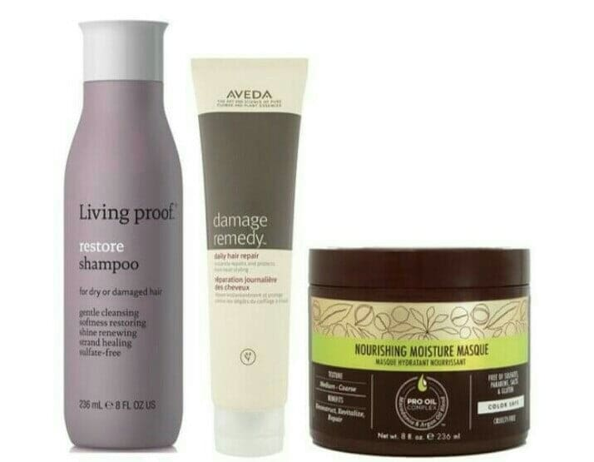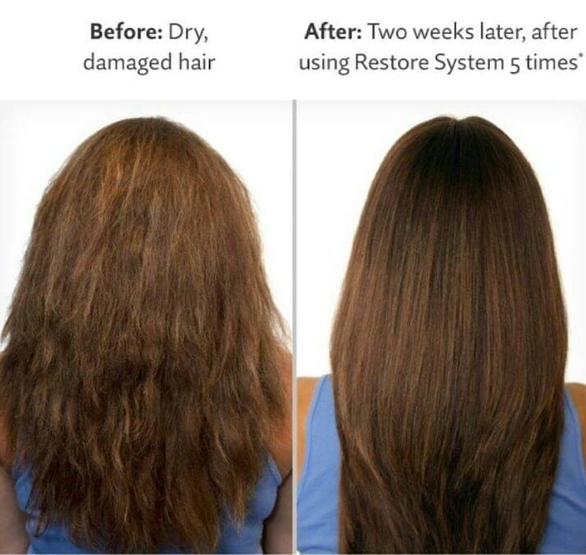

## ****Oily or Fine Hair****

### Shampoo

Be on the lookout for clear shampoos that are packed with thickening ingredients like panthenol or wheat protein. You can wash your hair daily to remove the excess oils and try to cleanse your hair once a week with a clarifying shampoo to remove hair product residue.

### Conditioner

Like shampoos, you don’t want a heavy conditioner in your hair because that will weigh it down. Look for lightweight formulas and apply the conditioner only from the mid-shaft of your hair and down (avoiding the root area). If you put too much conditioner on your scalp, you can make your hair look and feel more greasy. As an alternative to conditioner, you can spritz a leave-in-conditioner or detangler on your ends to help hydrate your hair further.

### Recommendations

Baby shampoo, Bumble & Bumble Seaweed Shampoo, Body Shop Rainforest Radiance Detangling Spray, [Neutrogena Anti-Residue Shampoo](https://www.beautylish.com/p/neutrogena-anti-residue-formula-shampoo?utm_source=beautylish_article&utm_campaign=vmvpj)

## ****Curly, Wavy or Thick Hair****

### Shampoo

These hair types tend to be on the drier side so use creamy shampoos (similar to dry or damaged hair types). Look for rich shampoos without harsh ingredients such as sodium laureth sulfate and creamy conditioners with ingredients such as shea butter. You don’t need to wash our hair every day so feel free to skip a day or two so the natural oils on your scalp can their magic (hair brushing with a natural bristle brush will help distribute oils from the roots to the ends).

### Conditioner

Curly, wavy or thick hair will work best with conditioners that contain silicone and proteins, which can coat the cuticle of the hair and reduce frizz. You can use conditioners with smoothing properties like soy or wheat protein before and after you shampoo for an extra boost of moisture. If your hair is extra frizzy, spritz on a light, leave-in conditioner.

### Recommendations

Aveda Be Curly [Shampoo](https://www.beautylish.com/p/aveda-be-curly-shampoo?utm_source=beautylish_article&utm_campaign=vmvpj) and [Conditioner](https://www.beautylish.com/p/aveda-be-curly-conditioner?utm_source=beautylish_article&utm_campaign=vmvpj)

## ****Coarse Hair****

### Shampoo

Coarse hair is the driest of hair types so it would be best to use super hydrating and creamy shampoos for your thirsty strands. Coconut and macadamia nut oil or shea butter are great ingredients in your shampoos that will coat the hair shaft and trap the water inside.

### Conditioner

Since this type of hair is extremely dry, you want an extra moisturizing conditioner. Deep conditioners that contain fatty alcohols like cetyl, stearyl alcohol, panthenol or silicone or essential oils will help hydrate your hair.

### Recommendations

[Wen Cleansing Conditioner](https://www.beautylish.com/p/wen-cleansing-conditioner?utm_source=beautylish_article&utm_campaign=vmvpj), Miss Jessie’s Super Sweetback Treatment, Philip Kingsley Moisture Extreme Shampoo and Conditioner

## ****Color Treated Hair****

### Shampoo

If your hair has been color-treated, you need a shampoo that cater to the treatment and keep it looking as fresh as possible. Use color-protecting shampoos, which will contain fewer harsh cleansers and prevent fading. The moisturizers in the shampoo will help restore hair shine and hydrate.

### Conditioner

Use specific conditioners designated for color-treated hair. These typically contain UV filters which work like sunscreen to prevent color fading.

### Recommendations

Biolage Delicate Care Shampoo, Pureology Hydrate LightCondition

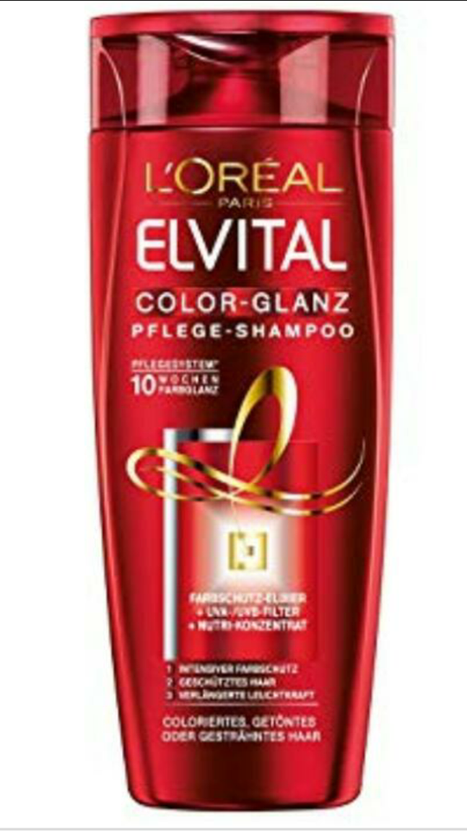 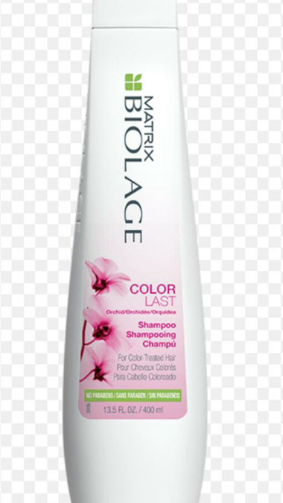

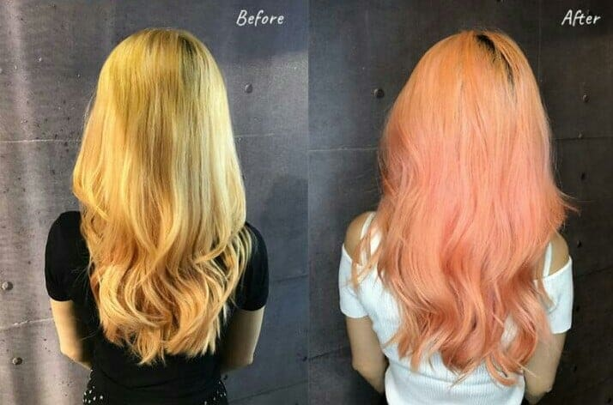

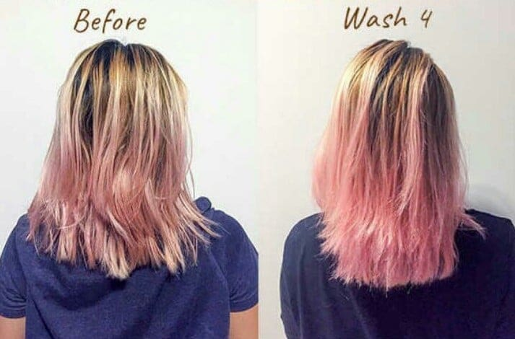

**Shampoo**

Shampoo is a [hair care](https://en.wikipedia.org/wiki/Hair_care) product, typically in the form of a viscous liquid, that is used for cleaning [hair](https://en.wikipedia.org/wiki/Hair). Less commonly, shampoo is available in bar form, like a bar of soap. Shampoo is used by applying it to wet hair, massaging the product into the hair, and then rinsing it out. Some users may follow a shampooing with the use of [hair conditioner](https://en.wikipedia.org/wiki/Hair_conditioner).

The typical reason of using shampoo is to remove the unwanted build-up of [sebum](https://en.wikipedia.org/wiki/Sebum) in the hair without stripping out so much as to make hair unmanageable. Shampoo is generally made by combining a [surfactant](https://en.wikipedia.org/wiki/Surfactant), most often [sodium lauryl sulfate](https://en.wikipedia.org/wiki/Sodium_lauryl_sulfate) or [sodium laureth sulfate](https://en.wikipedia.org/wiki/Sodium_laureth_sulfate), with a co-surfactant, most often [cocamidopropyl betaine](https://en.wikipedia.org/wiki/Cocamidopropyl_betaine) in water.

Specialty shampoos are available for people with [dandruff](https://en.wikipedia.org/wiki/Dandruff), color-treated hair, gluten or wheat allergies, an interest in using an [organic](https://en.wikipedia.org/wiki/Organic_farming) product, and infants and young children ("baby shampoo" is less irritating). There are also shampoos intended for animals that may contain [insecticides](https://en.wikipedia.org/wiki/Insecticide) or other medications to treat skin conditions or [parasite](https://en.wikipedia.org/wiki/Parasite) infestations such as fleas.

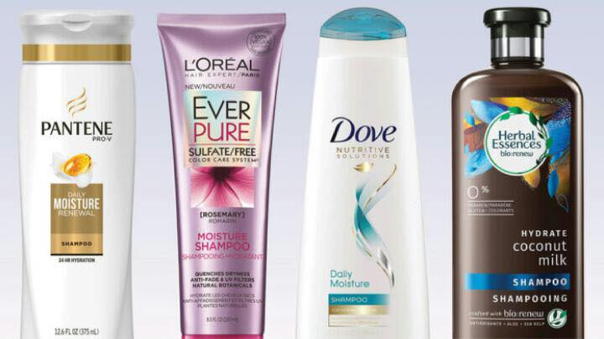

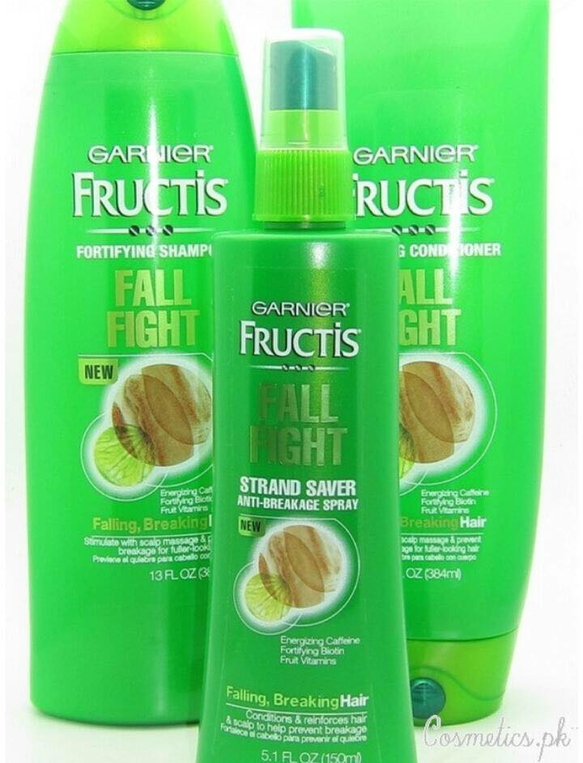 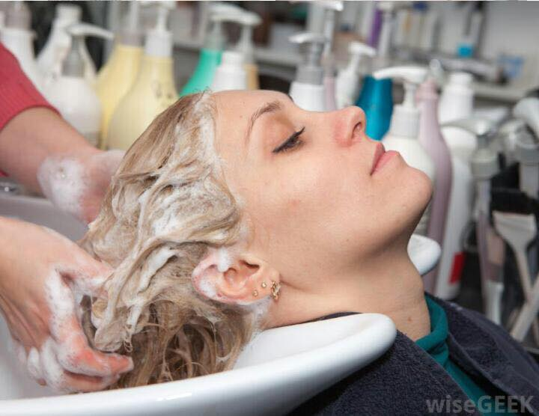

**01. Clarifying shampoo**

"Clarifying" sounds clean and clear -- but they can be rough on your hair, O'Brien says.

"Very few people will really need a clarifying shampoo," he says. They're generally used because someone has some kind of condition or is going to get a chemical treatment, and they really need to cleanse the hair. They rough up the hair's cuticle, for example, so the perm or color might take better. But some of them can be extremely harsh."

You should definitely avoid clarifying shampoos aftergetting your hair colored. "Even the mildest clarifying shampoos will unwind that color really fast," O'Brien says.

**How to Use Clarifying Shampoo**

### How Often Should You Clarify?

The answer depends on how much your hair goes through on a daily basis. If you use a lot of hair products or have very hard water, you might find it helpful to clarify weekly or even twice per week. Swimmers who are in the pool every day may need to clarify even more often to banish the greenish tint that chlorine causes over time. But, if you use minimal hair products or have soft water, you might need to clarify only as little as every other month. The average person should use a clarifying shampoo once or twice a month.

You might be wondering why you shouldn't simply use a clarifying shampoo on the daily. Sure, doing so would prevent buildup, but too-frequent use wouldn't leave enough beneficial oils in your hair to keep it healthy and shiny. Overuse can cause dryness. Oddly enough, it can exacerbate an oily-scalp problem, too, because the oil glands will react to the desert-like conditions by raining sebum.

You could find yourself caught in an endless cycle of using a clarifying shampoo to strip the excess oils that are produced in response to the dryness that the clarifying shampoo causes.

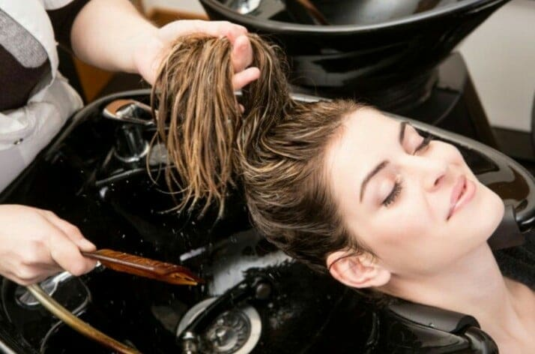

### How Do You Clarify?

Using a clarifying shampoo is really no different than using any other shampoo, with just a few tweaks. Start with a nickel- to quarter-sized amount of clarifying shampoo and work it into your scalp, massaging lightly for a good 60 seconds. Depending on the amount of buildup and oils on your hair, the shampoo may not lather very much, but that doesn't mean it's not working. Rinse very well.

Next, work a smaller dab of shampoo through your hair. (The more hair you have, the more you'll need to use, but typically no more than a quarter-sized amount is sufficient.) You should notice lots of suds. Let the shampoo sit in its bubbly glory on your head for a minute or two, while you take care of other grooming tasks, like shaving your legs. Letting the shampoo sit helps break down and release the product buildup so this is an important step. Then, rinse very well. If your hair has been sporting an unusual amount of buildup, you can repeat this step again, but only if dryness isn't a problem for you on the regular.

Condition your hair as you normally do. While that may seem to run counter to the objective of reducing buildup, it's a very important step; think of it as restoring the proper moisture balance. You might even need to use a bit more conditioner than usual, because clarifying shampoos don't usually include the moisturizers that regular shampoos do.

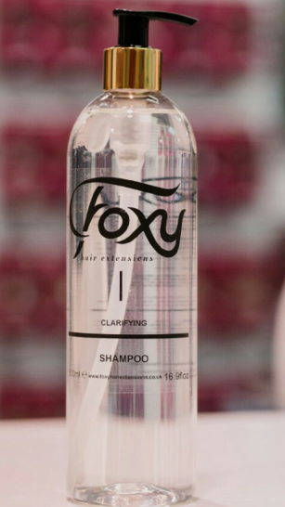 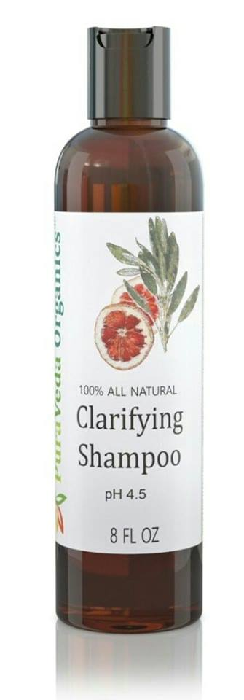 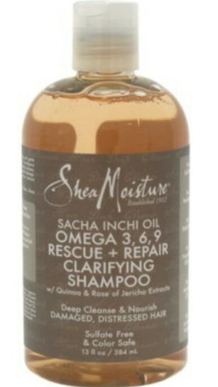

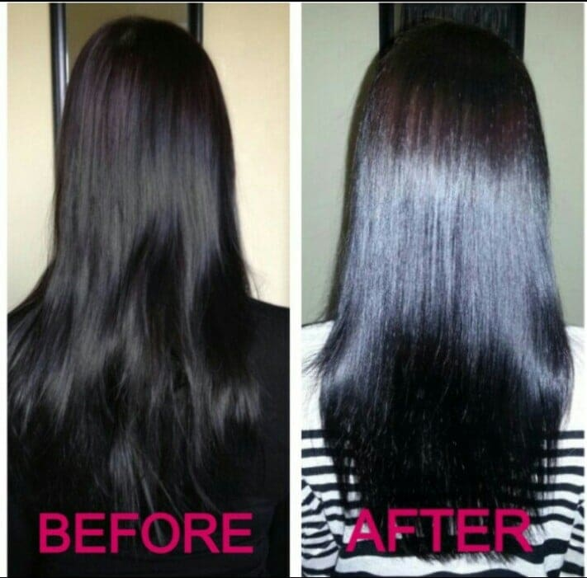

**02. Volumizing Shampoo**

Hair that has volume looks healthy, gives you a vibrant appearance, and makes you look like [you should be on the red carpet!](https://getgoodhead.com/4-steps-to-smooth-tasseled-red-carpet-hair/) (It also gives you better sex). If your hair could use a pick-me-up, here are some of the best volumizing shampoo choices, whether your hair is thin and straight, wavy and wispy, tight coiled or anywhere in between.

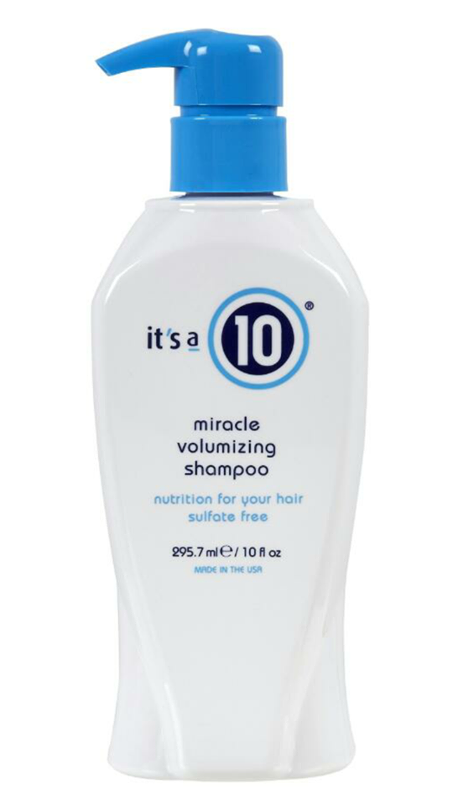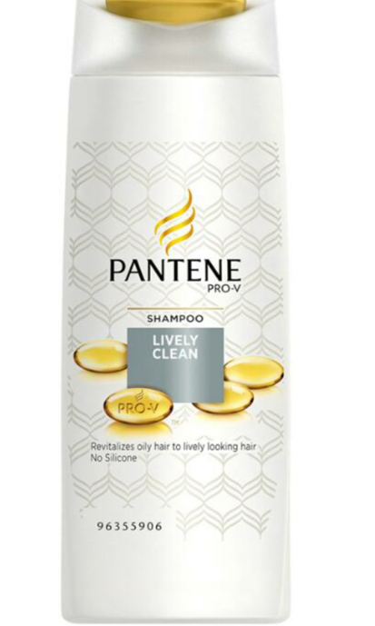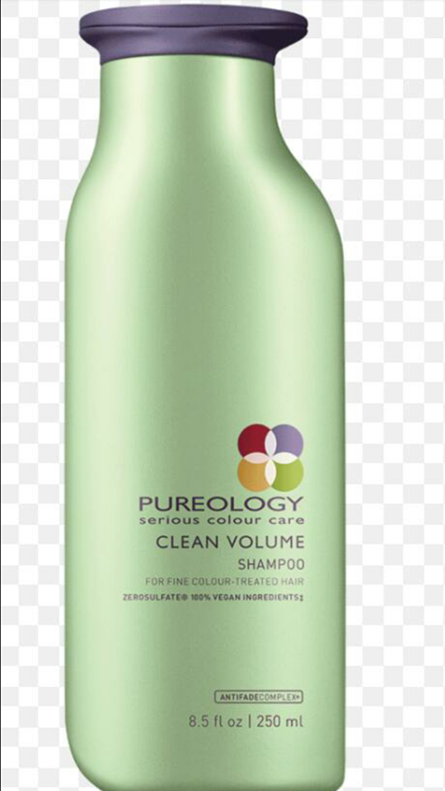

**03. Oily hair shampoo**

Sometimes it can feel like the whole haircare industry is marketed towards fighting dryness. [Hydrating shampoos](https://getgoodhead.com/shampoo-without-sulfate/), [moisturizing conditioners](https://getgoodhead.com/7-best-conditioners-for-dry-hair/), and intensely [creamy hair masks](https://getgoodhead.com/best-deep-conditioner/) litter our cosmetic shelves – but what about the rest of us who are fighting an oily head that just won’t quit? Where’s our parade?

We can all agree that oiliness is a difficult issue to combat in a world obsessed with hydration, and regular shampoo seshes. Maybe you’ve already tried some [top clarifying shampoos](https://getgoodhead.com/6-best-clarifying-shampoos/) and weren’t happy with the results? But, is it possible to cleanse, and moisturize your locks without sending your natural oils into overdrive?

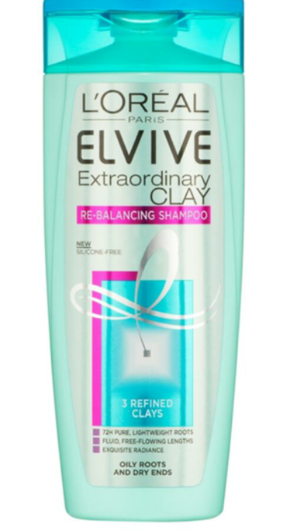 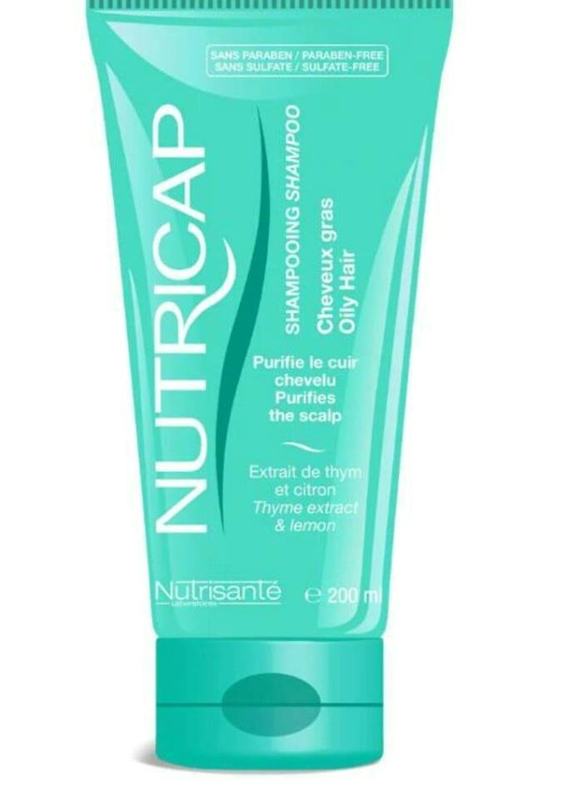

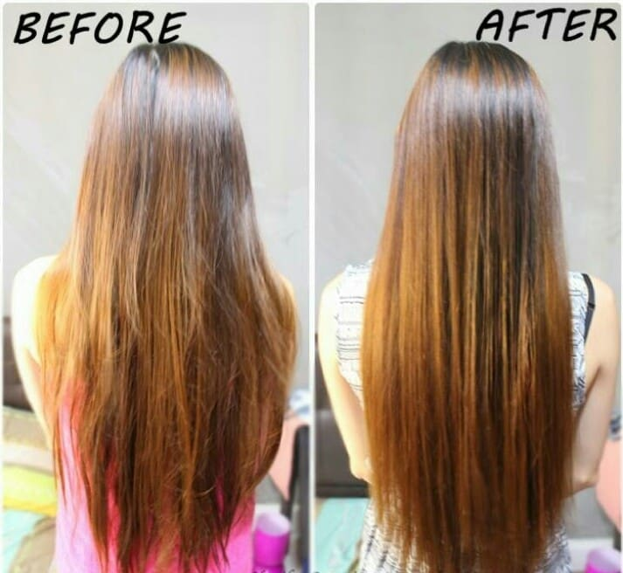

**04. 2-In-1 Shampoo**

Most women and men can agree that we feel better when our [hair is clean](http://www.huffingtonpost.com/2013/05/07/sustainable-way-to-wash-your-hair_n_3233030.html), yet this requires a lot of work and time. When [2-in-1 shampoos](https://www.google.com/search?q=2-in-1+shampoos+huffpost&ie=utf-8&oe=utf-8&aq=t&rls=org.mozilla:en-US:official&client=firefox-a#q=2-in-1+shampoos++&rls=org.mozilla:en-US%3Aofficial) hit drugstore shelves, it was truly life-changing. We were getting the best of both worlds (cleansing and conditioning), taking up less space in the shower and saving a couple of extra dollars.

Fast forward a few decades, and even with the existence of [dry shampoo](http://www.huffingtonpost.com/2012/04/06/dry-shampoo_n_1395302.html), we still find ourselves reaching for 2-in-1 shampoos when we're in a time crunch. But has the technology behind this super convenient haircare product evolved? And is it really getting both jobs done?

Puzzled by the formulation that make up [2-in-1 shampoos](http://www.self.com/blogs/flash/2012/04/2-in-1-shampoo-beauty-must-hav.html), we asked three top cosmetic chemists to explain what exactly is inside that big bottle and what it's doing to our hair.

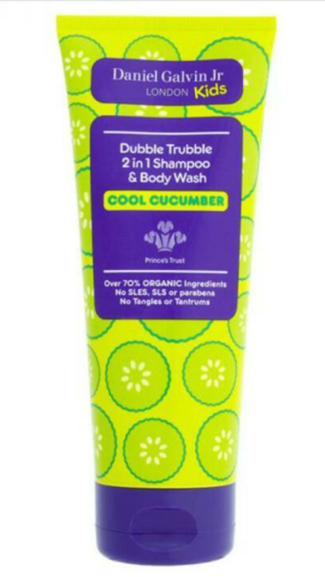 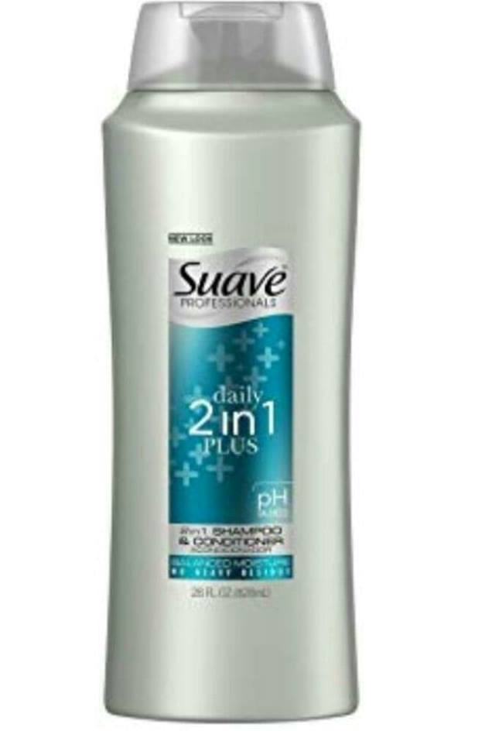

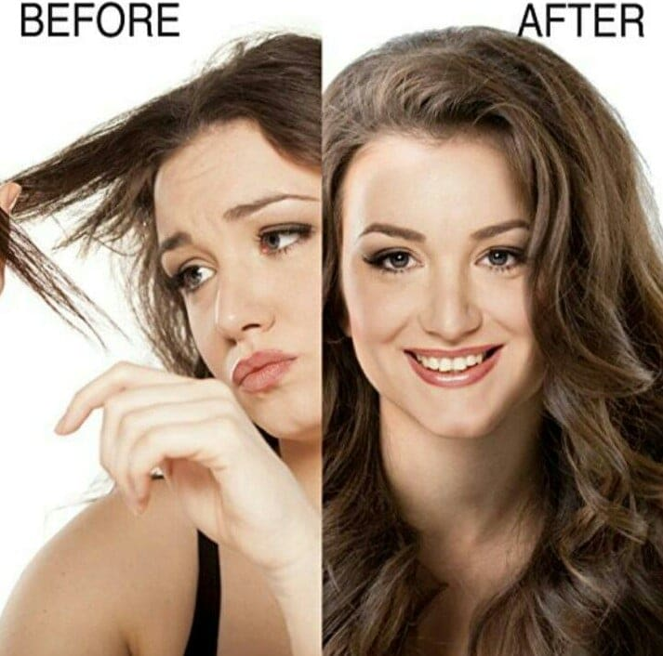

**05. Swimmer's shampoo**

Swimmer’s Shampoo removes build-up from chlorine and minerals, helps prevent swimmer’s green and protects from damage caused by sun and water exposure while restoring and maintaining shine, manageability and softness.

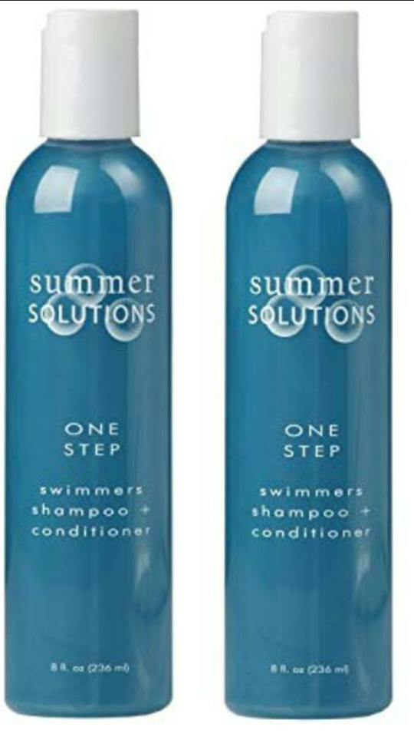 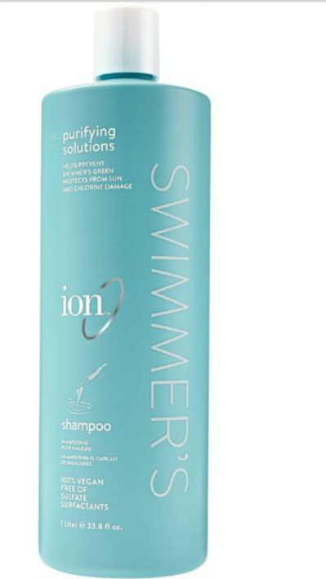

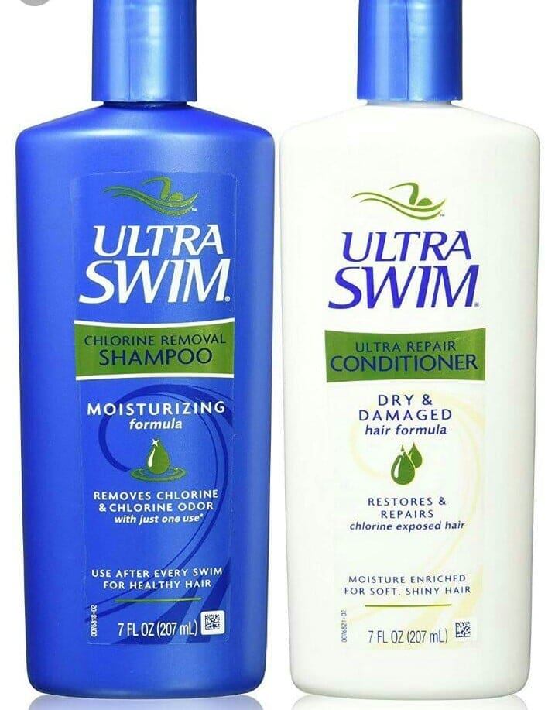

**Hair conditioner**

Hair conditioner is a [hair care](https://en.wikipedia.org/wiki/Hair_care) product used to improve the feel, appearance and manageability of [hair](https://en.wikipedia.org/wiki/Hair). Its main purpose is to reduce friction between strands of hair to allow easier brushing or combing, which might otherwise cause damage. Various other benefits are often advertised, such as hair repair, strengthening, or a reduction in split-ends.

Conditioners are available in a wide range of forms including viscous liquids, gels and creams as well as thinner lotions and sprays. Hair conditioner is usually used after the hair has been washed with [shampoo](https://en.wikipedia.org/wiki/Shampoo). It is applied and worked into the hair and may either be washed out a short time later or left in.

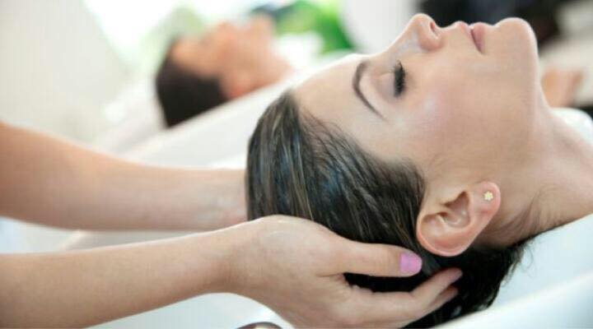

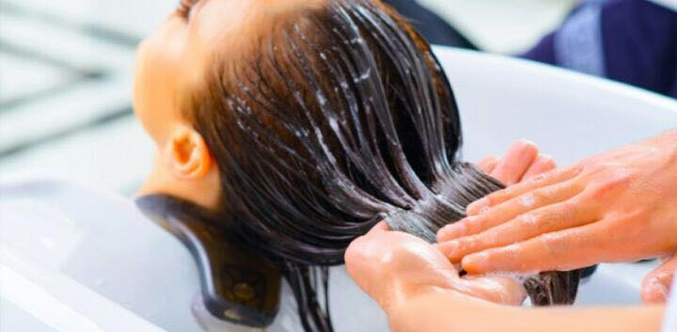

**01. Instant Conditioners**

Instant conditioners are the most common type of hair conditioning products. These are applied shortly after shampooing for a little time before rinsing, instant conditioners are made using water, a conditioning agent, thickeners and lipids. Conditioning agents in these conditioners may involve cationic detergents, proteins or film removers. Positive in charge, cationic agents are attracted towards the negative charge of damaged hair. Film formers are also positive in charge (hence reduce the static electricity) and are formed by polymers and correct hair shaft thereby resulting smooth hair.   
  
Instant hair conditioners condition hair and treat problems, such as hair loss and scalp irritability that are caused by alopecia, candida, psoriasis, and lupus. These conditioners are meant to be used directly from the bottle as they are premixed, and are applied immediately after shampooing. Instant conditioners generally contain additives, like herbal extracts, aloe, vitamins, balsam, and lanolin. These give sheen and nourishment to the hair but are only mildly conditioning.  
  
Now days, herbal instant conditioners are also available in the market that are made using natural organic products to ensure healthy hair and scalp. These conditioners provide optimum rejuvenation, revitalization, and growth while addressing hair loss and thinning. Natural instant hair conditioners have found to be good for hair types but especially for problem hair, such as dry, dull, lifeless, fly away, unruly or thinning. Natural instant hair conditioners provide effective conditioning for matted and tangled ends and make the hair a delight to comb or brush out after showering.

**Benefits**  
Suitable for daily use, an instant hair conditioner is color safe and leaves hair smooth and shiny. Some of the important benefits of daily using an instant hair conditioner are -

* Protect hair from thermal damage
* Locks out humidity and infuses silky shine
* Can also be used with curly irons for soft curl
* Making combing easier
* Easy and convenient to use
* Prevents breakage and hair damage

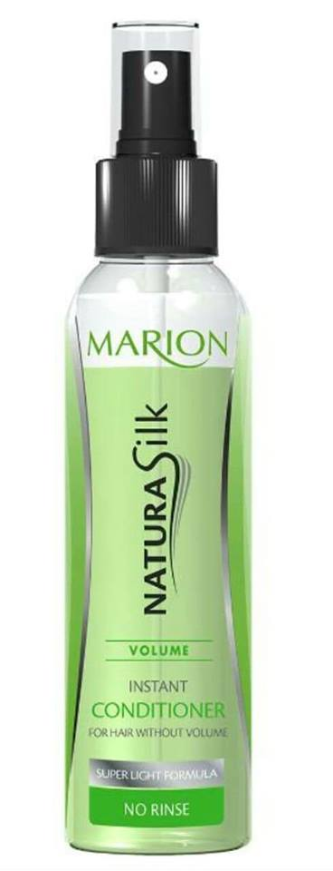 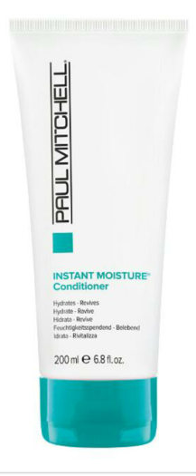 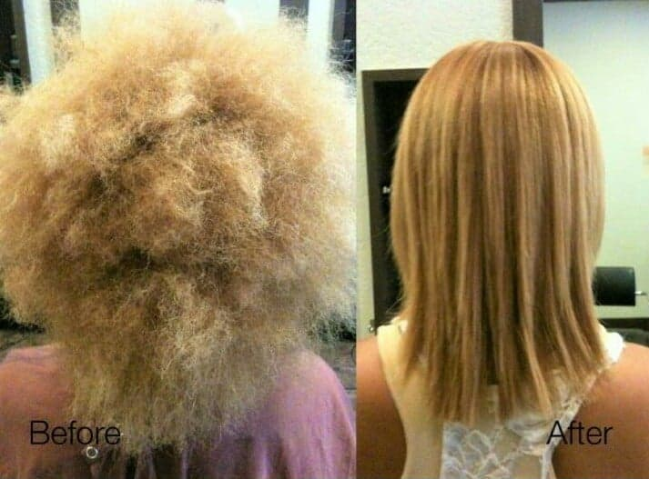

**02. Deep Conditioners**

Deep conditioners should be thought of as reparative treatments.

They can be used when needed, but generally don’t need to be used more than once a week.

With most deep conditioners, you apply the product from root to tip, and cover your head to help heat up the treatment to kickstart the absorption process. You can either use a shower cap and hair dryer on low heat, or a heat cap specifically designed to be used with deep conditioners.

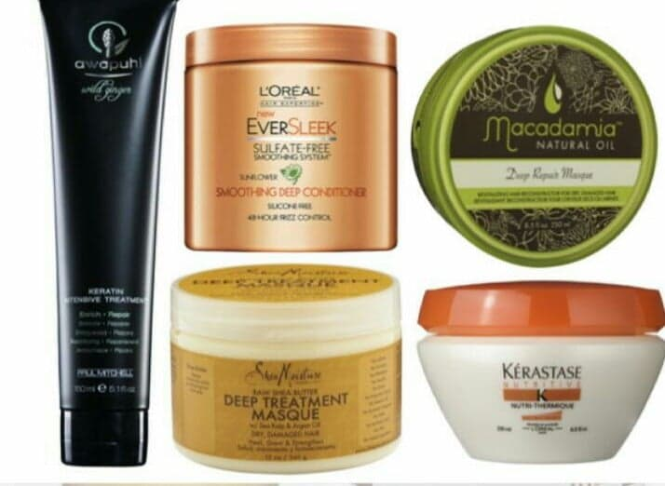 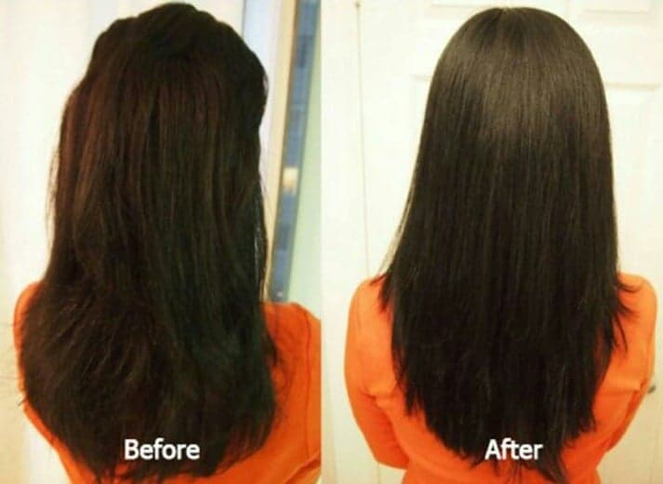

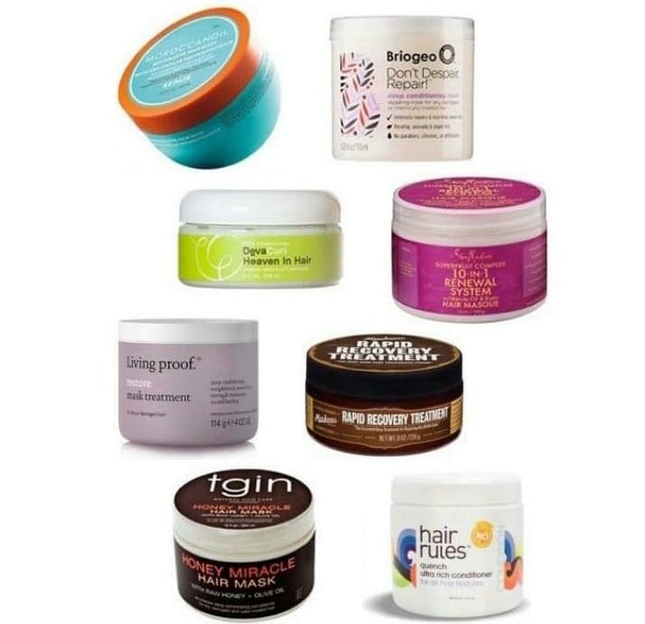

## 03. Protein Conditioners

• Temporarily rebuild damage along the hair's cuticle

• They are surface acting so when you wash your hair you remove this protein

• Also contain moisture boosting element unlike "protein reconstructors / treatments"

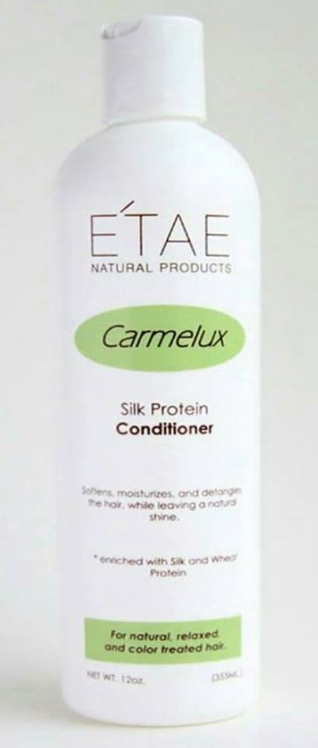 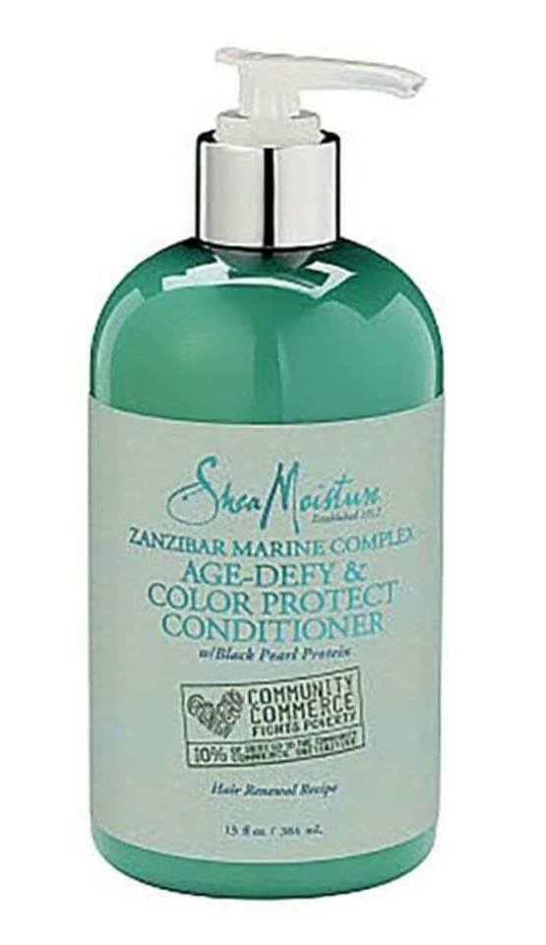

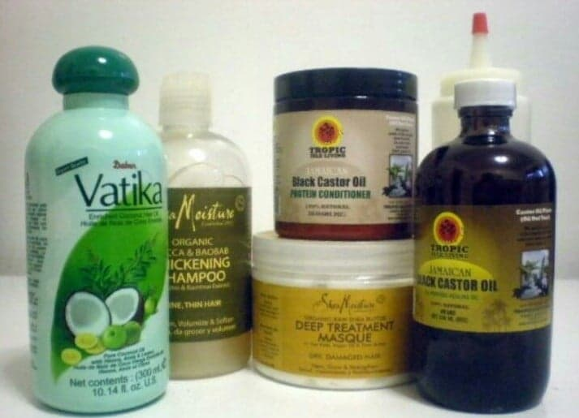 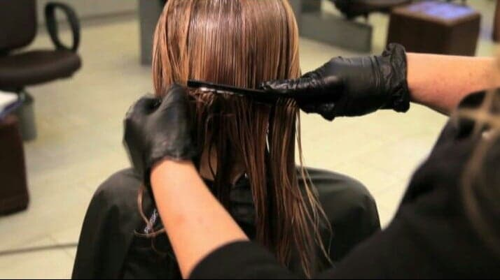

## Protein Treatments for Hair

## What Are Protein Hair Treatments?

Protein hair treatments (although you can also get this magic in the form of a shampoo or conditioner) are hair products loaded with a kind of protein that the hair can absorb. Hair protein treatments strengthen the hair, restore it if it’s been damaged, and fill in gaps between the cuticles thereby supporting the integrity of the hair shaft.

Proteins for hair slow water loss, and can help keep the hair moisturized. Emollients will also help slow down water loss, so keep reading to figure out which type of ingredient would be better for you – the health of your hair depends on making the right choice!

## Signs That You Need a Protein Hair Treatment

• Dry hair on its own is not enough to justify a protein hair treatment, because switching to a richer hair conditioner, or adding regular masking with emollients should always be the first step in treating dryness. If you try emollient-based treatments and they don’t work well enough on their own, then it is definitely time to give protein hair treatments a try.

• You should try protein hair treatments if your hair is more porous due to damage caused by bleaching, over-chlorination from the pool, or permanent chemical hair treatments like relaxing or perming. All of these circumstances can cause the hair to lose proteins.

To figure out if your hair is porous, you can do a strand test. Place a strand of your hair in a shallow bowl of water. If the hair sinks immediately, then your hair is very porous.

• Protein hair treatments are, in general, more appropriate for those who do not have very thick hair strands (i.e. anyone referred to as having fine or medium hair), because it’ll add strength and rigidity.

• If you are just about to undergo a serious hair treatment like bleaching or perming, doing a protein hair treatment first is a good idea. It will help to mitigate some of the damage the dyeing or perming will cause.

• If you have noticed a lot of hair breakage, and conditioning treatments haven’t helped, then give a protein hair treatment a try.

• If your hair is very flat, and has a difficult time achieving voluminous styles like curls or waves.

• If you are really unsure, you can give this strand test a try: wet a strand of hair with water, and then stretch it. If it stretches easily, but then breaks, it is a sign that your hair needs protein. If it doesn’t stretch much at all, your hair likely needs more moisturizing treatments.

## What Kind of Proteins Are Used in Protein Hair Treatments?

The most frequent proteins you’ll see show up in protein hair treatments are keratin, collagen, oat, rice, wheat, and silk. They will normally be preceded by the word “hydrolyzed”, meaning that the protein has been broken down into a smaller molecule that is able to penetrate through the layers of keratin that make up the hair more easily.

The words “amino acid” and “protein” in the ingredients list are also a good sign for a protein hair treatment, since hair proteins can come from so many different kinds of natural sources. Speaking of, you want to make sure these ingredients show up as one of the first 6 ingredients on the list, to know that there is a significant amount of protein in the formula.

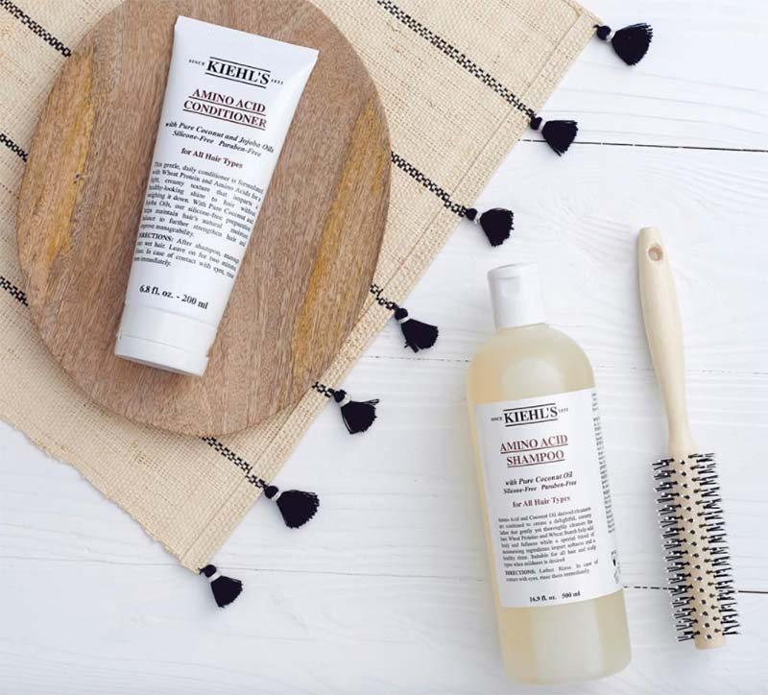

**04. Cream Rinse Conditioners**

* Great for detangling
* Great for heat protection, so you can use this type of conditioner AFTER your regular condition and shampoo for heat protection element

Cream-rinse conditioners generally do not contain all the moisturizers, oils and ingredients that are strongly attracted to hair as found in a deep conditioner, a moisturizing conditioner or a protein conditioner. On average they are also thinner in consistency.

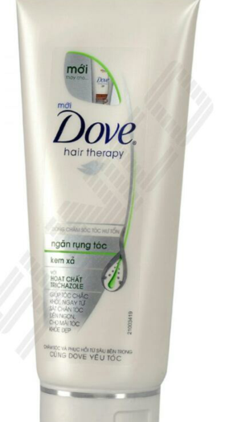 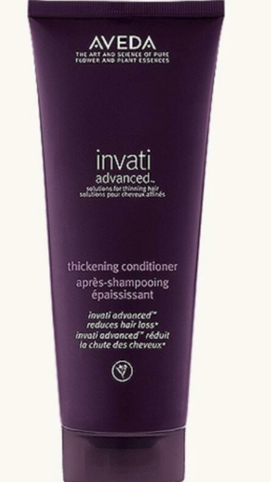

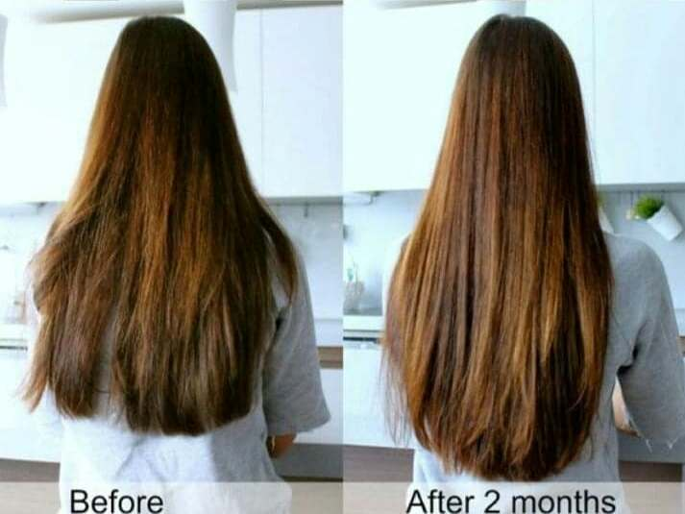

**05. Moisturising Conditioners**

* Boost moisture
* Boost hair elasticity
* Reduce frizz

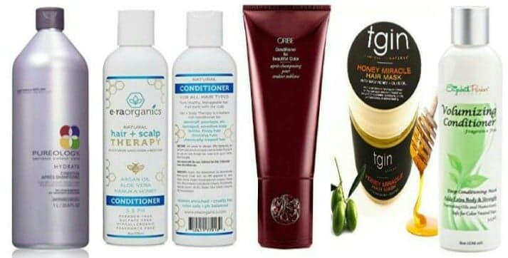

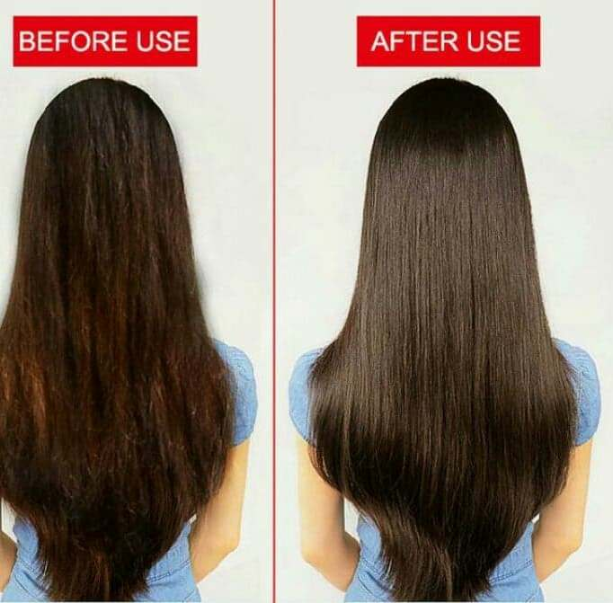

**Treat scalp & hair**

Different Types Of Dandruff

***1. Dry Skin-Related Dandruff***

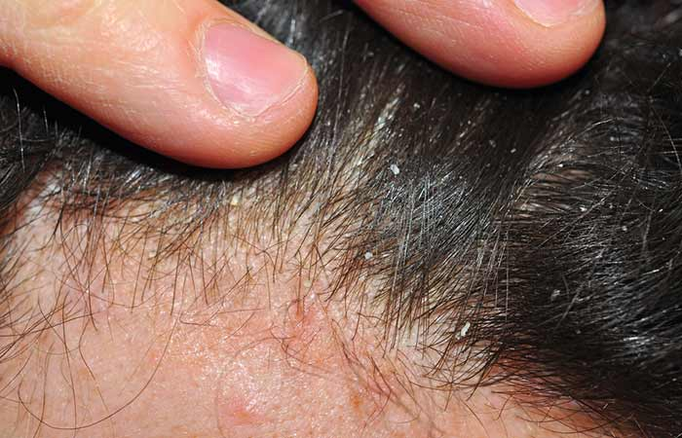

Dandruff often develops on people who generally have dry skin. This dry skin could be a result of winter months or not shampooing your hair regularly. People with curly hair also suffer from a drier scalp than other hair types. Using sulfate shampoos that create a lot of foam can also cause and aggravate dry skin-related dandruff.

*Symptoms*: A feeling of tightness on your scalp and small, round, white flakes of dandruff falling from your head.

***2. Oily Scalp-Related Dandruff***

[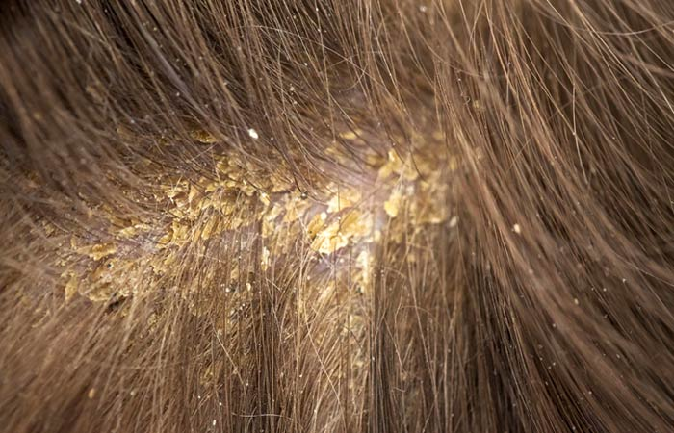](https://www.stylecraze.com/articles/the-different-types-of-dandruff-flakes-and-stop-them/)

Sebum is the natural oil that is produced by the sebaceous glands to moisturize your hair and skin and prevent it from drying up. It is also meant to keep the signs of aging at bay. However, sometimes your body may start producing excess sebum. This overproduction could be a result of puberty, pregnancy, stress, or irregular shampooing. When the excess sebum mixes with dirt and dead skin cells, it forms dandruff

*Symptoms*: Yellow patches on the scalp, big yellowish dandruff flakes, itching, greasy hair.

***3. Fungal Dandruff***

Fungal dandruff is caused by the infection of *Malasseziaglobosa*on your scalp. This fungal infection spreads quite rapidly when your scalp is excessively oily or has a pH imbalance. It is also highly contagious and can spread through sharing items like combs, towels or hats with an infected individual. What *Malassezia*does is, it produces oleic acid, which increases the turnover of skin cells, thus causing dandruff.

*Symptoms*: White or yellowish dandruff flakes, itchiness.

***4. Dandruff Caused By Product Buildup***

[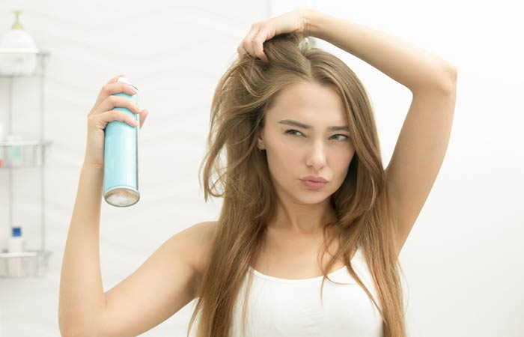](https://www.stylecraze.com/articles/the-different-types-of-dandruff-flakes-and-stop-them/)

If you are someone whose hair styling routine consists of like five different products, you need to stop. Immediately. Using excessive amounts of styling products like leave-in conditioners, gels, serums, pomades, mousses or hair sprays can cause them to build up on your scalp. This build-up can combine with dirt and dead skin cells to form dandruff. In fact, it could also lead to hair loss.

*Symptoms*: Big whitish or yellowish flakes of dandruff, irritation, hair fall.

***5. Dandruff Caused By Seborrheic Dermatitis***

[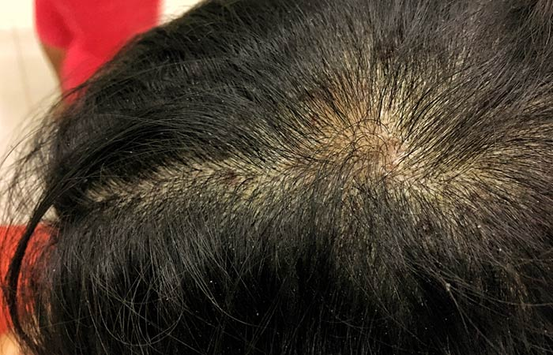](https://www.stylecraze.com/articles/the-different-types-of-dandruff-flakes-and-stop-them/)

Seborrheic dermatitis is a chronic inflammatory skin condition that can develop on parts of your body where there’s a higher concentration of sebaceous glands. This includes your scalp, neck, behind your ears, face, and eyebrows. Studies show that it is usually caused by an inflammatory reaction to yeast that is naturally found on your skin’s surface. Stress and hormonal changes could trigger seborrheic dermatitis.

***6. Dandruff Caused By Psoriasis***

[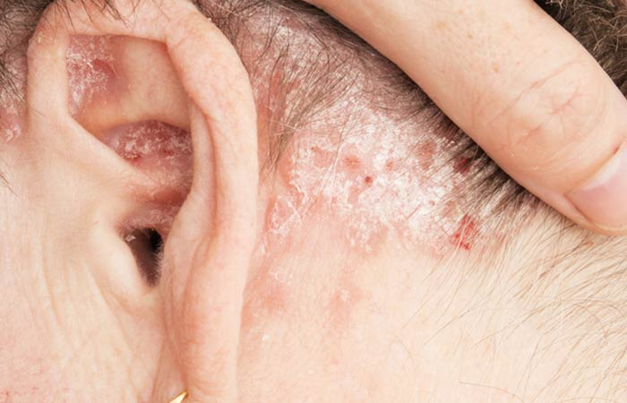](https://www.stylecraze.com/articles/the-different-types-of-dandruff-flakes-and-stop-them/)

Psoriasis is a chronic skin condition in which the immune system starts attacking healthy skin tissues. This leads to a rapid production of new skin cells before the old dead skin has had a chance to flake off. What results is the formation of thick silver-colored scaly patches on your scalp, neck, knees, and back.

*Symptoms*: Silver-colored scaly patches, thick white dandruff flakes, redness, mild itching.

For someone who suffers from dandruff, it can become an all-consuming part of their life. Not only do you fixate on it endlessly, you also feel embarrassed or ashamed when among company. But it doesn’t have to be this way. Dandruff can be treated fairly easily with the help of a few products and by following some simple tips. So just keep reading…

* onto your hair and scalp.

**Different Types of Dandruff** **Natural Treatments**

***Aspirin***



Aspirin contains the same active ingredient (salicylic acid) as many medicated dandruff shampoos. Keep flaking in check by crushing two aspirins to a fine powder and adding it to the normal amount of shampoo you use each time you wash your hair. Leave the mixture on your hair for 1-2 minutes, then rinse well and wash again with plain shampoo.

***Tea tree oil***

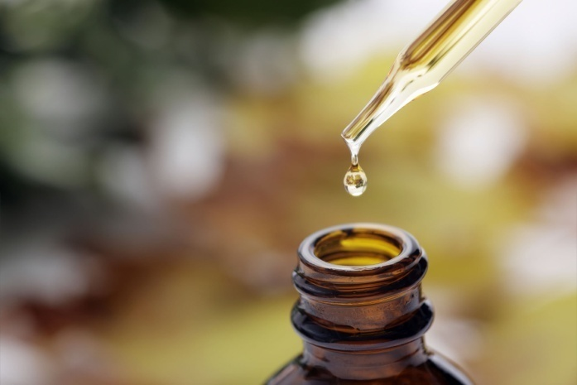

One [study showed](http://www.jaad.org/article/S0190-9622(02)00313-4/abstract) that shampoos with just 5 percent tea tree oil significantly improve the severity of dandruff. You can also add a few drops of tea tree oil to your favorite shampoo as you wash normally. [Tea tree oil can actually reduce the effects of several unpleasant conditions](https://www.rd.com/health/wellness/tea-tree-oil-uses/1/).

***Baking soda***

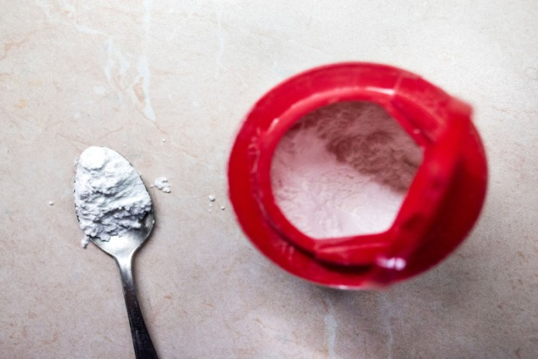

Your kitchen could hold the key to an itch-free, flake-free scalp. Some ingredients you use every day double as effective dandruff remedies—like baking soda. Wet your hair and then rub a handful of baking soda vigorously into your scalp. Skip the shampoo and go right to rinsing. Baking soda reduces overactive fungi that can cause dandruff. Your hair may get dried out at first, but after a few weeks your scalp will start producing natural oils, leaving your hair softer and free of flakes. Check out these other [ingenious uses for baking soda](https://www.rd.com/home/cleaning-organizing/baking-soda-uses/1/).

***Apple cider vinegar***

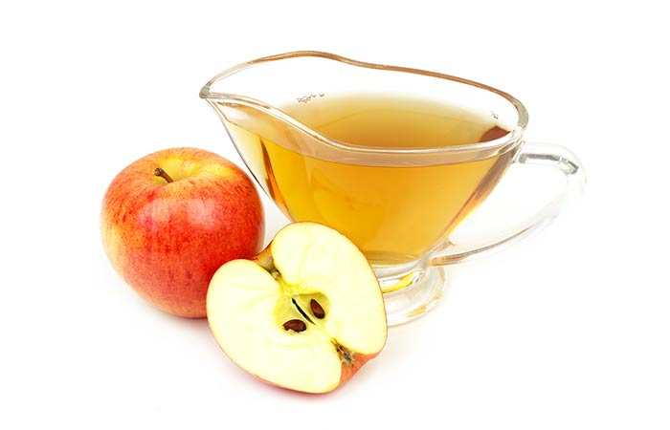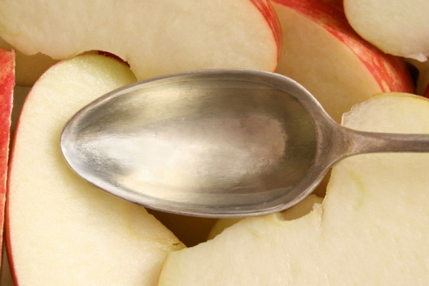

Dr. Mehmet Oz [swears by](http://www.doctoroz.com/videos/kitchen-cures-your-doctor-can-not-live-without) apple cider vinegar as a dandruff remedy, as the acidity of apple cider vinegar changes the pH of your scalp, making it harder for yeast to grow. Mix a quarter cup apple cider vinegar with a quarter cup water in a spray bottle and spritz on your scalp. Wrap your head in a towel and let sit for 15 minutes to an hour, then wash your hair as usual. Do this twice a week. Learn more about the amazing [health benefits of apple cider vinegar](https://www.rd.com/health/wellness/apple-cider-vinegar-benefits/1/).

***Mouthwash***

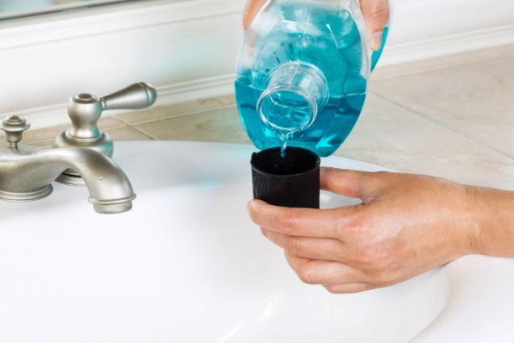

To treat a bad case of dandruff, wash your hair with your regular shampoo, then rinse with an alcohol-based mouthwash. Follow with your regular conditioner. Mouthwash’s [anti-fungal properties](https://www.livestrong.com/article/305946-is-listerine-effective-in-treating-dandruff/) help prevent dandruff-causing yeast from growing. Here are some [myths about mouthwash that just aren’t true](https://www.rd.com/health/wellness/myths-about-mouthwash/1/).

***Coconut oil***

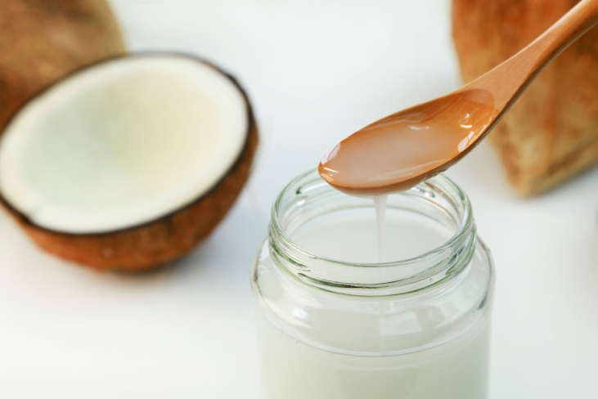

 says coconut oil is a “tried and true” dandruff treatment, and it smells nice too. Before showering, massage 3-5 tablespoons of coconut oil into your scalp and let sit for about an hour. Shampoo normally. You can also look for a shampoo that already contains coconut oil. [Coconut oil has lots of other great beauty uses as well](https://www.rd.com/health/conditions/coconut-oil-uses/1/).

***Lemon***

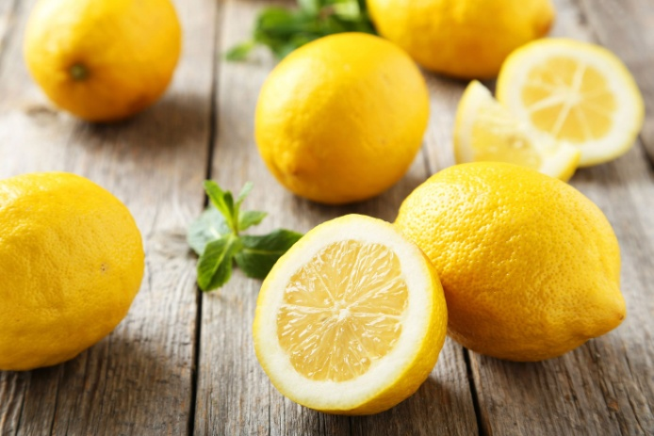

Dandruff relief may be no farther away than your refrigerator, if you have lemons on hand (which you should, because [they have lots of handy uses!](https://www.rd.com/home/cleaning-organizing/34-reasons-to-load-up-on-lemons/)) Just massage 2 tablespoons lemon juice into your scalp and rinse with water. Then stir 1 teaspoon lemon juice into 1 cup water and rinse your hair with it. Repeat this daily until your dandruff disappears. Lemon’s acidity helps balance the pH of your scalp, which helps keeps dandruff at bay.

***Salt***

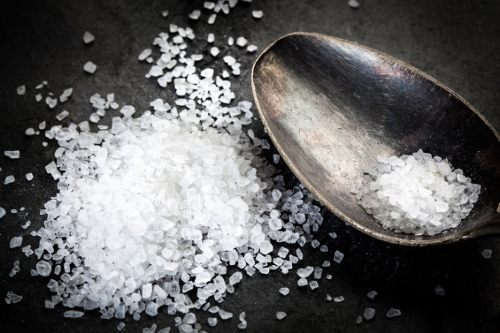

The abrasiveness of ordinary table salt works great for scrubbing out dandruff flakes before you shampoo. Grab a saltshaker and shake some salt onto your dry scalp. Then work it through your hair, giving your scalp a massage. You’ll find you’ve worked out the dry, flaky skin and are ready for a shampoo. Pair one of our other dandruff remedies with your shampoo for the full treatment. Dandruff relief is one of [dozens of handy ways to use salt](https://www.rd.com/home/over-60-ways-to-use-salt/).

***Aloe vera***

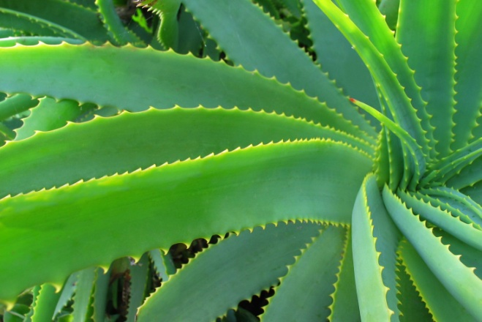

All of these dandruff remedies will make the dandruff go away, but aloe vera doubles as an itch-fighter. Stop yourself from scratching by massaging aloe vera into your scalp before shampooing. The cooling effects of [aloe vera will soothe the itch](http://tipsandbeauty.com/how-to-use-aloe-vera-gel-for-dandruff/). If you’re not sure why your head is itchy, [here are some more possible reasons](https://www.rd.com/health/conditions/itchy-scalp-reasons/1/) you feel like scratching your scalp.

***Garlic***

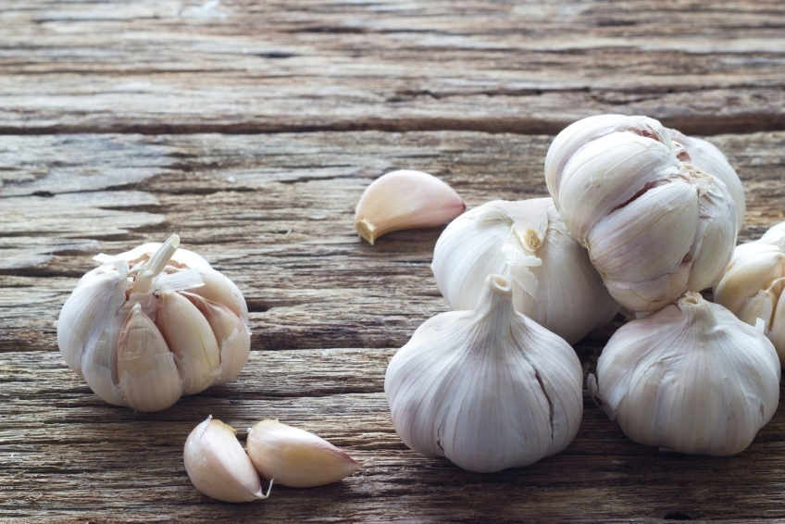

Garlic’s antimicrobial properties are perfect for eliminating dandruff-causing bacteria. ([They make it a great remedy for UTIs, too!](https://www.rd.com/health/conditions/natural-remedies-for-uti/1)) Crush garlic and rub it into your scalp. To avoid that potent smell, [healwithfood.org](http://www.healwithfood.org/dandruff/garlic-treatment.php) suggests mixing crushed garlic with honey and massaging into the scalp before washing as usual. In addition to being one of the best dandruff remedies, [you can use garlic for your hair, skin, and even immune system](https://www.rd.com/health/beauty/13-surprising-benefits-of-garlic/1/).

***Olive oil***

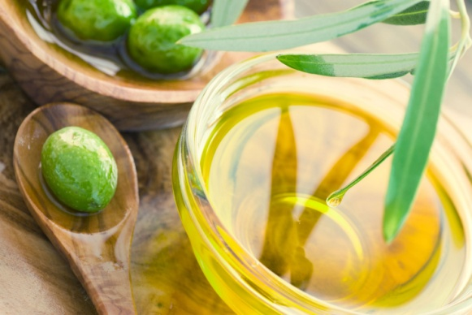

An overnight olive oil soak is a [folk remedy for dandruff](https://www.livestrong.com/article/117763-olive-oil-remedies-dandruff/). Massage about 10 drops into your scalp and cover with a shower cap overnight. Follow your regular shampoo routine in the morning. For a quicker cure, look for a shampoo that contains olive oil. But you should also keep some olive oil on hand so you can use it for [these 7 other things](https://www.rd.com/home/cleaning-organizing/7-extraordinary-uses-for-olive-oil/1/).

***Fenugreek Seeds + Lemon Juice***

1. Fenugreek Seeds For Dandruff

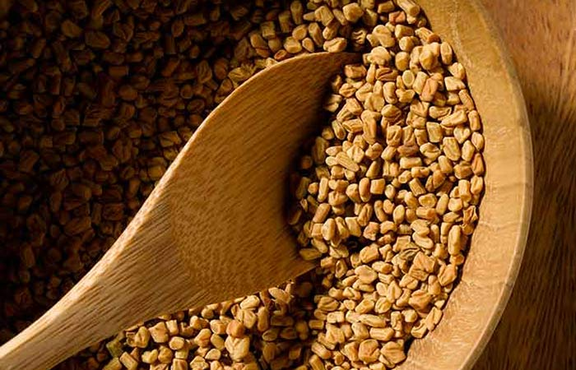

**Time**

Overnight + 30 minutes.

**Method**

1. Soak the fenugreek seeds in a bowl of water and leave it overnight.
2. In the morning, grind the seeds to form a smooth paste.
3. Apply this paste to your scalp and hair. Leave it on for 30 minutes.
4. Wash your hair with a mild shampoo.
5. Condition and let your hair air-dry.

**How Often?**

1-2 times a week.

**Why This Works**

Fenugreek seeds not only help prevent dandruff but they also promote healthy hair growth while preventing grays and adding shine to your hair.

***2. Fenugreek Seeds And Lemon For Dandruff***

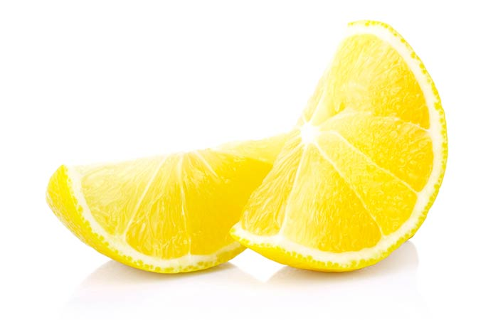

**INGREDIANS**

* 2 tbsp fenugreek seeds
* 1 tbsp lemon juice

**Time**

Overnight + 30 minutes.

**Method**

1. Soak the fenugreek seeds in a bowl of water and leave it overnight.
2. In the morning, grind the seeds to a smooth paste. Add the lemon juice to this paste and mix well.
3. Apply this paste to your scalp and hair. Leave it on for 30 minutes.
4. Wash your hair with a mild shampoo.
5. Condition and let your hair air dry.

**How Often?**

Once a week.

**Why This Works**

Lemon juice helps control oil while unclogging your pores and boosting hair shine. It also helps exfoliate dead skin cells, helping you achieve a flake-free scalp.

**Equipment for hair perming**

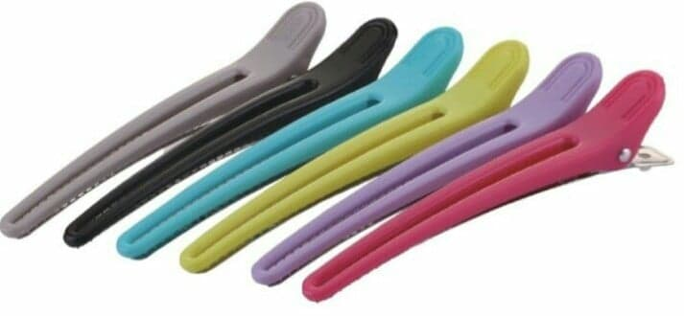 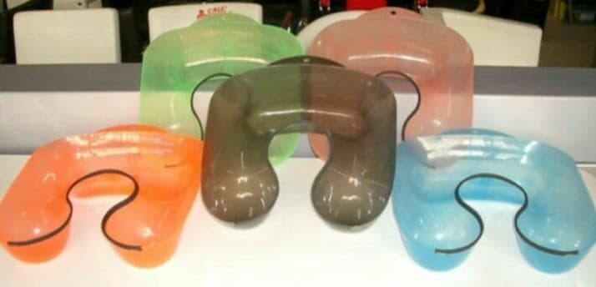 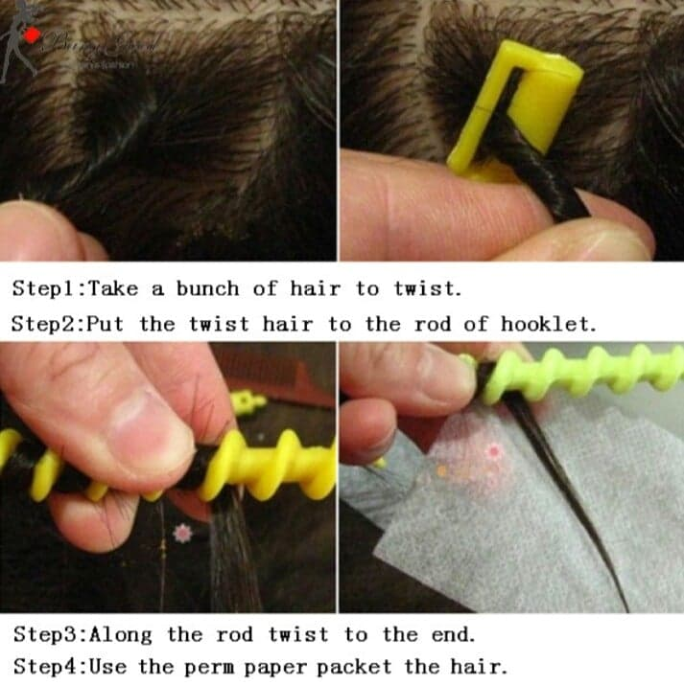 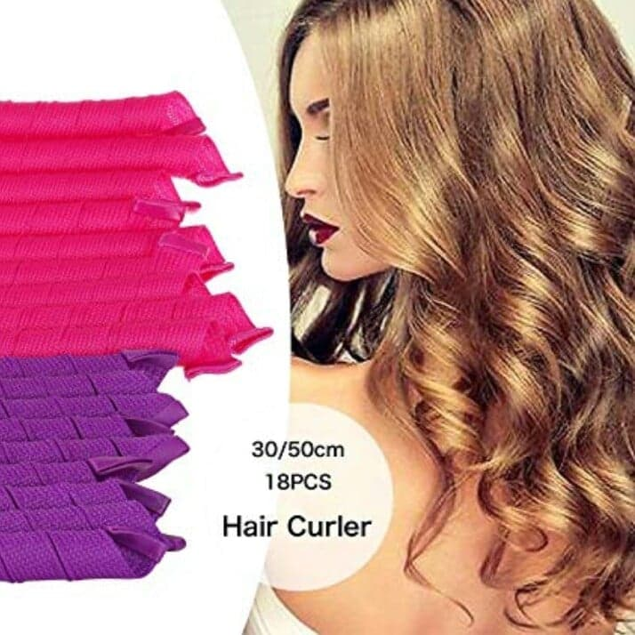

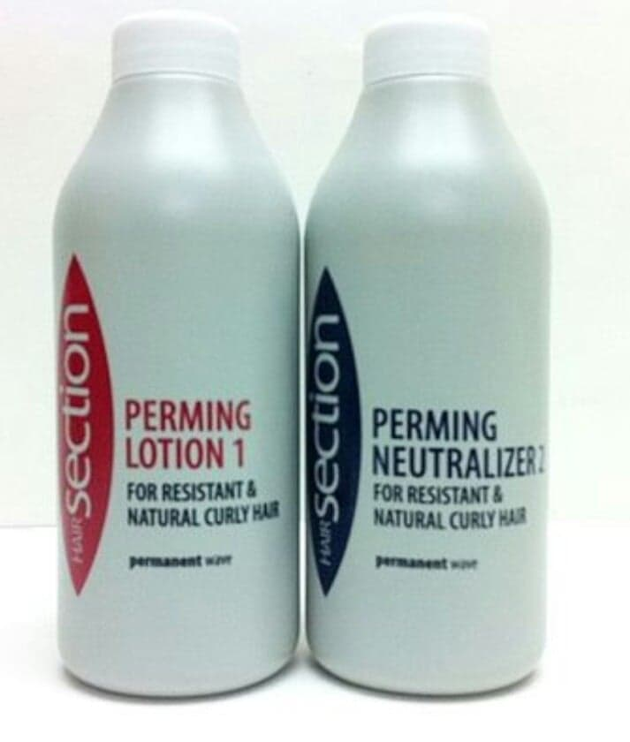 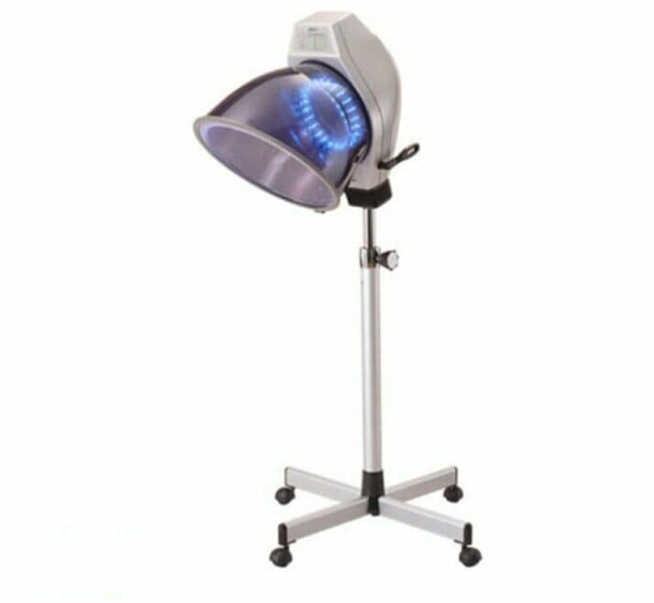

**Types Of Perm Hairstyles**

Back in the 80s, curls were 100% the hairstyle to have. Straighteners were out and curlers, crimpers and perms were everywhere. Girls loved their curls and why not? They brought volume, life and waves to their hair. Now, thirty years later, everything retro is back in fashion and women everywhere are realizing that the 80s rocked – especially when it came to fashion.

**Spiral Perm**

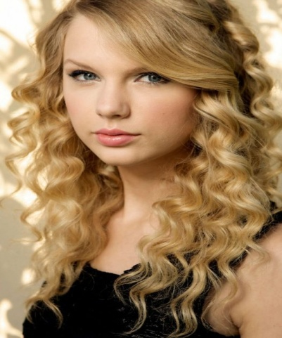

Spiral perms are created using long perm rods. The end result is extremely tight, cascading curls or ringlets. They look like tightly wound spirals or corkscrews. Of course, how tight the curls are depends on the size of the perm rod and the various chemicals used. These factors will mostly vary from salon to salon so be sure to ask – some salons will be able to provide pictures of their work as examples.

**Body Perm**

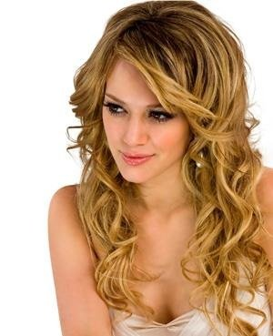

Body wave perms help to give volume to hair. They’re generally suited for people with thin or flat hair and the curls will be larger on women with hair that is naturally quite straight. It produces loose curls and a gentle wave which is great for adding volume and a bit of life to dull hair. It’s great for shoulder length hair or longer and suits people with square faces as it tends to soften facial features.

**Spot/Plain Curl Perm**

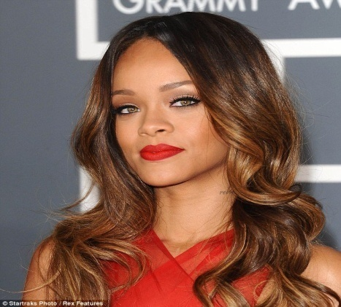

Plain curl perms (often referred to as ‘spot perms’) focus on curling a specific section of hair. They’re used generally to help achieve a certain style, for example curling only the ends or midsection of your hair. With plain curl perms, you can choose to either have tight or loose curls. The result tends to be natural looking waves depending on where you choose to have permed.

**Muti-Textured Perm**

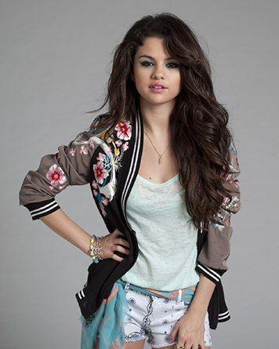

If you’re worried about your perm looking a bit too uniform and unnatural, a multi-textured perm could be perfect for you. It’s created using two different sized styling rods which means the curls end up varying sizes throughout your hair. This is thought to look more natural and the uniform and defined curls you would get otherwise.

**Root Perm**

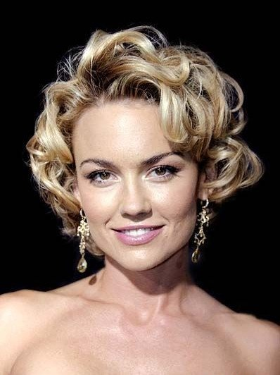

Root perms are perfect for women with flat, limp and lifeless hair. As the name suggests, this process involves perming just the roots. The slight curl will give your roots a bit of body which will in turn help to lift the rest of your hair, giving it volume.

Root perms can also be used on women with short hair who simply want to bring a bit of life to it. It’s perfect for giving your short hair an incredibly fashionable and retro look.

**Stacked Perm**

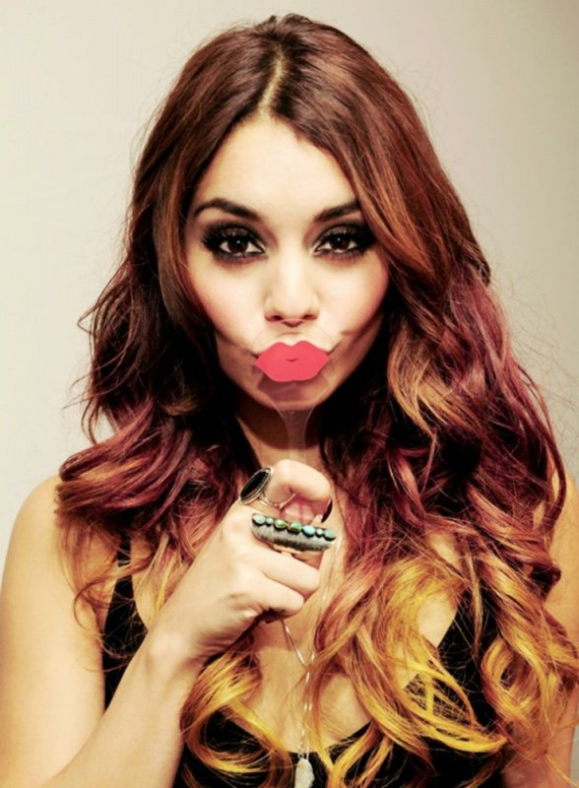

Stacked perms work better for women with hair of all one length opposed to hair with layers due to the fact it adds a lot of volume to hair. Generally, it suits women of all face types too. Stacked perms are where the stylist focuses on curling only close to the ends of the hair, giving hair volume and creating the illusion of layers.

**Pin Curl Perm**

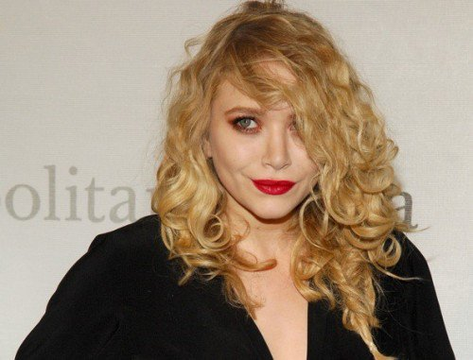

As the name would suggest, pin curl pins are created with pins and curlers. They tend to create quite tight curls however you do have some control over size as you can choose the appropriate curler size to be used. The one drawback to pin curl perms are that they tend not to last as long as other perms, especially if your hair is quite long. This is best done on medium or short hair.

**Loose Wave Perm**

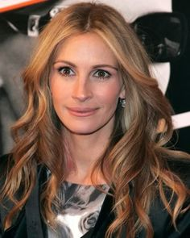

Loose wave perms are a great choice if you’re not totally committed to having super curly or wavy hair. As the name suggests, this type of perm creates loose waves which can be easily compared to the beach wave look, something which looks fab come summertime. It can be done on any length of hair but the longer the better in this case or the waves likely won’t have much effect on your look.

**Partial Perm**

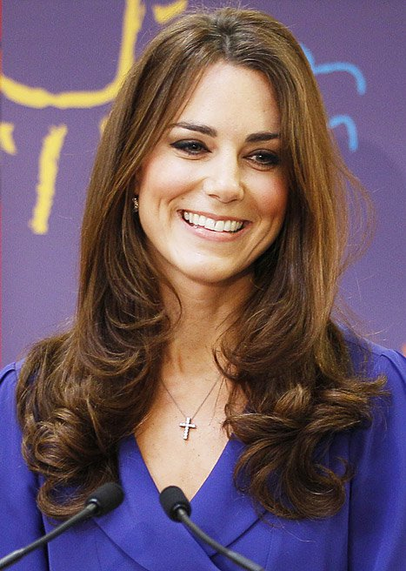

Partial perms involve perming only the bottom half of your hair (or even just the very end if you choose) and leave the part of your hair nearest your scalp completely straight. This is a great way to add volume to your look without overdoing it and also tends to be a much manageable style than most other perms. If you’re going to be tying your hair up a lot this look is perfect for you.

**Volumising Perm**

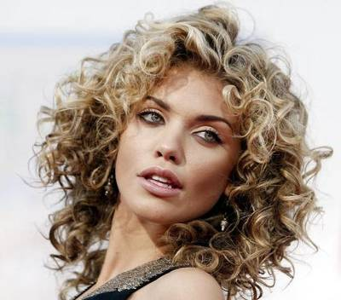

Volumising perms add volume – it really is that simple. You can get them in a variety of curl styles but as a rule they tend to use quite tight curls to create extra volume. Plus, there tends to be lots of small curls opposed to a few loose big ones which adds even more volume. It’s not the easiest style in the world to manage but it is a look that is sure to get you noticed.

# [How to Perm Your Hair](https://www.wikihow.com/Perm-Your-Hair)

### Part 1 - Preparing and Sectioning Your Hair

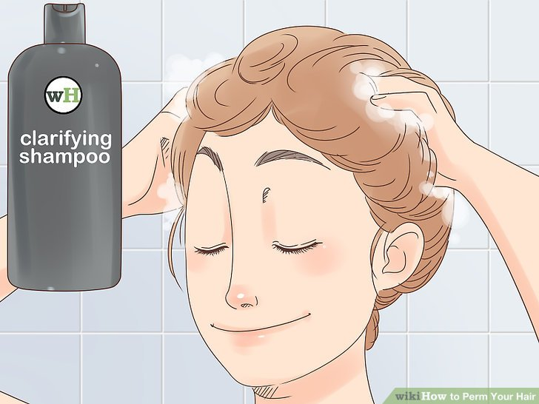

**Wash your hair with a clarifying shampoo.** This will remove any oil or residue and give you a clean base to work on. Do not use any conditioner, however, or the perm solution won't set properly. Once you’ve washed your hair, pat it dry with a soft towel or old T-shirt.

* A rich, protein conditioning shampoo would also be a great choice.
* It’s okay if your hair is damp, but make sure that it’s not soaking wet.
* Brush your hair before you wash it, then run a wide-toothed comb through it after washing it.

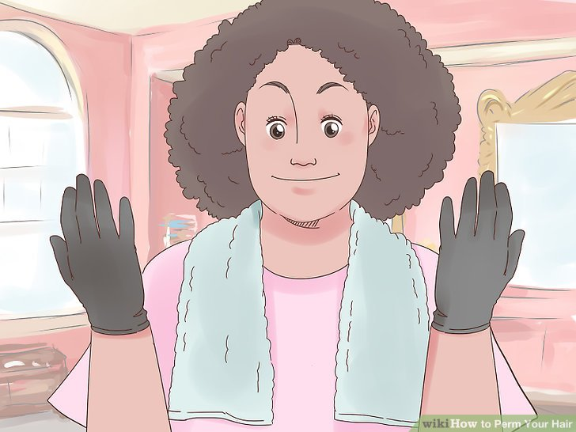

**Wrap a towel around your neck, then put on a plastic cape and gloves.** You do not want to get the perm solution on your skin, so you’ll have to take extra precautions. Wrap a towel around your neck first, then put on a plastic cape, like what you'd use for dyeing hair. Finally, pull on a pair of plastic or vinyl gloves.

* You can buy the cape and gloves at a salon or beauty supply store.
* The cape must be plastic, otherwise the perm solution will soak through it.
* It would be a good idea to put on old clothes that you don’t mind ruining

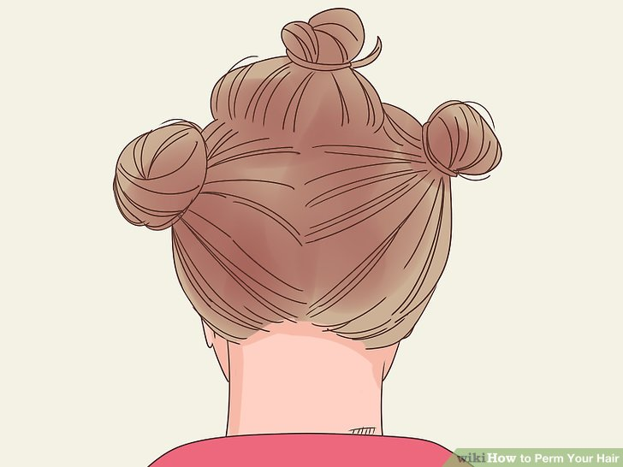

**Split your hair into 3 sections, with a middle and 2 sides.** Use the handle of a rat-tail comb to create 2 side parts, 1 on each side of your forehead. Make the middle section start at your forehead and end at your nape. Twist the 2 side sections into buns to keep them out of the way.

* The middle section needs to be a little narrower than your rod. How many inches or centimeters wide this is will vary.
* Consider splitting the top section in half at the back of your crown, then twisting the top/front section into a bun as well.

### Part 2 - Wrapping Your Hair

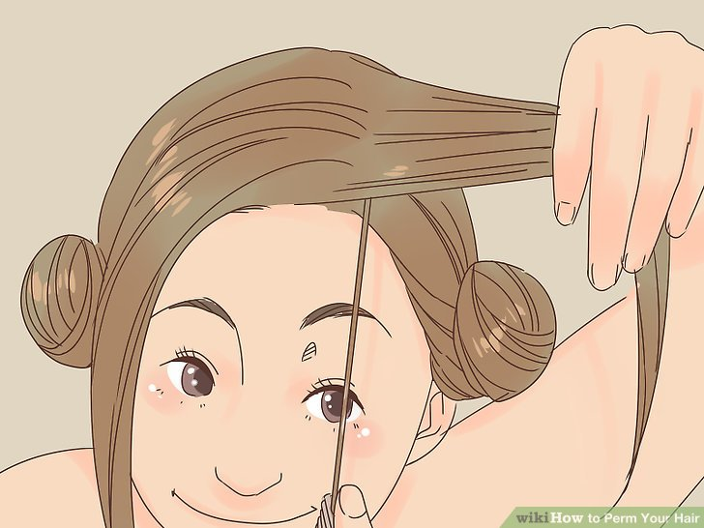

**Take a thin strand of hair from the middle section.** Use the handle of a rat-tail comb to separate a thin strand of hair from the middle section. Pull it taut so that it is perpendicular to your head. Select a strand that is no larger than the diameter of the perm rod you plan to use, since packing too much hair onto a rod can result in limp curls.

* You can start at your front hairline or at the back of your crown. If you did the latter, you’ll have to go back and do the front once you reach your nape.

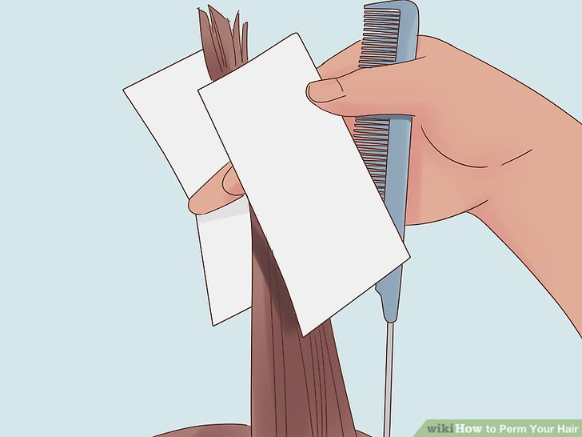

**Fold an end paper around the end of the hair strand.** Place an end paper against the hair strand, so that half of it is hanging off the side. Fold the excess paper under the hair strand so that it's sandwiched inside. Next, slide the end paper towards the bottom of the hair section.

* It would be a good idea to fold some end papers in half ahead of time. This way, you can just slide it over the edge of the hair strand, then pull it down.

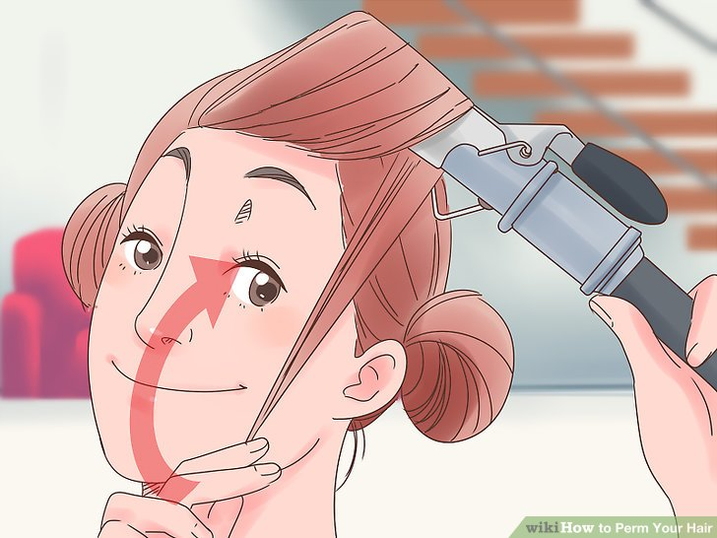

**Wrap the hair strand around a curling rod.** Place the end of the hair strand on top of a curling rod. Wrap the hair around the curling rod until you reach your scalp, then close the rod.

* Choose a rod size that’s appropriate for the curl size you want. Remember: the larger the rod, the larger and looser the curl.
* Roll the rod downward, away from your forehead and towards your nape.

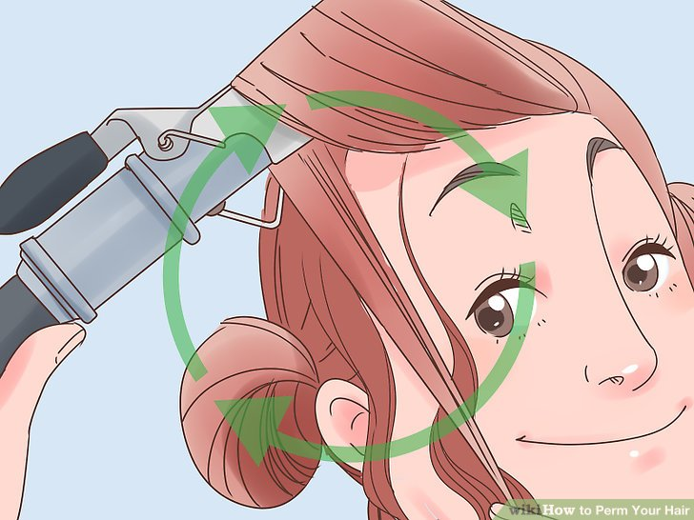

**Repeat the process for the entire middle section.** If you started from the back of your crown, work your way down to your nape first, then go back and do the front section. If you started from your hairline, just work your way down to your nape.

* Make sure that all of the hair from the middle section goes into the rod.

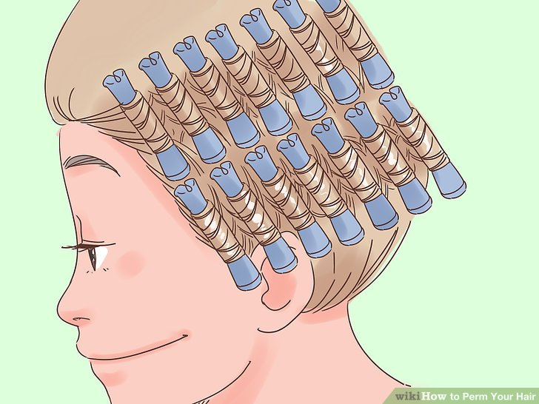

**Apply 2 columns of rods to each side section.** Choose a side to start with, and unravel the run. Create a vertical part, somewhere behind your ear, and wrap the front section of hair into a bun. Apply more rods horizontally in a vertical column, then do the front section of hair (the one that’s in front of your ears).

* The ends of the rods need to be touching each other--including the side-back section and the middle section.
* Start applying the rods at the top of the side section, right under the middle section, and finish at your hairline.
* At this point, your hair may start to dry as you work with it. If that happens, simply mist it with water. This will make it easier to wrap around the rod.

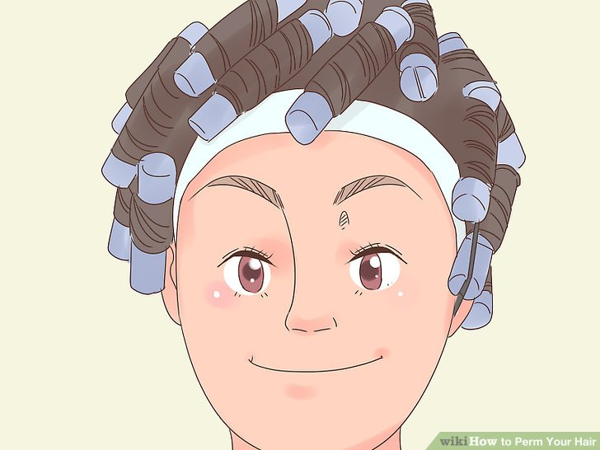

**Wrap a cotton strip around your hairline, tucking it under the rods.** This is very important, as you’ll need some sort of barrier between your skin and the perm solution. Purchase a strip of cotton batting from an online or local beauty supply store, then wrap it around your hairline, tucking it under the edges of the rods.

* The cotton batting is not fabric. It looks like a long cotton ball. It’s similar to what you’d find at a nail salon.

### Part 3 - Applying the Perm Solution

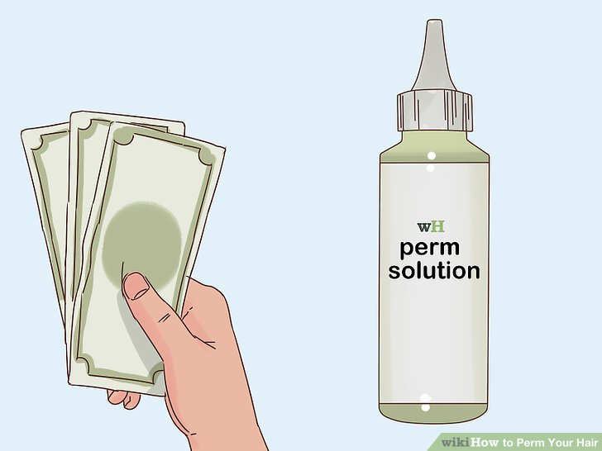

**Purchase a perm solution based on your hair type and health.** There are 2 types of perm solutions: alkaline and acid. Depending on your hair type, you’ll need to choose 1 or the other. If you choose the wrong type, you may end up with different results--or in some cases, you may damage your hair.

* Choose an alkaline solution if your hair is: Asian, coarse, fine, resistant, or has low elasticity.
* Choose an acid solution if your hair is: damaged, fragile, highlighted, tinted, or has high elasticity.
* Visit a salon if you have hair that has been extensively color treated or damaged, or if you have African-American hair. Choose a stylist who specializes in working with your hair type. Ask friends and family to recommend a good salon, or search for online reviews of local salons.

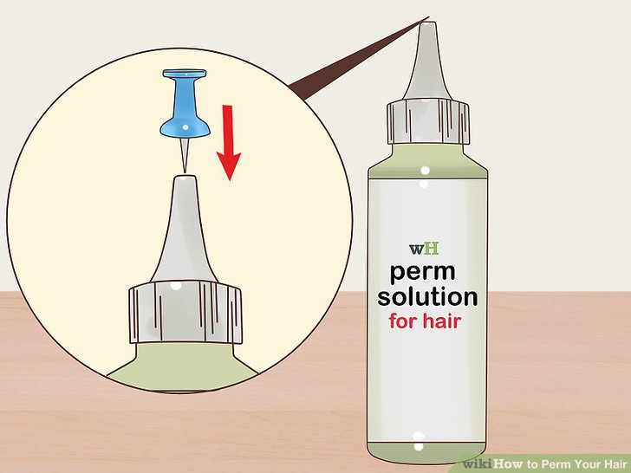

**Pierce the tip of the bottle with a push pin.** Perm solution comes in a plastic squeeze bottle. While you can snip the tip off, it is better to pierce it with a pin, like a thumb tack or a push pin. This will give you better control over the product

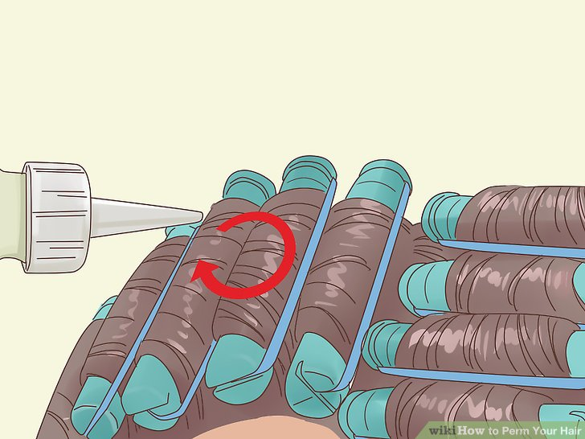

**Apply the solution close to the rods using small, circular motions.** Choose a section to start with: middle, left, or right. Position the bottle over the top edge of the rod, and begin to squeeze out the solution using a small, circular motion. Work 1 rod at a time until you complete the entire section, then move on to the next one. Use the entire solution that came in the bottle.

* Don’t worry about applying the solution over the entire rod. Gravity will pull the solution downward toward the bottom of the rod.

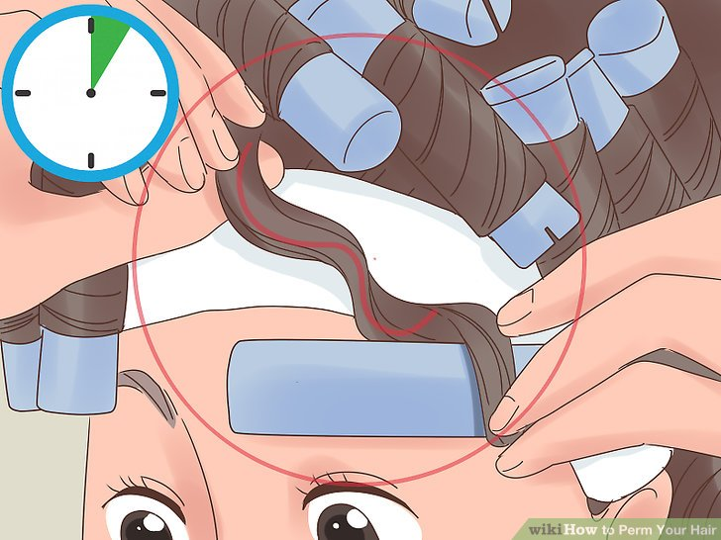

**Check your hair every few minutes for an S-shape when unraveled.** Wait 5 minutes first, then pick a rod and unravel it slightly. Take a look at the hair, and see if you can spot a tight S-shape. If not, wrap the hair back up. Check it again after 2 minutes. If you still don’t see the S-shape, check it every minute afterwards until you do.

* Don’t wait the full 10 to 15 minutes before checking your hair, or you’ll risk damaging it; everyone’s hair processes differently.
* When you see the S-shape in your hair, you’re ready for the next step.

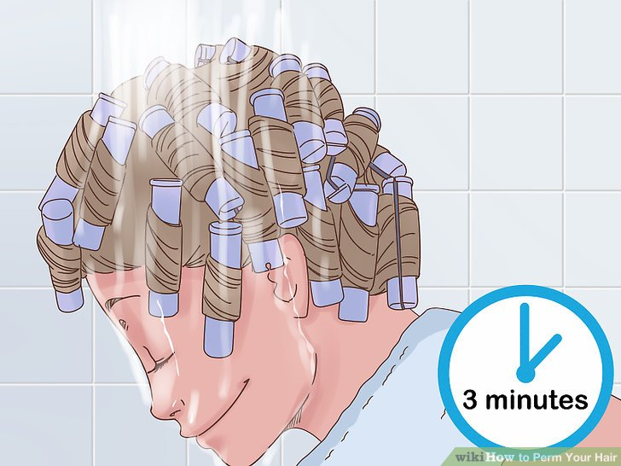

**Rinse your hair for 3 minutes without taking the rods out.** This is important. Leave the rods in your hair. Simply lean over a sink or step into a shower, then rinse the solution from your hair for 3 minutes.

* The cotton batting will get soaked, so you should remove it when you’re done rinsing.
* If you have very thick hair, run water between each rod for several seconds to make sure you rinse all the solution out thoroughly

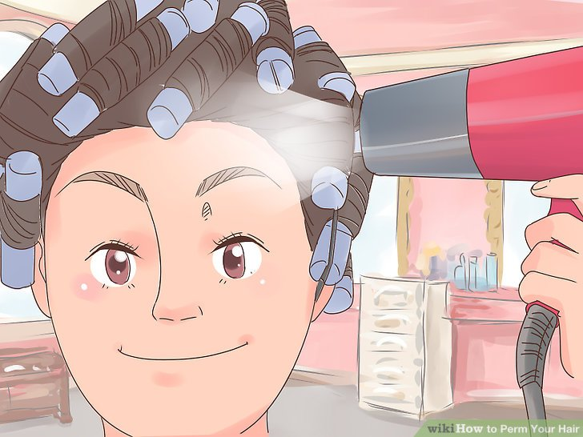

**Let your hair dry with the rods in place.** It would be best if you let your hair air dry, but if you are in a hurry, you could use a hair dryer to speed the process up. Do not take the rods out yet

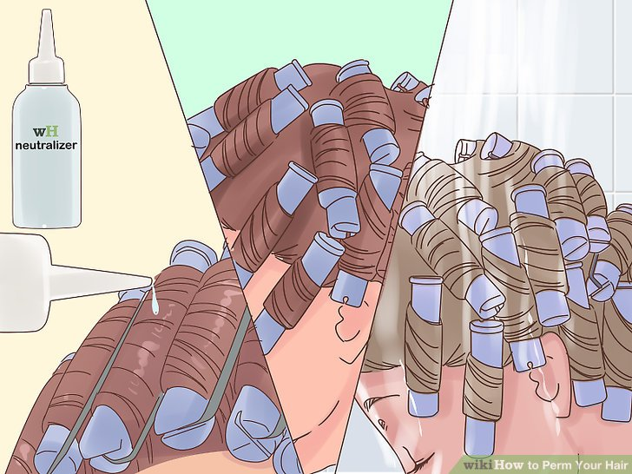

**Apply the neutralizer, wait 10 minutes, then rinse it out for 3 minutes.** Use the same technique when applying the neutralizer as you did for the perm solution. Since the neutralizer is gentler, you can wait the full 10 minutes without checking your hair. Once the 10 minutes are up, rinse your hair for 3 minutes.

* Keep the rods in your hair for the duration of the process.

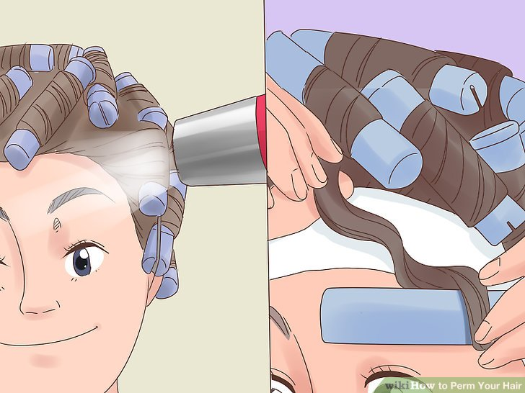

**Let your hair dry, then remove the rods.** Again, it’s better to let your hair air dry, but you can use a hairdryer, if needed. Once you remove the rods, leave your hair alone. Do not brush or comb it, of you’ll undo the curls.

* At the most, you can gently style the curls with your fingers.

### Part 4 - Maintaining Your Perm

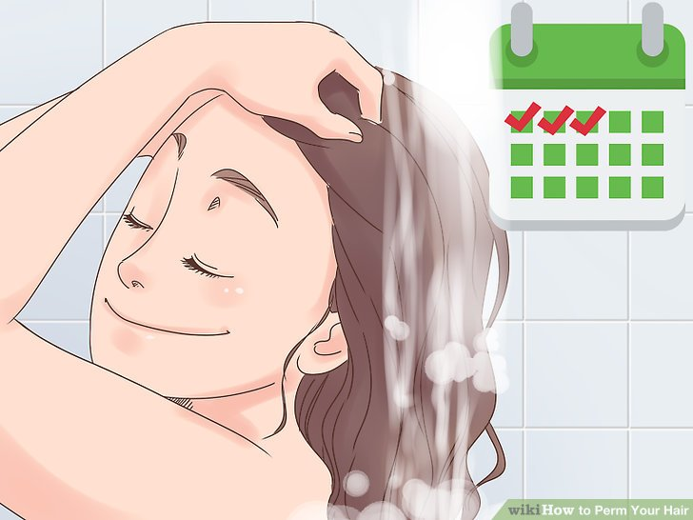

**Wait 3 days before you wash your hair.** This may feel gross, but it is very important. Curly hair doesn’t need to be washed as often, for starters. Also, if you wash your hair too soon, you’ll undo all of your hair work; the curls will come out.

* After those 3 days, you can wash your hair twice per week.

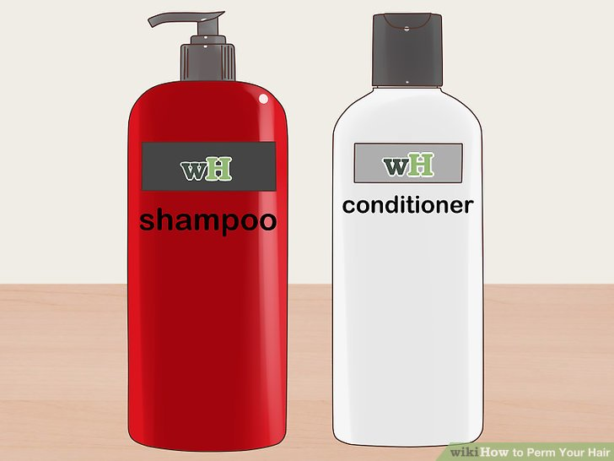

**Use shampoo and conditioner meant for chemically treated hair.** They'll keep your hair looking smooth and soft while prolonging the perm. Use conditioner each time you wash your hair; swap it out for a deep conditioner every so often. A natural deep conditioner, like argan oil, is a great option.

* Moisturizing, curl-enhancing products are a great choice.
* Don't use products containing silicones and alcohol. Silicones will lead to build-up, while alcohol will make it turn dry

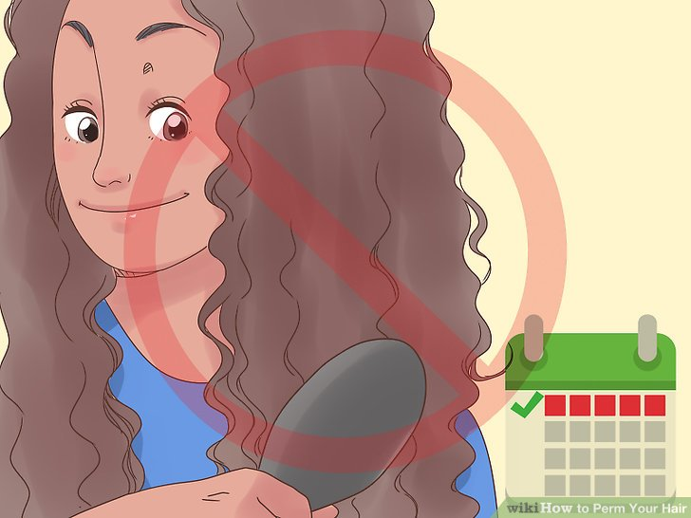

**Do not style or brush your hair for 1 week.** You can gently comb your hair with your fingers or a wide-toothed comb, but you’ll have to wait 1 week before you brush it. More importantly, leave your hair as-is for the duration of the week. This means no curling, straightening, ponytails, braids, etc.

* Tie your hair up in a silk scarf when you go to bed. This will help keep your curls frizz-free.

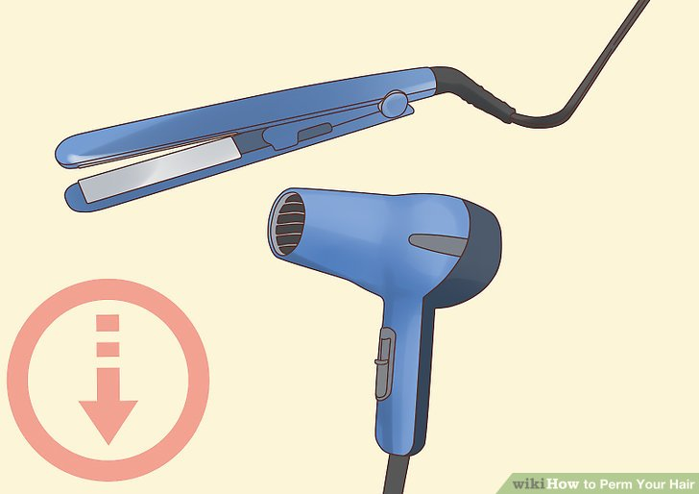

**Limit heat styling, including blow drying and straightening.** When possible, let your hair air dry. If you must use a hairdryer, wait until your hair is about 90% dry, then blow dry it with a diffuser. Avoid straightening when possible.

* If you must straighten your hair, apply a heat protectant and use a lower heat setting.

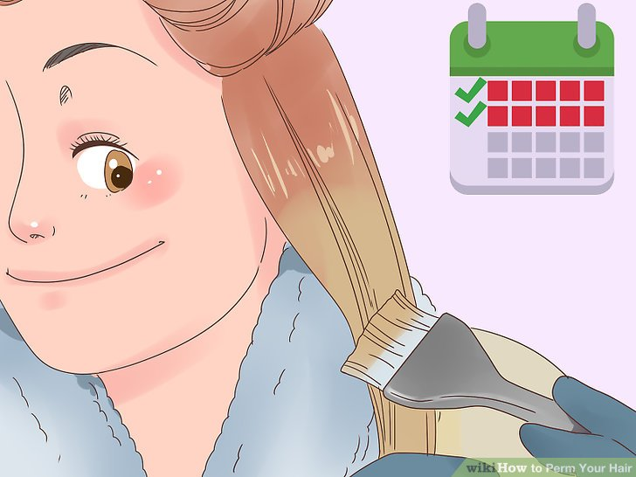

**Wait at least 2 weeks before you dye your hair.** If you dye your hair too soon, you not only risk damaging your hair further, but you may lose your curls. Once those 2 weeks are up, however, you can treat your hair like you would regular hair; you can dye it, bleach it, or even highlight it.

* Keep in mind that bleaching and highlighting are not recommended. The perming process is harsh to begin with; bleaching and highlighting are also harsh and will damage your hair further.
* Some stylists recommend that you wait 1 month before dyeing, bleaching or highlighting your hair

**Hair Setting Equipments**

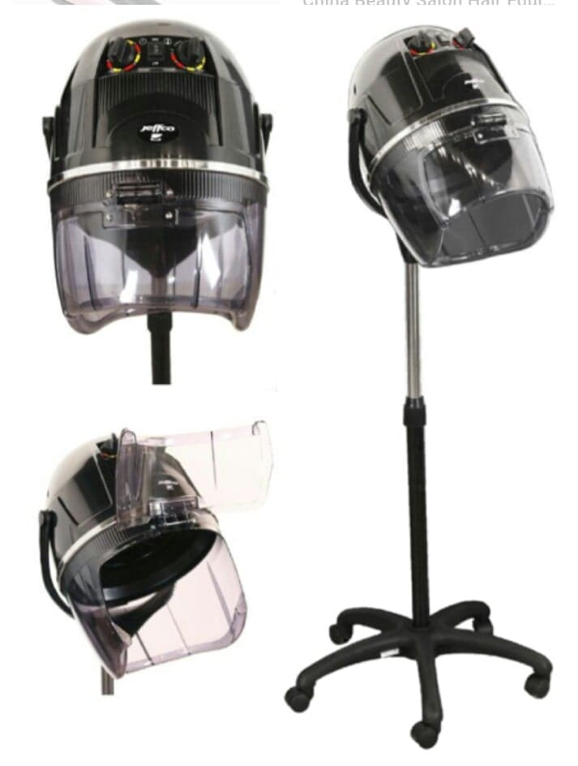 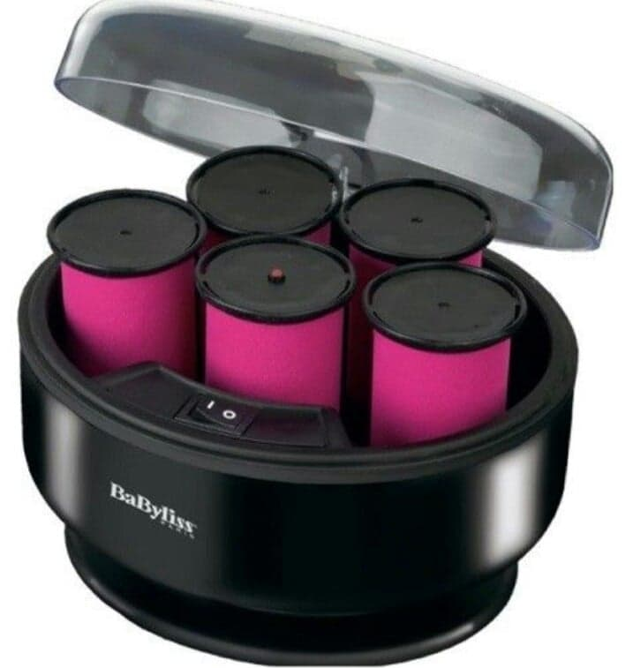

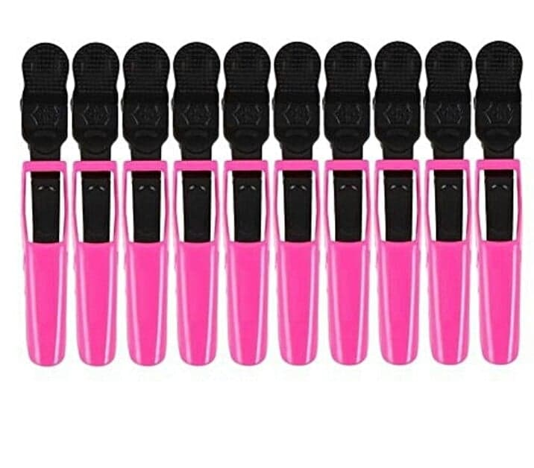 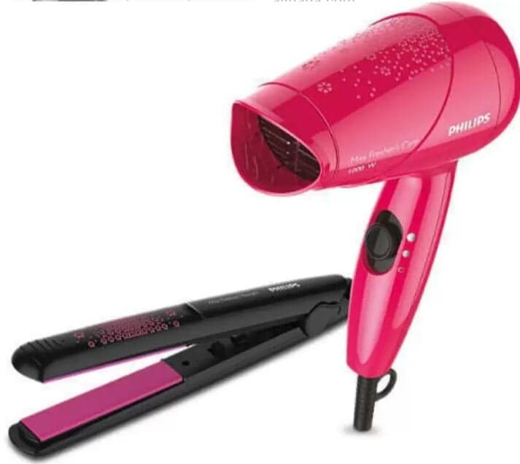

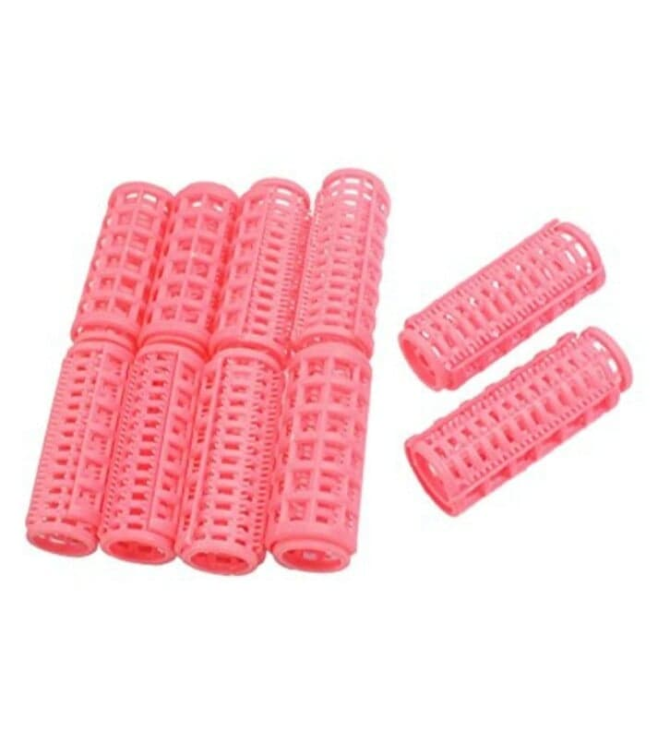 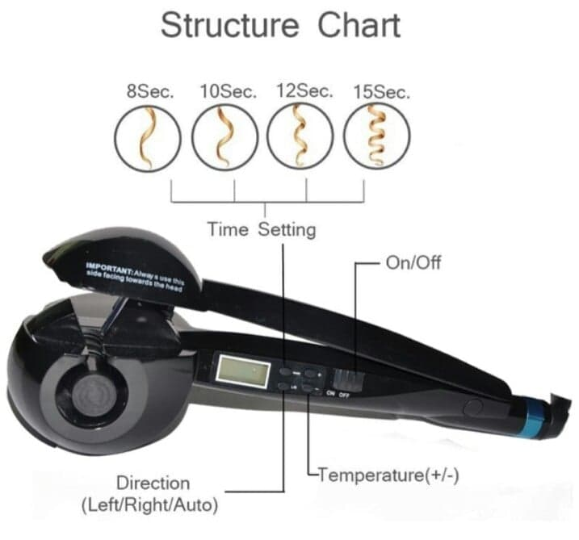

**Setti** **ng** **Hair**

# [How to Set Hair](https://www.wikihow.com/Set-Hair)

# Before tools such as straighteners, curling irons and hot rollers became available, women had to learn to set their hair without heat.They curled their wet hair with various sizes of rollers, letting their hair dry into the desired style. And while many modern hairstyles have abandoned setting, rollers are still a great way to create curled locks that last. It's also safer to style your hair without heat. Following a few simple steps will result in classically curled hair.

### Part 1 - Preparing Hair to be Set

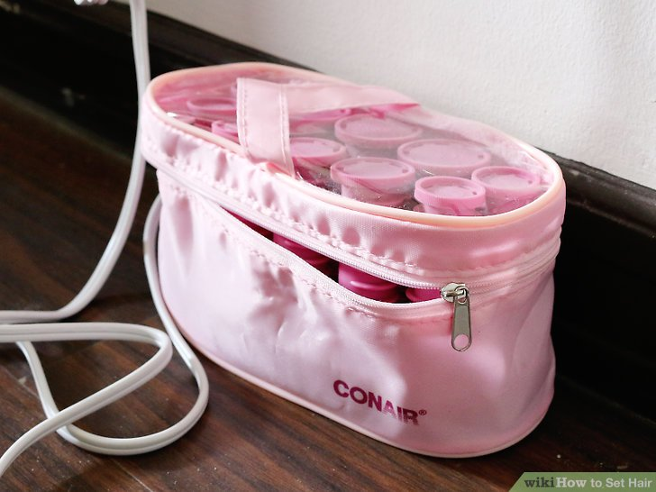

**Choose your curlers.** The size of your rollers will determine the size of your resulting curls. Larger rollers will create larger curls and waves, while smaller rollers will create tight pin, spiral or bouncing curls.

* Don't forget to consider the length and weight of your hair when choosing your rollers. Long and thick hair will naturally result in looser curls than short, fine hair.
* The ideal type of rollers will also vary based on how you plan to set the curls. For example, Velcro rollers will be easier to set using a hair dryer, but if you plan to sleep in the rollers, you'll be more comfortable with sponge or bendy rollers

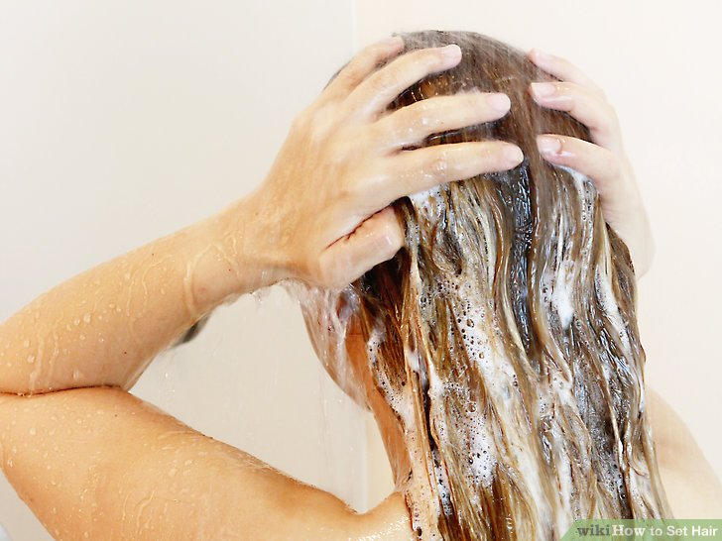

**Wash your hair.** Shampoo your hair thoroughly and rinse. Use a sulfate-free shampoo to prevent dryness and keep your curls from frizzing up. Use conditioner if that's part of your general hair-care routine. Rinse completely and gently towel dry.

* If you want to use leave-in conditioner, now is the time to apply it.
* Comb through wet hair so there are no tangles.

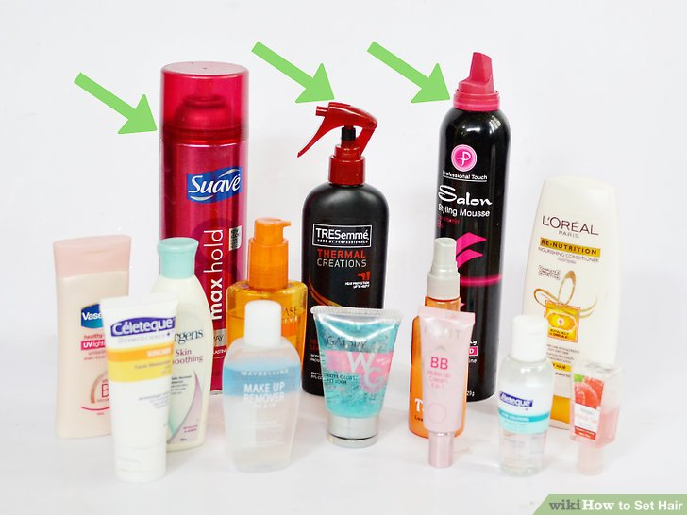

**Prepare hair for setting with a styling product.** Apply a styling product so your hair will better hold the curls once they are set. Remember, where there is more product, there is generally more hold. Choose from mousse, gel, hairspray or even thermal-activating setting spray. You can customize your curls by spraying just the ends of your hair for curls at the bottom, or spray the roots and underneath for voluminous waves.

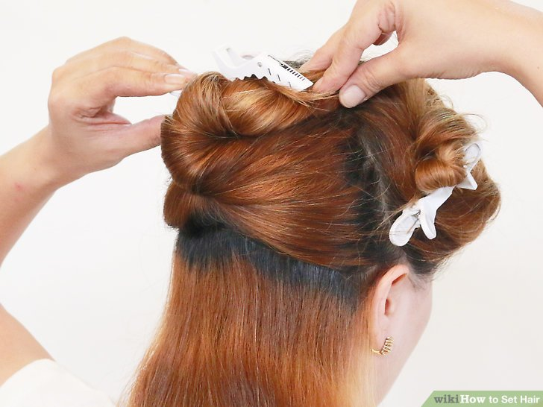

**Section your hair.** Part the hair into 3 sections, 1 on top and 1 on each side of your head, leaving the back hair loose. Placing curlers in 1 of these sections at a time will make the process much easier.

* Pin sections down with long hair clips.

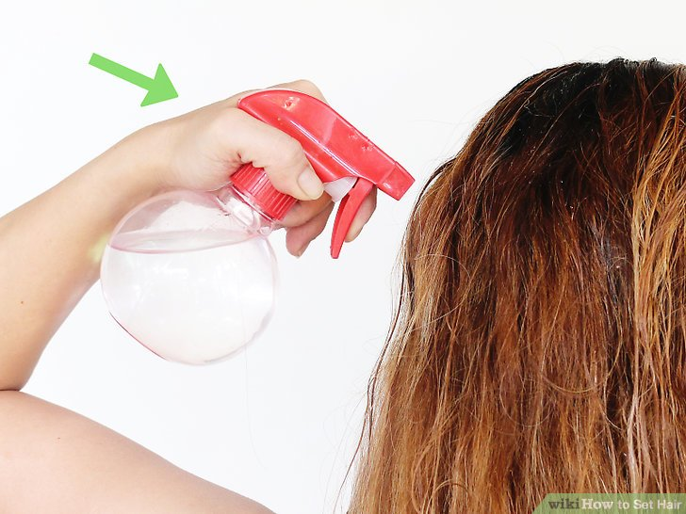

**Fill a spray bottle with water and keep the hair wet as you are rolling it.** There are no set times when to dampen your hair, just spritz it when you feel it is too dry to work with.

**Part 2 - Wrapping Your Hair with Rollers**

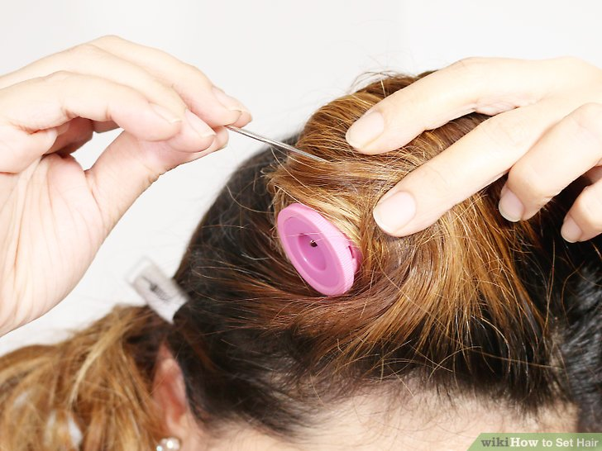

**Begin rolling the topmost section of hair.** Split each of the 3 sections into smaller sections about the width of your roller and no more than 2 inches thick. You will ultimately roll the sections in the direction you want the hair to fall. Secure the hair between 2 fingers. Now, smooth the ends of the hair around the roller, holding them down until the roll is started. Continue rolling until you get to the scalp.

* Repeat with the next roller section, duplicating what you did with the first.
* You may find it easier to roll your hair uniformly around the roller if you wrap the ends in end papers. This can be especially helpful for short hair.
* If you wish, you can use larger rollers for the top sections, then gradually move down in size as you get toward the bottom of the head. This will create looser waves on top, and tighter curls toward the bottom. For a more uniform look, use rollers of the same size all over

**Choose the direction of the curls.** Keep in mind what direction you want the curls to fall, toward or away from your face. Place the roller on whichever side you’ve chosen, and wrap from there. For most hairstyles, rollers on the top of the head will be rolled backward, away from the face.

* If you want curls that don't fall uniformly, roll the hair in various directions. If you roll some
* sections of hair forward and some sections of hair backward, your curls that look more natural

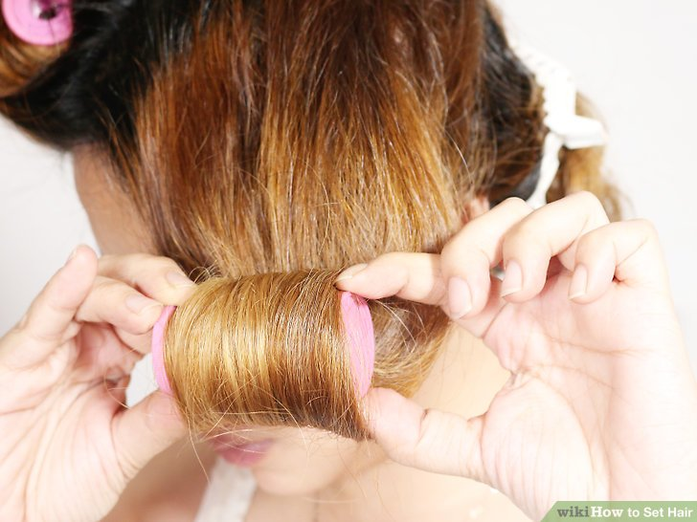

**Roll the hair on the sides of your head.** Start on either side of the top and put the hair in rollers. For most hairstyles, the side rollers will be rolled in a downward direction.

* Move from the top of this side section to the bottom of it (at the ear area).
* If you are using multiple sizes of rollers, begin to use gradually smaller rollers at the bottom of this section of hair, ending with the smallest you use.
* If you want an outward flip at the bottom of your hairstyle, roll the bottom curlers in an upward direction.
* Go to the other side section and repeat.

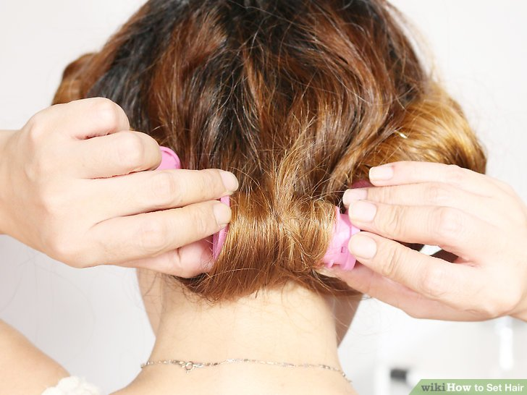

**Divide the back area into 3 sections, if it is not already done.** Roll from the top of each section of hair to the bottom.

* If you are using multiple roller sizes, make sure you use smaller rollers as you near the neckline for all of these sections.

### Part 3 - Setting and Styling Curled Hair

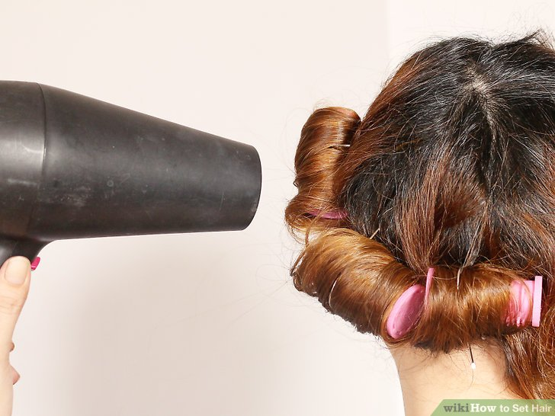

**Allow rolled hair to completely dry.** Sit under a hair dryer for 30 minutes before checking to see if your hair is completely dry. Remove 1 roller first to be sure it is dry. If not, add 10 to 15 minutes with the hair dryer before removing the rollers.

* The longer and thicker your hair is, the longer it will take to dry completely.
* If sleeping on your rollers, don't remove them until morning. Be sure and test 1 roller before removing the rest.

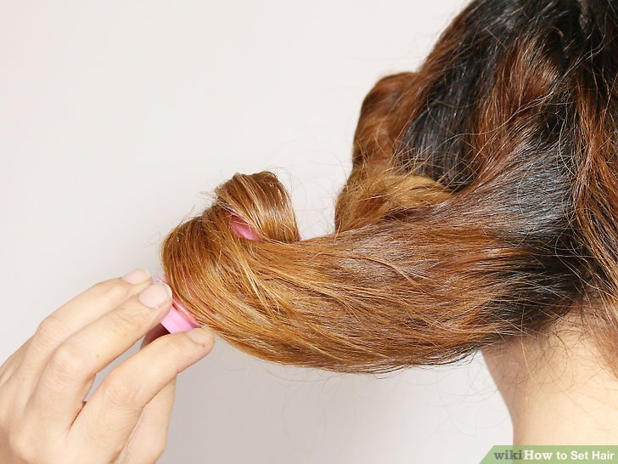

**Remove the rollers.** Unwind 1 roller at a time when your hair is completely dry. Work slowly to avoid tangling your hair. You'll find it easiest to remove the bottom rollers first and work your way up to the top sections of hair.

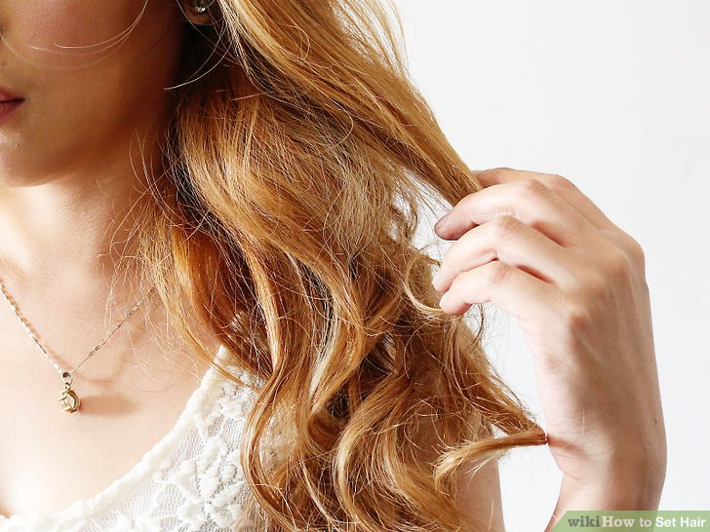

**Style curled hair.** Once the rollers are out, brush out the curls to loosen them. Be careful not to overdo it, since your curls should keep their shape for 2 or 3 strokes, but any more might cause them to fall out.

* You can also use a pick or simply run your fingers through the curls to separate them and add some volume.

**Finish your hairstyle.** Once you've reached the desired curls and volume, you can complete your hairstyle. For long, loose curls, you're already finished. But you can also tie back your curled hair or secure it in place with hair pins or barrettes, just as you would if it were straight.

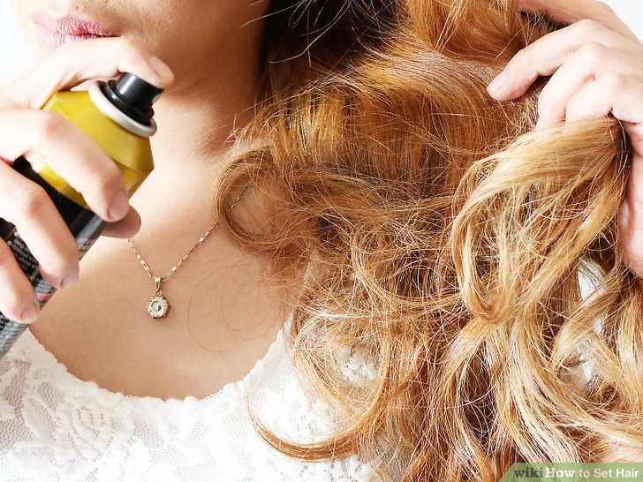

**Set the style.** Once everything looks just as you desire, complete setting your style by spritzing it with hair spray. Choose a spray with your desired effect, whether it's light and natural or stiff and set in place.

**Hair Cutting Equipment**

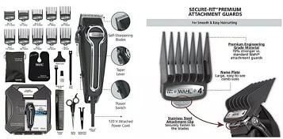 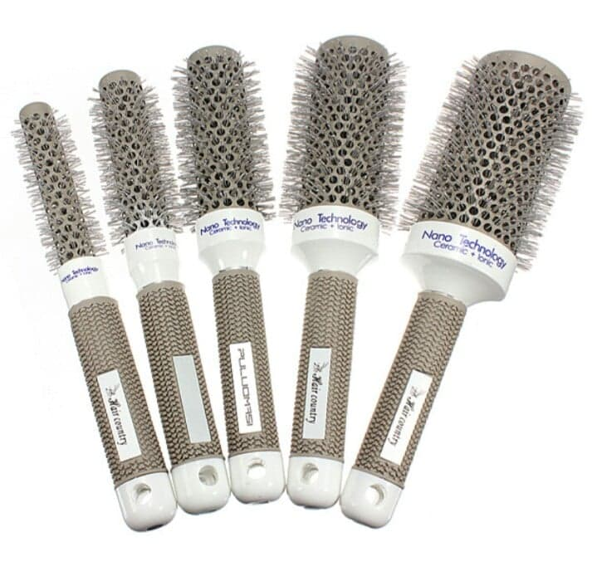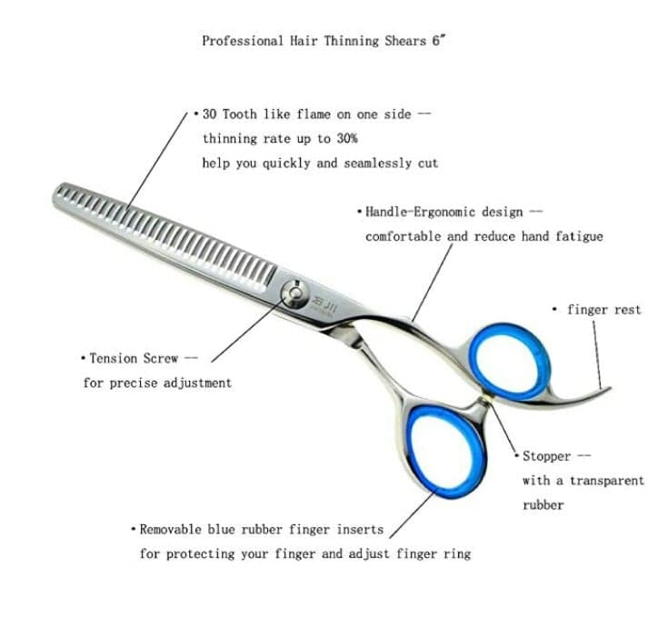 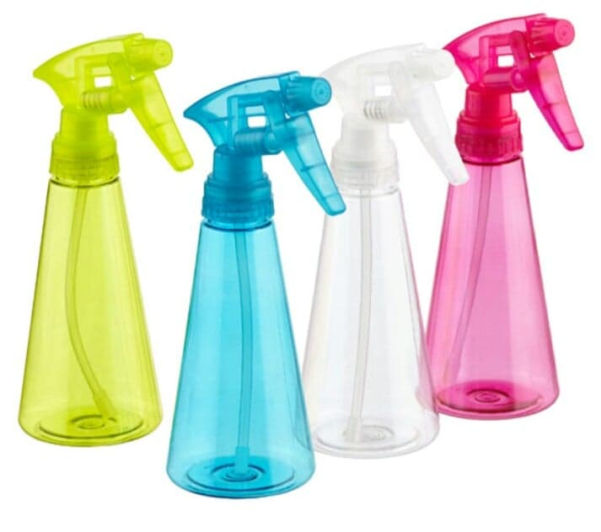 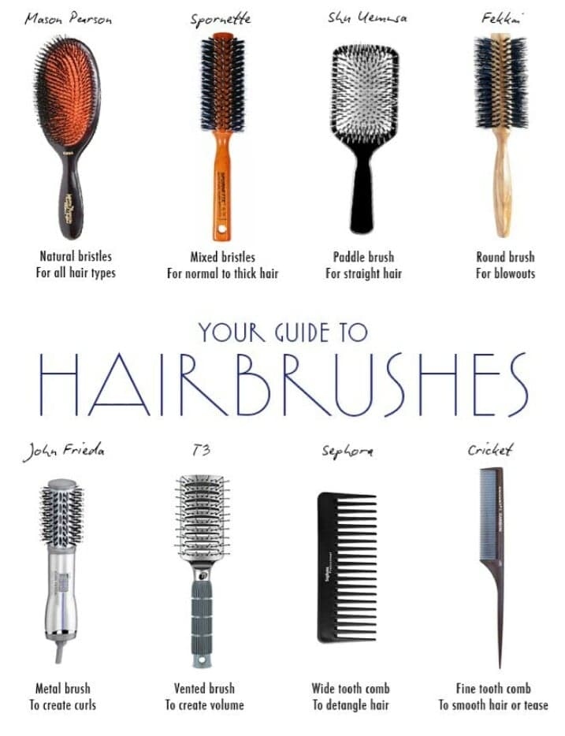 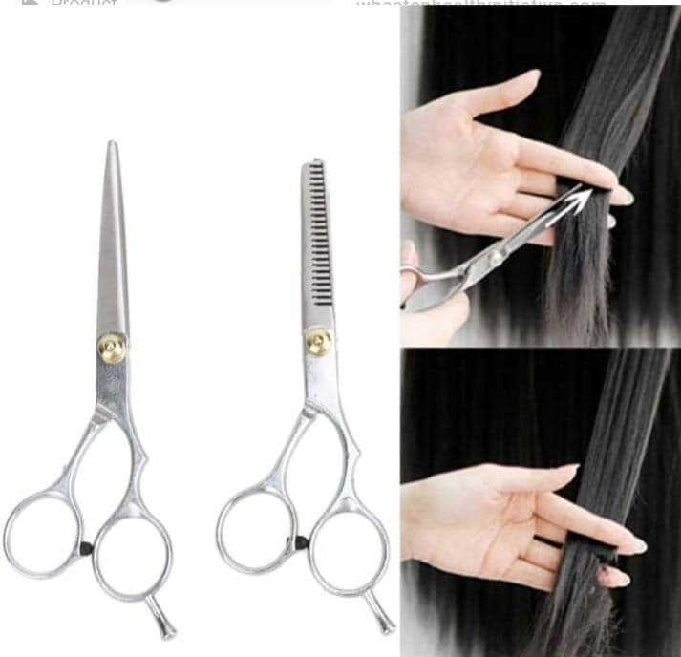

**Hair Cutting Techniques**

**Graduated Haircut Basics**

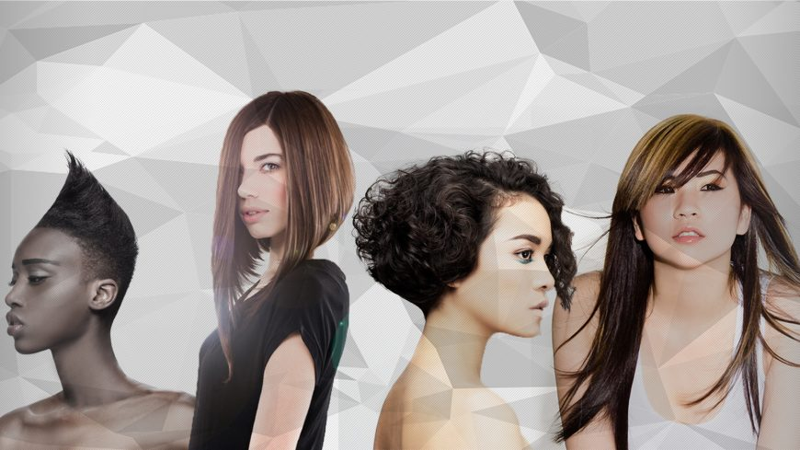

## What is a graduated haircut?

A graduated haircut is a haircut where weight is built up within the shape or the external line. It is a gradual progression of lengths from short to longer. Graduation can be performed at any length, however at longer lengths the results can be more diffused.

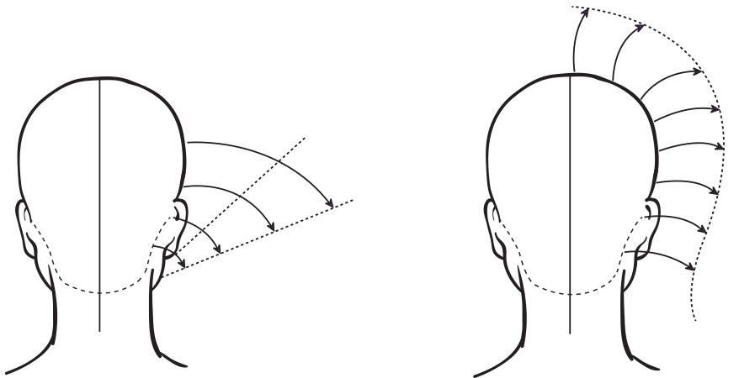

Graduation compared to uniform layering

When using graduation, you are in complete control of the outcome by placing your graduation to affect the shape. By adjusting your angle or elevation you can create low, medium or high graduation. Your body position and the tension you create with your comb and fingers, are critical factors in ensuring you nail your graduated techniques every time.

## Graduation on long hair

This is a hard concept for many of us to get our heads around.

“Graduation on long hair?” you ask, “Isn’t that layering?”

Unlike uniform layering, graduation on longer hair allows you to remove internal weight and creates bulk around the external lengths.

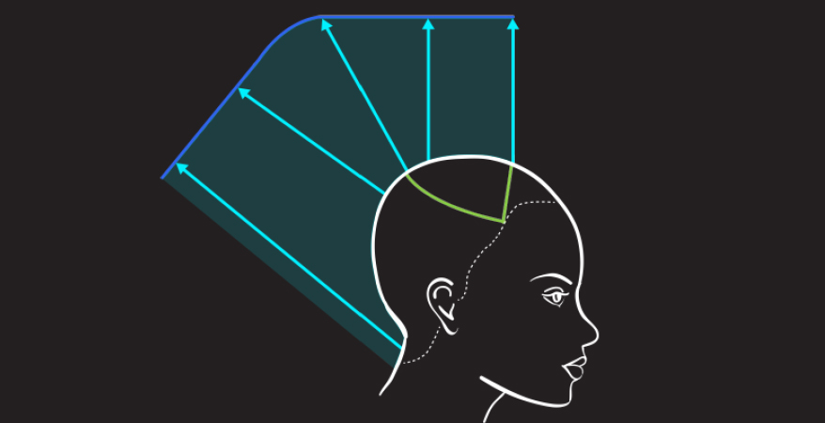

Long graduation creates bulk around the external lengths

This is an ideal technique to use when you have a client who would like layers but also wants to keep fullness around the outline of their haircut. Long graduation is usually cut at 135°.

## Forward or C-Shape graduated haircuts

Also performed on longer lengths, forward or C-shaped graduation is created by pulling the hair forward and cutting from shorter to longer. This graduated haircut technique is a variation of long graduation and is excellent for releasing and supporting natural curl. Graham Oglesby's [Shake](https://myhairdressers.com/videos/shake) uses forward graduation for this exact purpose on naturally curly hair.

## Mid-length graduated haircuts

On mid-length graduated haircuts using low or stacked graduation between 1° and 44° creates volume and texture around the perimeter of the hair.

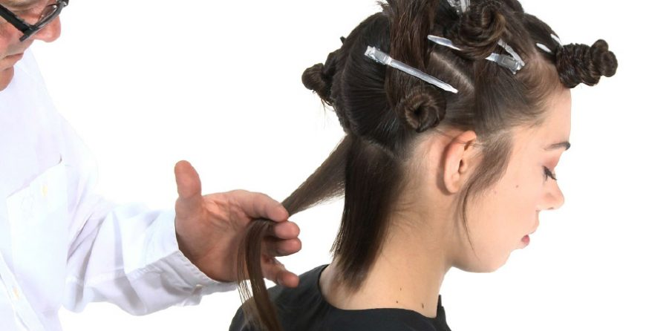

Low or stacked graduation is often featured in collar length or jaw length bobs. These are is commonly known as types of graduated bob haircuts.

## Short graduated haircuts

Classically a short graduated haircut is cut using 45°. The roots are combed down and the fingers are placed in the 45° angle at the desired length.

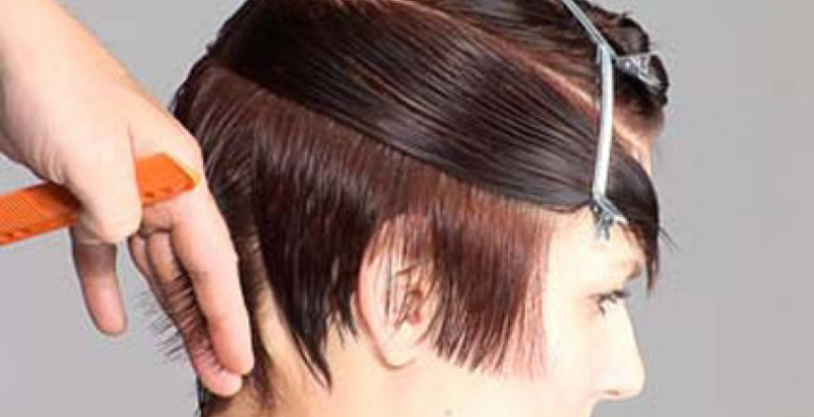

Short gradation is fantastic at creating volume on fine hair making hair look fuller than if it was at a longer length. Short graduation is a very versatile technique and salon staple for both men’s and ladies’ haircuts

## Reverse Long Graduation

**Before**  
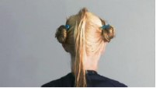

**Step 1**  
Create a central section from the front hairline, down over the crown into the nape approximately 2 cm thick. The section size will be dependent on hair quality and [density](https://www.hairfinder.com/hairquestions/hairdensity.htm). This section will be the guide for the total internal shape.  
   
**Step 2**  
This section is divided in front of the crown for practicality. Work with the back portion to start. Elevate and over-direct the hair and cut a line from shorter to longer towards the crown.

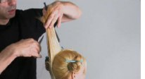 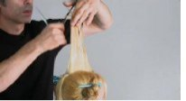

**Step 3**  
Using the same elevation and angle cut the front portion from shorter to longer towards the front hairline.

**Step 4**  
From this central section starting at the crown, use pivoting pie sections. Use the previous section as a guide and again the same elevation and over-direction.  
 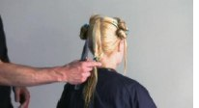 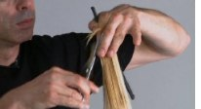

**Step 5**  
Continue with this technique, moving up the central section and pivoting towards the front - again using the same elevation and over-direction.  
   
**Step 6**  
Be careful to follow your guide from the previous section. Note the internal shape can be varied by the degrees of overdirection and elevation.

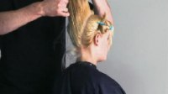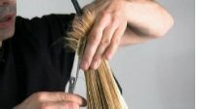

**Step 7**  
Repeat this process on the second side.  
Please note to be aware of your finger and body position on the second side. On the first side your fingers are angled down...  
   
**Step 8**  
While on the second side they are angled up for accuracy.  
   
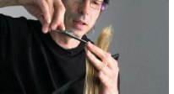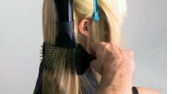  
   
**Step 9**  
Blow dry using a [paddle brush](https://www.hairfinder.com/info/combingbrushing3.htm) from roots to ends to smooth the cuticle.  
   
**Step 10**  
Now refine the finish with a set of straightening irons.  
   
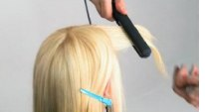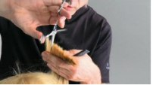  
 

**Step 11**  
Next use a free hand technique to loosen the internal shape.

**Step 12**  
Section the fringe area, working with a triangle section from the round of the top of the head to the temples.  
   
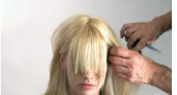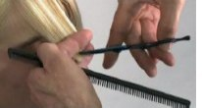  
   
**Step 13**  
Use a pointing technique to cut one side of the fringe.  
   
**Step 14**  
Repeat this process on the second side.  
   
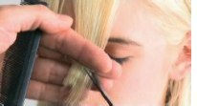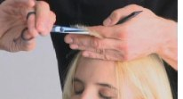  
   
**Step 15**  
Now refine the fringe using elevation and a pointing technique.  
   
  
   
**Finish**  
The result a simple [layered](https://www.hairfinder.com/hair/layered.htm) look - commercial, accessible and youthful in essence.

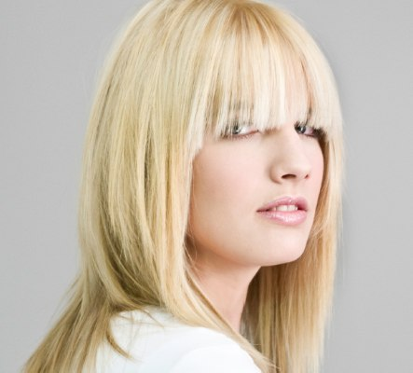

## The one length haircut

A [one length haircut](https://myhairdressers.com/videos/one-length-solid-form) is achieved by cutting the hair to the same perimeter length from the natural fall. The natural fall refers to the natural falling position of the hair to the perimeter length. A true one length haircut is created by combing the hair down from the natural fall and cutting to the same one length line with no over-direction or elevation.

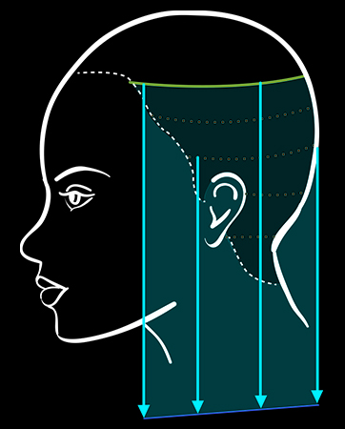

## 0° cutting angle

One length hair is cut at a 0° cutting angle with absolutely no elevation. Elevation or incorrect tension on the hair can disturb the 0° angle creating unwanted graduation on your one length haircut.

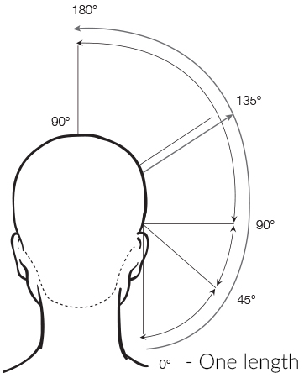

0° Cutting Angle

To achieve a true one length line you must choose the correct tension for the hair characteristics that you are working with. For hair textures such as curly hair types that will be dried naturally, this may mean that you use little or no tension. Whist on other hair textures, such as fine straight hair, a medium tension may be required. A thorough consultation and analysis of your client’s hair and lifestyle will help you choose the correct tension.

## Below the shoulder one length haircut

A below-the-shoulder one length haircut is a salon staple and excellent choice for fine long hair.  By cutting all the hair to a stationary guide you can achieve a strong, dramatic and defined outline edge which can make fine hair look fuller.

[Tracey Hughes](https://traceyhughes.com.au/) provides you with a tutorial on this classic technique in her [One Length Solid Form](https://myhairdressers.com/videos/one-length-solid-form) step-by-step.

## Above the shoulder one length haircuts

Also known as a bob haircut, a horizontal one length haircut is one of the most technically difficult of the classic haircuts to master. Not only do you need to choose your tension carefully,  but you also have to take into consideration the roundness of the neck, the ear protrusion and other facial features.

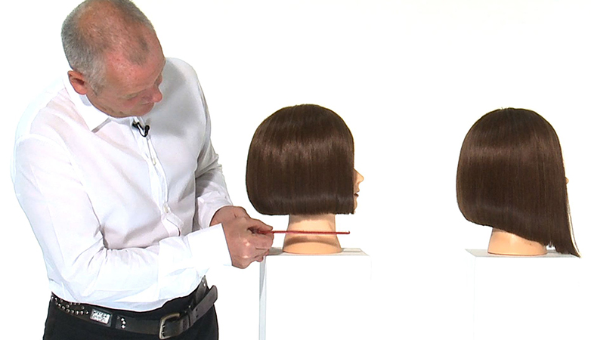

These factors can displace your perfect one length line and you will need to be very strategic throughout your haircut to achieve perfect results.

The Diagonally forwards or backwards one length haircut is another example of a one length line. This technique is often called an A-line bob.

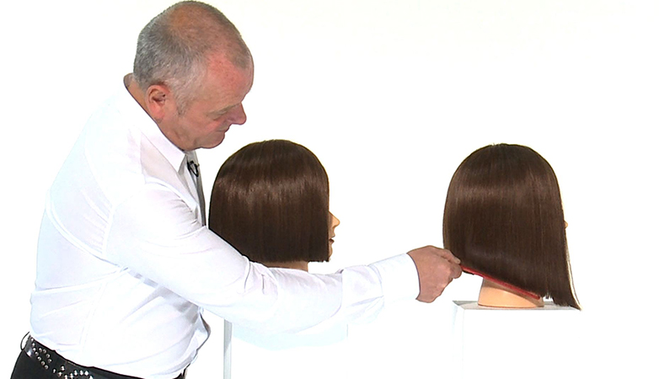

Curved one length hair cut above the should is known as the Pageboy hairstyle.

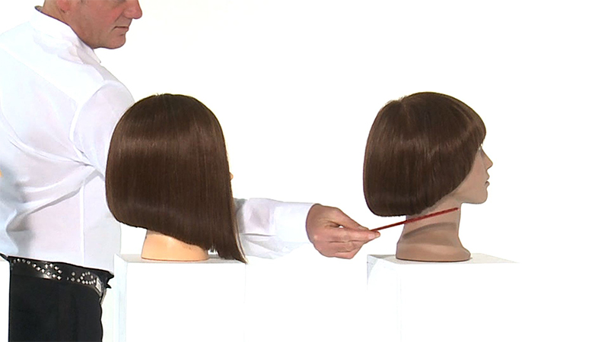

**Short Graduation**

Take a horizontal section from ear to ear. Using vertical sections cut hair at a 45 degree angle. Once the section is complete cross check with horizontal sections.

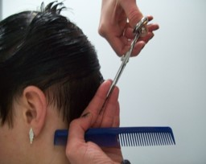 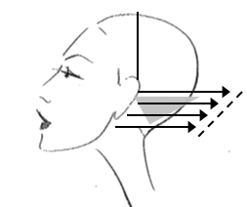

Continue at a 45 degree angle up to the crown area. Cross check the back section with horizontal sectioning.

**Please note** – You could run out of hair as you work towards the crown area.

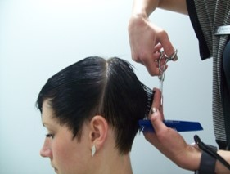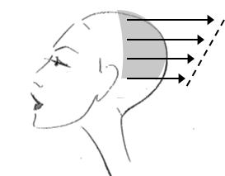

Continue with the same angle through to the side.

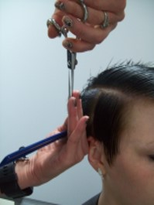 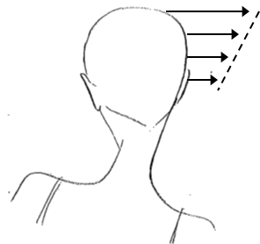

Continue through to the other side and cross check. Use the mirror to check for balance and weight.

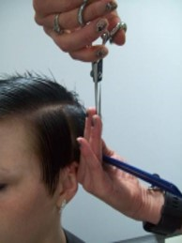 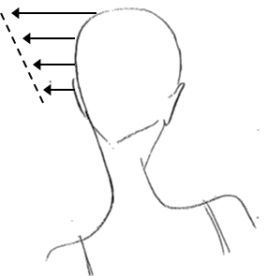

Take a new guideline for the top section (often referred to as a box section) and cut the whole top section at a 90 degree angle.

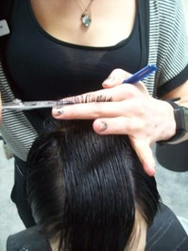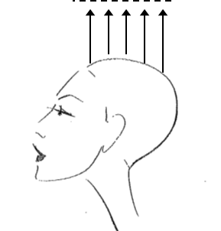

Take of the corner by holding hair at 90 degrees working from temple to temple.

**Please Note** – How much of the corner comes off differs from client to client.

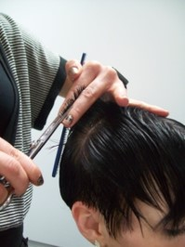 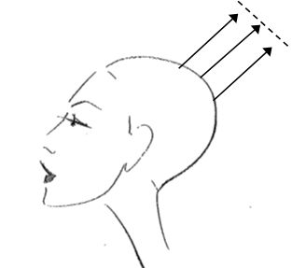

Personalise the look cutting the fringe and outline using a combination of texturising techniques.

**Please Note** – This is personal to the client’s requirements.

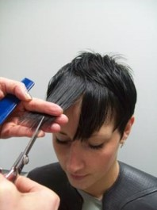 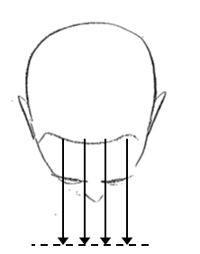

**Long Graduation Cut**

Start by cutting the baseline to see how this is done (Please see page the [One Length Below Shoulders](https://www.reflectionstraining.co.uk/one-length-below-shoulders) section).

Start the layer by taking a section at the highest point of the head pulling it up to 90 degrees and cutting to the desired length.

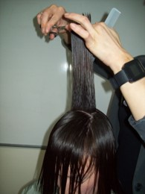 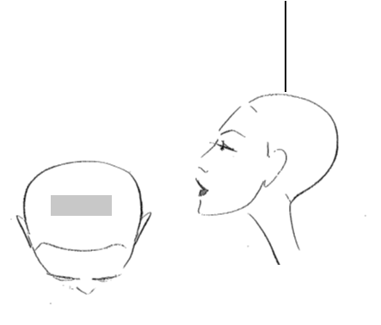

Work the guide from ear to ear pulling up to the required angle.

**Please Note** – The angle you pull up to determines the amount of layering and the finished look. This ranges between 135 degrees and 180 degrees. This cut is straight up at 180 degrees and is also referred to as basic layering.

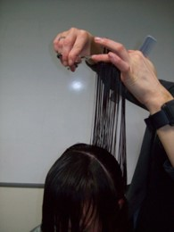 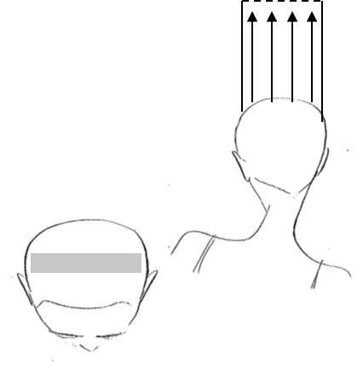

Using the same guide add a profile guide, creating four sections.

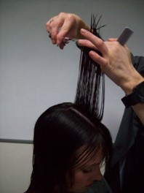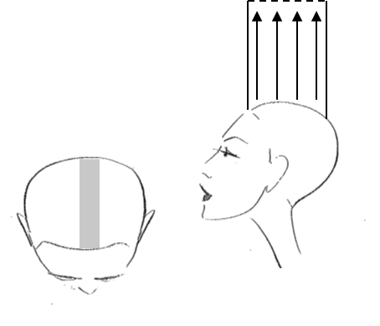

Take a section through the back of the head next to the central guide; include the guide and pull the section up at 180 degrees, when you see the central guide above your fingers cut to the same length. Using ‘orange segment’ sections continue this process until you reach the guide above the ear. Cross check thoroughly before moving on to the next.

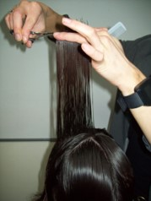 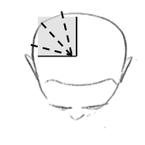 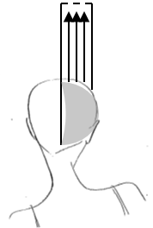

Complete the second back section in the same way. Once this is completed, cross check the whole of the back section before moving on to the front sections.

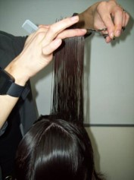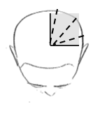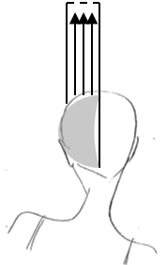

Now working through the front, take a horizontal section in front of the original ear to ear guide and down either side of the profile guide, pull hair up to guide and continue working to the front of the head.

**Please Note** – This can be done one side at a time depending on preference.

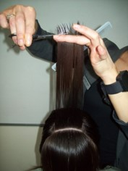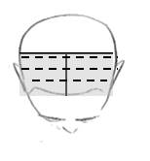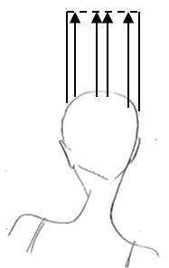

To tidy the front section pull all the hair forward and cut straight across until you meet with the baseline. This is important as this is what the client will see. 

**Please Note** – This is not forward graduation. If the client requires the front shorter, follow guide for forward graduation (Please see the Forward Graduation section) .

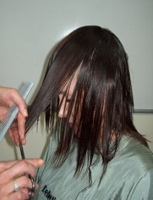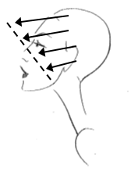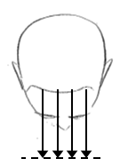

Dry to the desired result before thoroughly checking through the cut. This could include softening or texturising techniques to achieve the required effect. Use the mirror to check the balance and ask questions to ensure the best result.

**Long Layers – The Ultimate Guide to Long Layered Haircuts**

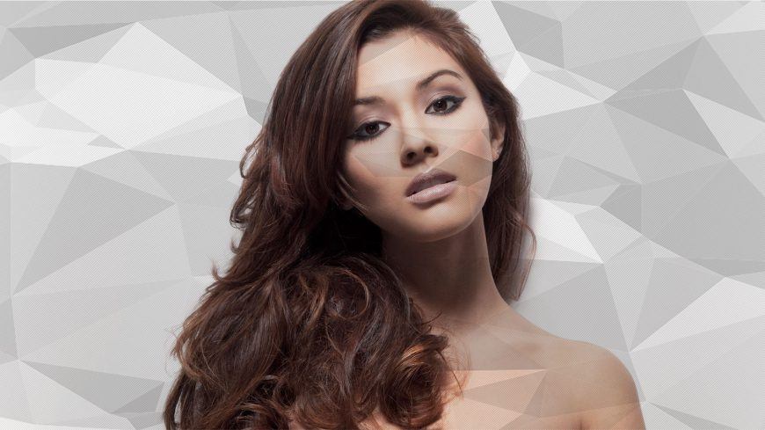

Long layered hair is one of the most the requested salon staple haircuts of all time. Layers allow long haired beauties to add dimension, texture and personality to their hairstyle. Long layers suit most hair textures, lifestyles and generations.

Layering is a cutting technique that removes weight from the internal lengths of the hair. Layers do not add volume, however; as they remove weight from inside the shape they do make the hair easier to hold the volume and shape added during styling and dressing.

Long layers can be cut at 90°, however they are most often cut between 135° and 180° of the head shape.

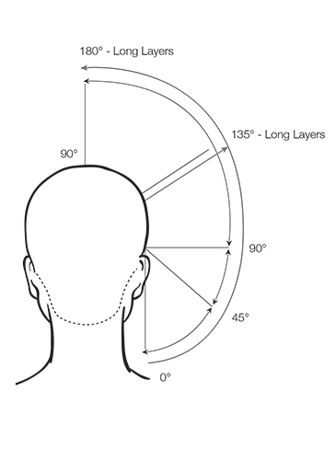

## Long layers to enhance texture

On normal to thick hair texture our [long layered variation](https://mhdpro.com/collections/long-layered) technique is an ideal choice for enhancing movement. This technique, based on round layering, enhances hair texture and softness. The round layering technique releases bulk and weight internally which gives the illusion of the hair looking longer.

To maximise texture, softness and length begin the technique in the front, over the cheek bones, incorporating over-direction and elevation.

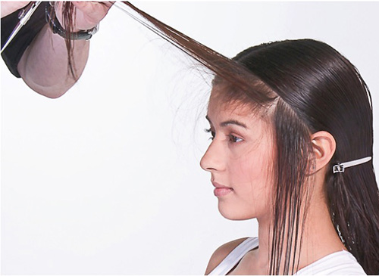

The key to this technique is creating a soft outline with no harshness. This is developed through the correct placement of finger angles and over-direction and elevation.

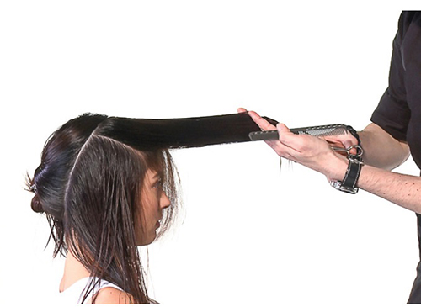

A long layer variation is an ideal choice for creating versatility on normal to thick texture hair when styling and dressing.

## Long layers for straight hair

A classic [long graduation](https://mhdpro.com/collections/long-layered) haircut is the ideal choice for clients with straight hair texture. Straight hair can be extremely unforgiving and the incorrect layering technique can give the illusion of the layers looking obvious and stacked. A classic long graduation ensures you maintain a strong outline to support soft movable internal long layers.

This technique begins by placing a square outline below the shoulders. This clean perimeter becomes the basis to support the long graduated layers.

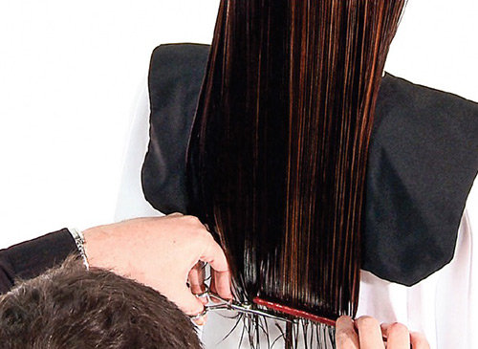

A long graduation is classically cut at 135°.  The sections from the crown to the front hairline are cut at 180°.  When cutting a long graduation on straight hair, it is important that all the hair is not elevated to 180°. 180° is an extreme angle for a long shape and can cause the shorter layers to push into the length and lay very flat. The 135° angle will encourage movement, volume and softness on straight hair.

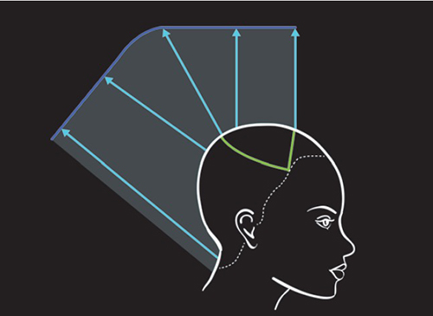

A long graduation is classically cut at 135°

## Long layers for fine hair

Adding long layers to fine hair can be a mine field if the wrong technique is chosen. The hair can easily become over layered, causing the outline to become weak and the layers unmanageable when styling and dressing.  Our [commercial long layered shape](https://mhdpro.com/collections/long-layered) uses internal graduated layering and over-direction to protect the outline and internal layers.

The key to this technique is to use a pivoting motion and elevation to extend the length and keep weight on the outside of the shape. On fine hair it is important to remember that reducing the length and making the outline stronger can give the appearance of longer hair.

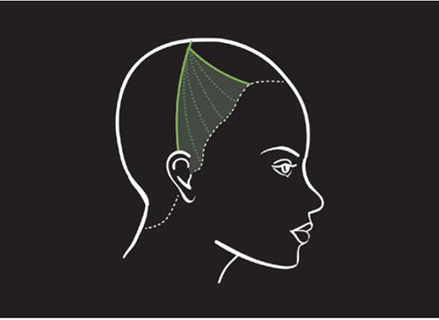

Over-directing the front sections behind the ears will create more weight towards the front of the shape, making fine layered hair appear fuller.

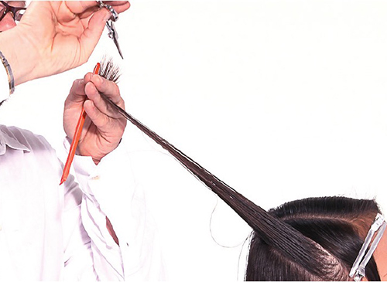

Over-direction creates more weight helping fine layered hair to appear fuller

## Long Layers for wavy hair

A classic [long uniform layering](https://mhdpro.com/collections/long-layered) technique is often the best choice for thick wavy hair texture. This technique looks fantastic worn wavy or smooth and the correct distribution of internal and external weight provides a symmetrical hairstyle that frames the face beautifully.

A classic long uniform layer is cut at 90°.  All the hair is layered to the same equal length throughout following the shape of the head.

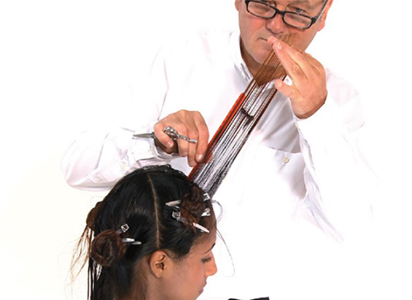

The technique incorporates pivoted sections from the crown to the nape using curved uniform layered sections.

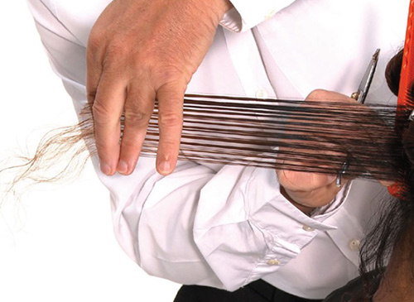

Placing long uniform layers near the nape of the neck.

A long uniform layer allows you to round out the front corners which can help the hair move away from the face. This super salon friendly technique is a perfect addition to your repertoire of long layered shapes.

## Long layers to enhance movement

Combining your layering techniques is the ideal way to enhance loose movement and texture in long hair. This uber commercial technique incorporates [increased layering](https://mhdpro.com/collections/long-layered) to maintain maximum length through the perimeter line whilst reducing weight through the mid sections

Started in the centre back, an increased layer is created by elevating the hair to 90° and then placing your fingers parallel to the floor. Place a square line from shorter to longer.

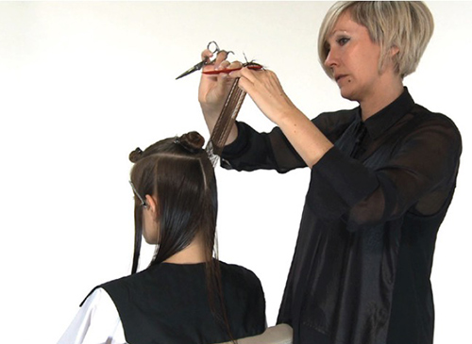

As you progress towards the front hairline the over-direction increases.

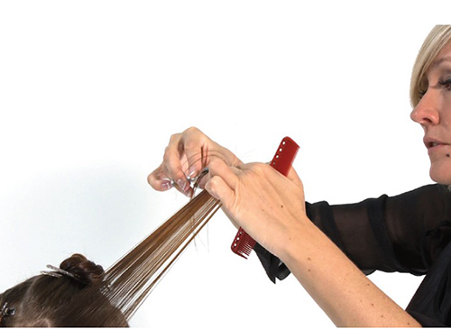

As you progress towards the front hairline the over-direction increases

The increase layering technique creates a loose, commercial layered look that facilitates movement and texture.

# [Fringe Bangs](https://www.wikihow.com/Cut-Fringe-Bangs)

# Bangs, or what many refer to as a "fringe," are a great way to change or spice up your look. The hairstyle entails shorter hair set in front of your existing hair, framing the face with a fashionable flair. The style has been utilized by such fashion icons as Bettie Page, Elizabeth Taylor and even The Beatles. Today, celebrities like Emma Stone and Rihanna can be seen flaunting the look with confidence. What most people don't know is you can have this popular hairstyle without leaving your own home.

### Part 1 - Preparing Your Hair

# C:\Users\My\Pictures\1.jpg

**Cleanse your hair.** Wash your hair thoroughly with shampoo in a shower or sink – for best results, try a high-quality one designed for your hair type. Make sure your hair is thoroughly rinsed of shampoo before proceeding.

* Cutting your hair while it's dirty is not what stylists consider ideal. Unwashed hair has a good chance of containing patches of grease or product build-up, which can lead shears to slip and cut unevenly.

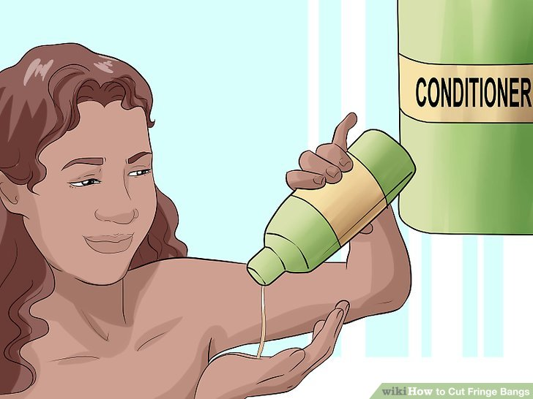

**Condition your hair, if needed.** Most people don’t need to condition the bang area. But for those who do, conditioner will help relax your hair and make it much easier to deal with in cutting. Conditioner leaves a bit of moisture in the hair, allowing it to fall agreeably and become easier to manage.

* Be sure to keep the conditioner at least 1 inch away from your scalp to avoid flat, greasy bangs.

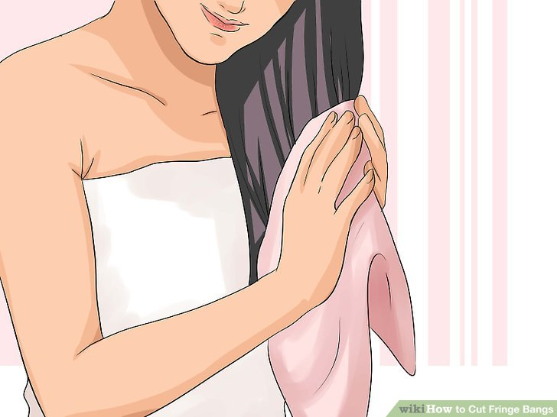

**Dry your hair.** Dry your hair by taking sections and squeezing them gently with a towel, working from the roots to the ends before moving to a new section. A microfiber towel works best for this.

* You can also use a blow-dryer for faster results, but be aware that heat causes changes in the hydrogen bonds that hold hair together. Too much heat can result in permanent damage.
* Don’t fret if your hair’s not completely dry. Actually, this might be better. Cutting completely dry hair gives you an immediate sense of the results but is hard to do and needs sharp tools. You may find it uneven when washed and restyled.
* Cutting your hair while damp is easier – not dripping wet, just towel dried to even dampness. It’s more likely to give an even result. Your hair shouldn’t clump together or drip.

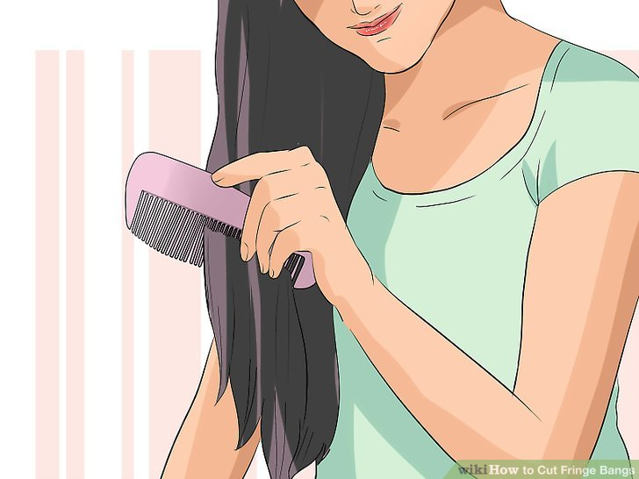

**Comb your hair.** Combing your hair will allow you to find an ideal length and measurement. The combing process will also detangle any hairs that have bunched up in the drying process.

* To get rid of tangles and knots with the least amount of hair damage, use a wide-tooth comb, start at the ends of your hair, and work your way up toward your roots.

# 

# C:\Users\My\Pictures\5.jpg

**Part your hair, or not.** There are un-parted as well as parted bang styles. If you’re going for a long-side swept bang or a parted bang, you can part your hair where you normally wear it before cutting. Otherwise, let it hang down un-parted.

* Bangs are essentially a shorter version of your current hairstyle, but help frame your face. Wearing it as normal will help you get a better idea of how you would like it cut.

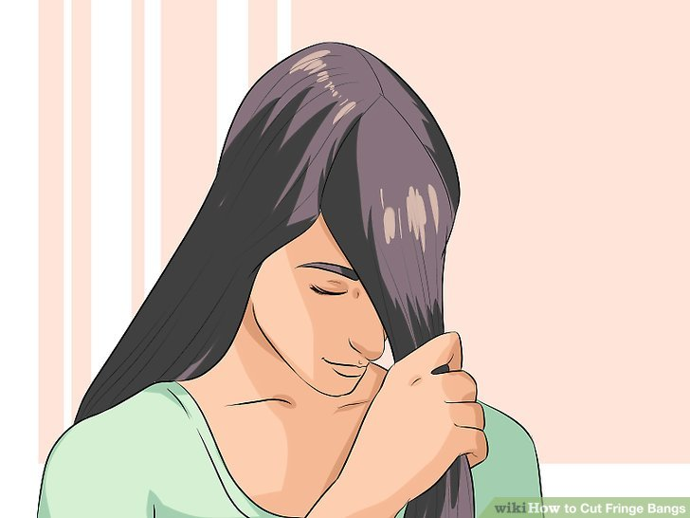

**Section off the hair that you intend to be your bangs.** Section off the triangle of hair from the top-center of your head to the outsides of your eyebrows. It shouldn’t extend past the outer corners of your brows or the top of your head.

* Use a uniform triangular shape when you section the hair. For thicker bangs, start further back on your head. For less thickness, start closer to your forehead.
* If your hair is layered, grab the strands of hair that are used to blend the front portion of your hair to the back portion. These hairs are often shorter and easier to transform into bangs due to their short length.

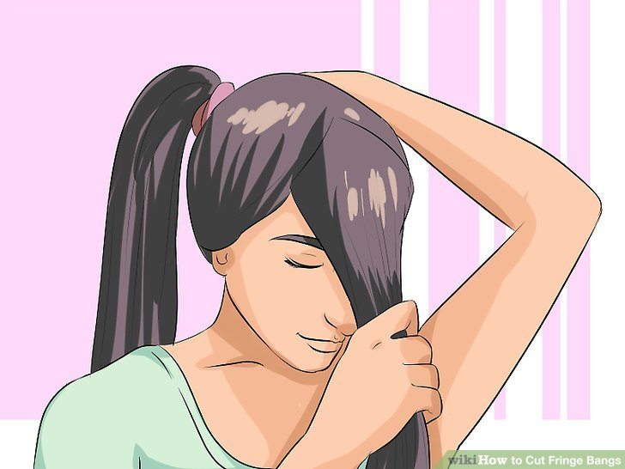

**Put the rest of your hair in a ponytail.** Having hair out of the way can give you a better sense of how the bangs will look.

* Working without hair potentially getting in the way can help you avoid mistakes and cutting unintended hair. A ponytail is also another look you may want to incorporate with your new style.

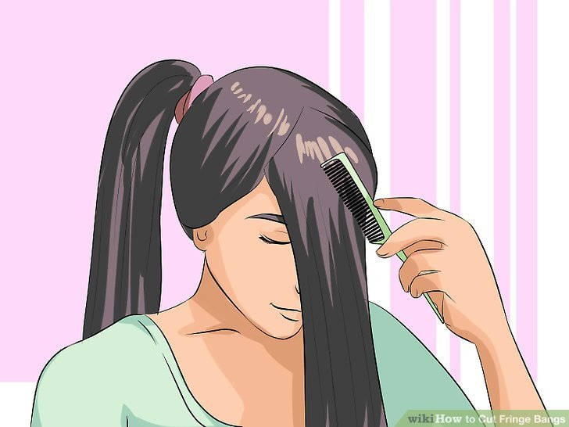

**Comb out the section of your hair evenly in front of your face.** Combing the hair out in front of your face will help you see when you are cutting as well as how short you will have to cut in order to see.

* Don't be afraid to pull hair from further back and near the center of your head. This can often help avoid issues of thinness when your bangs are ready to be styled.

### Part 2 - Cutting Your Hair

**Choose an appropriate pair of scissors.** Styling scissors can be bought at any beauty supply store. The scissors have a sharpness meant for hair. Common household scissors are meant to cut more coarse things like paper and plastic.

* Beauty supply stores often sell scissors meant for hair at various sizes. Smaller scissors will allow for more control and may come in handy when shaping your fringe

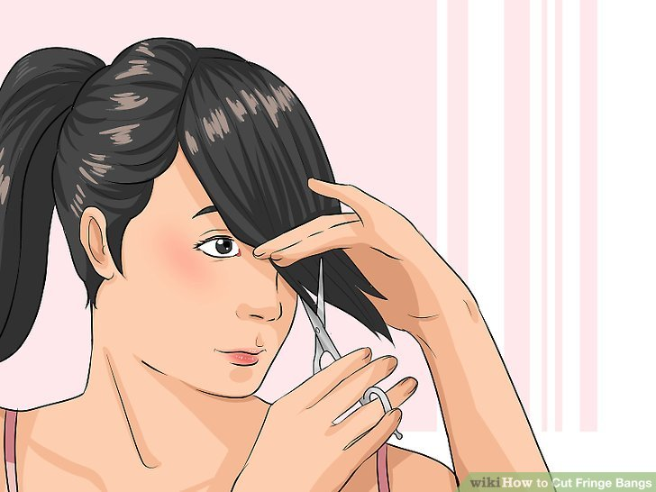

**Divide the bangs into 1” sections and start cutting at the bottom section.** Divide your hair into horizontal rows of no more than 1” thick. Then, begin at the bottom. Hold the scissors upright and line them up along your hair before cutting. Make minimal, vertical snips at your bangs that go along the hair rather than across. This will help avoid cutting your hair into a flat line.

* For classic bangs, the shortest point should fall at the bridge of the nose between your eyes. Remember to cut less and leave more. You can always come back and cut more if your new bangs are too long.
* You can keep your hair in position with a comb with your non-dominant hand and cut with your dominant hand.

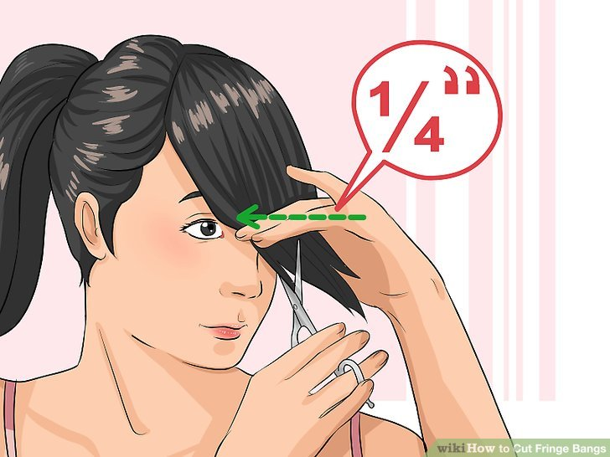

**Move your scissors to the left or right about a quarter of an inch, and continue cutting.** Move as little to one side as possible to ensure you're cutting all of your intended bangs. Continue making vertical snips along your hairs' ends. Cut as flat as possible - without cutting across - near the middle of your head and allow for longer strands as you work your way outward. After you've finished one side, repeat the process on the other.

* Cut at a diagonal angle - about 45 degrees - to achieve an edgier, less blunt look.
* Some bangs are straight across the forehead and longer as you get to one side. Other styles can be curved, with length that slightly increases toward the outside corners

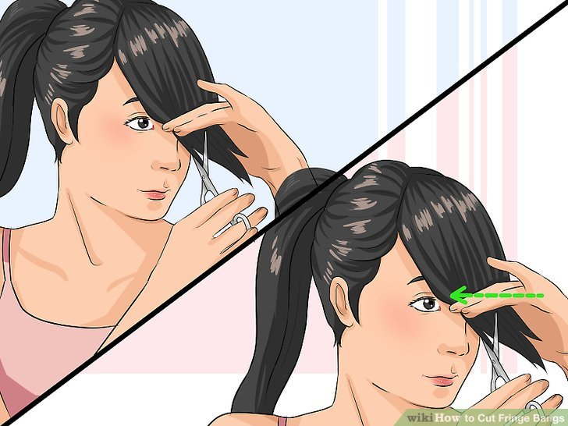

**Repeat the cutting process until you manage to shape your new bangs.** Keep working your way up toward the crown of your head, cutting as sparingly as possible and never directly across. When your bangs are there, you'll know it!

* Cutting less and leaving more hair is a great way to avoid common mistakes like a crooked line or missing chunks.
* Remember to be patient. Think of your hair as an art piece - nothing is perfect when rushed.

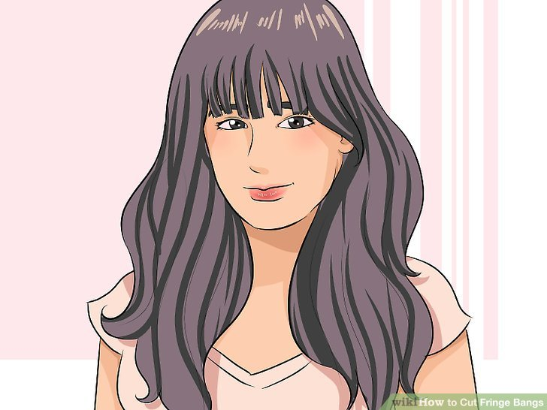

**Shake your hair around, part it, and you're done!** Congratulations, you've achieved one of the most popular and fashionable hairstyles out there, all from the comfort of your own home!

* Remember, if your bangs are still too long, you can always re-comb and re-cut. The same cannot be said about them being too short!
* If your new bangs are too thin, pull hair from closer to the top of your head and cut accordingly. If they’re too thick, hold them up straight and cut into the ends deeply with vertical or diagonal snips.

**Different Types of Bangs Styles**

Bangs (which are also known as a fringe in some English speaking countries) is a haircut which has remained popular for decades. However, just because bangs have been around for a long time, this does not mean that they are a dated look. In fact, there are so many different types of bangs and different ways to wear your hair if you have bangs, that you can keep changing your hair to make sure that you stay relevant. Every year, a new bangs trend hits the scene, and people go crazy over the bangs style.

### [Blunt Bangs](https://hairstylecamp.com/20-wispy-and-blunt-bangs-to-switch-up-your-style/)

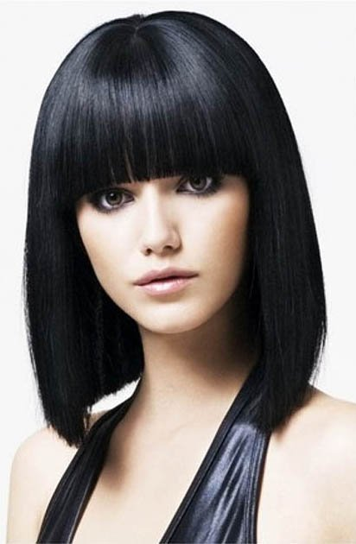

Blunt bangs are the bangs which are cut straight across your forehead. Most blunt bangs will stop at or around eyebrow length, although some people like to keep them a little bit longer than this for a more severe look.

Blunt bangs are great for drawing attention to your eyes and framing your face. If you have thinner hair you may have wispier blunt bangs, which look a little softer. If you have thicker hair and do not want to look to seem too severe, then you may be able to get your stylist to thin your hair out a little bit. Curling the bottom of your blunt bangs under slightly can also soften your look and create a beautiful retro style.

### Choppy Bangs

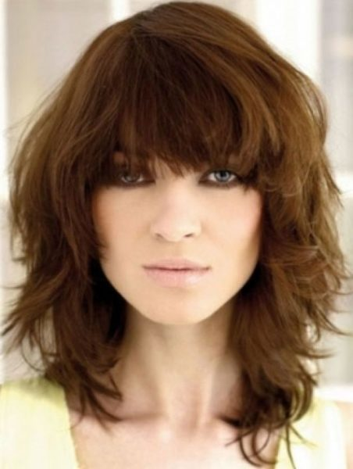

Choppy bangs are a really edgy style that looks brilliant with thicker hair. These bangs normally cover the forehead, but they are not cut as straight as blunt bangs are.

The choppy cuts take away some of the heaviness and severity that blunt bangs offer, however they draw attention to the eyes in the same way that blunt cuts do. If you have thicker hair, a choppy cut can be used to thin your hair out, without losing full coverage of your forehead. This can reduce the heaviness of your hair.

### Pixie Cut with Bangs

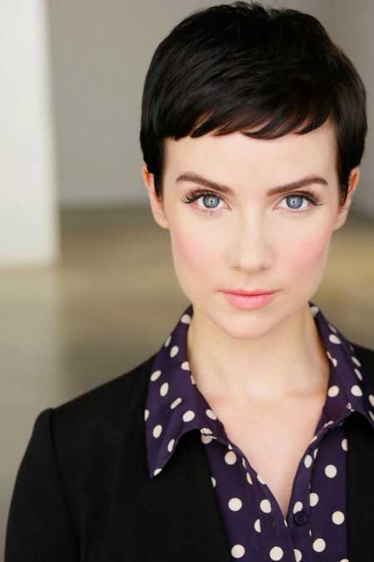

These are very short bangs which only cover the very top of your forehead. They look best on people with an oval face shape and are stunning when teamed up with a cropped hairstyle.

Pixie bangs can also look good on people with longer hair who keep their hair up most of the time. They help to open up the face and can make it look lighter and brighter.

### Parted Bangs

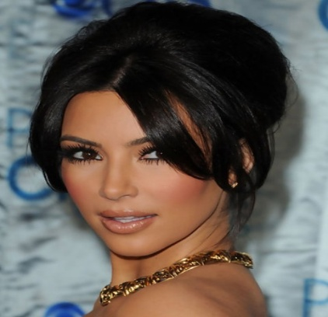

Parted bangs are the name given to a style in which the hair is parted. The parting can either be down the center of the bangs or it can be off to one side instead.

If your hair is getting a bit longer, you may want to part your bangs so that you can keep the hair out of your eyes. Depending on the length of your bangs, you might need to use a clip to secure your bangs in place. Parted bangs can be worn with your hair up or with your hair down

### [Side-swept Bangs](https://hairstylecamp.com/popular/bangs/side-swept-bangs/)

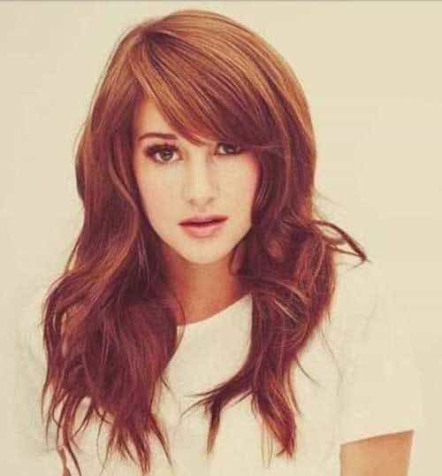

Side-swept bangs come from one side of your head and cross your forehead on a diagonal. They help to give your hairstyle an asymmetrical look which is very fashionable. People who have a perfectly symmetrical face shape may want to consider side-swept bangs because it’ll give them an unusual edge.

There are actually a few different ways to wear your hair if you want to try side swept bangs. Some people style their hair so that it thickly covers their forehead, but also covers one of their eyes. This style of side-swept bang is a very popular choice in the emo sub-culture. There are also many women who go for a more subtle side-sweep.

Side-swept bangs are probably the most common type of bangs. Side-sweeps look great with most hair types – thick hair and thin hair, wavy hair and straight hair, dyed hair and natural shades.

### Asymmetrical Bangs

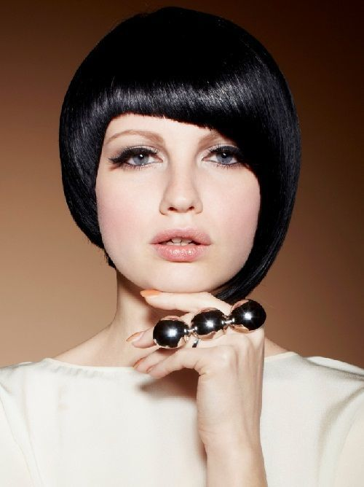

These bangs are slightly different to a [sweeping fringe](https://hairstylecamp.com/epic-fringe-bangs-to-elevate-beauty/) because of the way that your hair falls. In a sweeping fringe, your hair will normally come from one side and finish at the other.

However, with asymmetrical bangs, your hair normally comes from the top of your head and is cut so that the hair finishes asymmetrically. This style is perfect for funky, attention-grabbing hairstyles. It is also a very high fashion idea.

### Ached Bangs

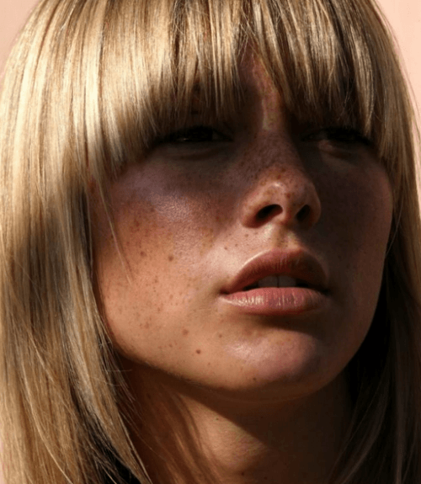

Arches bangs are similar to blunt bangs, except rather than the cut being straight across the forehead, it is arch-shaped and follows the curve of the face.

These bangs look better with thicker hair because they help the arch to stand out more. The arch will frame your face and can help to make your face look beautifully soft. Arched bangs are a perfect hairstyle to choose if you have a square face because they can actually help your face look rounder.

### Dyed Bangs

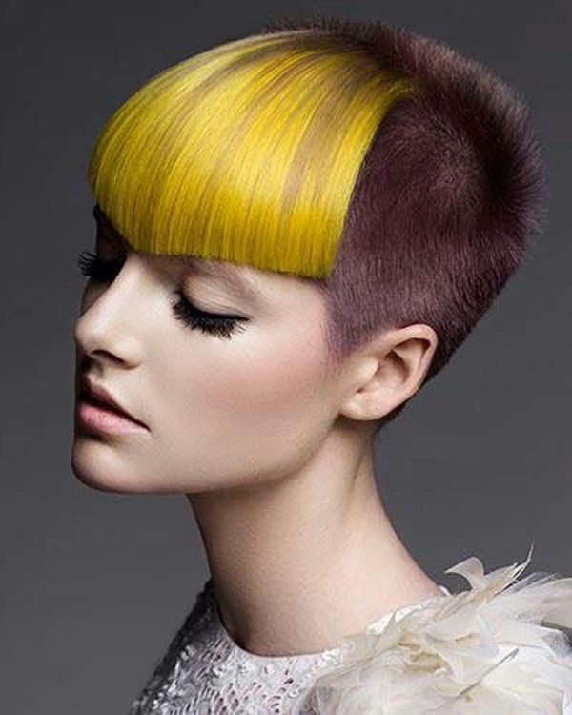

If you want to make a real statement with your hair, then you may want to consider dying your bangs a different color than the rest of your hair. This is a fun look which will set you apart from everyone else. If you are brave enough to make a statement like this, then you are brave enough to dye it any color that you want!

This style can be worn with any face shape and hairstyle. It will really draw attention to your face.

### Pin-up Bangs

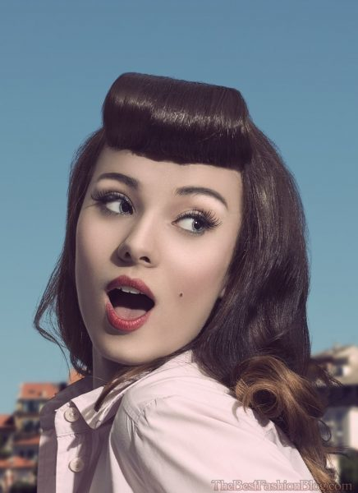

Pin-up bangs are a classic vintage style which looks great on women who love a touch of glamor. It can be created by carefully combining and styling many of the other types of bangs in this list. Pin-up bangs can be worn with any face shape, although they look best when worn with bold vintage make-up.

These different types of bangs are all stylish, elegant & beautiful. Choose the look that’ll fit your face shape and size.

**Equipment for hair coloring**

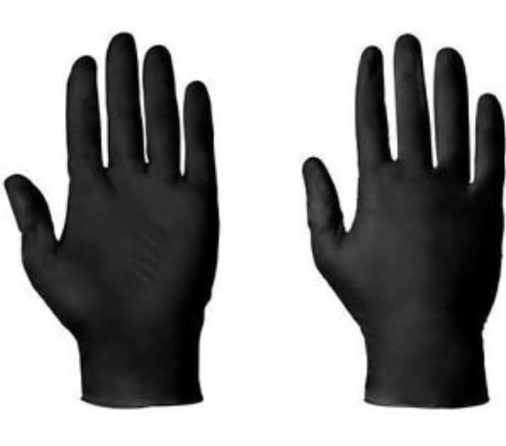 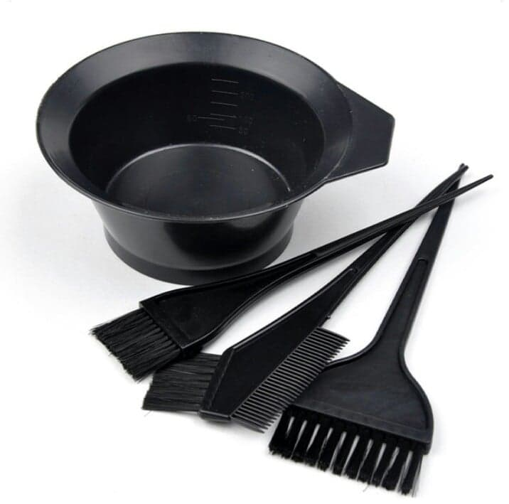

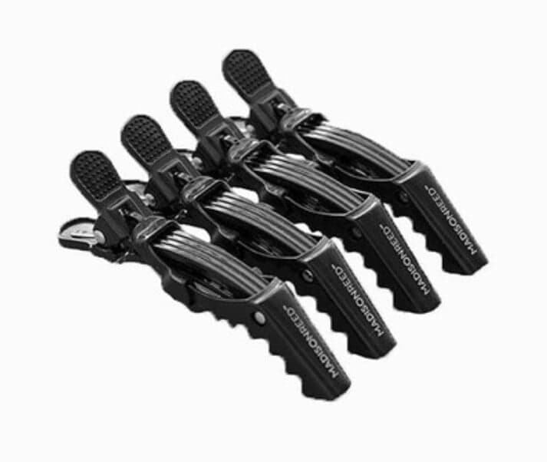 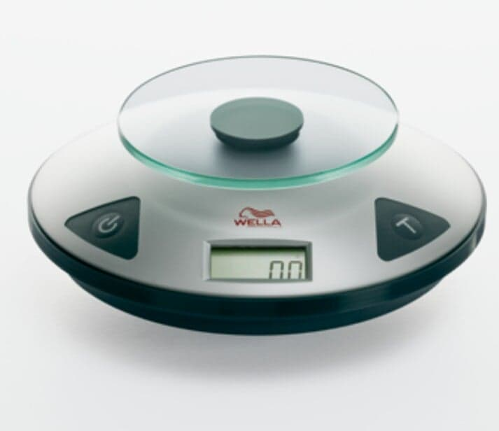

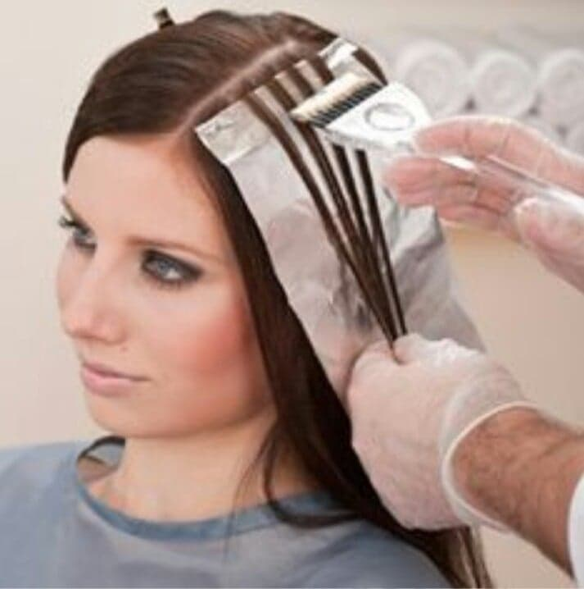 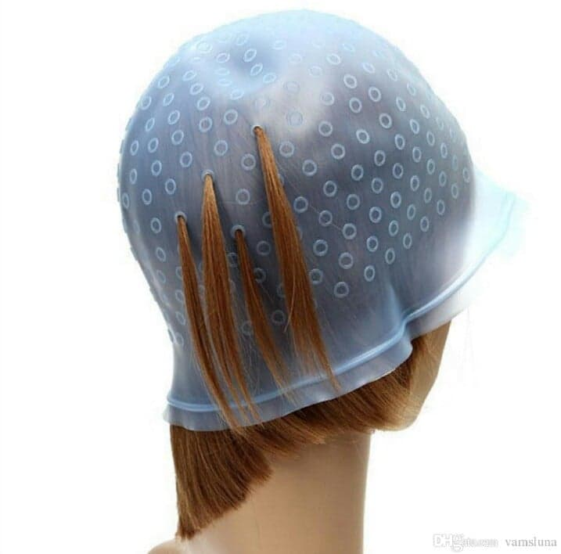

**Hair Color**

**Hair Color Techniques and Hair Colors**

Hair color is the main indicator of woman’s mood and state of mind. Well-cared locks mean everything goes smoothly. Hair color freshness is equally important as hair’s health. You need to update it on a regular basis to stay attractive and feminine. This article is a must-read if you plan hair changes or look for ways to care for already colored locks. We give a full guide to choosing shade according to your skin and hair type, a list of dyeing techniques, advice how to avoid damage and maintain your color, plus talk about dyeing during pregnancy and hair loss. All questions answered!

## Main Hair Coloring Techniques

Every year (and even season) top hairstylists update trends: new coloring techniques appear, some, on the contrary, [become outdated](https://therighthairstyles.com/hair-trends-we-left/). However, there exist sure-fire options. We’ve rounded up the most popular dyeing techniques, that will probably never go out of trend.

### All-Over Hair Color

All-over hair color is sometimes called “single-process” hair color because it involves applying a single shade to your hair.

There are three levels of permanence when it comes to single-process hair color:

* **Permanent:**

formula contains ammonia and peroxide which chemically change the color of your hair. This chemical change is what makes it “permanent”.

* **Demi-permanent:**

contains no ammonia, but does contain peroxide to help hair absorb color. Generally washes out in 12 to 24 shampoos.

* **Semi-permanent:**

contains no ammonia and color is deposited on the surface of the hair, acting more like a stain. Generally washes out in about 6 to 12 shampoos.

### Two-Tone Hair Coloring

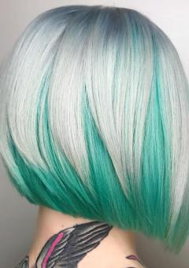

These are all hair coloring techniques that include just 2 shades – a base hair shade and one more for lightening strands, darkening, or enriching with color. In the era of balayage stricktly [two-tone dyeing jobs](https://therighthairstyles.com/two-tone-hair-styles/) may be hard to find. The majority of stylists like to use 3 and more shades to blend highlights seamlessly into the hair. However, some of them are still present in today’s life.

If you are interested, check the examples of [dip-dye hairstyles](https://therighthairstyles.com/dip-dye-hair/), and [blue and purple hair coloring](https://therighthairstyles.com/blue-and-purple-hair/). Very often stylists choose just 2 colors for the so-called [‘peek-a-boo hair’](https://therighthairstyles.com/peekaboo-hair/) too.

However, two-tone colorings are made not only with pastel or bright colors. It can be classic ombre or balayage as well.

### Balayage

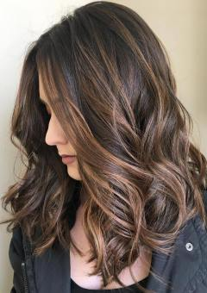

[Balayage](https://therighthairstyles.com/balayage-hair-colors/) refuses to go anywhere thanks to its versatility and beautiful effect. It differs from highlights because there is no foil or meche used. Color is swept through small triangle sections of hair by hand, creating natural-looking highlights.

A great benefit to this technique is that your stylist can make your hair as individual as you are with custom-blended colors and precise application to contour and frame your features.

Balayage is also very low-maintenance, making this technique perfect for busy gals. The natural transition from shade to shade makes roots less noticeable when hair grows out.

The only thing balayage can’t do is cover grays — unless you want to blend them into your look. If you have a lot of gray to cover, a full coverage color is your only option. Need just quick touch-ups? Try special [root concealers](https://therighthairstyles.com/the-best-root-concealers/).

Variations of this technique include [strobing](https://therighthairstyles.com/how-hair-strobing-work/) and [smudging](https://therighthairstyles.com/hair-smudging/).

### Foil or Meche Highlights

Foil highlights are a more precise way to apply color to hair. The use of the foil or meche allows the stylist to apply different colors at the same time, as well as, provide more even coverage throughout the hair. The application of different colors is great for adding layers of dimension to hair color, and can help create the illusion of volume for fine hair.

This technique can be more high-maintenance than others, however, depending on the number of highlights you apply and the shade you choose. Since the application is done close to the scalp, roots are more visible when hair starts to grow out.

### Highlights

[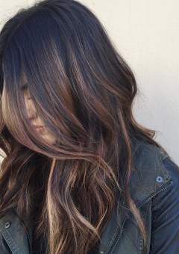](https://therighthairstyles.com/15-glamour-oozing-hairstyles-featuring-dark-brown-hair-with-highlights/)

In most cases highlights are lighter streaks aimed to enhance natural hair texture and brighten locks. They differ in shades, size, and placement. Many women opt for highlights to naturally transition from a dark base hair color to the lighter one without extreme bleaching. In this case, streaks have to be very thin. If wider sections are lightened, they are called [chunky highlights](https://therighthairstyles.com/chunky-highlights/).

Highlights may be placed all over your head, strategically in the front, on the top layer or just on ends. In other words, anywhere your stylist sees a lack of dimension. Basically, there are 2 most popular types of highlights: traditional foiling and free-hand (aka hair painting) techniques. The second variant is super-trendy nowadays and includes your beloved balayage.

Why did we say that highlights are lighter streaks ‘in most cases’? The answer: they may be done in all shades imaginable. Not just [super-trendy caramel](https://therighthairstyles.com/20-savory-looks-with-caramel-highlights-youll-love-to-treat-yourself-wi/) or light blonde. For example, a lot of women love bold hair colors and experiment with [pink](https://therighthairstyles.com/pink-highlights/), [blue](https://therighthairstyles.com/blue-highlight-hairstyles/) and even [purple streaks](https://therighthairstyles.com/ideas-of-purple-highlights/) in their hair. One more creative variant girls of all ages go crazy with are [silver and white highlights](https://therighthairstyles.com/shades-of-grey-silver-and-white-highlights/).

Highlighting looks great on long and [short locks](https://therighthairstyles.com/short-hair-with-highlights/), works equally perfect for blondes and women with [dark](https://therighthairstyles.com/15-glamour-oozing-hairstyles-featuring-dark-brown-hair-with-highlights/) and [light brown](https://therighthairstyles.com/15-trendiest-ideas-for-light-brown-hair-with-highlights/) base hair colors.

### Babylights

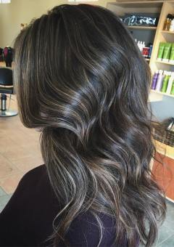

Babylights mimic natural hair by creating very subtle color changes to the base color. They are similar to regular highlights but are spaced closer together and much more delicate in size. The technique is so soft that roots are barely there when color grows out.

Babylights are perfect for any hair color and hair type. They can make your natural shade shine with a subtle, yet powerful, boost. However, be prepared to spend many hours at the salon since the process is so detailed.

### Lowlights

[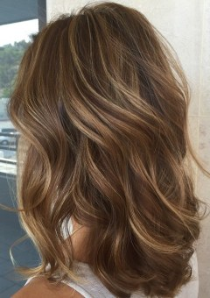](https://therighthairstyles.com/15-trendiest-ideas-for-light-brown-hair-with-highlights/)

[Lowlights](https://therighthairstyles.com/15-trendiest-ideas-for-light-brown-hair-with-highlights/) add depth and dimension to hair color that let the beauty of the natural color shine through. Instead of lightening the hair, lowlights add darker shades to create contrast and let the base color be the start of the show.

Anyone with a beautiful natural base color (except very dark hair) is a good candidate for lowlights. This technique works well for curly or thin, fine locks, as it creates the illusion of volume. Lowlights are very versatile but can make short hair look patchy.

### Ombre

[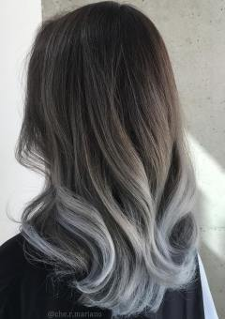](https://therighthairstyles.com/the-30-sizzling-ombre-hair-color-solutions-for-blond-brown-red-black-hair/)

This is another tried-and-true technique that is easy to wear and works on virtually every hair color and type. [Ombre](https://therighthairstyles.com/the-30-sizzling-ombre-hair-color-solutions-for-blond-brown-red-black-hair/) means “shaded” in French, and that is the perfect way to describe this popular style. Hair is left darker at the roots, and gradually lightens to the tips. Lighter at the crown and darker at the ends ombre is called [“reverse”](https://therighthairstyles.com/reverse-ombre-hair-with-perfect-fades-into-browns-blacks/).

Although the look works best on longer hair, as it gives enough room for the color to gradually melt from the roots to the tips, there are a lot of successful examples of [short ombre-ed hair](https://therighthairstyles.com/the-most-successful-short-ombre-hair-options-for-your-cropped-locks/). So if you have a longer pixie or a bob cut, you may try it too.

### Sombre

[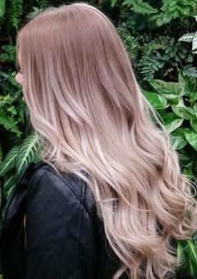](https://therighthairstyles.com/soft-ombre-hairstyles/)

[Sombre](https://therighthairstyles.com/soft-ombre-hairstyles/) is a softer version of ombre. The contrast between roots and tip color is only a shade or two apart, so the color looks more seamlessly blended. Very low-maintenance, this style is easy to care for and requires fewer trips to the salon.

## Choosing the Right Hair Color to Go with Your Skin

Before you choose a color for your hair, you need to consider which colors best suit your skin tone and complexion undertones. Skin tone is whether your skin is [fair](https://therighthairstyles.com/hair-color-for-pale-skin/), medium, olive or deep, and undertones are what give your skin a warm, cool, or neutral hue.

When trying to figure out your skin undertone, it’s best to use indirect, natural light. Indoor lighting can have warm and cool effects on your skin and skew the results. Ever looked in the mirror in a public washroom and felt a touch green or yellow? That’s because the artificial lights are projecting a greenish hue onto your skin. So, start off by sitting next to a bright window, but not in direct sunlight.

There are a couple of tests to determine what undertones your skin may have:

* **The Vein Test.**

The easiest way to determine your undertone is to look at the veins in your wrist. Since your veins are so close to the surface of the skin, the contrast highlights the undertones.

* **The Jewelry Test.**

Depending on your skin tone, you will look better in either gold or silver jewelry. Try on both colors and check to see which looks more natural against your skin.

* **The White or Beige Test.**

Try on a white and a beige or off-white t-shirt. If you have warm undertones, the white tee makes your skin appear more yellow. If you have cool undertones, the beige tee makes your skin look washed out and grey.

### Hair Colors for Every Type of Skin Tone and Undertone

Now, when you’ve figured out your skin undertone, it’s time to reaffirm your conclusions and find out what hues will look best on you.

**Warm Skin Undertone**

* Your veins look greenish and your skin has yellow and gold undertones.
* You look good in gold jewelry.
* Wearing beige complements your warm golden undertones.

Best hair shades for warm undertones:

* Fair: copper, golden blonde, caramel
* Medium: [bronde](https://therighthairstyles.com/bronde-hair/)
* Olive: chestnut, cinnamon
* Deep: violet red or black, honey, caramel

**Cool Skin Undertone**

* Your veins look blueish and your skin has pink and blue undertones.
* You look good in silver jewelry.
* Wearing white brings out the pink in your skin.

Best hair shades for cool undertones:

* Fair: icy platinum, baby blonde
* Medium: sand, wheat, and beige colors
* Olive: chestnut, cinnamon
* Deep: inky black, espresso, blue-black

**Neutral Skin Undertone**

* If you have “olive” skin, you most likely have a neutral skin undertone.
* If you have a hard time telling whether your veins are green or blue, you probably have a neutral skin undertone.
* You can wear either white or beige and either gold or silver, and they look equally good against your skin.

Best hair shades for neutral undertones:

* Depending on whether you have fair, medium, olive, or deep skin tone, you can experiment with any of the colors in the cool or warm spectrum.

## Choosing the Right Color and Technique for Your Hair Type

Before you hit the salon, it’s essential to identify your hair type and the [most complimentary color technique](https://therighthairstyles.com/how-to-choose-coloring-technique-for-hair/) to go with it.

* **Straight**

Options are endless for those with straight hair. With a wide variety of coloring techniques available, straight and relaxed hair can usually handle some wild types of hairstyles like tie-dye, mermaid, and rainbow looks. Babylights, sombre, and [ombre on straight hair](https://therighthairstyles.com/ombre-straight-hair/) create dimension and movement. Straight hair is perfect for any type of freehanded painting technique.

* **Wavy**

Hair with a subtle wave can look great with all hair techniques. It’s not too busy for dip dye, ombre, or tie-dyed hair, and has enough dimension to handle even the subtlest of babylights.

* **Curly**

Curly hair comes alive with highlights and lowlights. Freehand techniques like babylights and balayage allow your stylist to color your unique set of curls precisely and add dimension that works with, not against, your hair type.

## Coloring and Hair Loss

There exist a legend that dyeing hair may cause hair loss. Fortunately, it is one of the [hair coloring myths](https://therighthairstyles.com/hair-coloring-myths/). There are many reasons for hair loss in women but coloring hair is not one of them.

The number one reason for hair loss in women is androgenetic alopecia (AGA), also known as hereditary hair loss or female pattern hair loss. Your hair follicles are affected by genetics, hormones, and age throughout your life. They can also be affected by stress, pregnancy, and rapid weight loss.

While coloring your hair does not cause hair loss, it can damage your hair. Over-processing your hair can cause breakage and lead to thinner locks, but only for the short term. The hair fall will be temporary. To stop it give your locks [special treatment](https://therighthairstyles.com/treat-and-prevent-thinning-hair-in-women/).

## How to Care for Colored Hair

After spending all that money and time at the salon, follow these tips for keeping your color longer:

* Wash your hair 1 to 3 times a week. Frequent washing fades color faster.
* Use a [dry shampoo](https://therighthairstyles.com/best-dry-shampoos-review/) in between washes, if necessary.
* Get a quality shampoo and conditioner that suits your hair type.
* For blondes and greys, invest in a [good purple shampoo](https://therighthairstyles.com/best-purple-shampoo/) to keep brassiness at bay.
* Use lukewarm water to wash your hair and cool water to rinse. Cool water closes the cuticle to keep the color molecules, nutrients, and moisture sealed in.

### How to Minimize Hair Damage After Coloring

Any type of chemical process will take a toll on your hair. Not only do the chemicals from coloring affect your hair, the sun can damage it and degrade your color. Swimming in pools and saltwater can also dry out and damage hair and ruin your color.

Prevention is key to keeping hair healthy and color vibrant. Follow these tips to lessen damage caused by the elements:

* Condition your hair regularly, use hair masks, and consider applying a leave-in conditioner.
* Always use a [heat protectant](https://therighthairstyles.com/heat-protectant-products/) before styling.
* Consider a hair spray with UV protection.
* Use a silicone-based product on your hair or wet it with fresh water before going into the pool.
* Use a good quality shampoo and conditioner for color-treated hair.

### Choosing the Best Shampoo for Colored Hair

Does colored hair really need a special shampoo? Yes – regular shampoos strip away the color molecules causing the color to fade faster. Color-protecting shampoos are formulated to treat the specific needs of colored hair. They contain ingredients to restore and strengthen damaged strands, moisturize, add shine and softness.

Look for a shampoo that cleanses gently without stripping your hair of moisture and natural oils. If the product is taking moisture from your hair, it will be taking color with it. The shampoo should contain UV filters to prevent color fading in the sun, as well as, damage repairing properties, such as essential oils, proteins, and panthenol.

**Do You Need a Sulfate-Free Shampoo for Color-Treated Hair?**

All shampoos contain a cleansing agent necessary to remove dirt and buildup from hair. This common cleansing ingredient is a sulfate. There is no published scientific evidence to prove that sulfates cause color to fade faster than other detergents used in sulfate-free shampoos.

According to the [Food and Drug Administration](https://www.fda.gov/) and the [Cosmetic Ingredient Review](https://www.cir-safety.org/), sulfates are considered to be safe in small quantities and there is no need to avoid them unless you have very sensitive skin. In that case, sulfates can cause irritation as they strip the hair and scalp of natural oils and moisture.

Sodium lauryl sulfate cleanses well but strips hair of natural oils, protein, and peptides, which can take a toll on hair health. Sodium laureth sulfate is a gentler cleanser, although both may cause allergies.

Sulfates are what give your shampoo that great lather we all love. Sulfate-free shampoos may not lather as well, but rest assured that they are cleansing your hair just as well. Choose what you like more.

**What Other Ingredients Should Be Avoided in Shampoos for Color-Treated Hair?**

Alcohol dries out your hair. If it’s one of the first four ingredients for your product, steer clear.

Formaldehyde and its releasers, including Quaternium-15, DMDM hydantoin, imidazolidinyl urea, diazolidinyl urea, polyoxymethylene urea, sodium hydroxymethylglycinate, bromopol and glyoxal. The verdict is still out on formaldehyde, however, in large quantities, it can cause irritations to the skin, eyes, nose, and throat.

Parabensbreak the hair cuticle, making hair weak, brittle, and dull..

## Dyeing Your Hair When You’re Pregnant

Luckily, it is just one more myth. You may color your hair while pregnant. Just use techniques that keep hair dye away from the scalp, such as, balayage or ombre. Chemicals from hair dye can be absorbed through the scalp and may cause harm to the fetus. Also, it is recommended not to dye hair until the second trimester. Even ‘natural’ and ammonia-free hair dyes are still substances full of different chemicals. Anyway, consult your doctor before choosing to dye your hair for more information.

## Advanced Hair color Techniques

**Wavy Hair**  
   
**All-Over Color**  
   
 [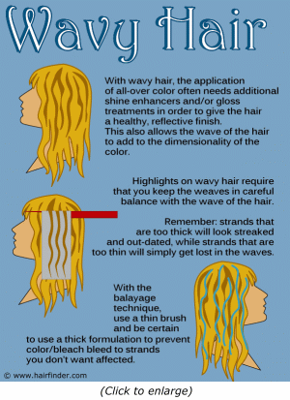](https://www.hairfinder.com/techniques/color-wavy-hair.gif)

Wavy hair – depending on the level of wave – can be shiny like straight hair tends to be, or may need enhancement in order to make the hair as glossy as we may want. For this reason, wavy hair types often respond well to translucent color formulas combined with shine enhancers. These shine enhancers are often referred to as “clear-gloss” or “cellophane” treatments.  
   
Because the waviness of the hair creates natural points along the hair shaft which more readily reflect light, using a color toner or translucent color formula with shine enhancers is a great way to add depth to wavy hair, embolden the color and increase the shininess and healthy look of the hair.

**Highlighting – Foils**  
   
Foil highlighting (as well paper highlighting) on wavy hair isn’t that terribly different than with straight hair. The techniques are the same, but you want to make sure to gauge the thickness of the weaves you take for coloring or lightening to be in balance with the wave of the hair. If you use weaves that are too thin, the results get lost in the waves. However, when the weaves are too thick, the results are streaky color that just looks outdated.

### Highlights – Balayage   Again, with balayage highlighting applications, wavy hair needs to be considered carefully. You must gauge how thick you want the painted lines of color to be to keep them in balance with the overall look of the hair. If the lines are too thin, the resulting highlights will get lost in the bends and turns of the wavy hair. If the lines are too thick, you get a streaked result that isn’t flattering and looks like a retro-style.   Remembering that the goal of balayage is to create lightness where you would normally find natural highlighting, be sure to focus your efforts on creating brightness in the tops and foreground of the hair, and keep your lines in the length thick enough to allow the waves to reflect the light to maximum effect

### Curly HairAll-Over Color

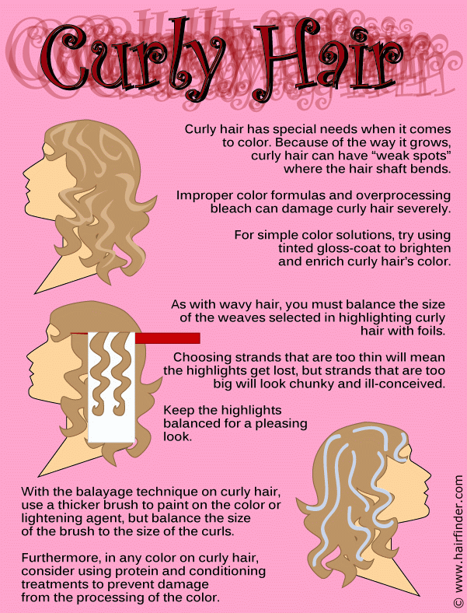

Curly hair often appears less shiny and healthy, because the twists and turns of the hair strands as they curl only reflect light from the arcs that bend toward the light. Because of this, you want to be sure to avoid using opaque colors on curly hair, which would result in a flatter color result and minimize the shine that exists in the hair. Translucent color formulas and tinted gloss are ideal for making curly hair more vibrant and enhancing the shiny and healthy-look of the hair.  
   
Of course, it is also important to make sure that you process curly hair carefully. Because of the way the hair grows, there are often “weaker spots” along the length of the hair shaft. When hair color is improperly formulated or over-processed (with regard to lightening formulas) these points on the hair can become fragile and can be places more prone to [breakage](https://www.hairfinder.com/hair4/hairbreakage.htm). Prior to coloring curly hair, it is often a good idea to apply protein treatments or deep conditioning packs.

**Hair Styling Equipments**

**1. Hair iron**

A hair iron or hair tong is a [tool](https://en.wikipedia.org/wiki/Tool) used to change the [structure](https://en.wikipedia.org/wiki/Structure) of the [hair](https://en.wikipedia.org/wiki/Hair) using [heat](https://en.wikipedia.org/wiki/Heat). There are three general kinds: curling irons, used to make the hair [curly](https://en.wikipedia.org/wiki/Curly_hair), straightening irons, commonly called straighteners or flat irons, used to [straighten the hair](https://en.wikipedia.org/wiki/Straighten_the_hair), and crimping irons, used to create [crimps](https://en.wikipedia.org/wiki/Hair_crimping) of the desired size in the hair.

Most models have [electric heating](https://en.wikipedia.org/wiki/Electric_heating); cordless curling irons or flat irons typically use [butane](https://en.wikipedia.org/wiki/Butane), and some flat irons use batteries that can last up to 30 minutes for straightening. Overuse of these tools can cause severe damage to hair.

## Types of hair irons

Curling irons, also known as curling tongs, create waves or curls in hair using a variety of different methods. There are many different types of modern curling irons, which can vary by [diameter](https://en.wikipedia.org/wiki/Diameter), material, and shape of barrel and the type of handle. The barrel's diameter can be anywhere from .5 in (1.3 cm) to 2 in (5.1 cm). Smaller barrels typically create spiral curls or ringlets, and larger barrels are used to give shape and volume to a [hairstyle](https://en.wikipedia.org/wiki/Hairstyle).

Curling irons are typically made of [Teflon](https://en.wikipedia.org/wiki/Teflon), [ceramic](https://en.wikipedia.org/wiki/Ceramic), [tourmaline](https://en.wikipedia.org/wiki/Tourmaline), [metal](https://en.wikipedia.org/wiki/Metal), or [titanium](https://en.wikipedia.org/wiki/Titanium). The barrel's shape can either be a [cylinder](https://en.wikipedia.org/wiki/Cylinder_(geometry)), [cone](https://en.wikipedia.org/wiki/Cone_(geometry)), or reverse cone, and the iron can have brush attachments or double and triple barrels.

The curling iron can also have either a spring-loaded, Marcel, or clipless handle. Spring-loaded handles are the most popular and use a [spring](https://en.wikipedia.org/wiki/Spring_(device)) to work the barrel's clamp. When using a Marcel handle, one applies his or her own pressure to the clamp. Clipless wands have no clamp, and the user simply wraps hair around a rod. Most clipless curling irons come with a [Kevlar](https://en.wikipedia.org/wiki/Kevlar) glove to avoid burns.

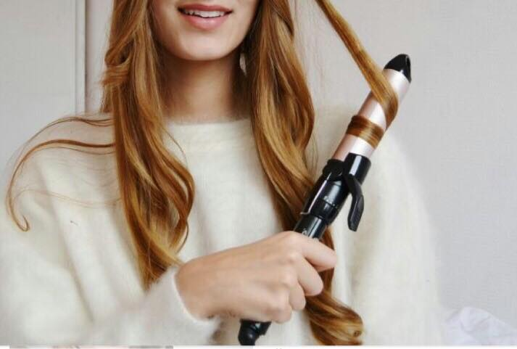 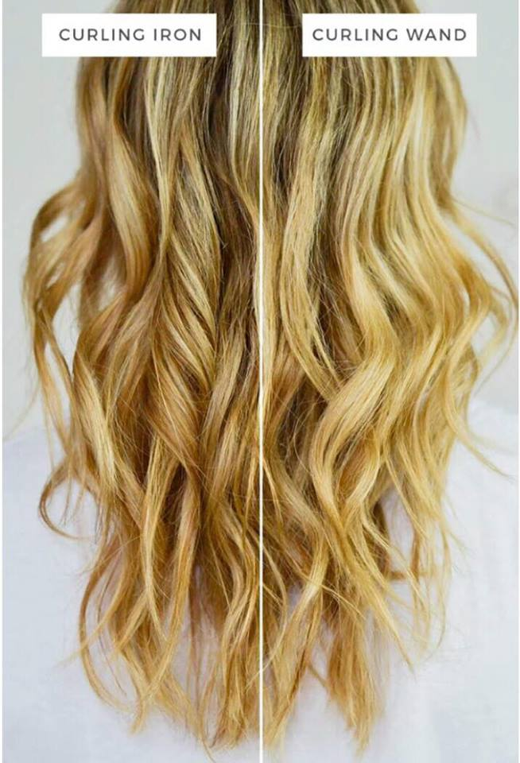

### Straightening irons

Straightening irons, straighteners, or flat irons work by breaking down the positive hydrogen bonds found in the hair's cortex, which cause hair to open, bend and become curly. Once the bonds are broken, hair is prevented from holding its original, natural form, though the hydrogen bonds can re-form if exposed to moisture.Straightening irons use mainly [ceramic](https://en.wikipedia.org/wiki/Ceramic) material for their plates. Low-end straighteners use a single layer of ceramic coating on the plates, whereas high-end straighteners use multiple layers or even 100% ceramic material. Some straightening irons are fitted with an automatic shut off feature to prevent fire accidents.

Early hair straightening systems relied on harsh chemicals that tended to damage the hair. In the 1870s, the French hairdresser [Marcel Grateau](https://en.wikipedia.org/wiki/Marcel_Grateau) introduced heated metal hair care implements such as [hot combs](https://en.wikipedia.org/wiki/Hot_comb) to straighten hair. [Madame C.J. Walker](https://en.wikipedia.org/wiki/Madame_C.J._Walker) used combs with wider teeth and popularized their use together with her system of chemical scalp preparation and straightening lotions.Her mentor [Annie Malone](https://en.wikipedia.org/wiki/Annie_Malone) is sometimes said to have patented the hot comb. Heated metal implements slide more easily through the hair, reducing damage and dryness. Women in the 1960s sometimes used [clothing irons](https://en.wikipedia.org/wiki/Clothing_iron) to straighten their hair.

In 1909 Isaac K. Shero patented the first hair straightener composed of two flat irons that are heated and pressed together.

Ceramic and electrical straighteners were introduced later, allowing adjustment of heat settings and straightener size. A ceramic hair straightener brush was patented in 2013. Sharon Rabi released the first straightening brush in 2015 under the DAFNI brand name. The ceramic straightening brush has a larger surface area than a traditional flat iron.

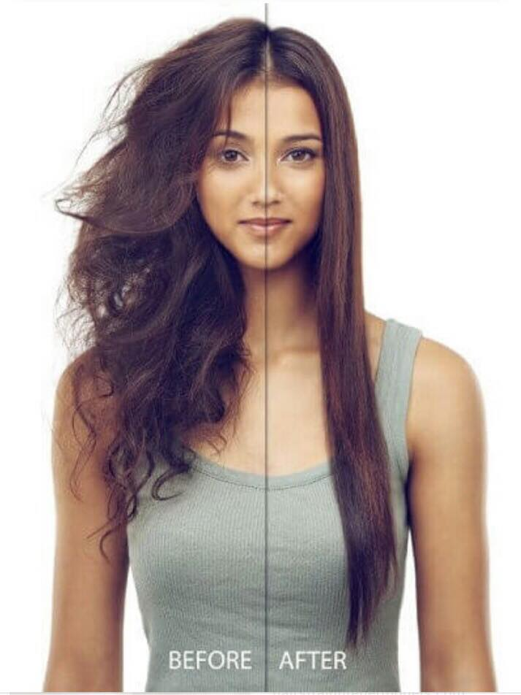 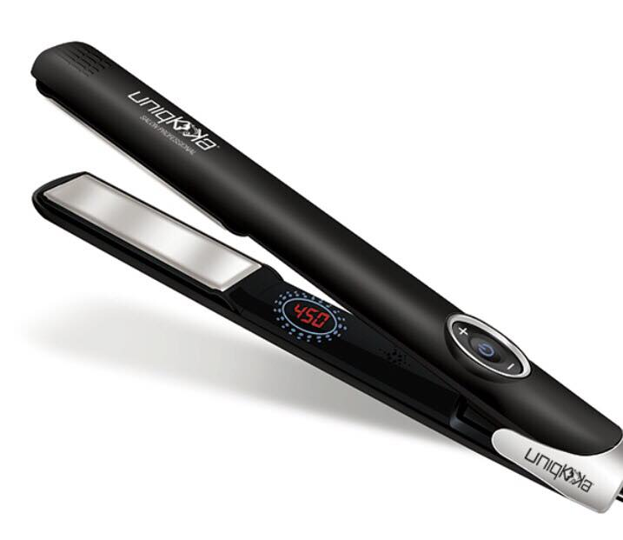

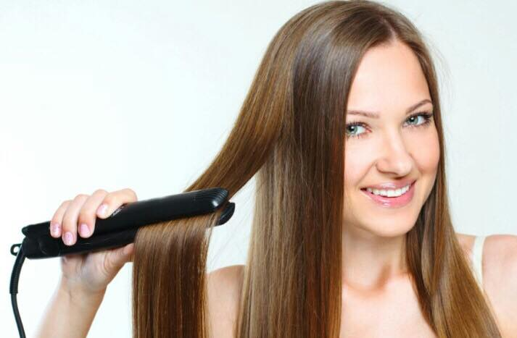

Curling Wands

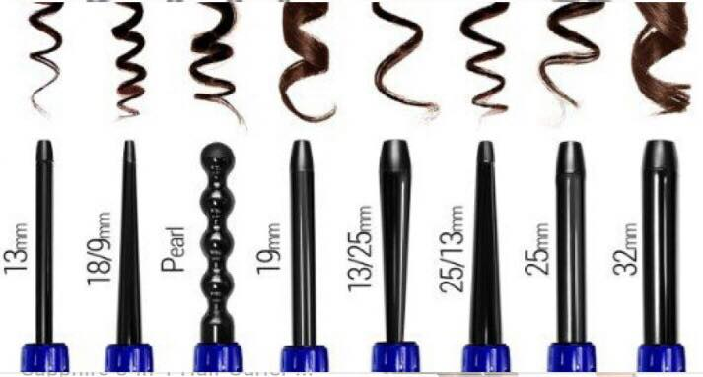

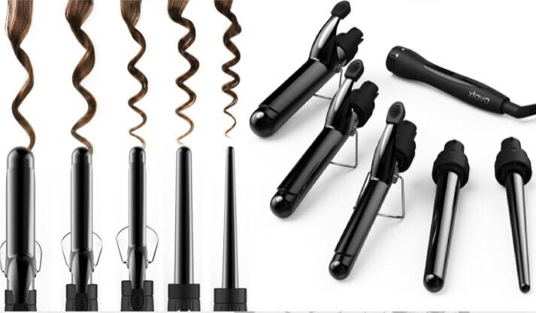

**2. Diffuser**

A diffuser is an attachment that goes on the end of your hairdryer.

It diffuses the air as it come out so that you no longer get a blast of air on your hair, but rather it spreads softly through your hair. Diffusers are mainly used to [style curly hair](https://www.hairromance.com/2012/11/how-to-style-curly-hair.html) as it lets your dry your curly quickly without disturbing their natural shape.

There are two main types of diffusers. The round plastic attachments, as shown in the photos, which are custom made for a particular hairdryer model or you can buy a [plastic universal diffuser](http://bit.ly/1VnL6Bu) that fits most hairdryers.

The other type of diffuser available is called a sock diffuser. This is made of a fine heat resistant mesh and fits like a loose sock on the end of your hairdryer nozzle. The sock diffuser is great for travelling as it is very small and easy to pack. (It also won’t freak out the guys as customs like my plastic diffuser does!) It’s also the only option for hairdryers that do not fit a universal diffuser, such as the ghd aura. The [ghd air](http://bit.ly/1OUITXH) now comes with a diffuser.

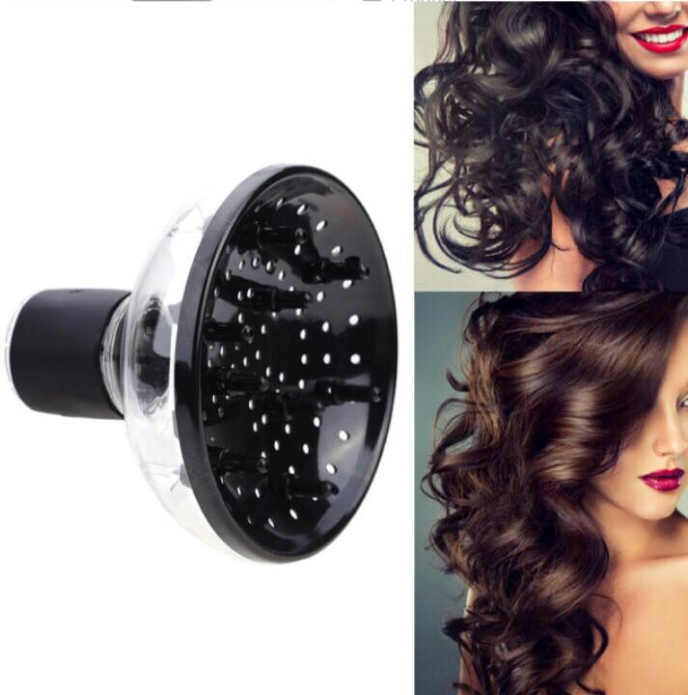 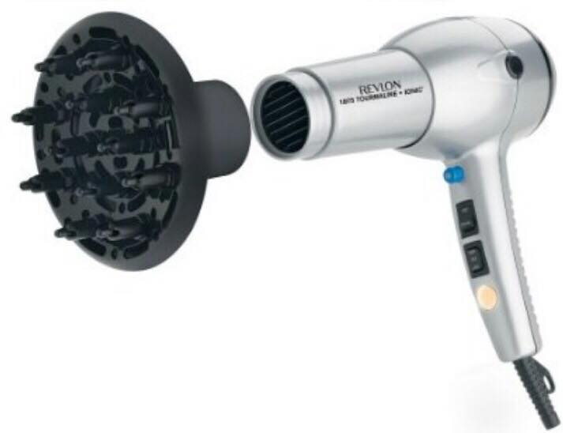

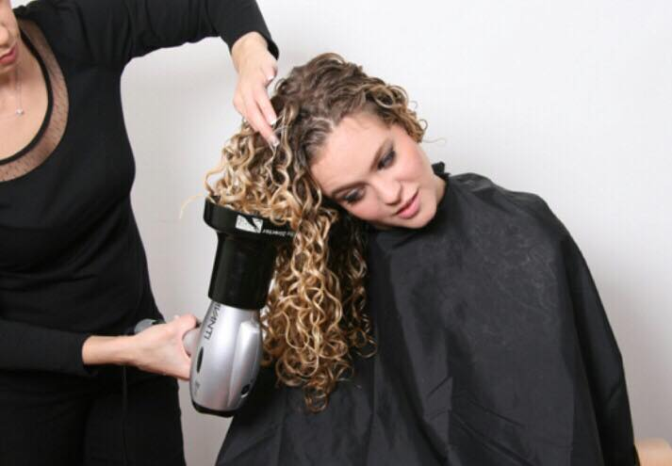

**3. Nozzle**

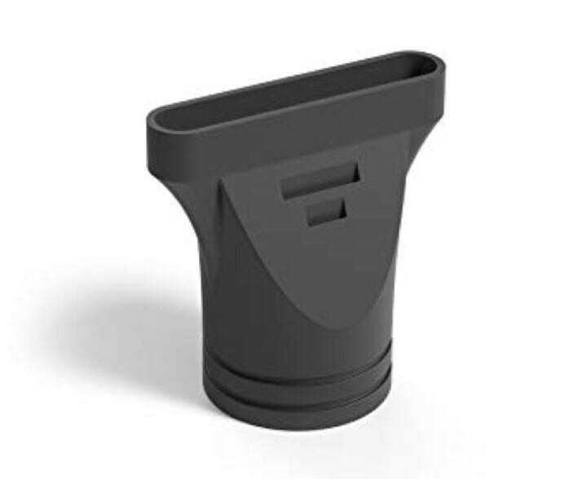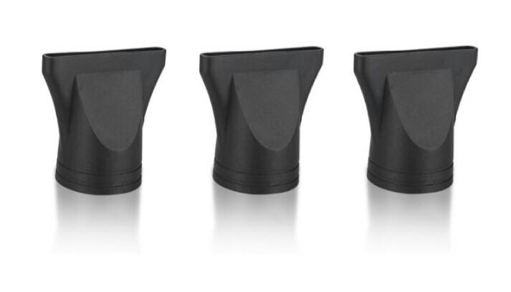

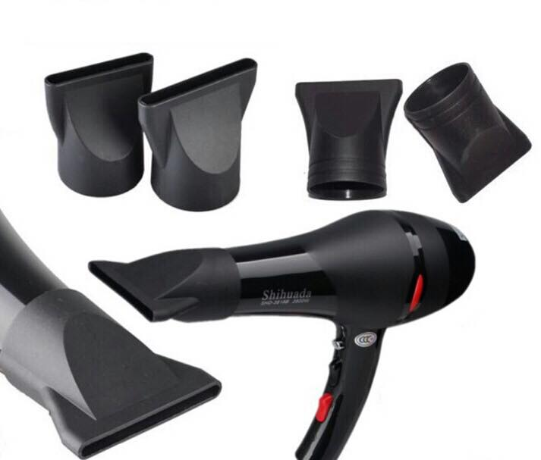

**4. Hair wigs & Hair buns**

A wig is a head covering made from [human hair](https://en.wikipedia.org/wiki/Human_hair), [animal hair](https://en.wikipedia.org/wiki/Animal_hair), or [synthetic fiber](https://en.wikipedia.org/wiki/Synthetic_fiber). The word wig is short for periwig., which makes its earliest known appearance in the English language in [William Shakespeare](https://en.wikipedia.org/wiki/William_Shakespeare)'s [The Two Gentlemen of Verona](https://en.wikipedia.org/wiki/The_Two_Gentlemen_of_Verona). Julia, disguised as the boy Sebastian, says "I'll get me such a coloured periwig." Some people wear wigs to disguise baldness; a wig may be used as a less intrusive and less expensive alternative to [medical therapies for restoring hair](https://en.wikipedia.org/wiki/Hair_restoration) or for religious reasons.

### Types of human hair wigs

There are two basic kinds of hair wigs: The traditional machine stitched weft wig and the hand tied [lace wig](https://en.wikipedia.org/wiki/Lace_wig). The machine stitched wigs are still the most widely worn wigs today. The hair is sewn on a stretch weft material and come with back straps for adjusting to various head sizes. These wigs are typically pre-styled and lack any kind of realistic expectations.

Lace wigs are quickly becoming one of the most sought-after wigs among wig wearers. The illusion of hair growing from the scalp is the feature that makes this wig the best of the best when it comes to wearing fake hair. These wigs are made with a French or Swiss lace material base. They are made as a full lace or partial lace front with a stretch weft back. Each hair strand is individually stitched into a lace material which creates the natural look of hair at the base. This is where the term "hand tied" originates.

Hair type is the distinguishing factor in human hair wigs. Four main types of hair are used in manufacturing: Chinese or "Malaysian", Indian, Indonesian or "Brazilian", and Caucasian or "European". The majority of human hair wigs are made of Chinese or Indian hair, while European hair is considered the most expensive and rare, as most donors are from Russia or Northern Europe, where there is a smaller portion of hair donors to the market.

Remy human hair is considered to be the best quality of human hair because the cuticles are kept intact and not stripped away. The preserved cuticles are also aligned in a unidirectional manner, which decreases tangling and matting. It has been carefully separated after collecting from the hair donor to ensure all the cuticles are of the same length.

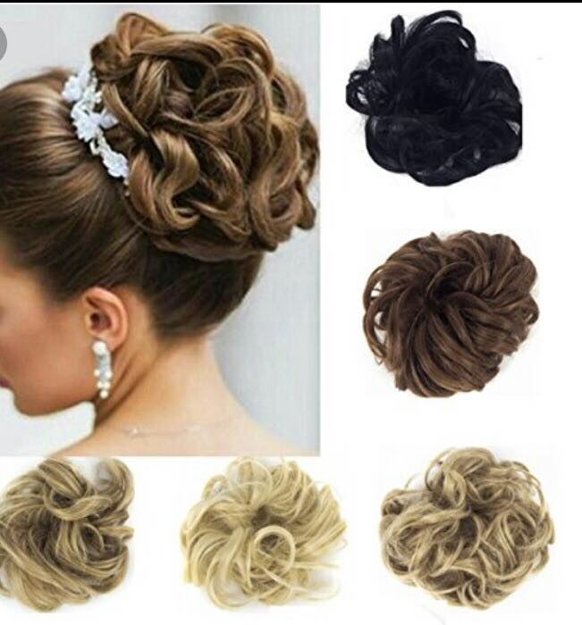 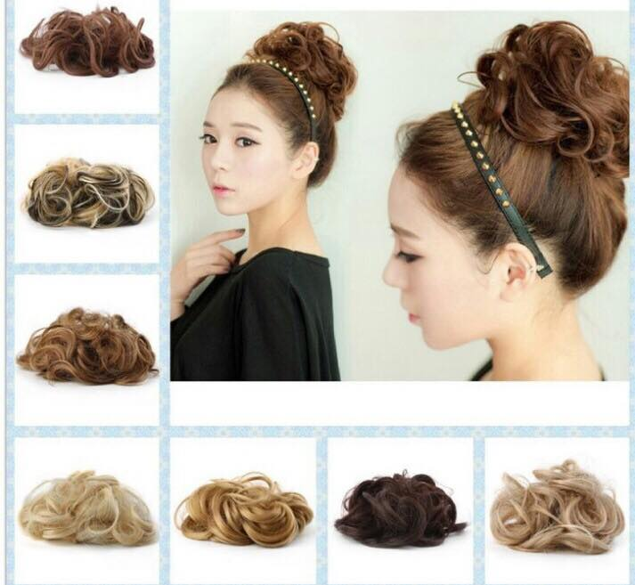

**Hair buns**

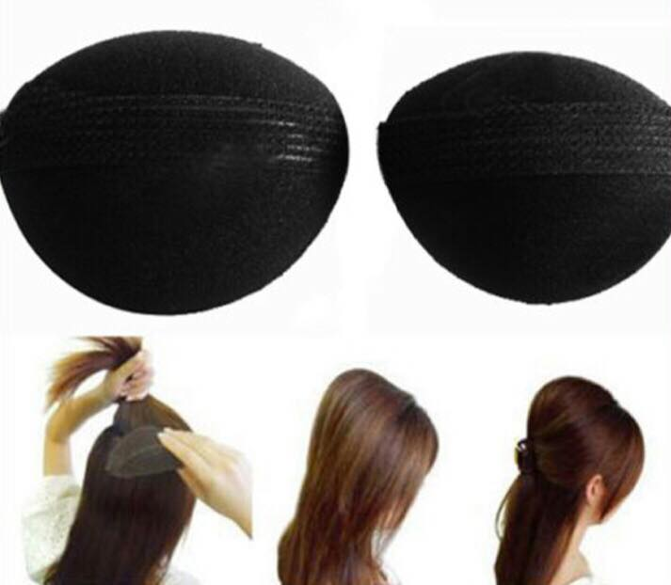 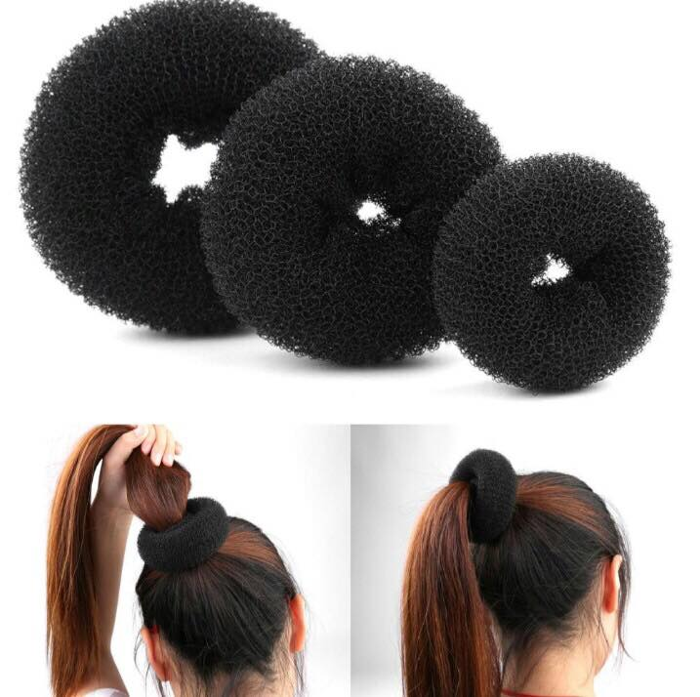

**5. Bobby pin**

A bobby pin (also known as a kirby grip or hair grip in the United Kingdom) is a type of [hairpin](https://en.wikipedia.org/wiki/Hairpin), usually of metal or plastic, used in [coiffure](https://en.wikipedia.org/wiki/Hairstyle) to hold hair in place. It is a small double-pronged hair [pin](https://en.wikipedia.org/wiki/Pin) or clip that slides into hair with the prongs open and then the flexible prongs close over the hair to hold it in place. They are typically plain and unobtrusively colored, but some are elaborately decorated or jeweled. Bobby pins became popular in the 1920s to hold the new [bobbed](https://en.wikipedia.org/wiki/Bob_cut) [hairstyles](https://en.wikipedia.org/wiki/Hairstyle).

## Uses

The main use of a bobby pin is to hold hair in place. In addition to bobbed hair, bobby pins are often used in up-dos, buns, and other hair styles where a sleek look is desired. To use a bobby pin in hair hold the hair in the desired position and push the bobby pin (straight side up) into place.

Bobby pins can also be used to hold head coverings such as [headbands](https://en.wikipedia.org/wiki/Headband), [bandannas](https://en.wikipedia.org/wiki/Bandanna), and [yarmulkes](https://en.wikipedia.org/wiki/Yarmulke) in place.

They can be used as decorative elements in hair.

Attributes such as the clipping action or the having a readily available thin, flat piece of metal mean the bobby pin can be used in other ways as well.

* As makeshift [lockpicks](https://en.wikipedia.org/wiki/Lock_picking) by straightening out two bobby pins to pick the lock.
* They can be used in place of a [clothespin](https://en.wikipedia.org/wiki/Clothespin) for drying lightweight articles.
* They can be used as clips to hold multi-portion packages closed between uses.
* They can be slipped over book pages as a bookmark.
* Bobby pins are sometimes employed to protect the fingers from burns while smoking the final portion of a marijuana cigarette. In such use, the bobby pin is known colloquially as a "roach clip."
* Bobby pins may be used to thread laces through pre-cut holes in leather and other heavy materials.

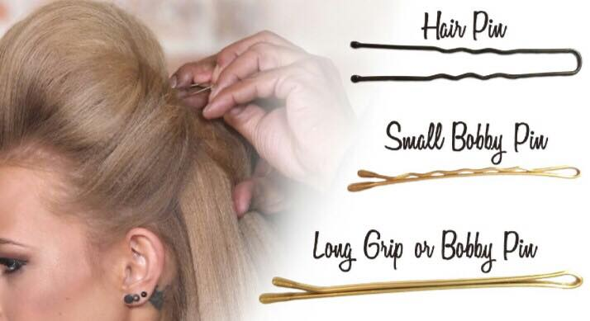

## Appearance

Like [barrettes](https://en.wikipedia.org/wiki/Barrettes), decorated bobby pins are sometimes meant to be noticed in hair. A decorated bobby pin can have beads, ribbons or other details on it, and is usually worn to pull back front sections of hair while looking decorative.

Bobby pins may also be tinted a hair colour, such as blonde, brown, or red to blend better into the hair.

Some are made without the wavy rigid side and instead are smooth and curved. They are made this way to help with the grip factor and they stay closer and more tightly attached to the hair that it is pinned to.

Bobby pins may also be padded in order to avoid creasing the hair.

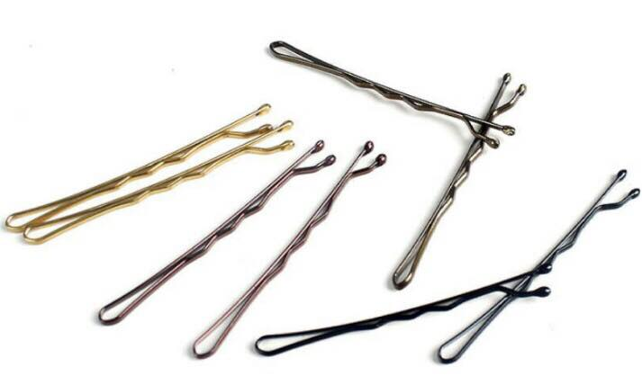 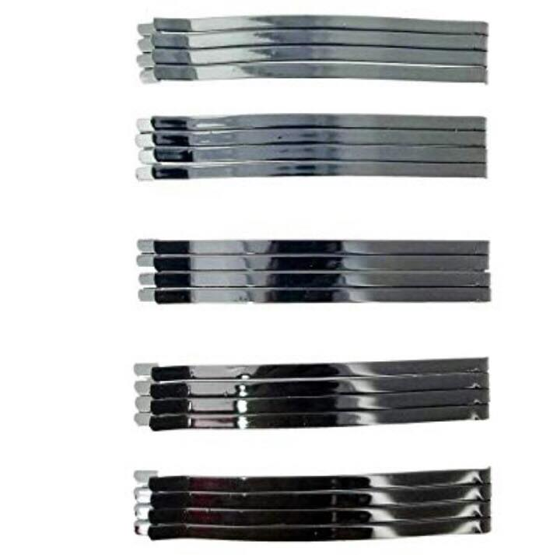

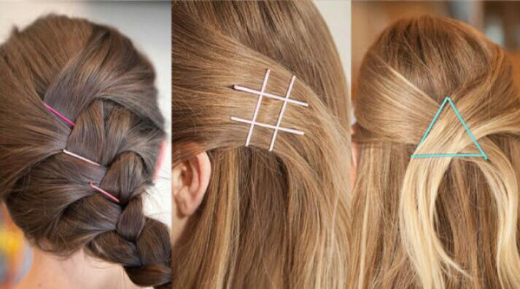

**Hair long pins**

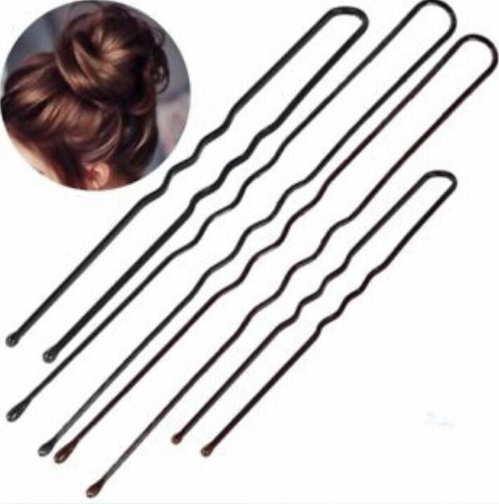 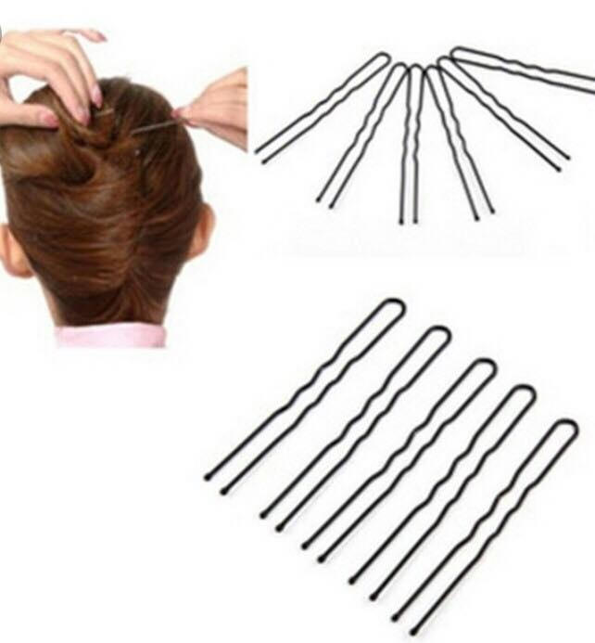

**Invisible hair pins**

These pins are the finest we have ever used. Their delicate structure allows them to be hidden within the hair making them perfect for holding very fine details or to keep in place a hair style that has already been secured or set. The quality of this pin lies in its delicacy not its strength

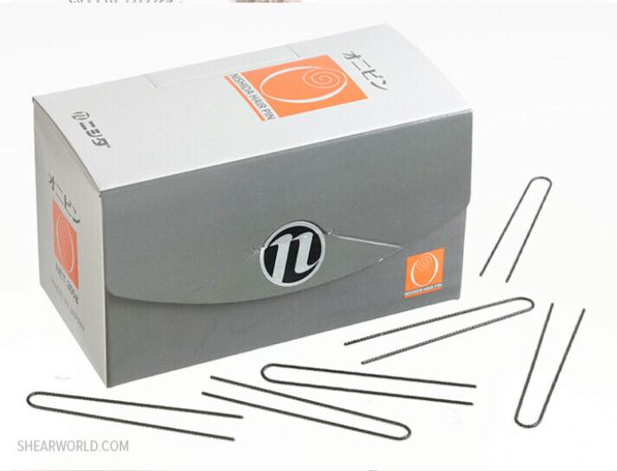 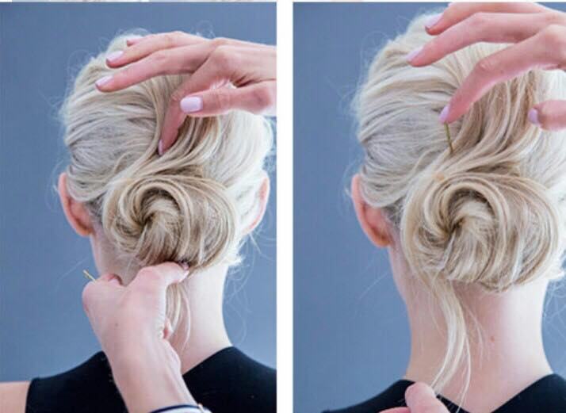

**6. Scissors**

Scissors are hand-operated shearing tools. A pair of scissors consists of a pair of [metal](https://en.wikipedia.org/wiki/Metal) [blades](https://en.wikipedia.org/wiki/Blade) pivoted so that the sharpened edges slide against each other when the handles (bows) opposite to the pivot are closed. Scissors are used for cutting various thin materials, such as [paper](https://en.wikipedia.org/wiki/Paper), [cardboard](https://en.wikipedia.org/wiki/Paperboard), [metal foil](https://en.wikipedia.org/wiki/Metal_leaf), [cloth](https://en.wikipedia.org/wiki/Cloth), [rope](https://en.wikipedia.org/wiki/Rope), and [wire](https://en.wikipedia.org/wiki/Wire). A large variety of scissors and shears all exist for specialized purposes. [Hair-cutting shears](https://en.wikipedia.org/wiki/Hair-cutting_shears) and [kitchen shears](https://en.wikipedia.org/wiki/Kitchen_shears) are functionally equivalent to scissors, but the larger implements tend to be called [shears](https://en.wikipedia.org/wiki/Shears_(disambiguation)#Cutting_devices). Hair-cutting shears have specific blade angles ideal for cutting [hair](https://en.wikipedia.org/wiki/Hair). Using the incorrect scissors to cut hair will result in increased damage or split ends, or both, by breaking the hair. Kitchen shears, also known as kitchen scissors, are intended for cutting and trimming foods such as meats.

Modern scissors are often designed [ergonomically](https://en.wikipedia.org/wiki/Ergonomically) with composite [thermoplastic](https://en.wikipedia.org/wiki/Thermoplastic) and [rubber](https://en.wikipedia.org/wiki/Rubber) [handles](https://en.wikipedia.org/wiki/Handle_(grip)) which enable the user to exert either a power grip or a precision grip.

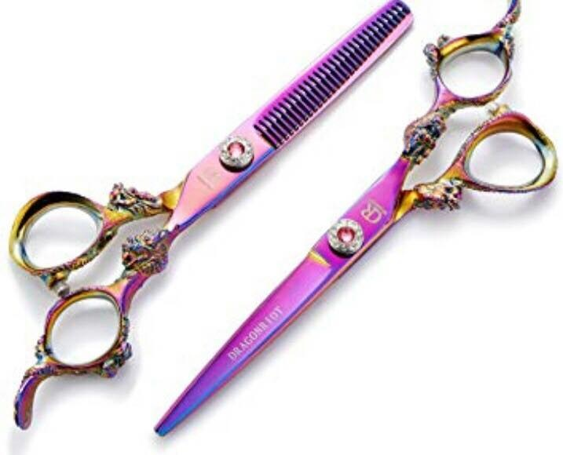 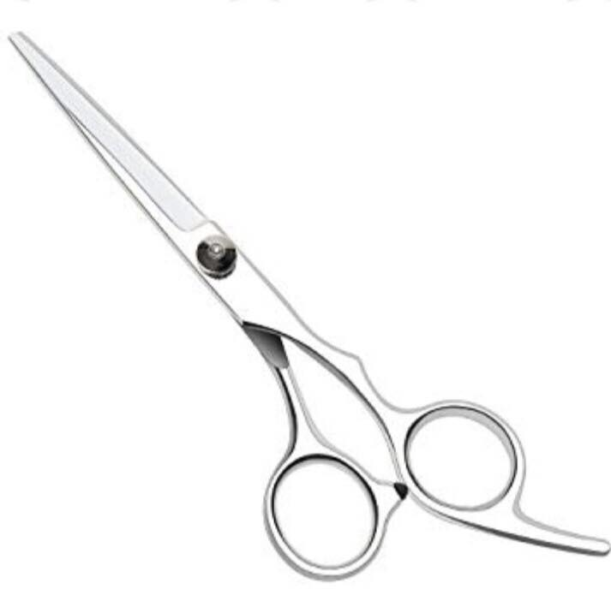

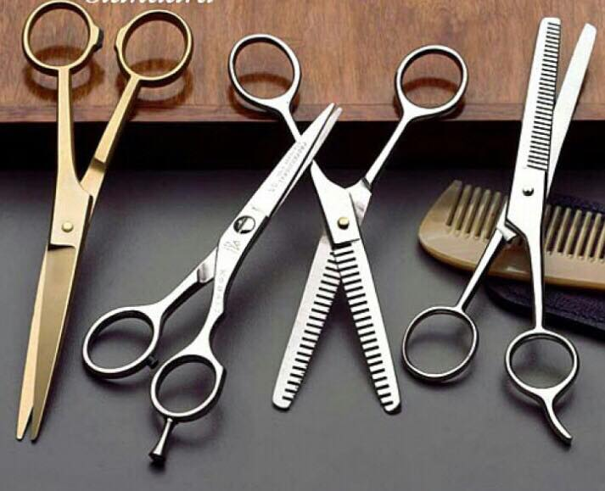

**7. Section clips**

• These sectioning clips are like the ones professional stylists use for sectioning hair during haircuts

• Also great to use when straightening hair by sections

• Professional strength grip holds hair securely in place

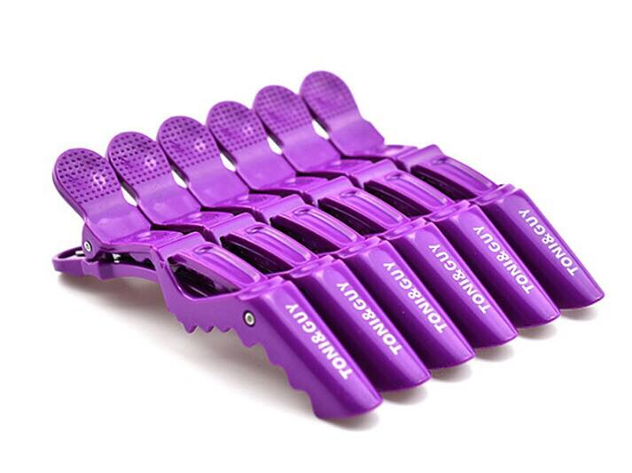

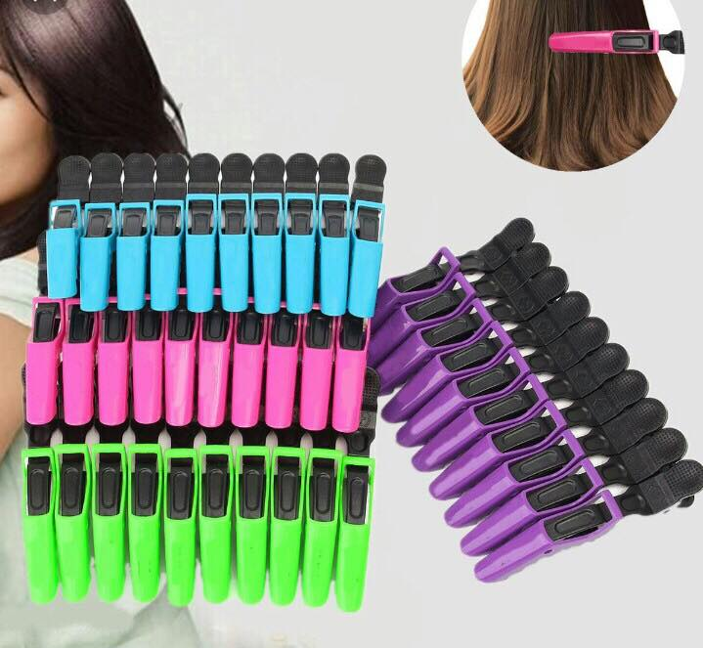

**8. Hair net**

A hairnet, or sometimes simply a net or caul, is a small, often elasticised, fine net worn over long hair to hold it in place. It is worn to keep hair contained. A snood is similar but a looser fit and with a much coarser mesh and noticeably thicker yarn.

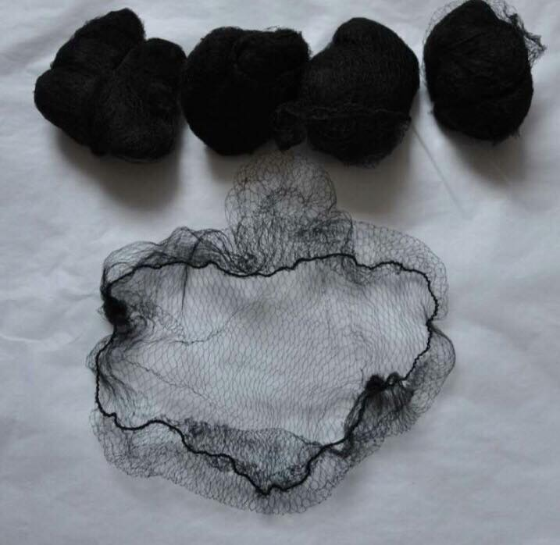 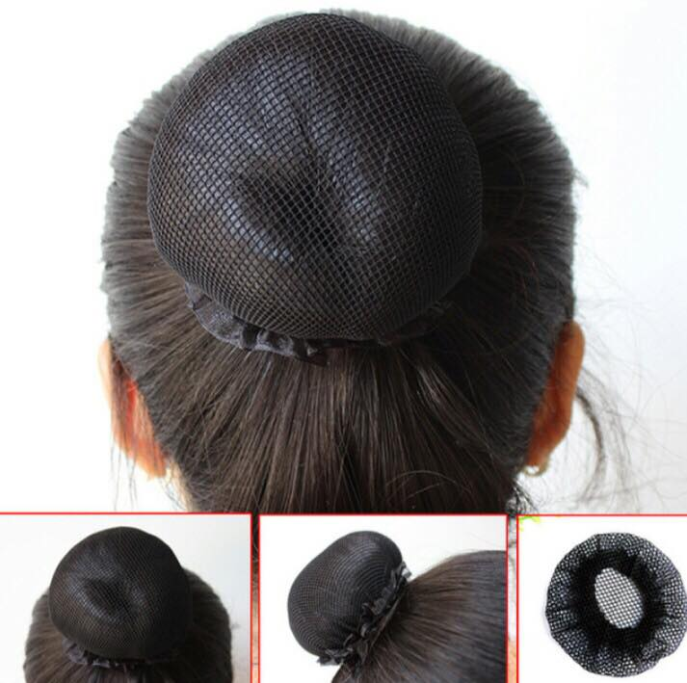 \

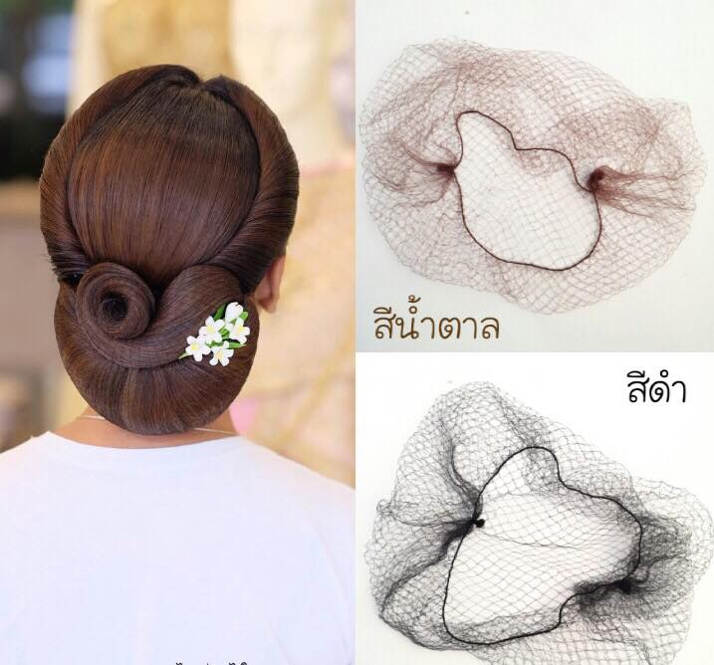 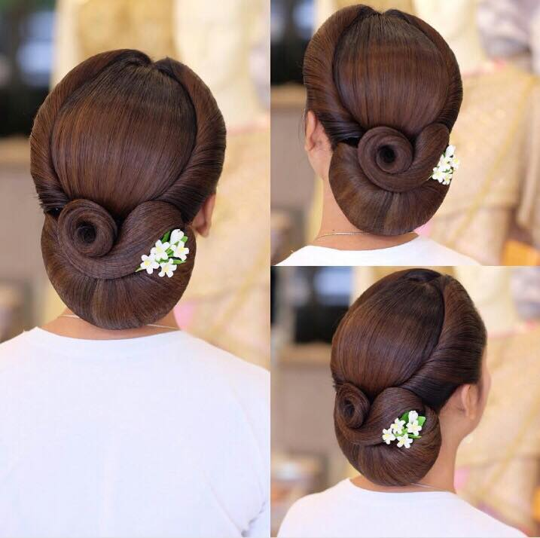

**9. Decorative items**

* **Oval Face**

If your face shape is oval, consider it a blessing! All hair accessories look good on this face shape.

* **Round Face**

If you have a round face, then you need to make sure the hair accessory you pick will not make your face appear rounder. The key is to add length to your face. Also, allow a few strands of hair to fall on your face as it will help in face framing.

* **Heart Face**

If you have a heart-shaped face, then try hair comb pins or simple hairpins on one side of your head. This accessory will frame your face nicely as one side of your hair will be left loose. When using hairbands, add height to your hair at the top or leave a few strands loose rather than pushing your hair back entirely.

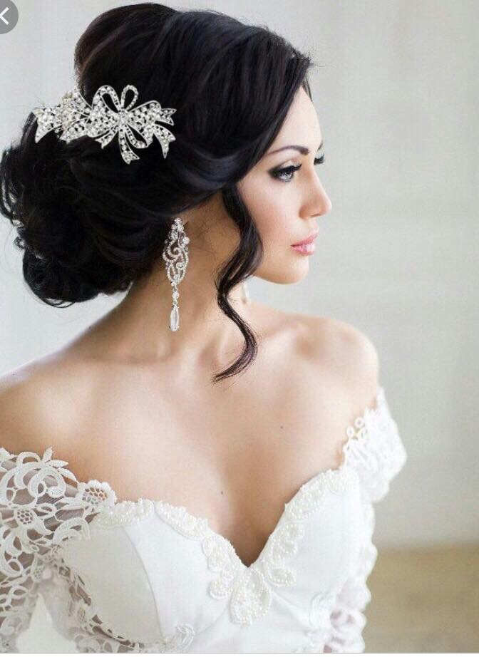 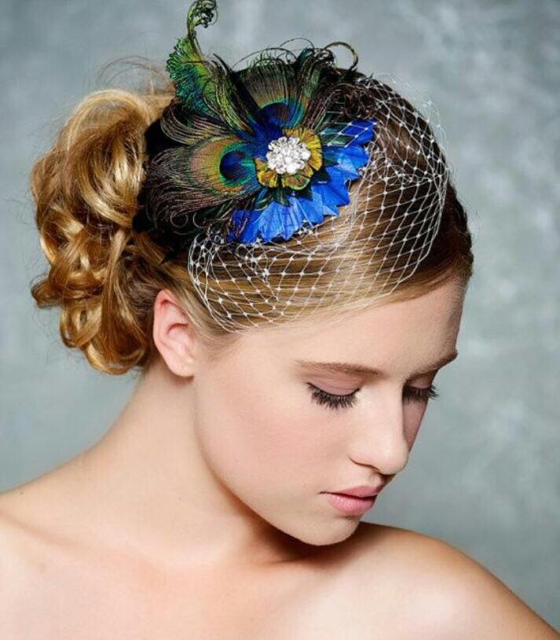

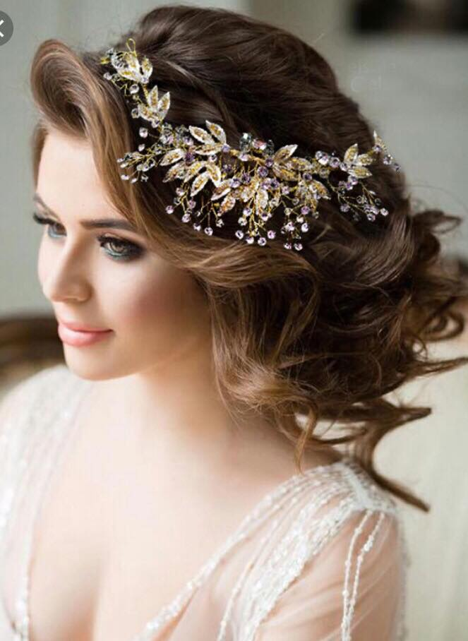 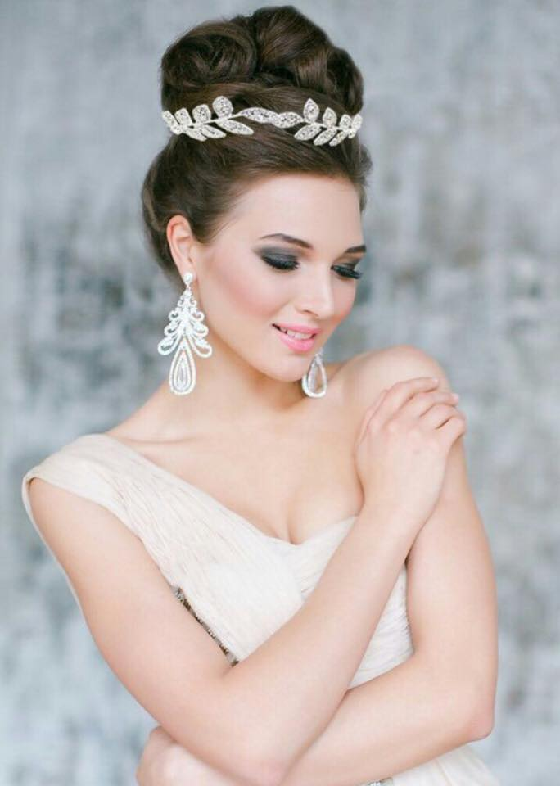

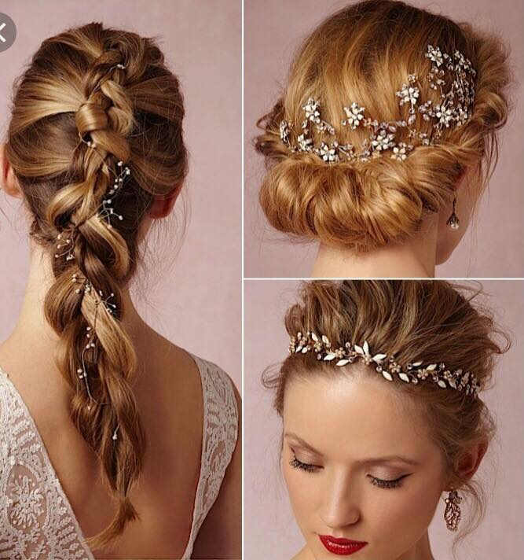

**10. Hairbrush**

A hairbrush is a stick [brush](https://en.wikipedia.org/wiki/Brush) with rigid or soft [bristles](https://en.wikipedia.org/wiki/Bristle) used in [hair care](https://en.wikipedia.org/wiki/Hair_care) for smoothing, styling, and detangling human [hair](https://en.wikipedia.org/wiki/Hair), or for grooming an animal's fur. It can also be used for styling in combination with a [curling iron](https://en.wikipedia.org/wiki/Curling_iron) or [hair dryer](https://en.wikipedia.org/wiki/Hair_dryer).

## Human use

A flat brush is normally used for detangling hair, for example after sleep or showering. A round brush can be used for styling and curling hair, especially by a professional [stylist](https://en.wikipedia.org/wiki/Hairdresser), often with a [hair dryer](https://en.wikipedia.org/wiki/Hair_dryer). A paddle brush is used to [straighten hair](https://en.wikipedia.org/wiki/Straighten_hair) and tame fly-aways. For babies with fine, soft hair, many bristle materials are not suitable due to the hardness; some synthetic materials and [horse](https://en.wikipedia.org/wiki/Horse)/[goat](https://en.wikipedia.org/wiki/Goat) hair bristles are used instead.

**Denman brush (flat brush)**

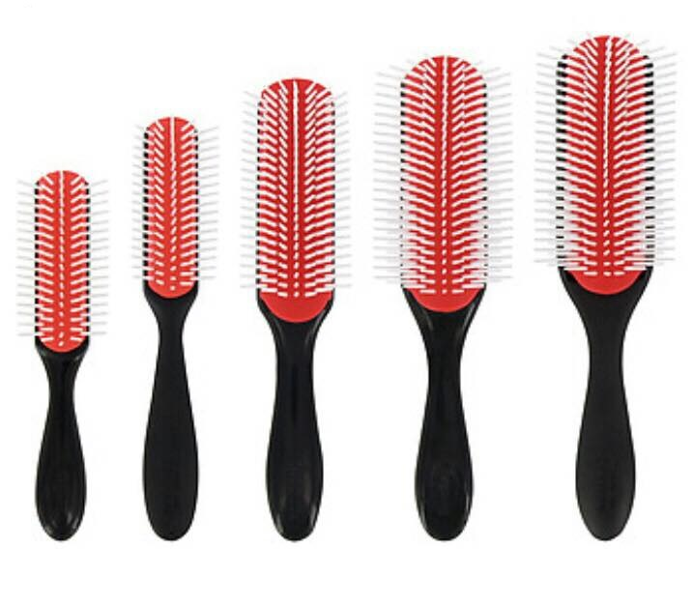 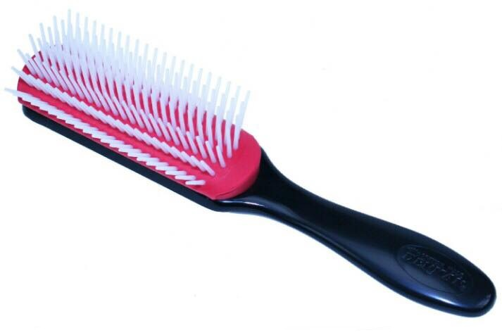

**Dressing out brush**

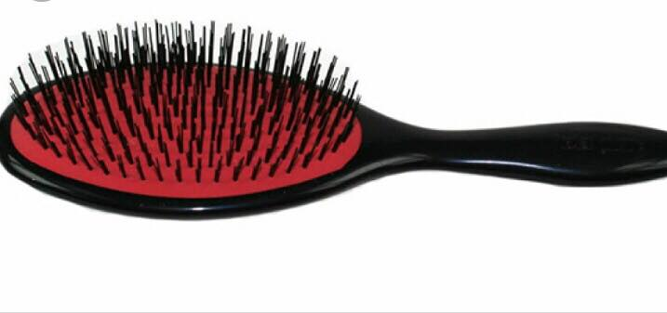 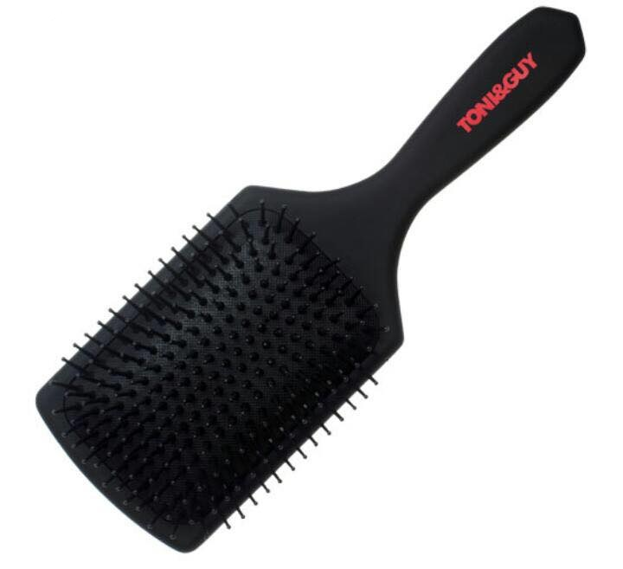

**Radial brush (small, medium, large)**

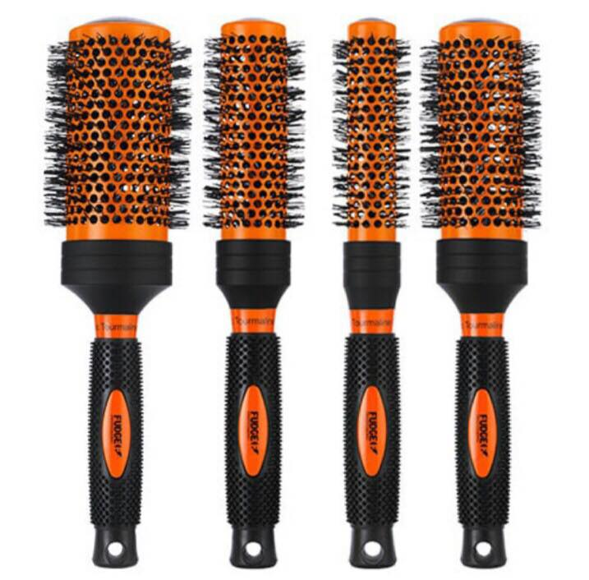 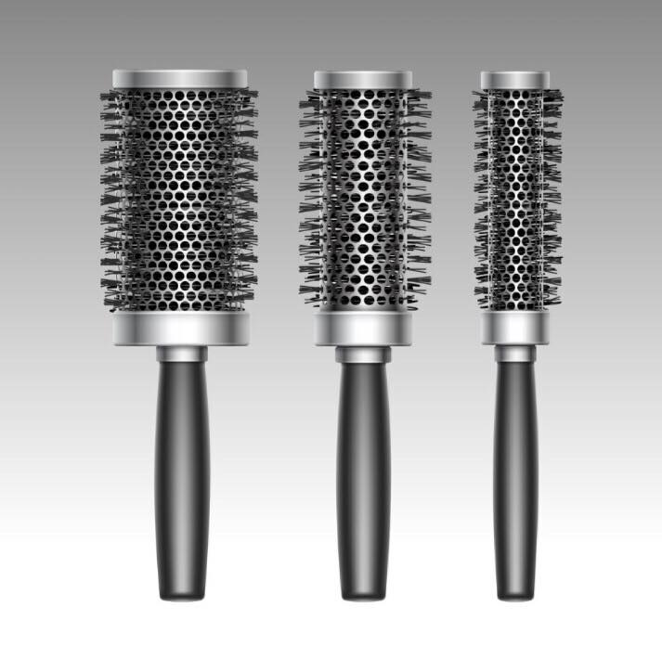

**11. Combs**

## ****Wide Tooth Comb****

A ‘wide tooth comb’ specifically refers to the large spacing between the teeth of a comb. Some people mistake the term for the teeth of the comb in particular being wide but that’s not the case although many wide tooth combs do have teeth that are bigger in size as well.

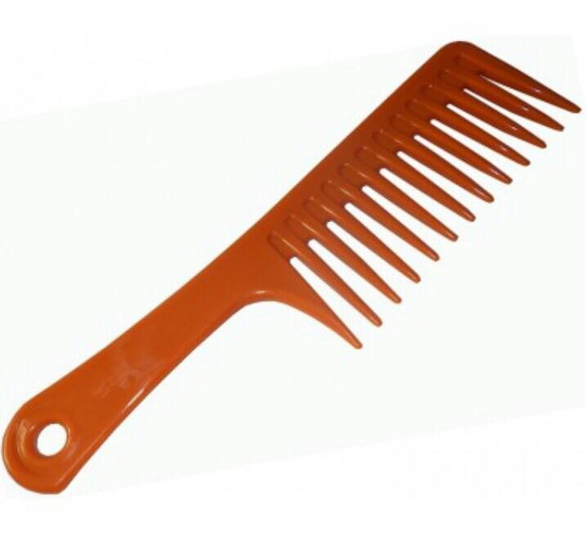 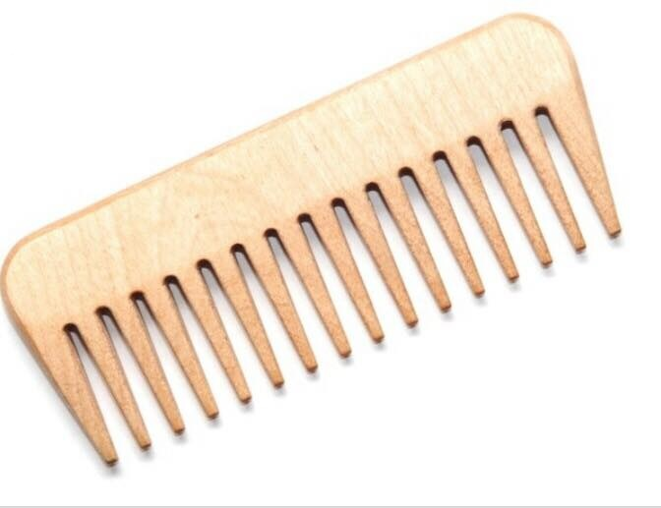

**Tail comb**

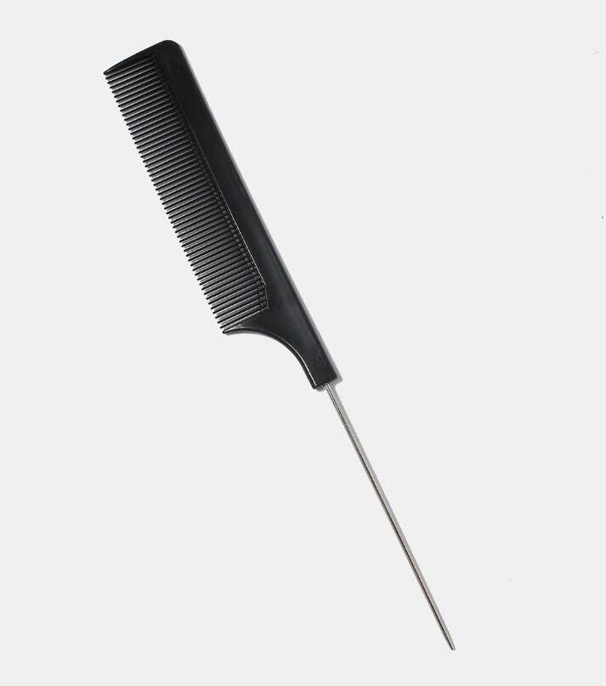 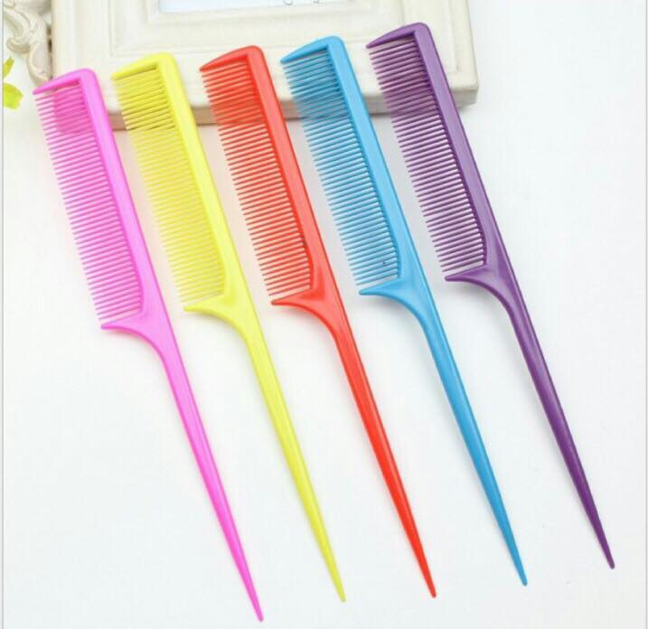

**12. Afro Comb**

The black fist Afro comb is an evocative symbol of the second half of the twentieth century. Coming into production at some point in the 1970s, the comb’s marriage of object and iconography was a perfect one. With its reference to the Black Power movement, and its historical links to the re-emergence of the popularity of the wider-toothed hair pick in the USA to serve the Afro hairstyle, , the comb has become more than simply representative of an era and a political affiliation. It also symbolises Black pride and identity.

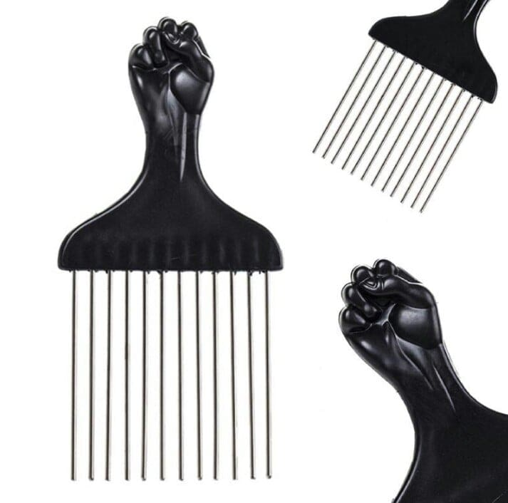 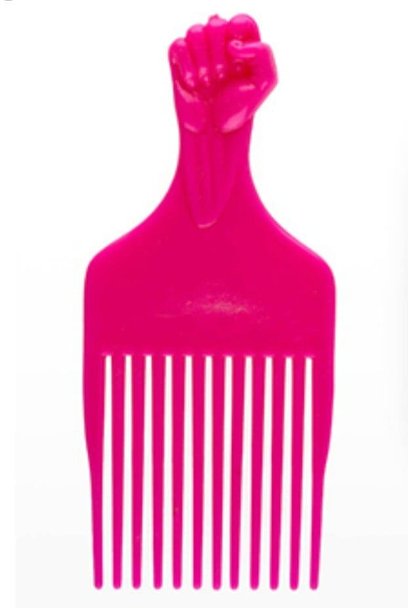

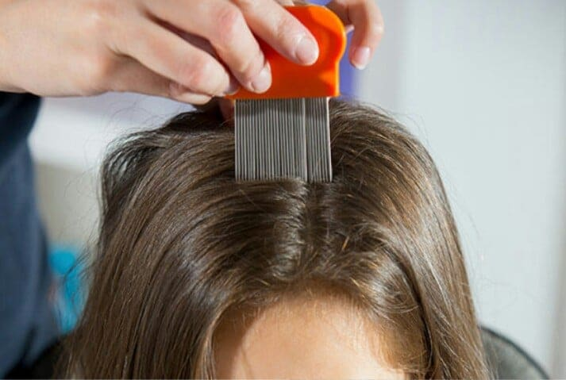

**Hair Styling Products**

**1. Hair gel**

Hair gel is a hairstyle product that is used to stiffen hair into a particular hairstyle. The end result is similar to, but stronger than, those of hair spray and hair wax. Hair gel is most commonly used in the hairstyling of men, but it is not gender specific. Hair gel can come in tubes, pots, small bags, or even in a spray form.

## History

Analysis of [ancient Egyptian](https://en.wikipedia.org/wiki/Ancient_Egypt) mummies has shown that they styled their hair using a [fat](https://en.wikipedia.org/wiki/Fat)-based [gel](https://en.wikipedia.org/wiki/Gel). The researchers behind the analysis say that the Egyptians used the product to ensure that their style stayed in place in both life and death. Natalie McCreesh, an archaeological scientist from the KNH Centre for Biomedical Egyptology at the [University of Manchester](https://en.wikipedia.org/wiki/University_of_Manchester), England, and her colleagues studied hair samples taken from 18 mummies. The oldest is approximately 3,500 years old, but most were excavated from a cemetery in the Dakhleh Oasis in the [Western Desert](https://en.wikipedia.org/wiki/Libyan_Desert) and date from [Greco-Roman](https://en.wikipedia.org/wiki/Greco-Roman) times, around 2,300 years ago.

The Irish [bog body](https://en.wikipedia.org/wiki/Bog_body) [Clonycavan Man](https://en.wikipedia.org/wiki/Clonycavan_Man), which has been [radiocarbon dated](https://en.wikipedia.org/wiki/Radiocarbon_dating) to between 392 BC and 201 BC, was found to have been using a hair gel made from pine tree resin imported from Spain or South-west France.

In 1914, in a small pharmacy located in the heart of Buenos Aires, Argentina (Florida at 600), veterinary student José Antonio Brancato created the first fixative for hair, which would carry the name gomina as a registered trademark. For this, he mixed gum Arabic, Persian tragacanth and different essences. Soon the word "gomina" became synonymous with fixative. A fixative that displaced the soaps and oils used for this purpose

In 1929, the British company Chemico Works invented [Brylcreem](https://en.wikipedia.org/wiki/Brylcreem), which became the market leader among hair styling products in both the U.K. and the U.S. during the following decades.

In the 1960s, modern hair gel was invented in the United States, by what would later be renamed the Dep Corporation. Marketed under the brand name Dep, modern hair gel was given this name by its inventor, Luis Montoya, in recognition of the substance that gave it its unique, non-greasy consistency: [diethyl phthalate](https://en.wikipedia.org/wiki/Diethyl_phthalate), commonly abbreviated as DEP

## Hair Gel Tips: The Effects of Hair Gels and other Styling Aids

* Fat-containing products such as waxes or pomade work well if you want great shine and a soft sleek look
* Alcohol-containing products such as gel or styling crème provide rigidity and volume
* Gel waxes are mixed products as the name indicates. They support a well-defined hair structure and provide light hold and a trace of shine.

When using any styling aid remember to start out by rubbing a very small amount of it between your fingers and working it into your hair beginning at the lower hair portion near the roots. Only then should you use the product to style individual strands of hair on top of your head. In case you want to create a very smooth and straight look, part your hair and comb it all back. Distribute a little wax in the palms of your hands before softly stroking over your hair several times.

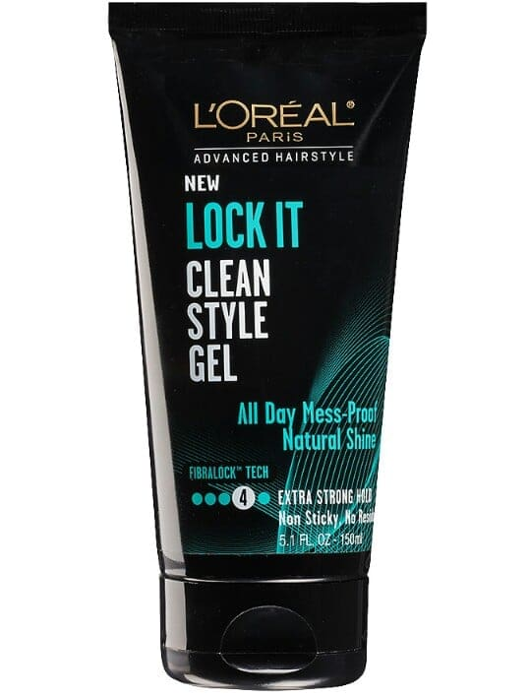 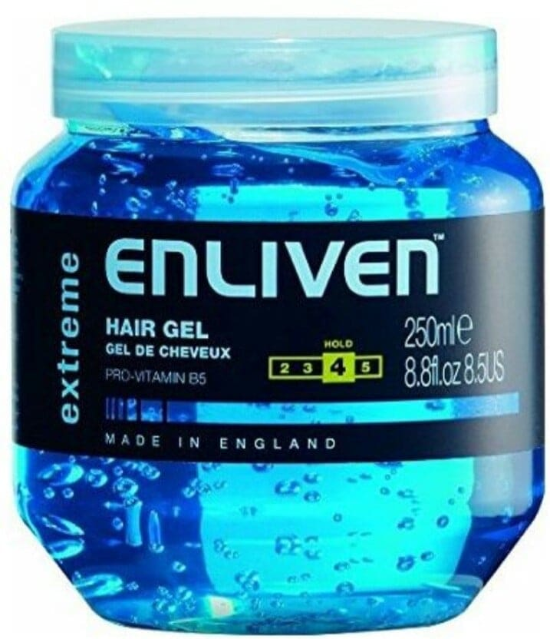

**Types of hair gel**

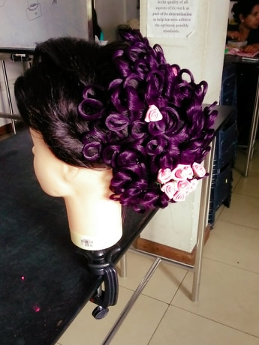 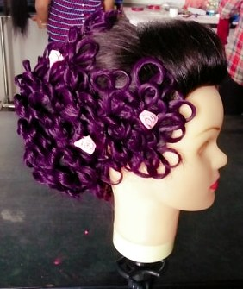

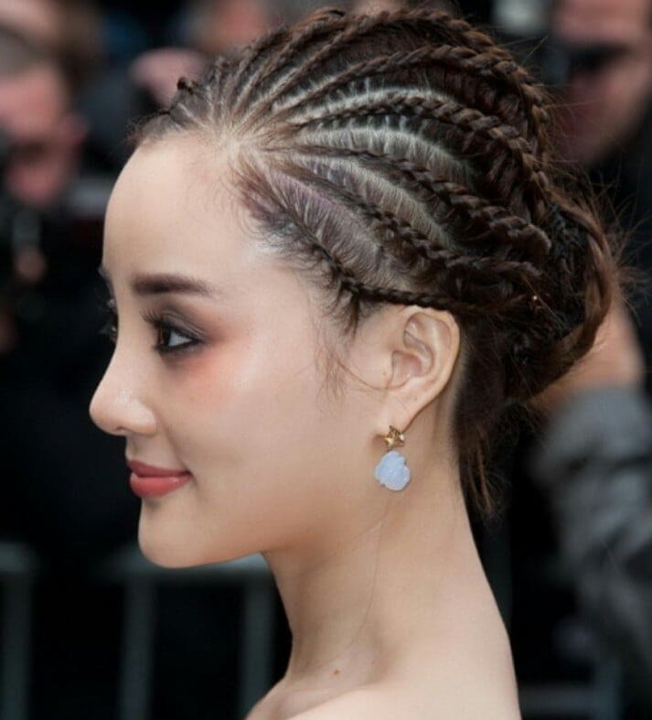 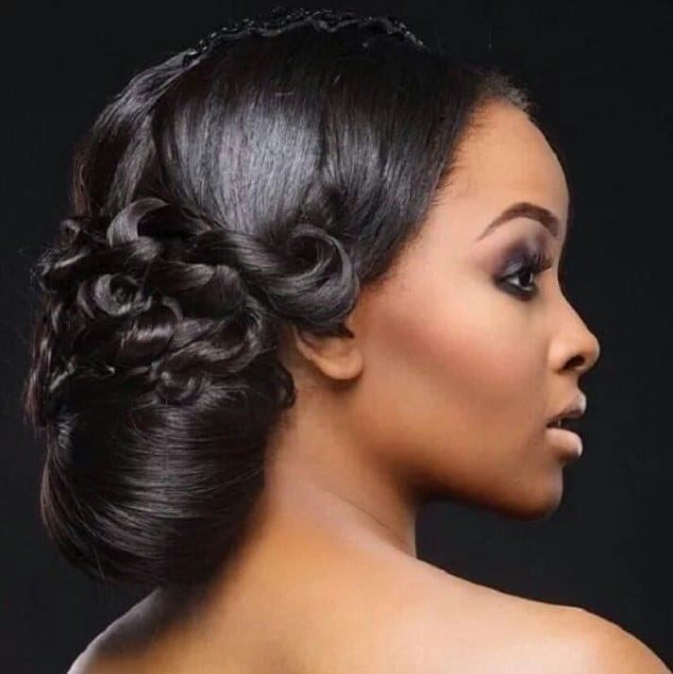

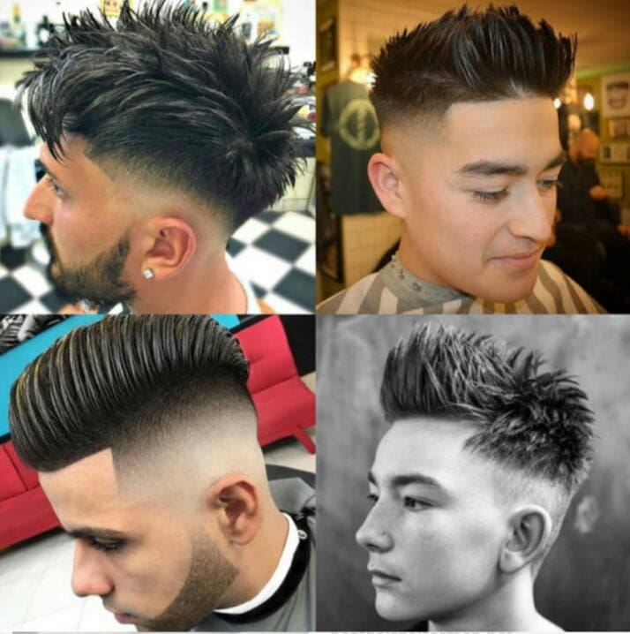

**2.Hair wax**

Hair wax is a styling product with extraordinary capabilities. Aside from conditioning hair, wax enhances hair volume, shine, structure and texture. This is a formidable list of benefits from the use of clear wax. Find out when and how to use hair wax as the ideal all-in-one styling aid.

Wax used for hair styling is a solid substance with qualities similar to hair gel. Thanks to the waxy nature, the styling aid does not stiffen hair. All through the day, your hair will remain bouncy and pliable. This is a definite plus for all who like to keep their hair soft, flexible and touchable.  
  
The conditioning effects of hair wax provide damaged hair with new shine, prevent hair from drying out and reduce hair breakage.  
  
Hair wax with different strength and hold is available for individual hairstyles.

## How to Style Hair with Hair Wax

Styling wax works well even if applied by styling novices. Wax may be applied to dry or wet hair, so wax hairstyles are easy to achieve.  
  
Distribute the styling wax across the palms of your hands. The wax will melt due to your body temperature. The best way to use hair wax is in its melted state, since it can be evenly worked through your hair. Now the hair can be styled as desired.  
  
**The Proper Amount of Wax**: Avoid applying too much wax for your hair styling. Otherwise, your hair may look stringy and greasy. About a pea-sized amount of wax is enough for medium-length hair.  
  
**Layered Haircuts:** Apply the wax to your hair ends only by twirling the hair ends between your fingertips. This will give your wax hairstyle a lively look.  
  
**Creating Structured, Flexible Curls:** Both natural and styled [curls](http://www.schwarzkopf.com/en/hair-styling/how-to-curl-hair-hairstyles/using-curling-iron-to-create-curls.html) are springier and hold the style longer after application of hair wax. Simply work the wax into the ends of your hair. **Providing Volume for Fine Hair:** Work trace amounts of styling wax into the hair next to the roots. Then finish your hair wax style using a blow-dryer with diffuser attachment.  
  
**Out-of-Bed Hairstyles:** Distribute styling wax through your hair before tousling it for the undone look. For the final touch, you may like to accentuate strands of hair by twirling the ends of individual strands between your fingers.  
  
Alternate hair wax styling tip: Wax is also ideally suited for shaping eyebrows.  
  
Removal of Styling Wax:  Hair wax cannot be brushed out of the hair.correctly with shampoo to remove it.

## Ingredients

The following are some of the ingredients typically found in commercial hair wax products.

* [Beeswax](https://en.wikipedia.org/wiki/Beeswax)
* [Candelilla wax](https://en.wikipedia.org/wiki/Candelilla_wax)
* [Carnauba wax](https://en.wikipedia.org/wiki/Carnauba_wax)
* [Castor wax](https://en.wikipedia.org/wiki/Castor_wax)
* [Emulsifying wax](https://en.wikipedia.org/wiki/Emulsifying_wax)
* [Japan wax](https://en.wikipedia.org/wiki/Japan_wax)
* [Lanolin](https://en.wikipedia.org/wiki/Lanolin)
* [Ozokerite](https://en.wikipedia.org/wiki/Ozokerite)

Some stylists prefer making their own blends of hair wax customized for their clientele. Various recipes exist, including some with "secret" ingredients.

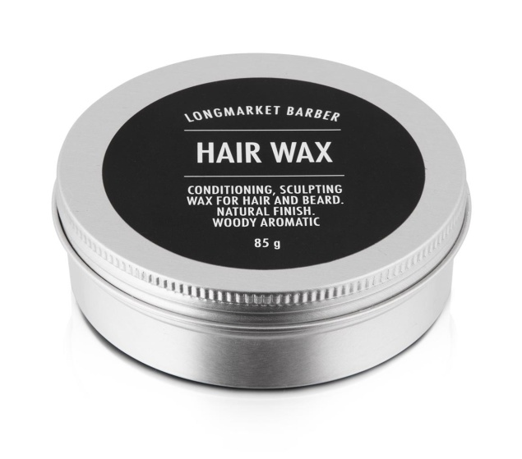 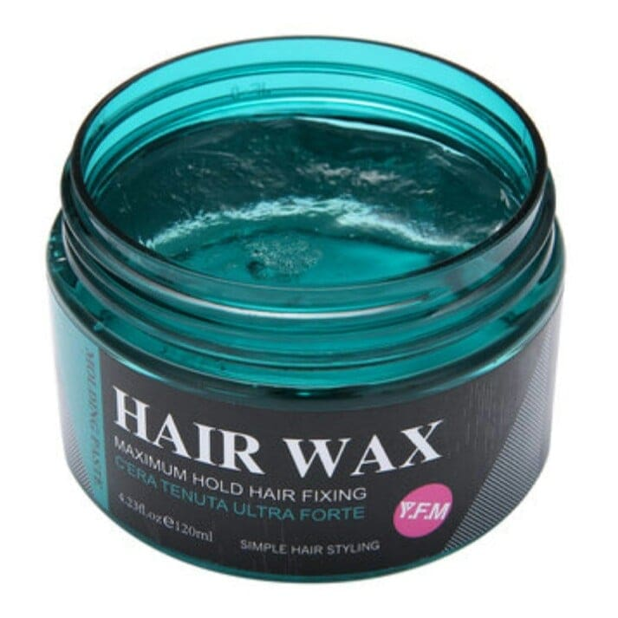

**Types of hair wax**

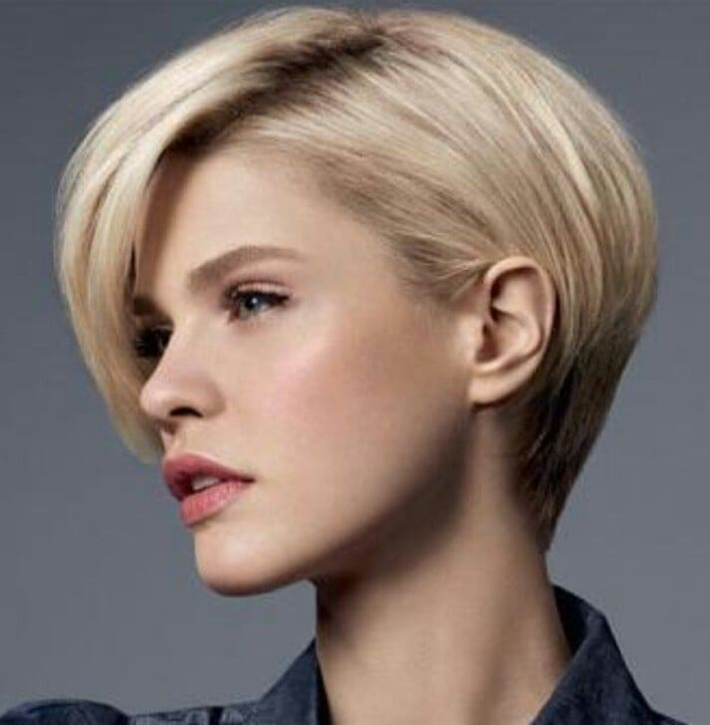 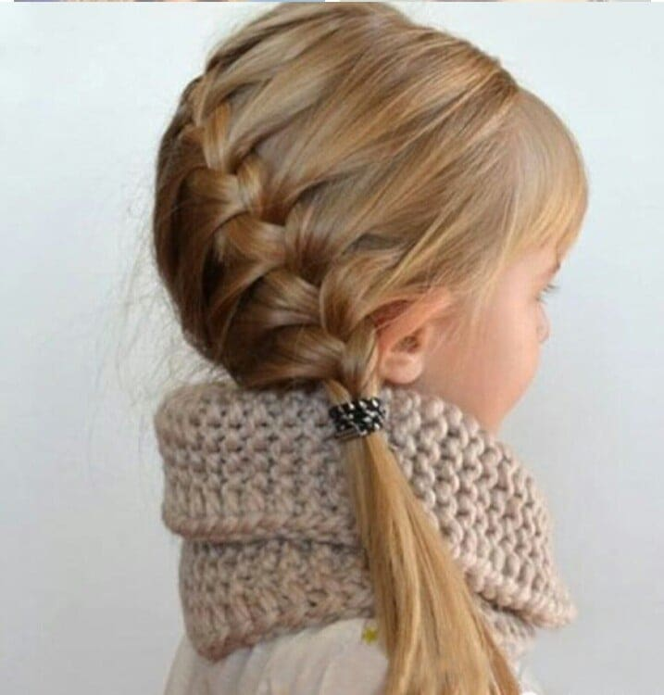

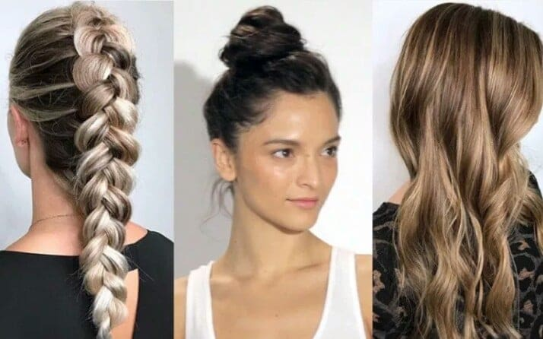

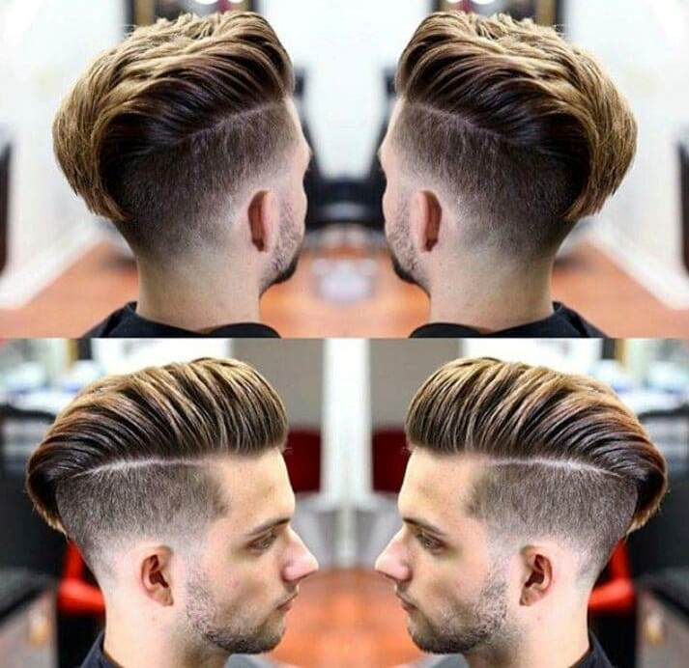

**Temporary colour wax**

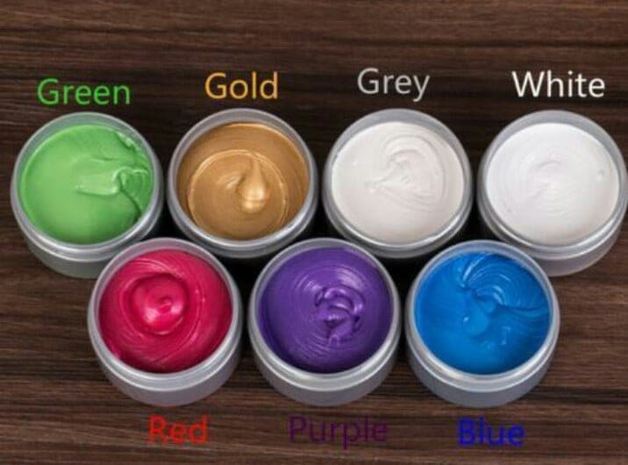 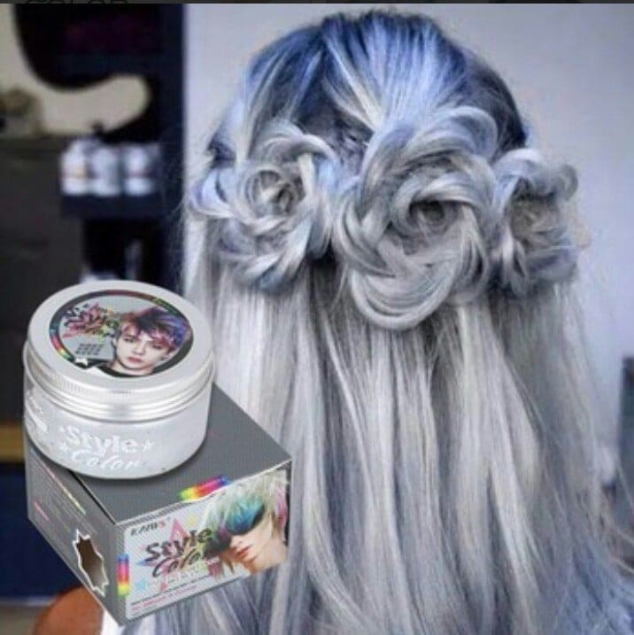

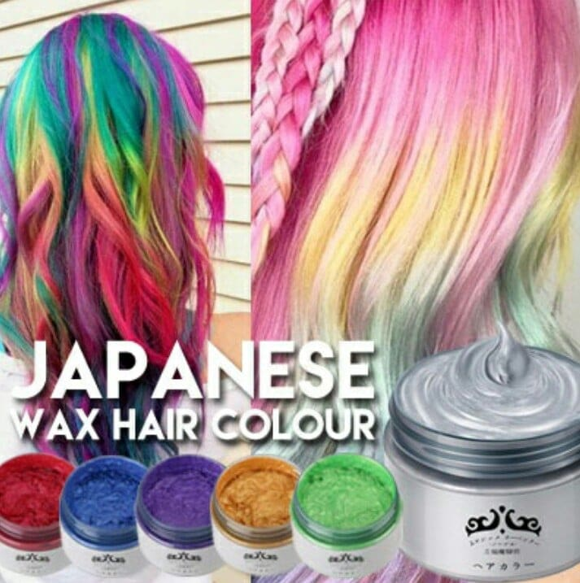 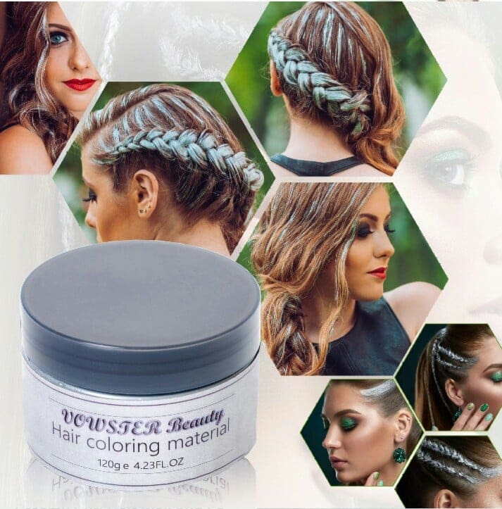

**3.Hair mousse**

Hair mousse, also referred to as styling foam, is a [hairstyling product](https://en.wikipedia.org/wiki/Hairstyling_product) to protect, stiffen, or style [hair](https://en.wikipedia.org/wiki/Hair). "Mousse" originates from a French term meaning foam.Hair mousse originated in France and was brought to the North American retail market by [L'Oreal](https://en.wikipedia.org/wiki/L%27Oreal) in the 1980s, the first mousse product coming out under the label "Valence".[]](https://en.wikipedia.org/wiki/Hair_mousse#cite_note-Johnson-3) It is often dispensed in an [aerosol](https://en.wikipedia.org/wiki/Aerosol) foam spray or in cream form. Hair mousse adds volume to hair and often provides both [conditioning](https://en.wikipedia.org/wiki/Hair_conditioner) and hold, without any clumps or build-up. It is a hairstyling product which works by using synthetic resins to coat the hairs, to assist the hair in taking a certain shape. Hair mousse is [purple](https://en.wikipedia.org/wiki/Purple) while in the can and turns an off-white color upon coming in contact with the air. One of the lighter-weight hair styling products, hair mousse is applied to wet hair before drying and styling. Hair mousse can be used on naturally curly or [permed hair](https://en.wikipedia.org/wiki/Perm_(hairstyle)) to reduce frizz and define curl

## History

The early 1980s arrival of hair mousse in North America was known as "mousse mania", as hairdressers unveiled the new foam product to their clientele. Throughout its first years on the market, hair mousse quickly became a multimillion dollar product. 1984 domestic retail sales for the product ranged from $100–$150 million and almost $200 million in sales by 1986.

Due to the mid-1980s, the [big hair](https://en.wikipedia.org/wiki/Big_hair) style trend and the usage of mousse and other volumizing products increased in popularity. It is believed that the year 1987 marked the decline of "mousse mania", as the popularity of having big hair decreased and people began to grow concerned about using more environmentally friendly products.Due to the chemical makeup of the hairstyling product it was not commonly deemed "environmentally friendly". Today, the product is not only produced and marketed under many different brand names, but also sold for different hair types. There are mousse products sold specifically for those with curly hair, as well as for those with colour-treated or straight hair.

## Ingredients

Usually, the first ingredient in a canister of hair mousse is water, which is the top substance used to blend the varying chemical substances together. Another key ingredient is alcohol which helps dissolve the ingredients already added to the water as well as help produce a quick breaking foam.

The next ingredient used is polymer or resin. Polymers are the most effective and important component of hair mousse, which acts as a conditioning agent. These resins are long chain molecules that form a film on the hair allowing a tighter grip on the hair strands, making it harder to brush off and form a resistant film. This allows users to comb or brush their hair, as well as apply heat from a blow dryer without the mousse leaving the hair stiff.

.

Cationic resin is often blended with another film former to give a firmer hold on the hair. In order for this to be successful, the polymer chosen must be nonionic in nature and should be compatible with the cationic resin Emulsifiers are used to help blend the product creating foam. Mousses do not require long-lasting foam stability. Ideally, the foam will break down immediately once worked into the hair

Other added ingredients in various hair mousses, such as vitamins, silicones, sunscreens, and dyes, tend to assist in additional functions for the hair mousse product, such as providing an additional conditioning component.

Certain brands contain [alcohol](https://en.wikipedia.org/wiki/Alcohol), which is suitable for most hair types except dry.

Color mousse is used to cover up [grey hair](https://en.wikipedia.org/wiki/Hair_color) and to create [hair styles](https://en.wikipedia.org/wiki/Hairstyle) at the same time. Semi-permanent color mousse can be used to give toning to hair that is fading from hair color processes.

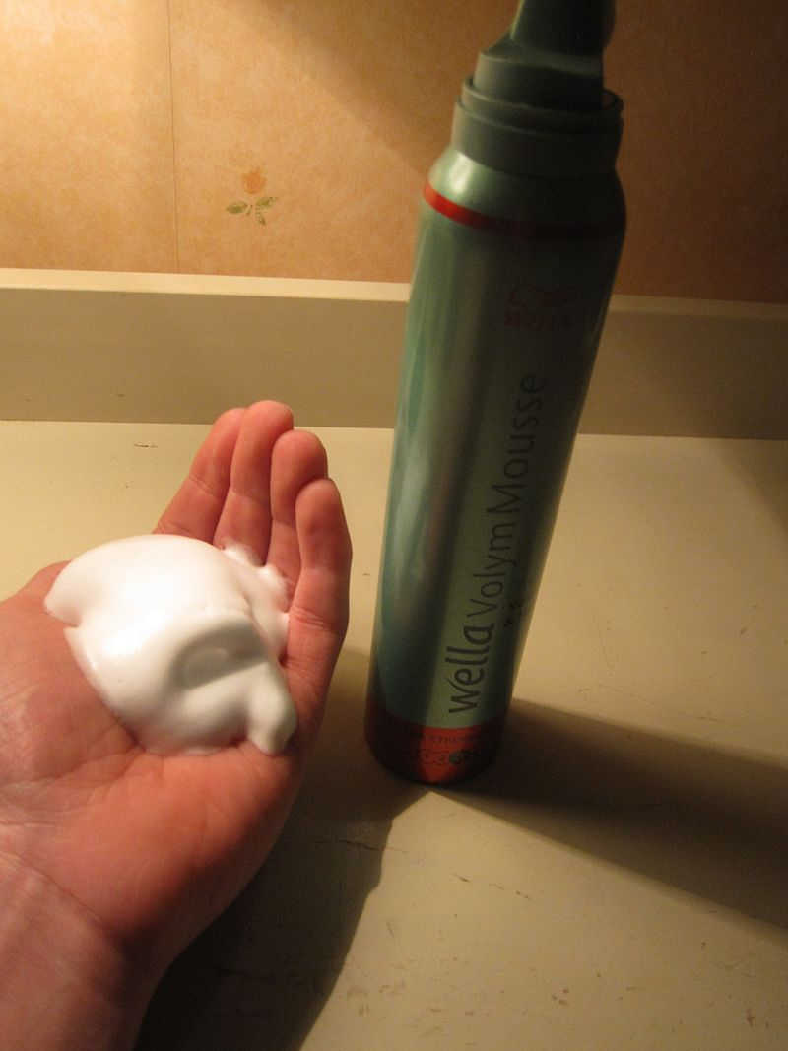

### Mousse – Use For Volume

Most men tend to shy away from hair mousse. Possibly because it reminds them of the crunchy hairstyles of the 80’s.

Mousse is designed to add light hold, body and shine to your hair.

It’s foamy and surrounds the hair strand with chemical compounds called polymers, resulting in a fuller appearance. Even though men may not be chasing that thick look, some mousses are specifically formulated to thicken fine hair with agents like rice protein and rosemarymaking it perfect for foliage that’s starting to thin up top.

Applying mousse at the hair roots and blow drying from the roots outward is key to achieving massive volume.

Using mousse with this method works well for all hair types. Unlike hair gel, if you disturb the crunchy hair you won’t be left with flakes and residue.

Use mousse to get the initial volume – then use another product, like a hair paste, to better define and shape the hairstyle.

[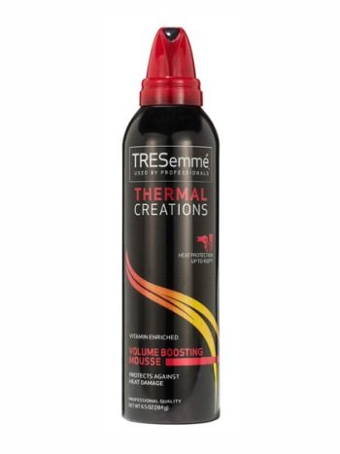](https://www.realmenrealstyle.com/340-amz-hair-mousse)

## Styling Mousse: More Volume, More Hold, More Style

Your good styling ally is always there when needed and is not going to let you down. Updos have [volume](http://www.schwarzkopf.com/schwarzkopf/us/en/hair-care/thin-hair/make-more-of-thin-hair.html) and keep their shape, quiffs bounce, spiking short haircuts do not fall flat and finger waves line up in shiny undulating order. Be sure to use styling mousse if you like to wear hair jewelry. It helps clips, pins, and Alice bands stay in place.

Apply volumizing mousse only where it is needed or where you like to create extra volume. A golf ball-sized dollop is enough for the hair near the [roots](http://www.schwarzkopf.com/schwarzkopf/us/en/hair-styling/tips-and-tricks/volume-base.html). Distribute a tennis ball-sized amount of volumizing mousse through the length of your hair, e.g. for layered long hair. Styling mousse may contain precious oils like Argan oil to achieve supple silkiness and keep the moisture in your hair. If this is the case, your styling ally also doubles as [conditioner](http://www.schwarzkopf.com/schwarzkopf/us/en/hair-care/hair-conditioner/conditioner.html).

The end of flat heads is here! Special care series for fine and limp hair are going to help you build up a full head of hair. Mousse hairstyles that utilize shampoo, rinses and lotions containing a collagen complex will give more substance to your hair near the scalp and immediately produce the appearance of more volume. Using silicon-free hair care formulas keeps your hair from going limp again.  
  
How to mousse hair? For best results you should use an alcohol-free mousse before blow-drying your hair. This gives your hair more volume without drying it out. Simply towel your hair dry and then work a tennis ball-sized portion of mousse through it. You need to work the mousse only through the hair near your scalp if your hair is longer.



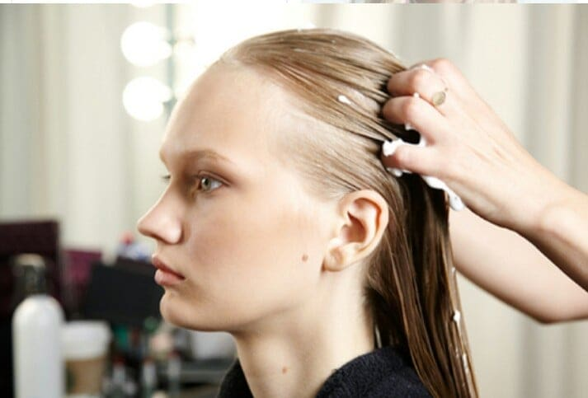

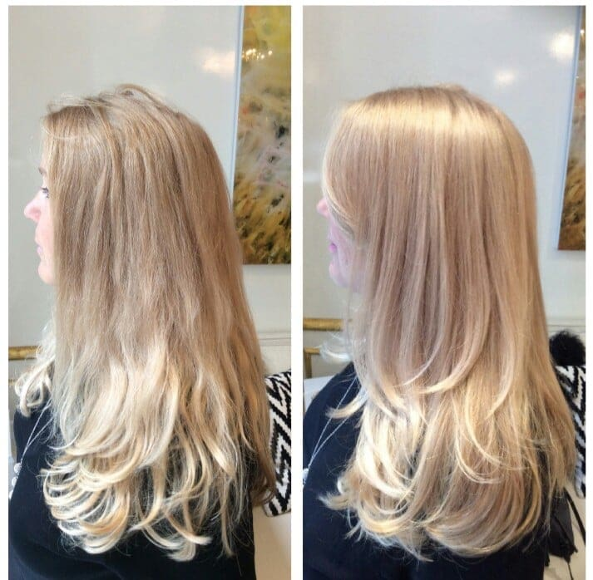

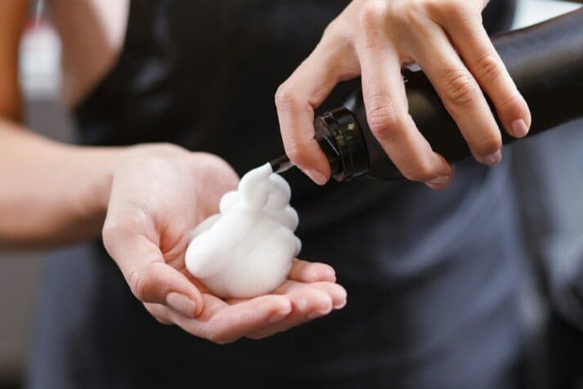

### Steps of hair Moussing

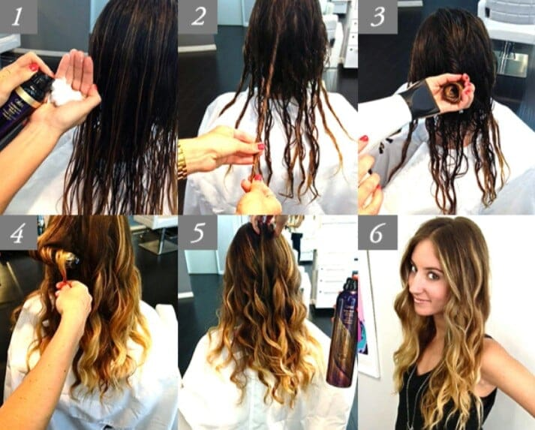

**4.Hair spray**

Hair spray is a common [cosmetic](https://en.wikipedia.org/wiki/Cosmetics) [hairstyling product](https://en.wikipedia.org/wiki/Hairstyling_product) that is sprayed onto hair to protect against humidity and wind. Hair sprays typically consist of several components for the hair as well as a propellant.

## History

Early hair sprays were developed in Europe in the 1920s. In the US, hair sprays were developed around the time of the [aerosol can](https://en.wikipedia.org/wiki/Aerosol_spray) in the 1940s, and the first patents describing [copolymers](https://en.wikipedia.org/wiki/Copolymers) for hair styling were published in the 1940s.

In the US, the first to package it was Chase products (an aerosol manufacturer) in 1948, as the beauty industry saw that the aerosol cans used in World War II for insecticides could be used as a dispenser for hairspray. It thrived and became increasingly popular and mass-produced, as [updos](https://en.wikipedia.org/wiki/Updo) and other such hairstyles were created. By 1964, it became the highest selling beauty product on the market.

In 1968 at the feminist [Miss America protest](https://en.wikipedia.org/wiki/Miss_America_protest), protestors symbolically threw a number of feminine products into a "Freedom Trash Can." These included hairspray, which was among items the protestors called "instruments of female torture" and accouterments of what they perceived to be enforced [femininity](https://en.wikipedia.org/wiki/Femininity).

Sales of hairspray declined in the 1970s as hairstyles became predominately worn straight and loose. By the 1980s, hairspray’s popularity came back as big hairstyles resurged with the [glam metal](https://en.wikipedia.org/wiki/Glam_metal) scene.

Prior to 1979, the most popular propellants in hairsprays were [CFCs](https://en.wikipedia.org/wiki/Chlorofluorocarbon). Owing to environmental concerns, they were replaced.

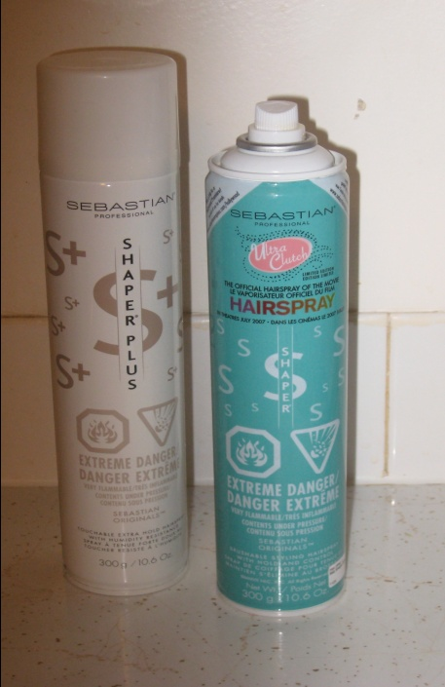

## Ingredients and operation

Hair sprays consist of the following components: concentrate, [plasticizers](https://en.wikipedia.org/wiki/Plasticizer), luster agents, and [fragrances](https://en.wikipedia.org/wiki/Fragrance), as well as propellants.

[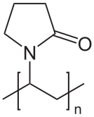](https://en.wikipedia.org/wiki/File:Polyvinylpyrrolidon.svg)

### Concentrate

Hair spray are a blend of polymers that provide structural support to hair. These frequently include [copolymers](https://en.wikipedia.org/wiki/Copolymers) of [polyvinylpyrrolidone](https://en.wikipedia.org/wiki/Polyvinylpyrrolidone) (PVP) and [polyvinyl acetate](https://en.wikipedia.org/wiki/Polyvinyl_acetate) (PVAc). Vinyl acetate-[crotonic acid](https://en.wikipedia.org/wiki/Crotonic_acid) copolymers give harder films. In this way hairsprays can be formulated as flexible, medium, and maximum hold.[[2]](https://en.wikipedia.org/wiki/Hair_spray#cite_note-2) The copolymer mixture is usually adjusted to achieve the desired physical properties (adhesive strength, foaming, etc.), using [plasticizers](https://en.wikipedia.org/wiki/Plasticizer) such as [aminomethyl propanol](https://en.wikipedia.org/wiki/Aminomethyl_propanol), [surfactants](https://en.wikipedia.org/wiki/Surfactant) such as [benzalkonium chloride](https://en.wikipedia.org/wiki/Benzalkonium_chloride), and other agents like [dimethicone](https://en.wikipedia.org/wiki/Polydimethylsiloxane).

### Propellants

Since the phase-out of CFCs in the 1980s, hydrocarbons are popular propellants. These include propane, butane, isobutane, and related volatile hydrocarbons, as well as mixtures thereof. Such hydrocarbons are poor solvents for the active ingredients such as the polymers. For this reason [dimethyl ether](https://en.wikipedia.org/wiki/Dimethyl_ether) is often added as well. It functions both as a propellant and a solvent.

### Other components

Plasticizers used in hair spray include esters of [citric acid](https://en.wikipedia.org/wiki/Citric_acid) and [adipic acid](https://en.wikipedia.org/wiki/Adipic_acid). Silicones and polyglycols are also used.

The concentrate comprises only a small volume of a can of hairspray. Most of a canister is filled solvents such as isopropanol (rubbing alcohol) and ethanol.

### Hairspray – Finishing Touches

Reminiscent of the age of shoulder pads and Top Gun screen savers.

A quick spritz of hair spray is like casting a protective net over your hair that keeps it set in times of humidity and when riding in convertibles.

Hair spray can be used by itself, or used in conjunction with any hair paste or pomade.  They can also be sprayed on the outer layer of hair to lock in the hairstyle in place, or sprayed deep into the roots to coat the hair and lift them up.

Typically, hair spray is packaged in an aerosol can or bottle with a pump sprayer, and is primarily geared towards women – this does not mean that men can’t and shouldn’t use them as well.

* **Flexible-hold hair sprays** offer the least amount of staying power and work well for longer hairstyles.  They provide just enough control to reduce frizzing, but still allow some natural movement.
* **Medium-hold hair sprays** have a slightly stronger hold than the flexible types and should be used sparingly if movement is still desired. Suited for hairstyles that require volume without the stiffness.
* **Maximum-hold sprays** keep every strand in the same place throughout the day.  If you’re styling product isn’t giving you enough hold throughout the day, then blast it with a few shots of maximum-hold sprays and that’ll do the trick. You’ll still maintain the definition and texture of the hairstyle, but it’ll now be locked in place.

Just be mindful that some types of hair spray product may require washing with a clarifying shampoo to remove all residues.

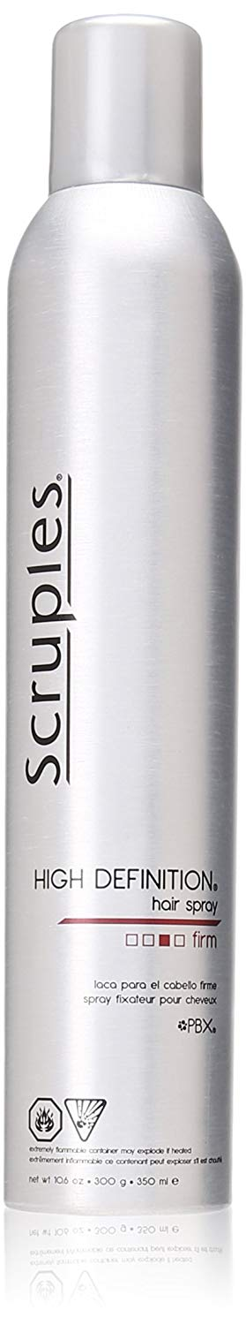

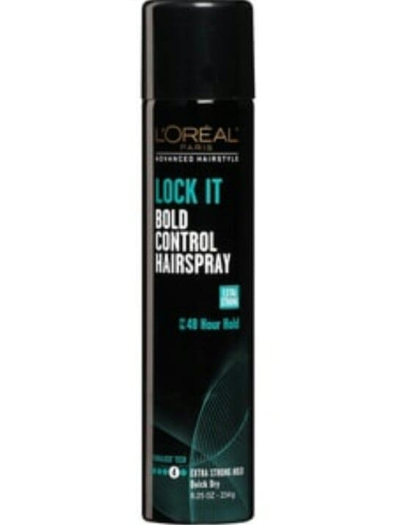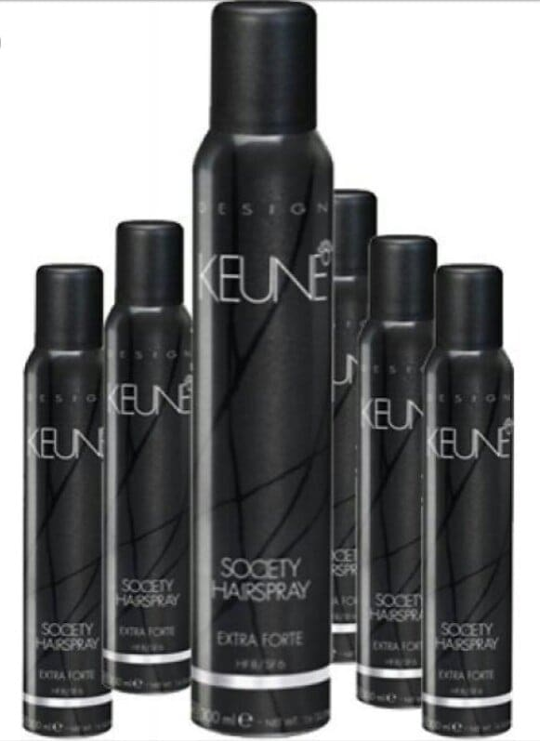

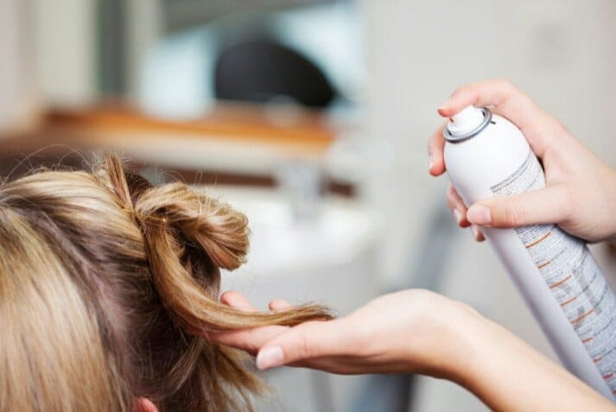

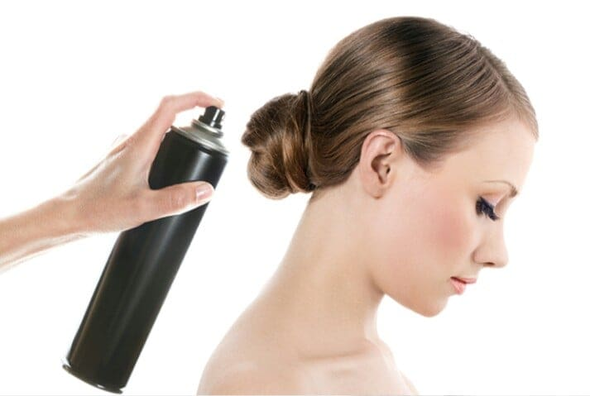

### Color spray

For all hair types and colors. Temporary hair color with pure pigments. Quick spray application. L’Oréal Paris Colorista Spray lets you play with color in a whole new way! A temporary hair color spray that allows you to instantly get bold looks when you want them and how you want them without the commitment – this color spray for hair is out after 1 day and is kind to your hair. Just spray, play, wash, repeat. Each shade is formulated to allow for vivid color on all hair types, no bleach required. Break with the routine and start exploring your style with Colorista Sprays!

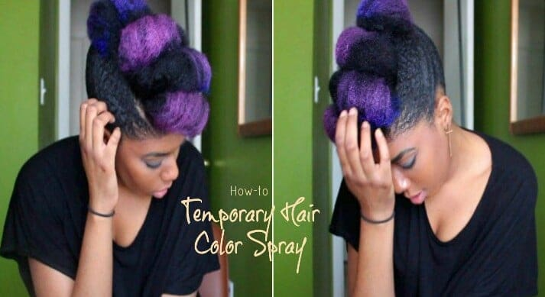

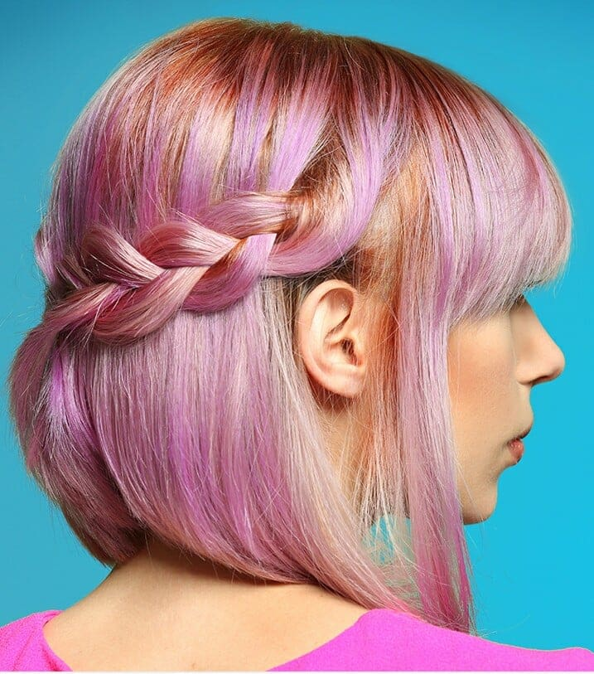 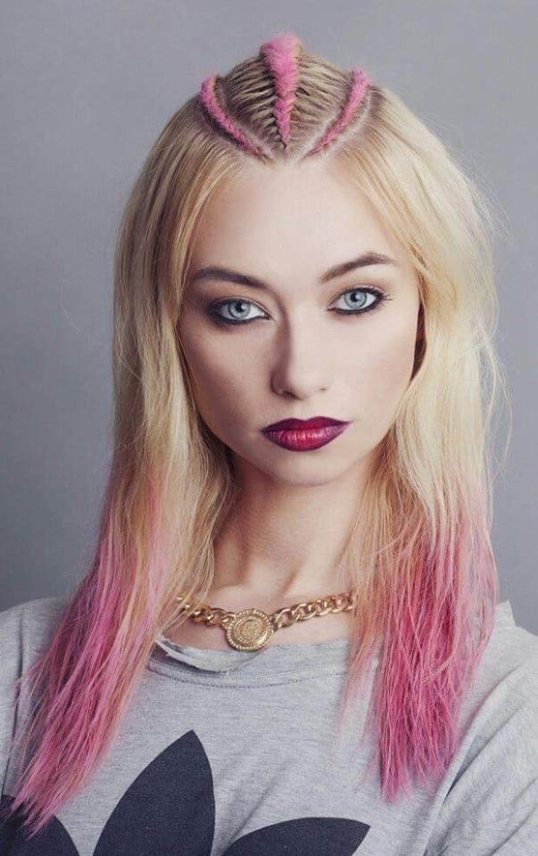

**5.Pomade**

Pomade is a greasy, waxy, or a water-based substance that is used to style hair. Pomade generally gives the user's hair a shiny and slick appearance. It lasts longer than most hair care products, often requiring multiple washes to completely remove. The original pomade of the eighteenth and nineteenth centuries consisted mainly of [bear fat](https://en.wikipedia.org/wiki/Bear_fat) or [lard](https://en.wikipedia.org/wiki/Lard). [Lanolin](https://en.wikipedia.org/wiki/Lanolin), [beeswax](https://en.wikipedia.org/wiki/Beeswax), and [petroleum jelly](https://en.wikipedia.org/wiki/Petroleum_jelly) have been used extensively in the manufacture of modern pomades. Stiffening properties of pomades make sculptured hairstyles such as the [pompadour](https://en.wikipedia.org/wiki/Pompadour_(hairstyle)) possible; while long lasting moisturizing properties make it popular with individuals with [Afro-textured hair](https://en.wikipedia.org/wiki/Afro-textured_hair).

In [perfumery](https://en.wikipedia.org/wiki/Perfumery), a pommade is a [plant extract](https://en.wikipedia.org/wiki/Plant_extract) obtained by [enfleurage](https://en.wikipedia.org/wiki/Enfleurage).

## History

During the Roman era, soap was used as a pomade by some European tribes.In the 19th century, [bear fat](https://en.wikipedia.org/wiki/Bear_fat) was usually the main pomade ingredient.In 1873 UK company Morgan's Pomade was established selling Hair Darkening Pomade across the World. By the early 20th century, petroleum jelly,beeswax, and lard were more commonly used. Early 20th century examples of pomades include [Murray's Superior Pomade](https://en.wikipedia.org/wiki/Murray%27s_Pomade) (originating in 1925), Sweet Georgia Brown Hair Dressing Pomade (originating in 1934)and Royal Crown Pomade (originating in 1936). Dixie Peach Hair Pomade was popular with teenage boys in the U.S. from [World War II](https://en.wikipedia.org/wiki/World_War_II) through the 1960s.

Pomades were much more popular in the 1920s to 1950s than they are today, although they have made a comeback in the 2010s with recent alternations to the marketplace, which feature not only traditionally manufactured petrolatum and oil based pomades but also modern water-soluble pomades. Compared to oil based pomades, water-based pomades wash out more easily.

Modern hairstyles involving the use of pomade include the [ducktail](https://en.wikipedia.org/wiki/Ducktail), [pompadour](https://en.wikipedia.org/wiki/Pompadour_(hairstyle)), and [quiff](https://en.wikipedia.org/wiki/Quiff).

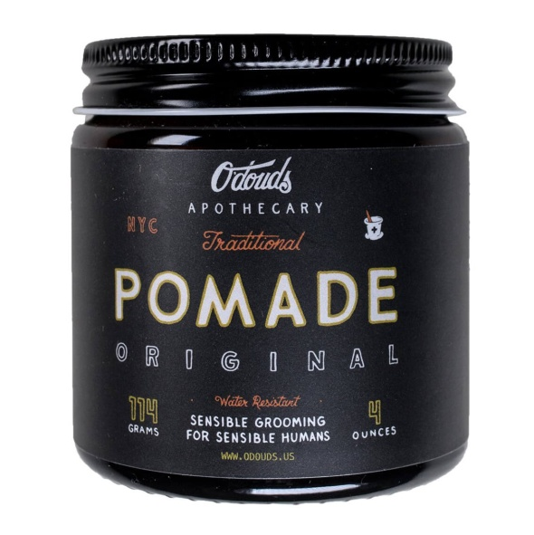

## How to Style Hair with Pomade?

While styling your hair with pomade might seem straightforward, there a number of things you should take into consideration.

Firstly, your hair should be at the correct dampness before you apply any product. Many guys think your hair has to be completely dry before you using pomade. But the truth is you want it to be **slightly damp**. How damp exactly? You want your hair to feel as though it may be dry in the next couple of minutes, but not too wet where your hair won't mix well with the oils of the pomade.

Next, you need to decide on the amount of pomade to use. With pomade hairstyles this is always a bit tricky. Too much and your hair might take on an overly oily appearance, too little and you might not have the correct amount of hold. There's no right answer here – it largely depends on the length of your hair, your hair type and the style that you're after – but a good benchmark to **start with is a teaspoon's worth**, and to experiment from there.

Lastly, the application. Always remember to **rub it over your hands first** – the warmth from your palms will make the pomade much more pliable – this way you'll have much more surface area to attack your hair with. Once the pomade is applied to your hands, simply plunge them into your hair. Using both hands, massage the pomade in the same way you would [shampoo](http://www.schwarzkopf.com/en/hair-care/shampooing/shampoo-can-do-it-all.html), taking special care to get deep into the roots and distribute it evenly. After this your pomade hairstyle is ready to be styled!

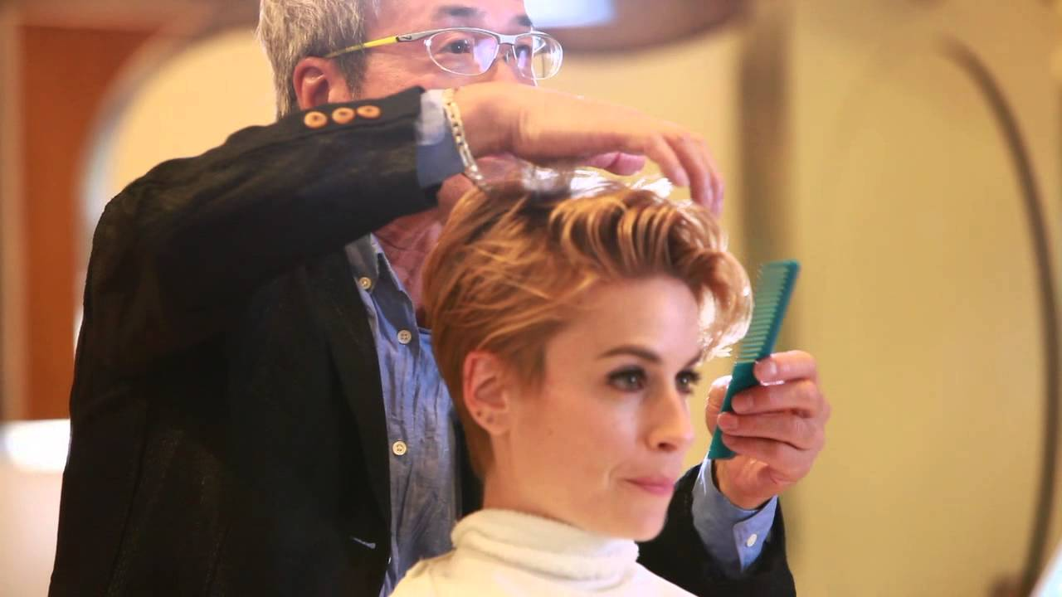

## Pomade Hairstyles

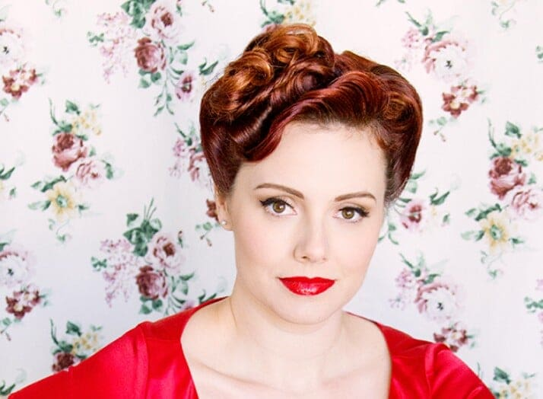 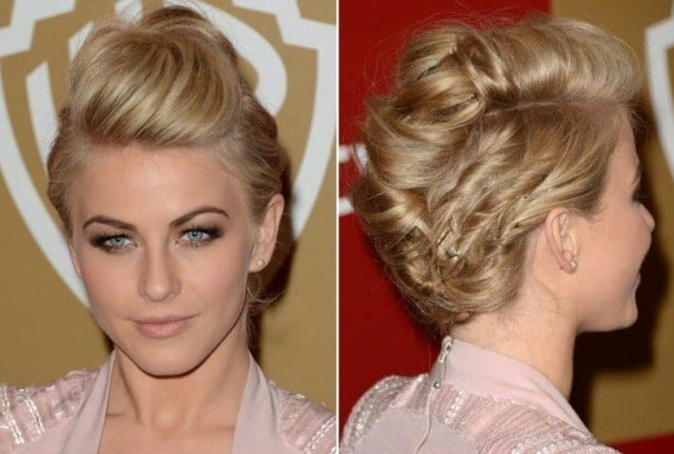

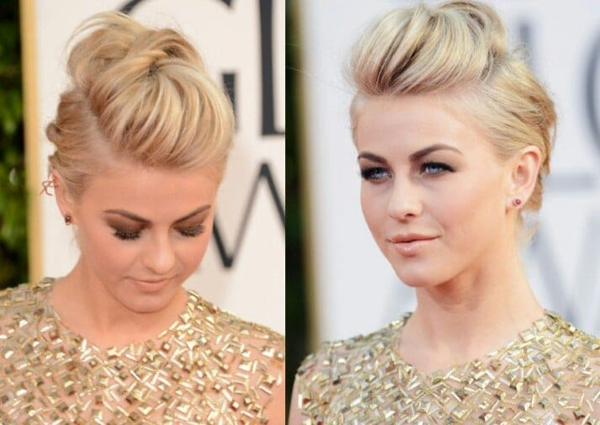 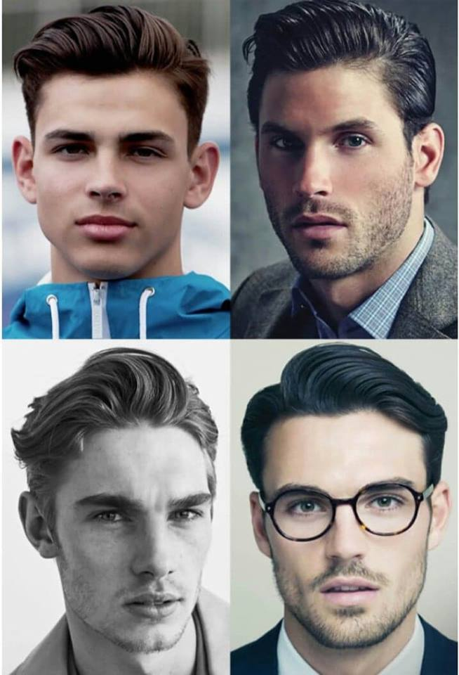

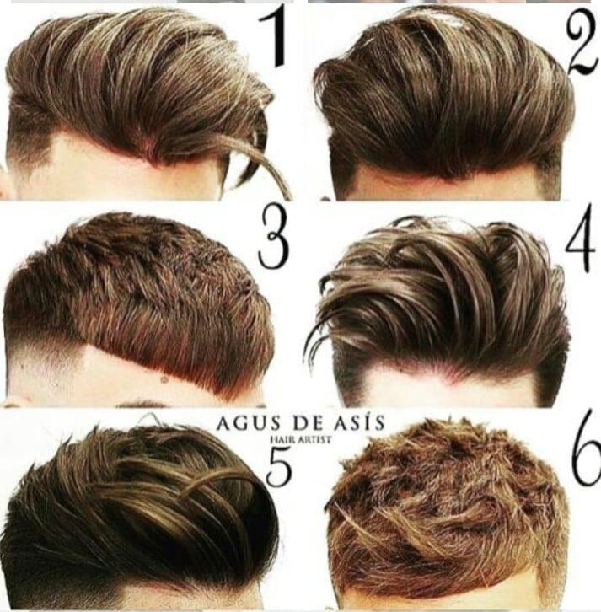

**6.Hair volumizer**

Volumizing powder comes to the rescue when hair is not full enough or not manageable enough. It solves several styling problems at once. The fine, light powder adds fullness to fine hair, makes limb hair more manageable, and refreshes hair between shampoos. We describe how to take full advantage of volumizing powder to create fuller, more manageable, and more appealing hairstyles

Volumizing powder is a potent problem solver when hair is limp or does not have enough grip for updos, twirls or braids. As a welcome side-effect volumizing powder also freshens up oily hair between shampoos. The ultra-light and fine powder is suitable for any hair type and length, and it helps with many hair problems.

## The Praises of Volumizing Powder

**Volume:** The main role of volumizing powder is to add fullness and bounce to thin or limb hair. Simply apply it where more volume is needed. The volumizing micro-particles fluff up hair for added volume without teasing and blow-drying. There is no faster way to turn limb, lifeless hair into a full head of impressively bouncy hair.

**Structure and Shape:** Volumizing powder adds definition to your hairstyle. Hairstyles from bobs to updos look fuller and therefore also shapelier.

**Hold:** Hairstyles hold their shapes better and longer thanks to the magical powers of volumizing powder. [Hair accessories](http://www.schwarzkopf.com/en/hair-styling/hairband/hairaccessorytrends.html), slides, and pins also stay in place longer.

**Manageability:** The hair’s manageability determines how well you can create the desired hairstyles. Hair can be styled much easier in the presence of volumizing powder. Especially twirled and braided hair elements are easier to manage with the volumizing micro-particles in your hair.

**Freshness:** Volumizing powder absorbs oil and therefore counteracts the bedraggled look of oily hair. Your hair will look fresher in seconds.

**Matte Finish:** You may also like to use volumizing powder to create a matte finish for undone looks. The powder works well for the cool out-of-bed look for men and undone bobs for women.

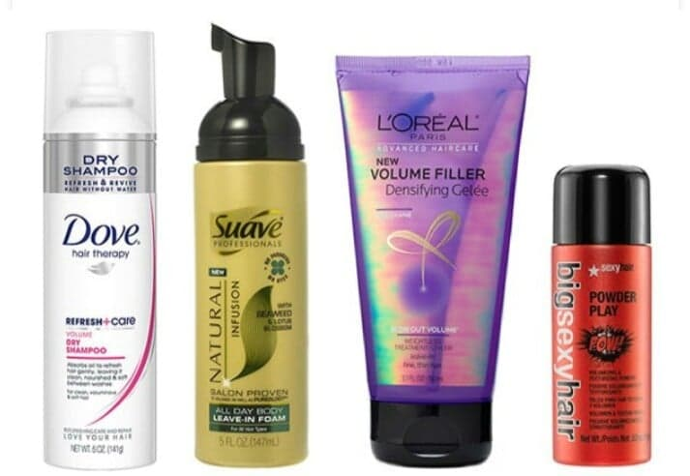

## How to Apply Volumizing Powder

Volumizing is applied where it is needed either near the hair roots or around the hair ends. Simply sprinkle a small amount of volumizing powder on the desired portion of your hair and use your fingers to distribute the powder thoroughly. Alternatively, you may like to distribute the powder in the palms of your hands or on your fingers and work it through the targeted part of your hair. The powder does not need to be brushed out of the hair. It leaves no visible residue and can be easily washed away with shampoo with these [hair wash tips](http://www.schwarzkopf.com/en/hair-care/shampooing/proper-shampooing.html#contentPar_textimage_f456).

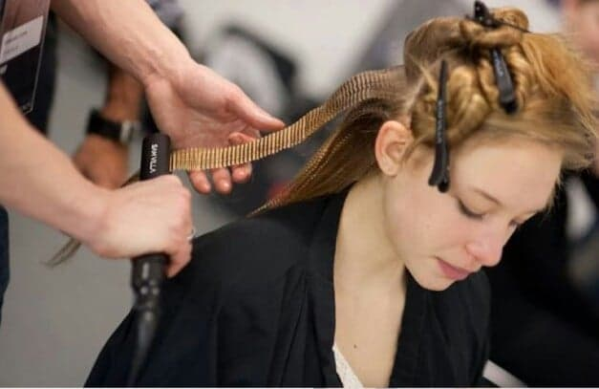

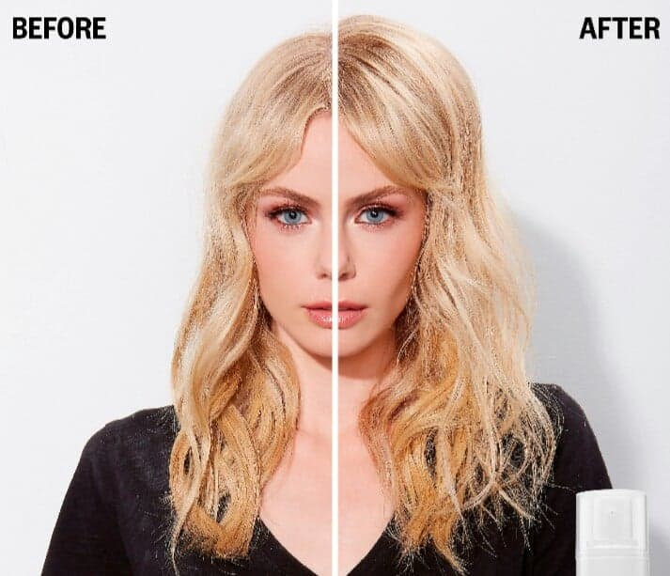 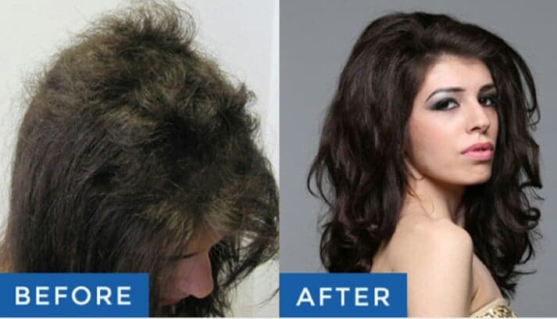

**Style Hair**

# [01. French Braid](https://www.wikihow.com/French-Braid)

# The French braid is a beautiful and classic hairstyle. Although its intricate weave may appear complicated, creating your own French braid is a simple process. The secret is to add a strand of hair to each section before braiding it. Once you've gotten the basics of a traditional braid down, you could try a French lace braid for a fancy twist.

### Method 01 - Creating a Classic French Braid

**01. Prep your hair**

Brush through your hair to get all the tangles out and make it soft, smooth, and ready to braid. For a single braid going down the back of your head, brush your hair backwards, away from your forehead.

* You might want a braid down the side of your head instead, or maybe you're making more than one braid. In that case, part your hair and brush it into sections.
* You can braid your hair when it's dry or when it's wet. But, braiding wet hair gives you soft, pretty waves when you take it out later.

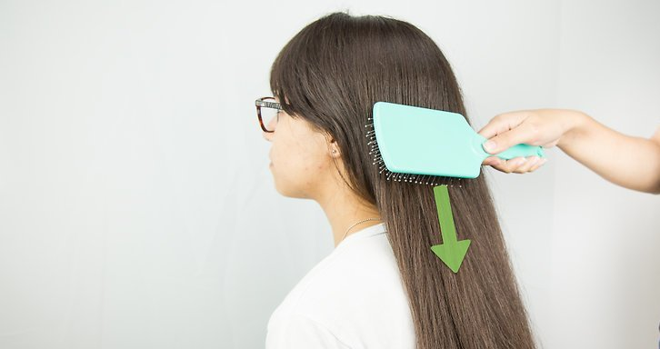

**02. Begin sectioning your hair.**

Start the process by gathering a big chunk (3-4 inches wide) from the top-center of your head. All the hair in this section should come from the same "hair row." You don't want to grab strands from higher up or lower down.

* If you have bangs, you can bring them into the braid at this point or leave them loose. Choose what you think looks best. To braid them, you'll need to grab hair from the very top-center of your head, right above your forehead.
* The section you start with has nothing to do with how big your braid will be. You start with a small section, but the braid grows thicker as you add more hair.

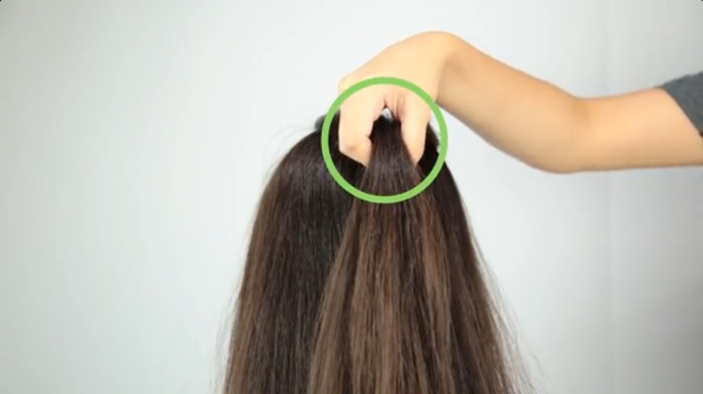

**03. Separate this first "chunk" into three pieces.**

Just like traditional braids, French braids use three sections of hair to create their pattern. Separate them out by running your fingers through the chunk you are holding to create three even pieces. Make sure that none of the pieces are larger or smaller than the other two.

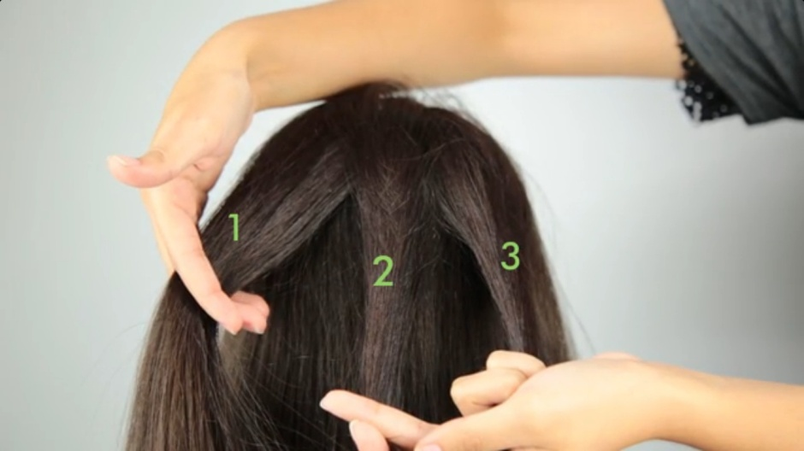

### 

### 04. Begin in a traditional braid

### First, you have to get your hand positioning right: hold two strands in one hand, and the third strand in the other. Begin in a [traditional braid](https://www.wikihow.com/Braid-Hair) by crossing the “right” strand over to the center. Then, cross the “left” strand from over to the center. Repeat until you've made a few rows of a traditional braid.

### C:\Users\My\Pictures\Untitled.03.jpg

**05. Work in new hair**

Keep going with this traditional braid pattern, but start bringing in other pieces of hair. Before crossing a section over to center, grab some hair from that side of your head and include it in the cross-over.

* Every time you cross over, work in another small piece of hair. How much new hair you grab each time doesn't matter, but the less hair you grab, the more intricate the braid will look.
* For the best-looking French braid, pick up the hair near your face and neck. If you only pick up pieces from the center (near the main strand), they'll get covered up later with strands from the outside.

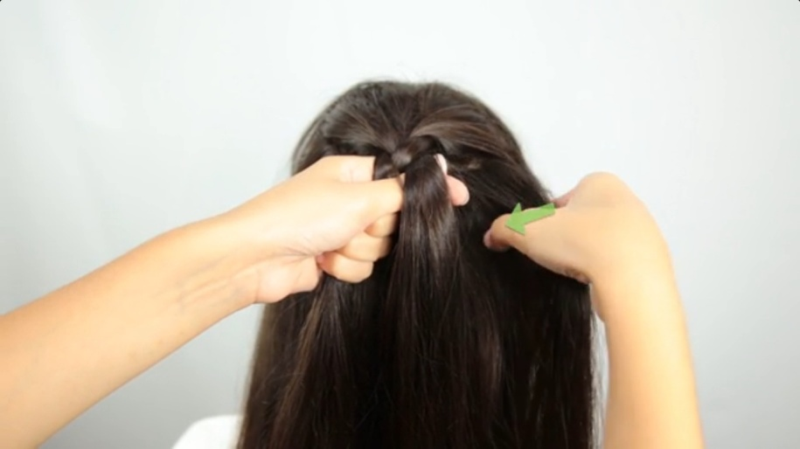

**06. Bring all of your hair into the braid**

As you work down your head, you'll start running out of free hair to bring into the braid. By the time you reach the nape of your neck, you should have incorporated all of your hair.

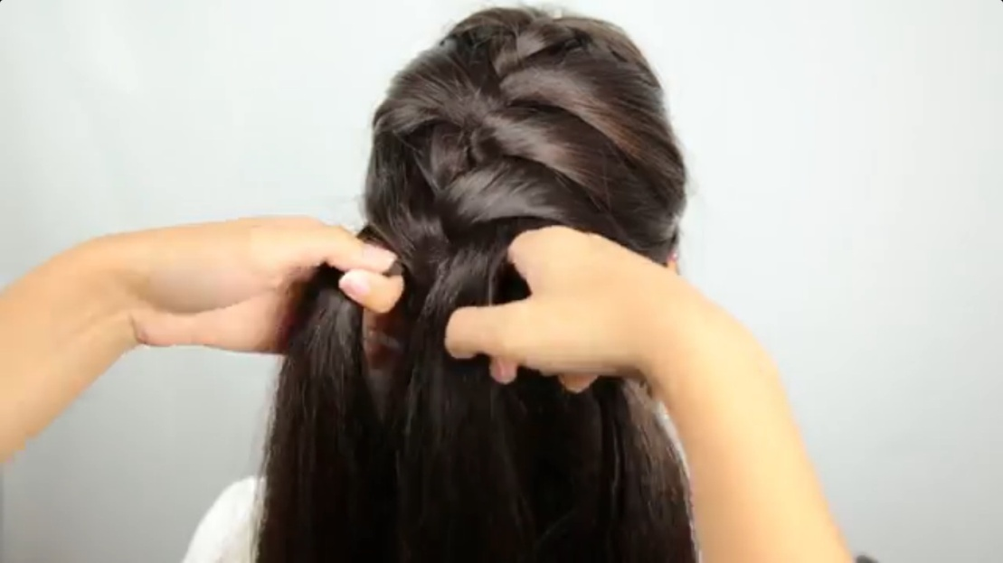

**07. Finish the braid**

When all of your hair is in the working braid, finish it off as a traditional braid. Keep going until you reach the end of your strands. Then, secure the braid with a ponytail holder.

* Avoid using rubber bands, as these rip and break hair when you remove them.

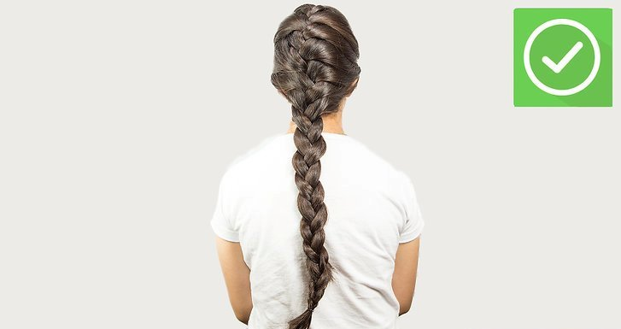

**02. The Fishtail Braid**

Just like the [Basic Braid](http://2good2lose.com/braid-basic.shtml), this braid turns out best if you pull hair back into a tight ponytail first. The difference between the two braids is that you are going to seperate the ponytail into 2 strands instead of three.

**1.** Once you have separated the ponytail, you are going to start out by holding the 2 strands in your left hand.

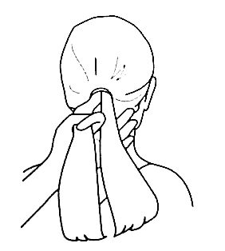

**2.** Now you are going to take a thin piece from the outside of the right strand and join it with the left strand.

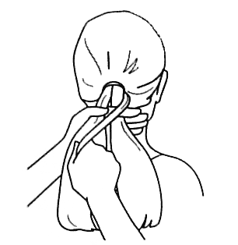

**3.** Reverse how you are holding hair and switch hands.

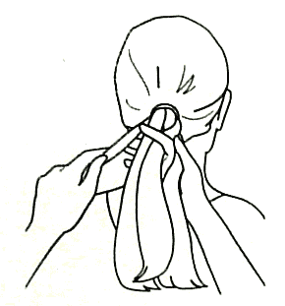

**4.** With your left hand take a thin piece from the outside of the left strand and join it with the right strand.

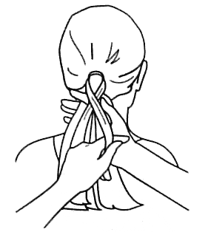

**5.** You are going to repeat steps 2 and 3 until the braid is as long as you desire. Then finish with an elastic.

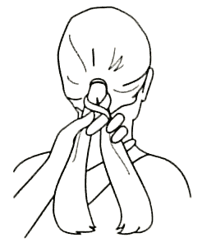

**03. Rope Braid**

This is another braid that works best on a ponytail, preferably long and one length. You may want to start with damp hair.

1. Separate the ponytail into 3 strands. Hold 2 strands in the left hand and 1 in the right hand.

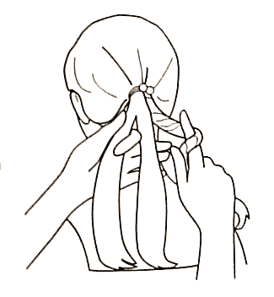

**2.** Wind the strand in your right hand around your index finger to the right. Then switch hands so that all 3 strands are in your right hand, separated with your fingers. Hold onto wound strand, so it does not unravel.

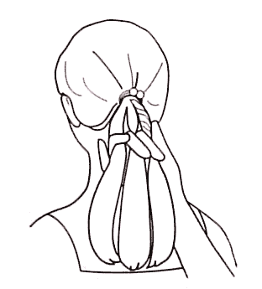

**3.** Bring the wound strand over so it is now on the left. Then switch all 3 strands back to the left hand.

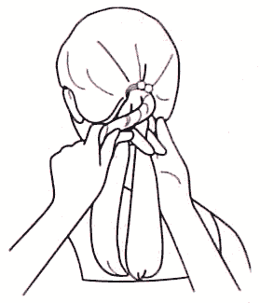

**4.** Now your right hand can wind the right strand again. Repeat steps 2 and 3 to the end of the ponytail. Do Not release or the rope will unravel!

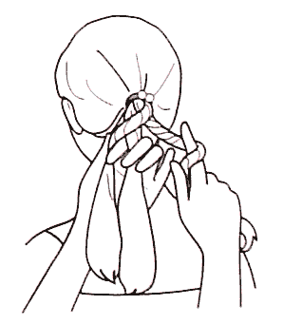

To secure Rope, fasten with a tight elastic.

**04. The Messy Rose Braid**

Spring has sprung! Or at least we had a couple of days of sunshine and warmer weather here, and I'm pretty much over-the-moon about it! It has been a long, grey winter, and I'm so ready for longer days and colorful buds to start popping up from the earth. If I had a green thumb, I'd be outside working in the garden, but since I'm not really that good with plants, I'm channeling spring in my clothes and hair. Floral prints might not be that original but they're certainly pretty, and a flower braid is a perfect and unexpected finishing touch. Bonus: it's super easy.

**Step One:**

Twist two small sections of hair from either side of your head into a small ponytail and secure with a clear elastic.

**Step Two:**

Braid your small ponytail and secure with a clear elastic. You can add some other hair from where your ponytail falls if the braid looks too small or thin to you.

**Step Three:**

Take your braid and twist it around in a circle. I like the top of my braid to be the outside of the circle and work the end of my braid towards the center (this way the outer edges are usually fuller).

**Step Four:**

Secure your little twist in place with a few bobby pins and admire your handiwork!

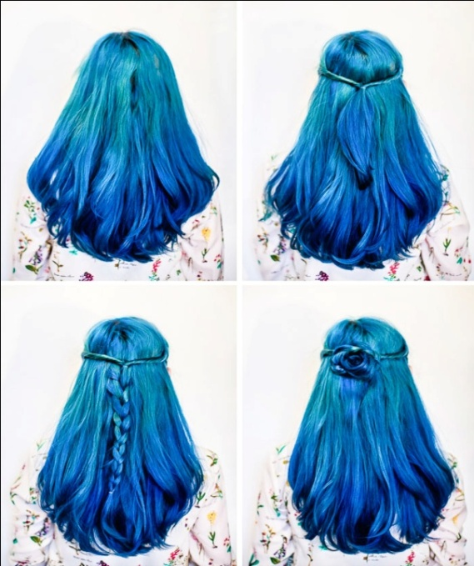 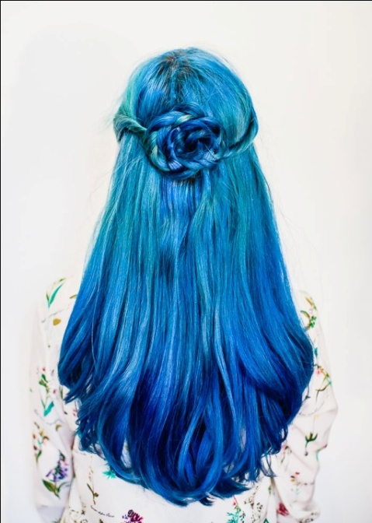

# [05. Braid Hair with a Ribbon](https://www.wikihow.com/Braid-Your-Hair-with-a-Ribbon)

## Steps

**01.**

Wash your hair if it's not clean. If clean, brush it.

[[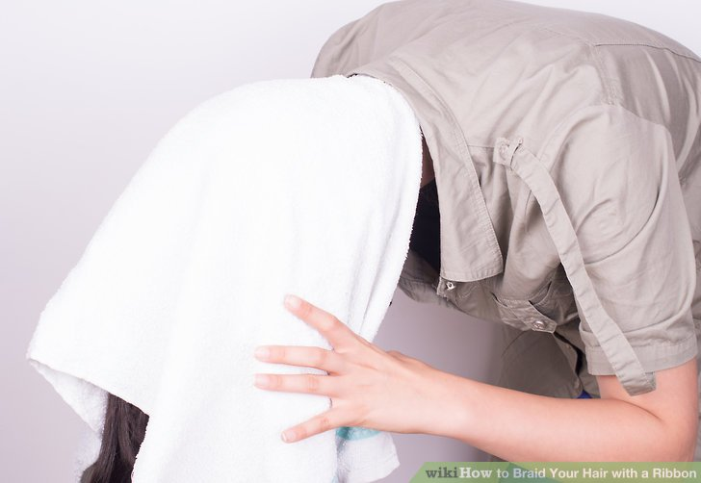](https://www.wikihow.com/Braid-Your-Hair-with-a-Ribbon?fbclid=IwAR062fzWnKPP21xqYxWCtgS4x5-4PKLWcxela8MrC-L_Hah4qVTIPrvVb0g#/Image:Braid-Your-Hair-with-a-Ribbon-Step-1.jpg)](https://www.wikihow.com/Braid-Your-Hair-with-a-Ribbon?fbclid=IwAR062fzWnKPP21xqYxWCtgS4x5-4PKLWcxela8MrC-L_Hah4qVTIPrvVb0g" \l "/Image:Braid-Your-Hair-with-a-Ribbon-Step-1.jpg)

**02.**

Add your parting where you would like it to be. A parting will work best if it's in a place where it has been parted before, so as not to pull your hair or look askew.

[[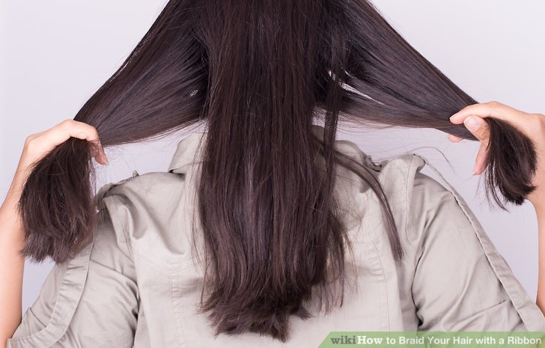](https://www.wikihow.com/Braid-Your-Hair-with-a-Ribbon?fbclid=IwAR062fzWnKPP21xqYxWCtgS4x5-4PKLWcxela8MrC-L_Hah4qVTIPrvVb0g#/Image:Braid-Your-Hair-with-a-Ribbon-Step-3.jpg)](https://www.wikihow.com/Braid-Your-Hair-with-a-Ribbon?fbclid=IwAR062fzWnKPP21xqYxWCtgS4x5-4PKLWcxela8MrC-L_Hah4qVTIPrvVb0g" \l "/Image:Braid-Your-Hair-with-a-Ribbon-Step-3.jpg)

**03.**

Split your hair into three almost equal sections. The thickness of the sections will depend on which braid you are doing, for example, a fishtail, Dutch braid, etc., just be sure you know how to braid the type.

* + Have your ribbon at the ready, and also a bobby pin.

[[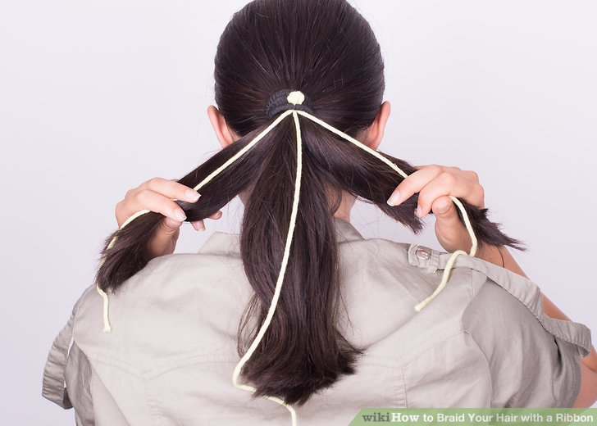](https://www.wikihow.com/Braid-Your-Hair-with-a-Ribbon?fbclid=IwAR062fzWnKPP21xqYxWCtgS4x5-4PKLWcxela8MrC-L_Hah4qVTIPrvVb0g#/Image:Braid-Your-Hair-with-a-Ribbon-Step-4.jpg)](https://www.wikihow.com/Braid-Your-Hair-with-a-Ribbon?fbclid=IwAR062fzWnKPP21xqYxWCtgS4x5-4PKLWcxela8MrC-L_Hah4qVTIPrvVb0g" \l "/Image:Braid-Your-Hair-with-a-Ribbon-Step-4.jpg)

**04.**

Place the ribbon by one section of hair. Clip it into place on a part of your top hair that you won't be braiding.

It is also possible to braid in a ribbon for each strand. If you decide to do this, it's best to try with just one ribbon first, to get the hang of it, then try the three strands. Also, be sure to either use all the same color of ribbon for each strand of hair, or match the colors so that they don't clash.

[[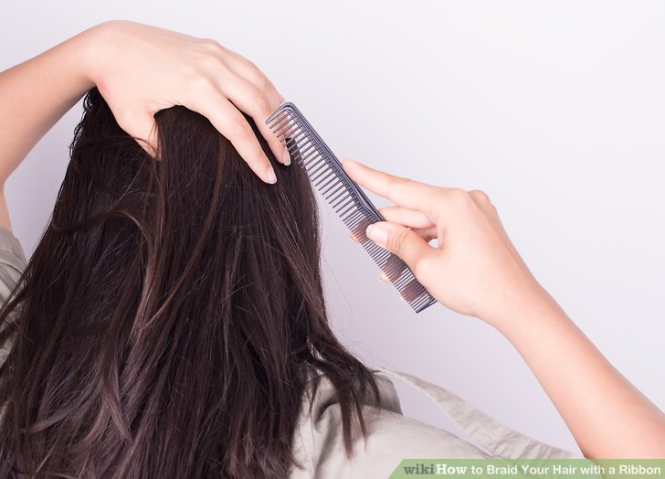](https://www.wikihow.com/Braid-Your-Hair-with-a-Ribbon?fbclid=IwAR062fzWnKPP21xqYxWCtgS4x5-4PKLWcxela8MrC-L_Hah4qVTIPrvVb0g#/Image:Braid-Your-Hair-with-a-Ribbon-Step-2.jpg)](https://www.wikihow.com/Braid-Your-Hair-with-a-Ribbon?fbclid=IwAR062fzWnKPP21xqYxWCtgS4x5-4PKLWcxela8MrC-L_Hah4qVTIPrvVb0g" \l "/Image:Braid-Your-Hair-with-a-Ribbon-Step-2.jpg)

**05.**

Begin braiding in the way that you would usually do. Again, braid according to the type of braid you have chosen. As you braid, keep the ribbon aligned at all times with the same section of hair you chose to begin with.

* + If you've added a ribbon to each of the sections of hair, keep each ribbon aligned with that section of hair.

[[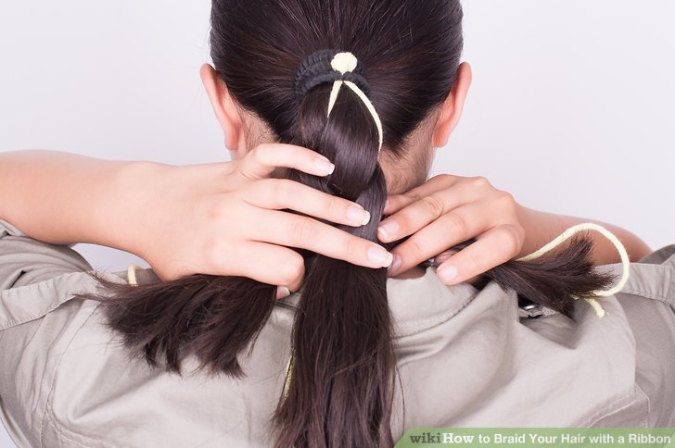](https://www.wikihow.com/Braid-Your-Hair-with-a-Ribbon?fbclid=IwAR062fzWnKPP21xqYxWCtgS4x5-4PKLWcxela8MrC-L_Hah4qVTIPrvVb0g#/Image:Braid-Your-Hair-with-a-Ribbon-Step-5.jpg)](https://www.wikihow.com/Braid-Your-Hair-with-a-Ribbon?fbclid=IwAR062fzWnKPP21xqYxWCtgS4x5-4PKLWcxela8MrC-L_Hah4qVTIPrvVb0g" \l "/Image:Braid-Your-Hair-with-a-Ribbon-Step-5.jpg)

**06.**

Continue braiding until you reach a good place to finish, or you have run out of ribbon/hair. Secure it tightly with a hair band/bobble to ensure that it doesn't fall out.

* + You could add a cute hairband to finish off your look, or maybe even a bit of holding spray to fix in any unwanted flyaways. If you want it to be a bit messy, just leave it be.

[[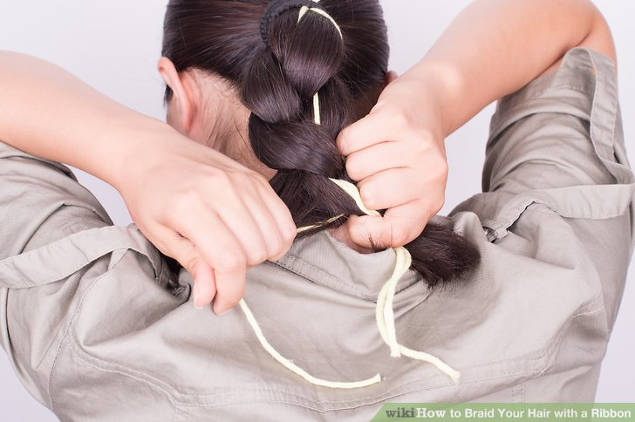](https://www.wikihow.com/Braid-Your-Hair-with-a-Ribbon?fbclid=IwAR062fzWnKPP21xqYxWCtgS4x5-4PKLWcxela8MrC-L_Hah4qVTIPrvVb0g#/Image:Braid-Your-Hair-with-a-Ribbon-Step-6.jpg)](https://www.wikihow.com/Braid-Your-Hair-with-a-Ribbon?fbclid=IwAR062fzWnKPP21xqYxWCtgS4x5-4PKLWcxela8MrC-L_Hah4qVTIPrvVb0g" \l "/Image:Braid-Your-Hair-with-a-Ribbon-Step-6.jpg)

**07.**

Use a clip, if wished. If you perhaps wanted to hide the bobby pin, or even the hair bobble, you could retrieve a prettier clip from somewhere, or wrap a bit of left over hair around the bobble and clip that into place, too.

[[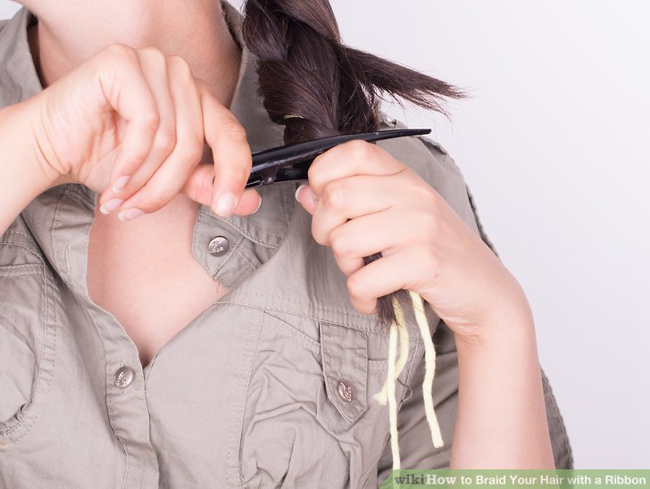](https://www.wikihow.com/Braid-Your-Hair-with-a-Ribbon?fbclid=IwAR062fzWnKPP21xqYxWCtgS4x5-4PKLWcxela8MrC-L_Hah4qVTIPrvVb0g#/Image:Braid-Your-Hair-with-a-Ribbon-Step-7.jpg)](https://www.wikihow.com/Braid-Your-Hair-with-a-Ribbon?fbclid=IwAR062fzWnKPP21xqYxWCtgS4x5-4PKLWcxela8MrC-L_Hah4qVTIPrvVb0g" \l "/Image:Braid-Your-Hair-with-a-Ribbon-Step-7.jpg)

**08.**

Done. The braided hair now contains a strand of ribbon running through it. At each upturned interval of the hair section that contains the ribbon, the color will show outward for everyone to see. It's a very effective look, especially when paired with your clothing color scheme.

[[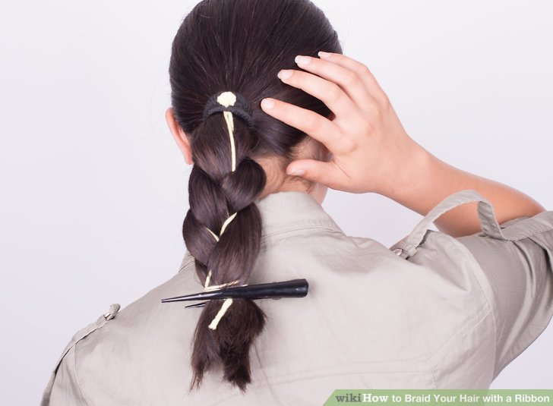](https://www.wikihow.com/Braid-Your-Hair-with-a-Ribbon?fbclid=IwAR062fzWnKPP21xqYxWCtgS4x5-4PKLWcxela8MrC-L_Hah4qVTIPrvVb0g#/Image:Braid-Your-Hair-with-a-Ribbon-Step-8.jpg)](https://www.wikihow.com/Braid-Your-Hair-with-a-Ribbon?fbclid=IwAR062fzWnKPP21xqYxWCtgS4x5-4PKLWcxela8MrC-L_Hah4qVTIPrvVb0g" \l "/Image:Braid-Your-Hair-with-a-Ribbon-Step-8.jpg)

**06. Braiding Hair**

**Materials Needed:**

• Hair Brush

• Hair tie of choice

• Detangler (optional – see trouble shooting section near the end for more details)

**Preface:**

• The colored ribbons in the pictures and instructions are for instruction clarification only. You do not need to add these ribbons to the hair you are braiding.

• Braiding works best on middle length to long hair. Too short of hair (above the shoulder length) is too short and will not work as well.

## Step 1: Start Off by Brushing Through the Hair. – Figure 1

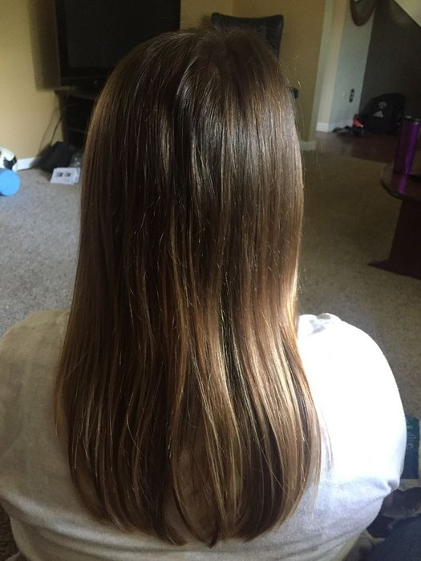

Helpful tip:

• If the hair is very tangled, start by brushing the ends of the hair first. Start brushing the bottom of the hair and then brush the middle half of the hair down to the ends, and then brush from the scalp down to the ends.

## Step 2: Pull All of the Hair Towards the Back of the Head and Split It Into Three Sections (Pink- Left Strand, Brown- Middle Strand, and Yellow- Right Strand) – Figure 2

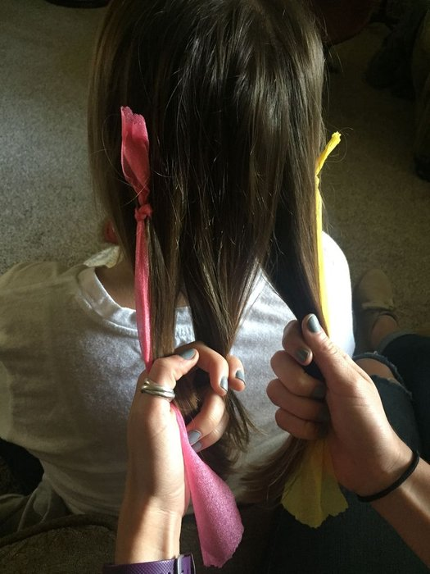

Helpful tip:

• Hold two strands with one hand, and one strand with the other hand.

## Step 3: Next, Bring the Yellow Strand Over the Brown Strand and Into the Middle. - Figure 3

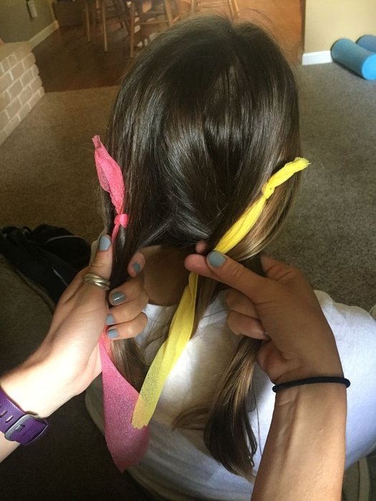

Helpful tip:

• Try not to ever drop a strand of hair; you should always have two strands in one hand and one strand in the other hand.

• Since the yellow strand is now in the middle, the brown strand should be on the right side.

## Step 4: Now Bring the Pink Strand Over the Yellow Strand and Into the Middle. – Figure 4

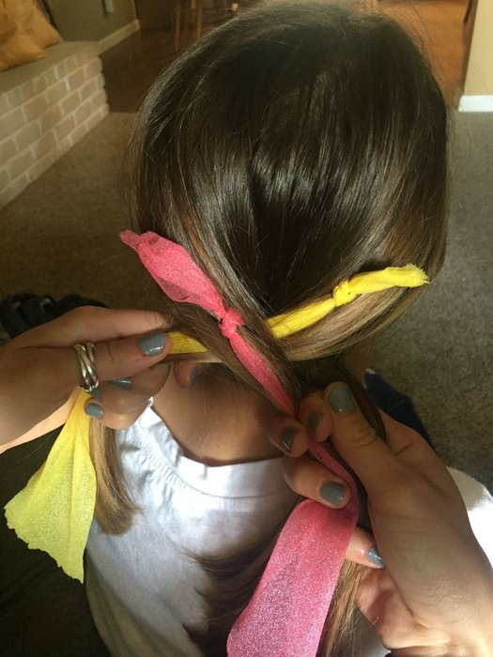

Helpful tip:

• Since the pink strand is now in the middle, the yellow strand should be on the left side.

## Step 5: Next, Bring the Brown Strand Over the Pink Strand and Into the Middle. – Figure 5

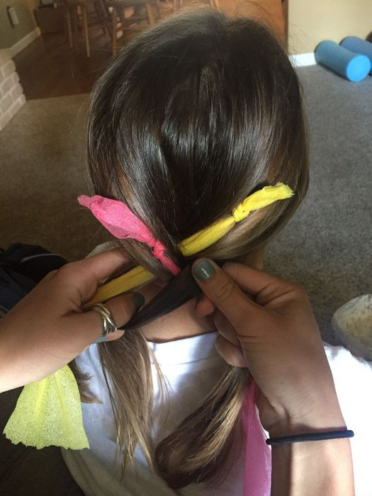

Helpful tip:

• Since the brown strand is now in the middle, the pink strand should be on the right side.

## Step 6: Repeat This Process Until You Reach the End of the Hair. – Figure 6

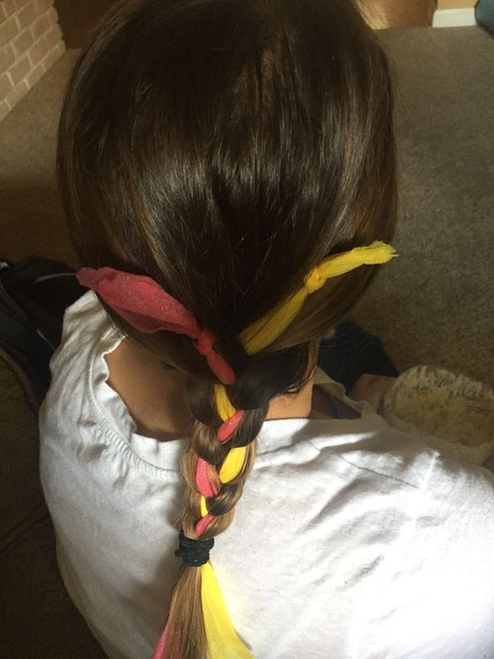

Helpful tip:

* If you run out of hair for one of the strands, make sure that you are not letting the braid be too loose. If there is a gap wide enough that you could easily stick two or more fingers through, most likely you need to tighten up your braid.

## Step 7: Tie the Hair Tie at the End of the Braid to Secure It in Place. – Figure 6



Helpful tip:

• You can use any hair tie you choose.

**07. Chain Braid**

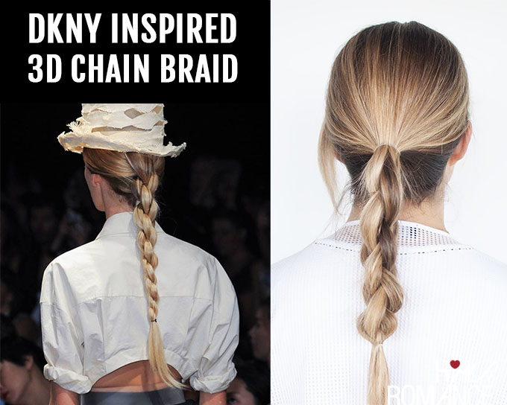

## What you need:

* 2 clear hair elastics

## Step-by-step:

1. Start by splitting your ponytail into 4 equal sections and hold them in your left hand with your palm up.
2. Then with your right hand, pick up the 2nd and 4th sections to become the new 1st & 2nd sections, then flip the 1st and 3rd sections to become the 3rd and 4th sections.
3. You then repeat the same process from hand to hand. Pick up section 2 and place it between your thumb & forefinger on your left hand and then place section 4 between your forefinger and middle finger. Then section 1 goes between your middle finger and ring finger and section 3 goes between your ring finger and little finger.
4. Continue the same technique, picking up sections 2 and 4, then flip your hand over to place sections 1 and 3 in the opposite hand.
5. Secure the end of your braid with a small clear elastic and stretch it out gently to emphasise the shape of the braid.

## Styling Tips

* You will need another pair of hands to do this style unless your hair is very long. If you want to DIY, try a side ponytail so that it’s easier to reach.
* If you want to, you can snip out the top hair elastic once your braid is complete.
* I find it easier to talk the steps through while I do this braid to keep track of the technique. Once you’ve practiced a couple of times you’ll get the hang of this style.
* This braid creates a beautiful shape in your hair which would look incredible in a bun too. I wish I’d photographed that in Laura’s hair! Maybe next time

# C:\Users\My\Pictures\Hair-Romance-DKNY-inspired-3D-chain-link-braid-tutorial.jpg

**08. Top Knot**

The top knot is one of our very favorite [updos](https://www.lorealparisusa.com/beauty-magazine/hair-style/updo-and-bun-hairstyles.aspx?page=1) for a reason. For starters, it’s super-easy to throw your mane up into one when you’re running late and don’t have time to straighten or curl your hair. (Seriously, heat styling your hair takes a whole lot of work!) And second of all, there’s just something about a top knot that is oh-so-chic, isn’t there? Of course, while the top knot is great for busy mornings, there is a certain technique to it. The good news is, it’s not difficult. Whether you want to rock a sleep top knot or one that’s on the messier side, we’ve got you covered. Follow along with our two tutorials below!

### The Sleek Top Knot

For a slick look, opt for the classic, sleek top knot. Keep this in mind: This hairstyle is a particularly good choice for second-day hair that you just haven’t had the chance to wash. It’s an easy way to get your hair off your face—and it doesn’t hurt that it looks great on just about everyone.

**What you’ll need:**

* Texturizing spray
* Hair elastic
* Bobby pins

**Get the look by following these simple steps:**

**Step 1:** Start by spritzing on a little bit of texturizing spray to give your hair some grit.

**Step 2:** Brush your hair to evenly distribute the texturizing spray before creating your top knot.

**Step 3:** Pull your hair back into a high [ponytail](http://www.lorealparisusa.com/beauty-magazine/hair-style/updo-and-bun-hairstyles/how-to-do-the-perfect-ponytail.aspx) and tie it with a hair elastic. When making the ponytail, try to include all of your loose hairs so that you can get that sleek look.

**Step 4:** Take the length of your hair and wind it around the base of your ponytail.

**Step 5:** Secure it with a couple of bobby pins.

**Step 6:** Finish off your look with a hairspray

### The Messy Top Knot

For an edgy look that boosts a ton of texture, it’s time to try a messy top knot. Think of this hairstyle as a more put together version of the messy bun. They two differ in that top knots are still situated at...you guessed it…the top of your head! The messy top knot is one of the best hairstyles to try on those lazy days when you don’t feel like doing much but still want to look good.

**What you’ll need:**

* Bobby pins
* **Hairspray**

**Get the look by following these simple steps:**

* **Step 1:** You can either create this look on freshly-washed strands or on second-day hair. If you’re going to wash your hair, spritz on a wave spray, to towel-tried hair to help create some texture. Then, let your hair air dry. If you’re working with second-day hair, use a texturizing spray instead.
* **Step 2:** Like with the sleek top knot, pull your hair into to a high ponytail—but this time you don’t have to worry about flyaways. (Aren’t you happy that messy hairstyles are in?)
* **Step 3:** Divide your ponytail into two parts and then wrap each part in opposite directions.
* **Step 4:** Secure the bun with a couple of bobby pins—and remember, the messier the better!
* **Step 5:** If you want, you can gently pull at the top of your hair to make it look even messier. It’s up to you!

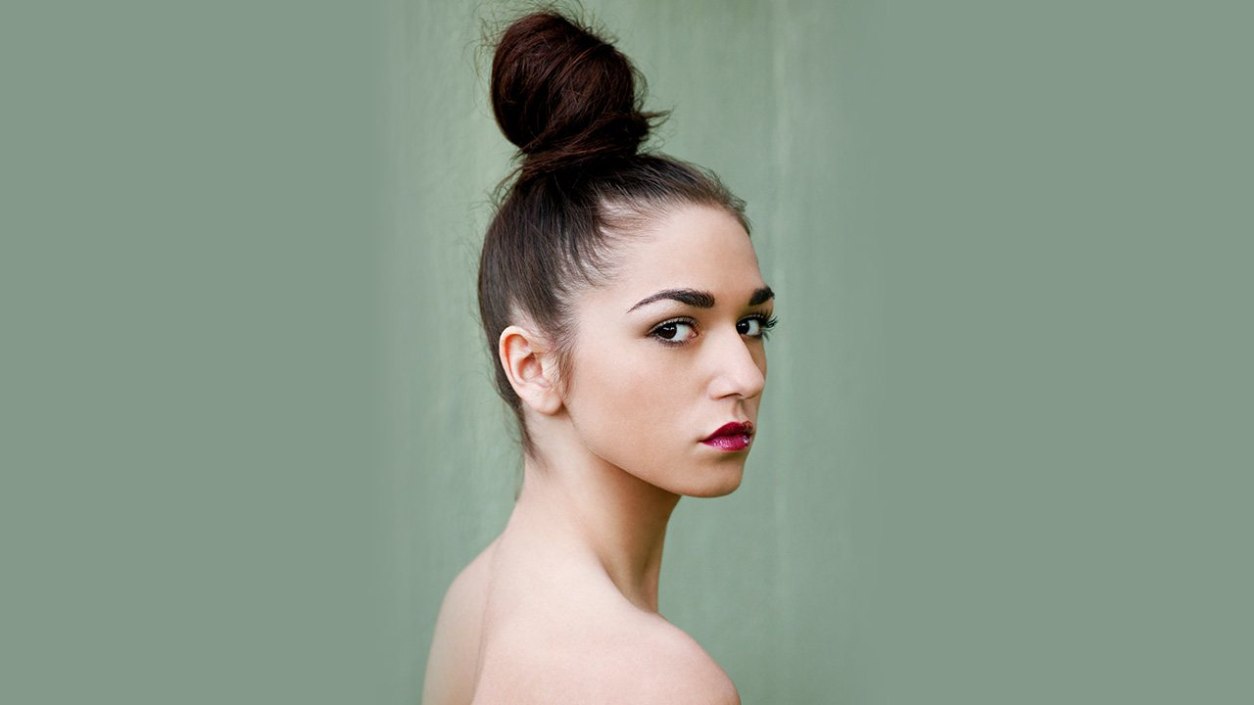

**Steps**

### Tame It

Add a soft holding spray or moisturizing product to your hair. This will tame flyaways and nourish your tresses while it's in this protective style.

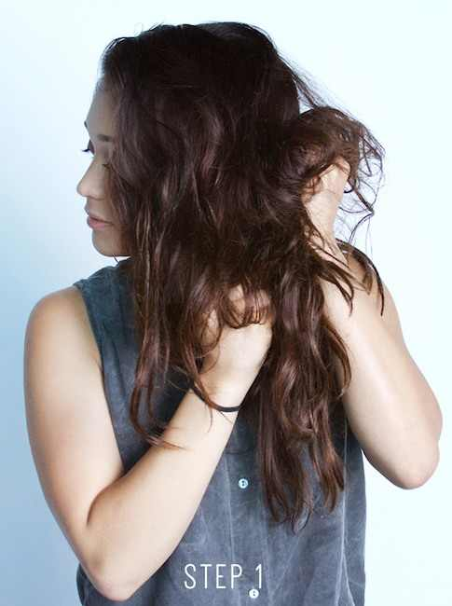

### Brush It

Brush your hair towards the center of your head.

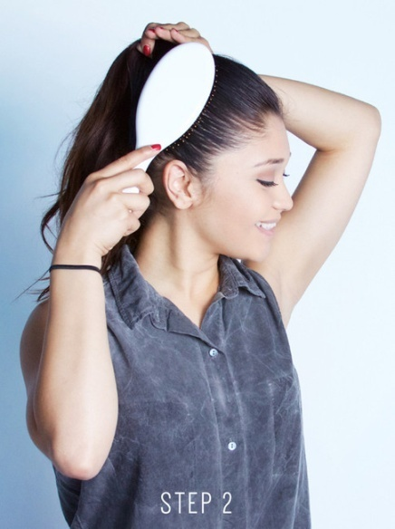

### Secure It

Secure the high ponytail with a hair tie.

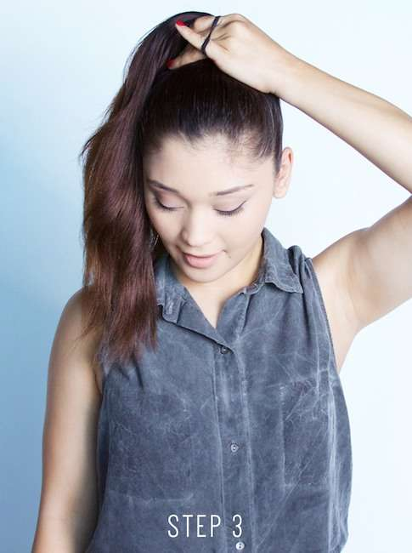

### Twist It

Twist your ponytail, so it's easier to form a circular bun.

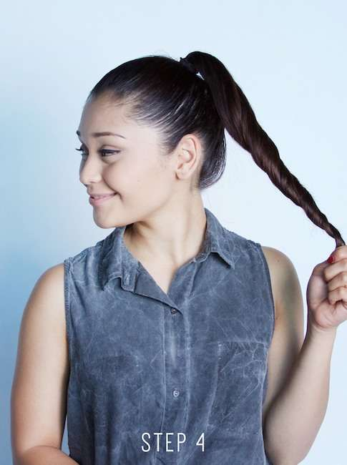

### Wrap It

Wrap your twisted ponytail around the base of the hair tie. Once you've completed one circle around, wrap the remaining hair below your newly formed bun.

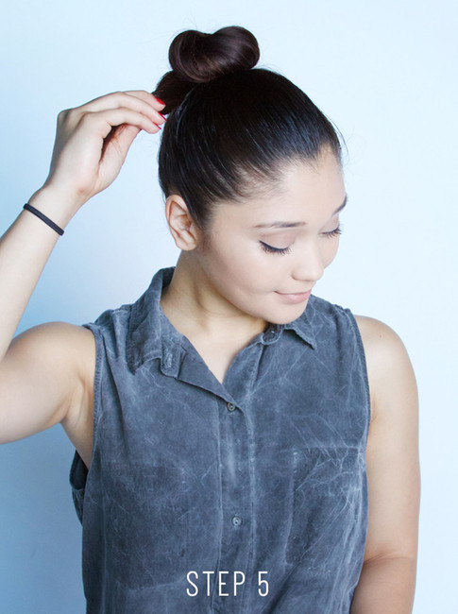

### Pin It

Using a bobby pin, tuck the remaining hair under the base of the bun.

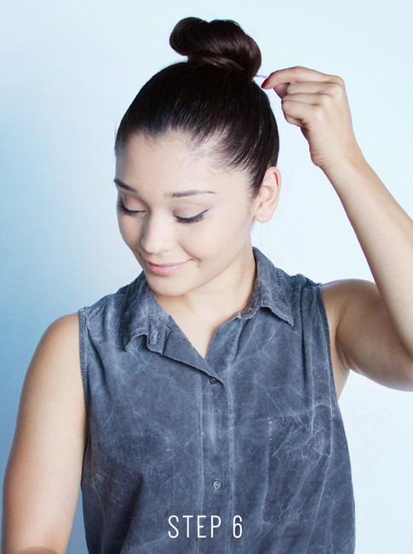

# 09. Front Twist

A twisted crown hairstyle is similar to a milkmaid brad style, where you wrap your hair around your head. Instead of using Dutch and regular braids, however, you use twisted braids instead. You can do a standard up-do, where you pull all of your hair up into a twisted crown. You can also try a relaxed version, where you only pull part of your hair up into the twisted crown, leaving the bottom part of your hair loose, like a half-up, half-down ponytail.

### Method 1

**01**

**Brush your hair to remove any tangles.** Some people find it easier to do this with wet hair.[[1]](https://www.wikihow.com/Do-a-Twisted-Crown-Hairstyle?fbclid=IwAR0cevWx1ldkCfrBd9gXrD9fK98QovFINTBgxwdFO1PFoCOakCkYBte0PuM#_note-1) Other people find it easier with dry hair. If you are going with freshly-washed dry hair, however, you might want to apply some texturizing spray or mousse to it to make it easier to work with

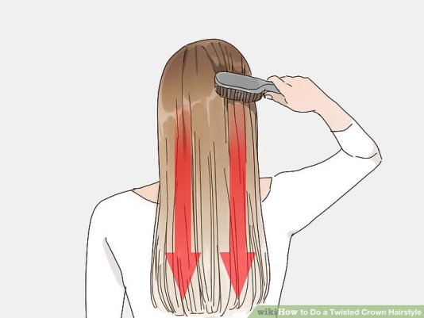

**02**

**Gather two sections from your hairline, right next to the part.** It does not matter which side of the part you will start from.This style will end up looking like a braided crown around you head, similar to a milkmaid braid style.

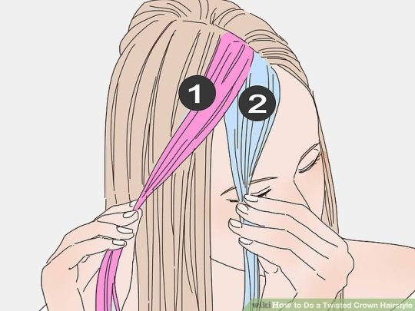

**03**

**Twist and cross the two sections.** Twist both sections towards your face, like starting a rope. Next, cross one section over the other towards the back of your head.

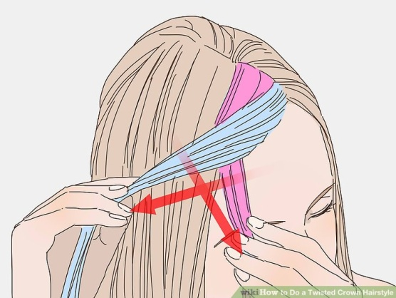

**04**

**Add some hair to the section that's closer to your face.** Gather some hair from your hairline. Add it to the bottom section—the one that is closer to your face.

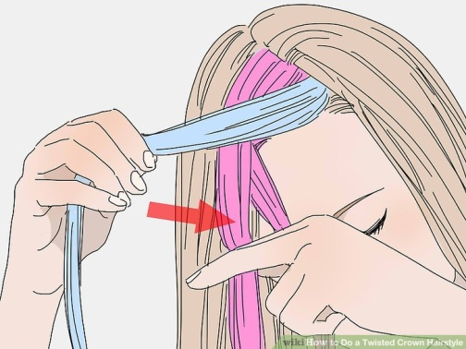

**05**

**Twist and cross the two sections again.** Twist the front section towards your face. Cross it over the back one. What used to be the back section should now be in front.

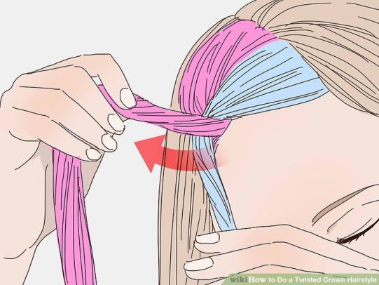

**06**

**Repeat the process until you reach the back of you head.** Keep gathering hair from your hairline and adding it to the front section before twisting and crossing it over. Only add hair to the front section, not the back one. When you reach the nape of your neck, stop.

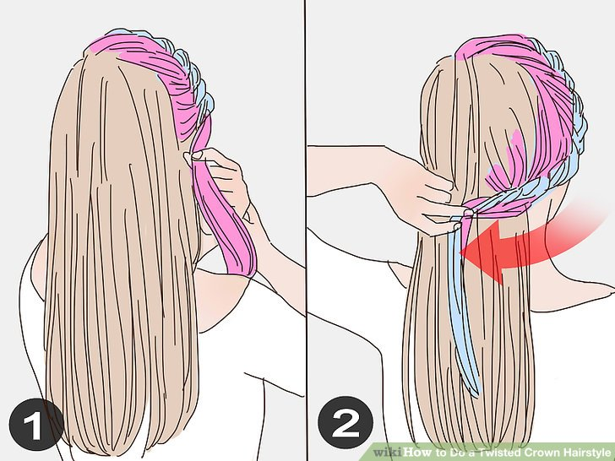

**07**

**Finish off with a rope braid.** Gather all of your hair into a ponytail, then split it into two sections. Twist each section towards the right to form two ropes. Next, twist the sections together towards the left to form one rope. Tie the rope off with a clear elastic

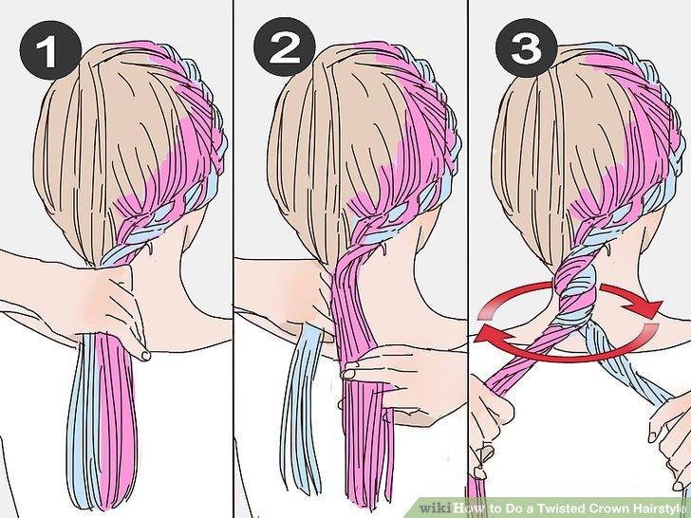

**08**

**Wrap the rope around your head and pin it in place.** Pull the braid across the back of your head, up the side, and back towards where you started. Secure it to the start of the braid with bobby pins

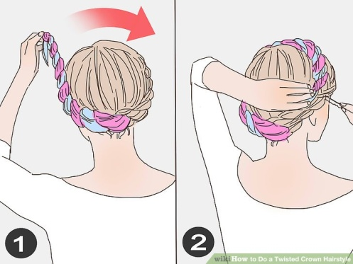

**09**

**Muss up your hair, if desired.** You don't have to do this, but it will help give you a more boho-chic touch. Set your style with a light misting of hairspray, if needed.

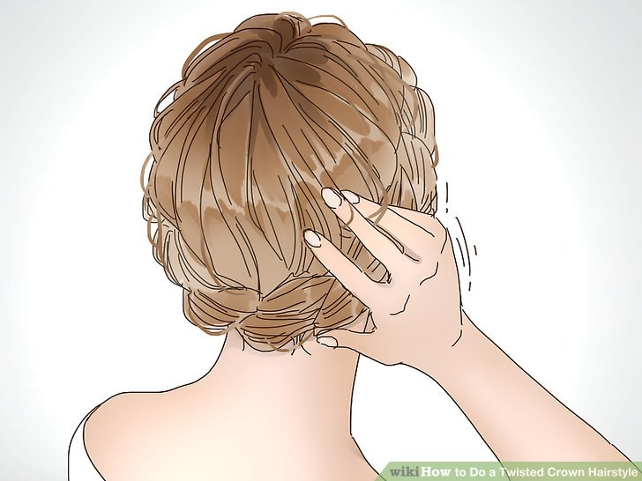

**10. Zipper Braid**

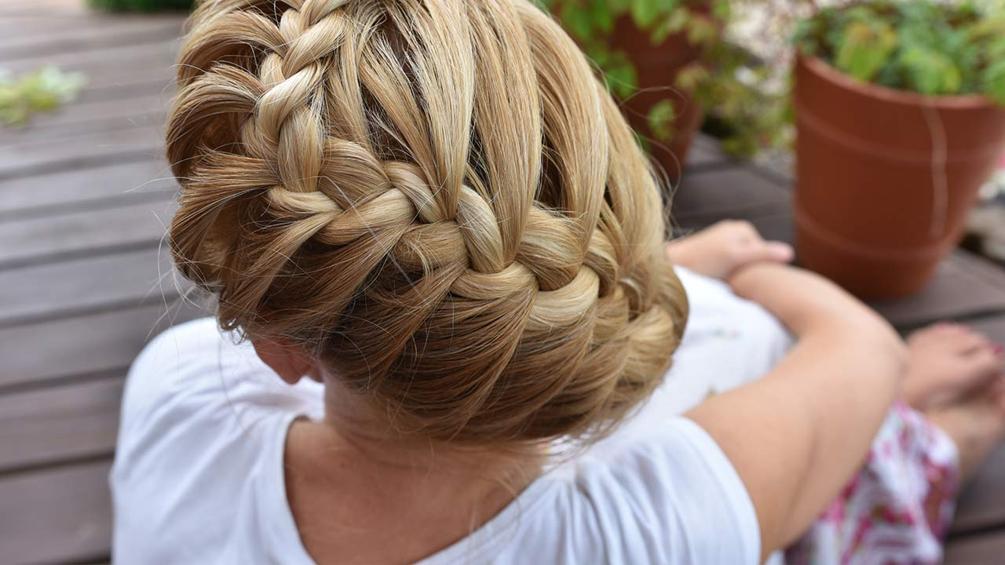

**Get the look by following these simple steps:**

**Step 1:**

**Dampen your hair.** Believe it or not, braids can be significantly easier to create when your hair is slightly damp. So, spritz on a little water before you begin your zipper braid.

**Step 2:**

**Start with a small section at your hairline.** Grab a section of hair that’s about two inches wide and divide it into three even strands.

**Step 3:**

**Create your first base weave.** To do this, take the middle strand over the left strand, followed by the new middle strand over the right strand. Congratulations: you’ve created your first base stitch. Not too difficult so far, right?

**Step 4:**

**Here’s where things get a bit more complicated.** After your first stitch, take the new middle strand over the left strand before looping it under the two strands to the right. This process secures the stitch in place so that no hair will slip out of your zipper braid. Make sure to hold that strand in place while moving to your next step.

**Step 5:**

**Grab a small section of hair from the right side of your head.** This will be your new strand since the other one is locked in place.

**Step 6:**

**Stitch your new right strand.** Loop it over the middle section and under the left. After completing these two stitches, your base is officially set and it’s time to begin zipper stitching. Yup, that wasn’t even the hard part. Just make sure you still have that right strand in your hand held tight so that your work doesn’t unravel.

**Step 7:**

**It’s zipper time!** Grab a section of hair from the left side of your head and take it over the middle section and under the right section. Hold this section in your hand, along with the other section you’ve been holding, without combining them together. At this point of juggling strands, you might wish you had a little help. If you someone else is around, consider getting them involved!

**Step 8:**

**Complete your first zipper stitch.**

Take the first right strand out of your friend’s hand and weave it under the new section you just gave her so that you can add it to the middle strand. Just think of this as a little sandwiching technique around the section you just gave her.

**Step 9:**

**Complete the same process on the right side of your head.** Grab a chunk of hair, take it over the middle strand and under the left strand, holding it with the first left strand that was held out of the way. Then wrap the first section in your hand under the new section to add it to the middle section.

**Step 10:**

**Repeat the process all the way to the ends.** It’s tricky, but as you continue weaving, you’ll quickly watch your zipper braid take shape. Once you reach the ends, just finish your braid off with a clear mini elastic and fluff it up a bit for a more voluminous-looking braid.

# [11. French Knot](https://hair-styling.wonderhowto.com/how-to/make-french-knot-hairstyle-easy-way-0148236/)

## 

## C:\Users\My\Pictures\1.jpg

## Step 1

## Separate a Section of Hair

Comb your hair thoroughly so that they become smoother and easier to manage. Neatly separate a section of hair from the central region of the top of your head.

# C:\Users\My\Pictures\1.1.jpg

## Step 2

## Start a Pony

Again, comb your hair entirely, including the separately held section and hold them together as you do while making a pony.

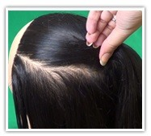

## Step 3

## Twist Pony Around Left Fingers

Hold the base of the pony and twist the pony so that it covers your left hand fingers.

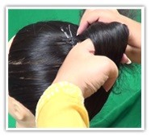

## Step 4

## Start Forming the Bun

Now remove your left hand from the center of the twisted pony keeping it tight and fix it at the top using bobby pins on all its sides so that it forms a bun. Similarly fix the tail. Settle the extra hair which may come out of the bun.

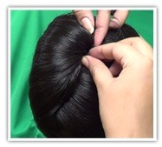

## Step 5

## Finish the French Knot

Tighten the bun as much as possible. Use a hair spray for a shiny look. Add flowers or any other catchy hair accessory to enhance your look. Surely you have the urge for a better look.

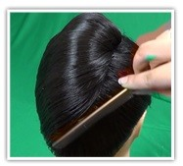

**12. Half-Up Twist Hairstyle**

This style is remarkably simple a couple of twists, a few pins, and you’re done and yet it’s undeniably striking.

### Step 1

Begin by separating the hair at your crown area. Using a fine-tooth comb, tease the hair by slowly combing it toward your scalp.

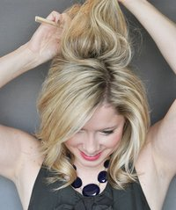

### Step 2

With your fingers (or the wide-tooth end of the comb), smooth the hair to cover the teasing. Then secure that top section of hair, up at your crown, with a few bobby pins inserted horizontally.

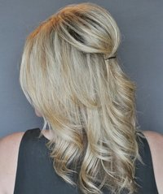

### Step 3

Separate a section of hair in front of one ear and twist it toward the back. Position the twist on top of the previously inserted pins to cover them. Insert a bobby pin or two into the twist to secure it. Repeat on the other side.

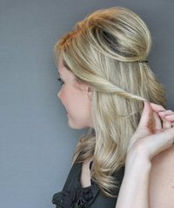

### Step 4

Check the back of your style with a hand mirror and make sure all the bobby pins are covered. Stretch out the twists if you need to. Finish with a mist of hair spray.

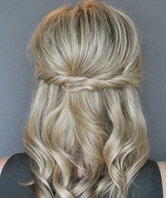

# 13. [French Knot](https://www.wikihow.com/Make-French-Knot-Easy-Way-Hair-Style)

The French knot is a classic, simple hairstyle that’s perfect for work, school, or simply a day out with friends. While it looks sleek and polished, it’s actually very simple to create. With just a little bit of practice and the proper hair supplies, you can create this gorgeous look.

### Part 1 - Prepping Your Hair

**01.Work with second day hair.**

While some hairstyles may work best with freshly washed, perfectly clean hair, the French knot actually works best with slightly dirty hair. When hair is immaculately clean, it’s often silky and hard to hold in place. While satin hair is often nice, it will slide out of your pins and the hairstyle won’t hold for the entire day. Hair that hasn’t been washed in a day or two will be full of natural oils that will help you create a shape that stays.

* If you have your heart set on wearing a French knot right now but you just washed your hair, don’t worry. You can mimic second day hair with product, which will be discussed later.

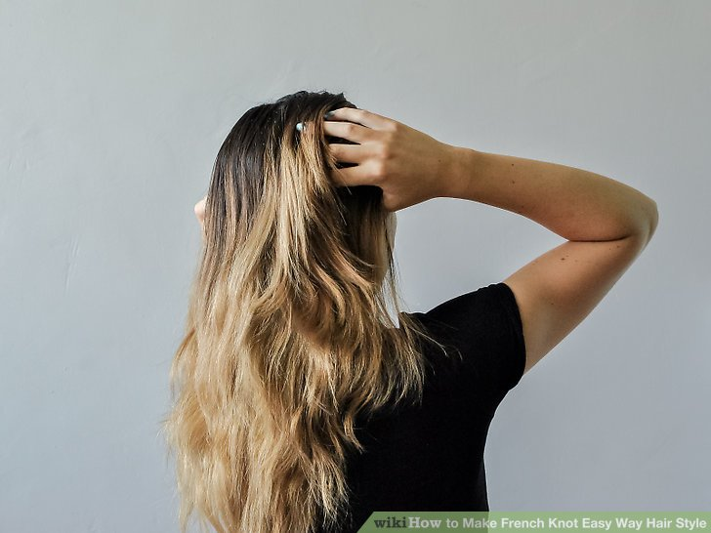

**02.Comb out your hair.**

Before you start creating your French knot, it’s important to work out all the tangles and knots. Begin combing from the bottom, slowly bringing your comb higher and higher. Don’t tug on your hair, as that can cause breakage. If you come across a tangle, gently focus on that section of hair until it’s untangled. Continue combing until you’re confident all of the tangles have been worked out.

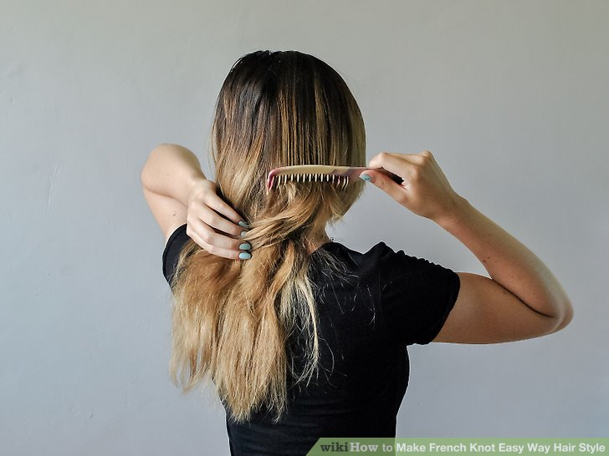

**03. Spray with dry shampoo or a texturizing spray.**

This step is especially important if your hair was recently washed, but it’s helpful to use a product on second or third day hair as well. Dry shampoo or texturizing spray both add a bit of “grit” to your hair, giving it texture that will keep it in your bobby pins. If your hair is silky and sleek, spray your hair with one of these products to make it a bit more coarse.

* Start spraying the product about an inch from your roots, coating your hair thoroughly and then running your hands through your hair to work the product in.

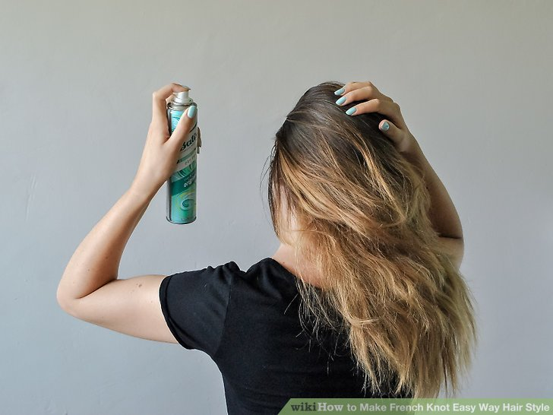

### Part 2 - Creating the Knot

**01. Divide your hair into three sections.**

There should be two front sections on either side of your face, and one section down the back of your head. All of the sections should be equal sizes, so the actual size of each section will differ depending on how much hair you have on your head! Part your hair however you normally do. Side or middle parts both work fine. You will be working with the back section first, so bring the two front sections in front of your shoulders.

* If it is helpful, you can also clip the two front sections out of the way.

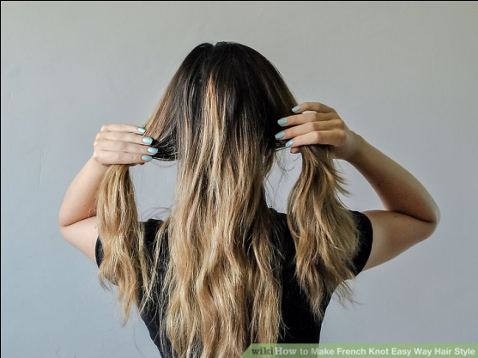

**02. Tease the hair in the back section.**

You want to tease the hair at the base, or roots, of the middle section of hair you created. Teasing your hair is a simple way to create volume and to create texture for bobby pins to hold onto. It will ensure that your French knot stays in place.

* Grab a teasing comb, and place it a couple of inches away from the root of your hair.
* Gently back-comb, or push your hair up, by moving the comb towards the root of your hair. In other words, you are strategically roughing up the hair, creating a little patch of “tangles” at the root of your hair.
* Do this only on the hair at the bottom of the middle section. Feel free to clip the top of the middle section out of the way to do this successfully.

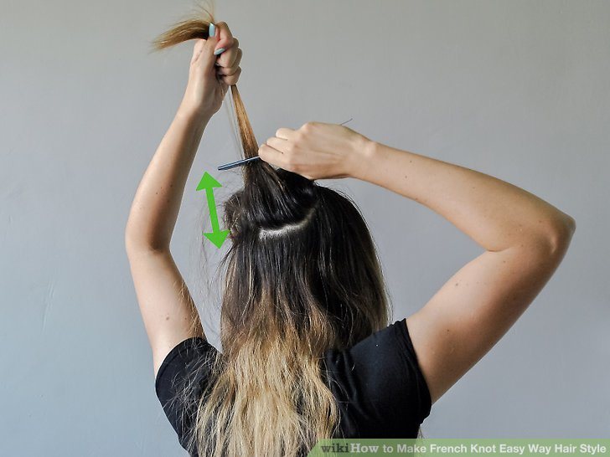

**03. Tease the hair in the back section.**

You want to tease the hair at the base, or roots, of the middle section of hair you created. Teasing your hair is a simple way to create volume and to create texture for bobby pins to hold onto. It will ensure that your French knot stays in place.

* Grab a teasing comb, and place it a couple of inches away from the root of your hair.
* Gently back-comb, or push your hair up, by moving the comb towards the root of your hair. In other words, you are strategically roughing up the hair, creating a little patch of “tangles” at the root of your hair.
* Do this only on the hair at the bottom of the middle section. Feel free to clip the top of the middle section out of the way to do this successfully.

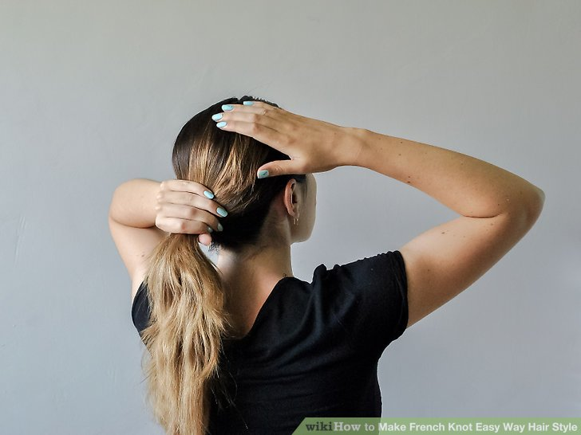

**04. Twist your ponytail to create the knot.**

Twist your ponytail at the base so that you feel it tighten up near your scalp. Then bring the length of your ponytail to your head, so that it’s flattened against your head. After your hair is tucked to your head, gently push on one side of the ponytail so that it becomes tucked into your hair. In other words, the hair from the ponytail should almost become concealed, pushed into the rest of your hair.

* This is the part of your French knot that will require practice. It is helpful to bring up a YouTube tutorial for this part so you can see what this step actually looks like.
* After you understand the concept, practice it a few times. Soon, you will develop muscle memory and the French knot will become second nature!

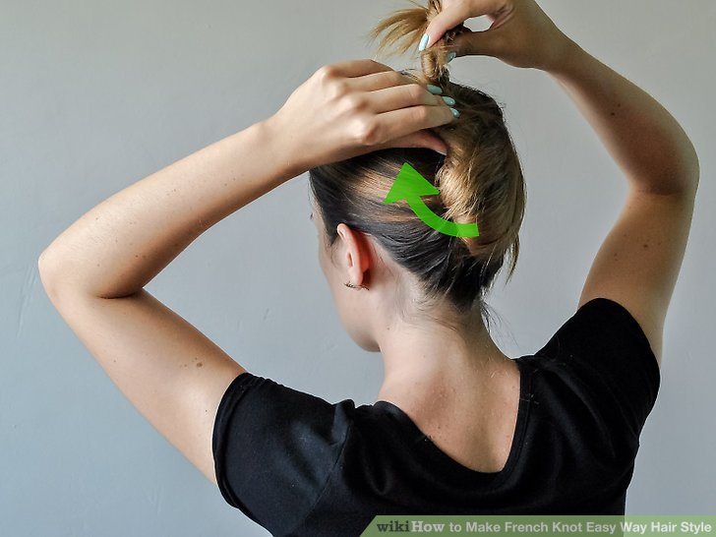

**05. Slide bobby pins into the knot to hold it in place.**

Open the bobby pins a bit with your fingers, so that they can grasp a bigger section of hair. Slide them into your knot so that they are holding both the “knot” section created by the ponytail and the hair at the base. Use as many bobby pins as you need until the knot feels secure.

* Because you will probably end up using a fair amount of bobby pins, find ones that match your hair color. The French knot should appear simple and effortless, and the bobby pins should be invisible.

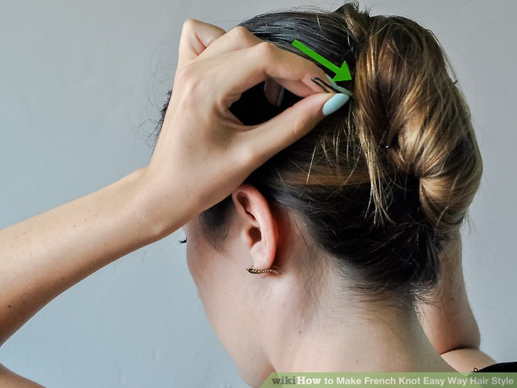

### Part 3 - Finishing the Look

**01. Style any short pieces near your face.**

If you have bangs or short wisps that frame your face, style them however you like. Leave them untouched, create a soft curl with a curling iron, or make a sleek, straight style with a flat iron. If you would rather not have any hair near your face, use extra bobby pins to pull these strands back and secure them at the sides of your head.

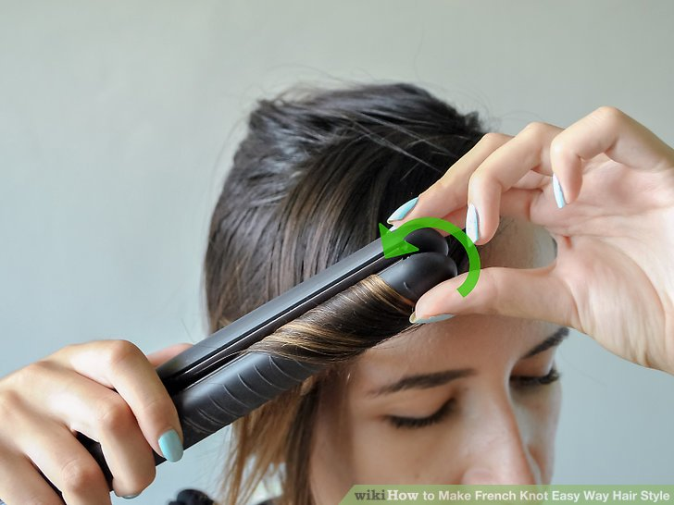

**02. Spray your French knot with hairspray.**

Even if your hair feels completely secure with bobby pins, it’s smart to give your French knot a spritz of hairspray as well. This will ensure that your knot stays in place all day, and it will also help to eliminate frizz. Don’t over-do it– no one wants their hair to look like hard plastic.

* Hold the hairspray about 6 inches away from your hair and only hold down the spray for a second.
* Once you’ve applied the hair spray, avoid touching your French knot. This can cause frizz and ruin the sleek look you’ve created.

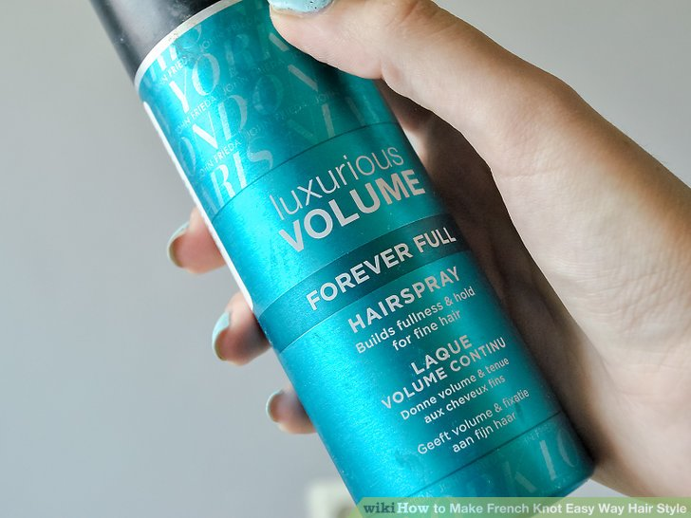

**04. Bring bobby pins along with you.**

If you’re going to be out of the house all day, make sure you throw a couple of bobby pins in your purse or backpack. The French knot is a great style because of its simplicity and elegance, but one big stray hair can really throw off the entire thing. In case of stray pieces of hair, turbulence, or unforeseen bad weather, it’s always important to bring emergency touch-up supplies!

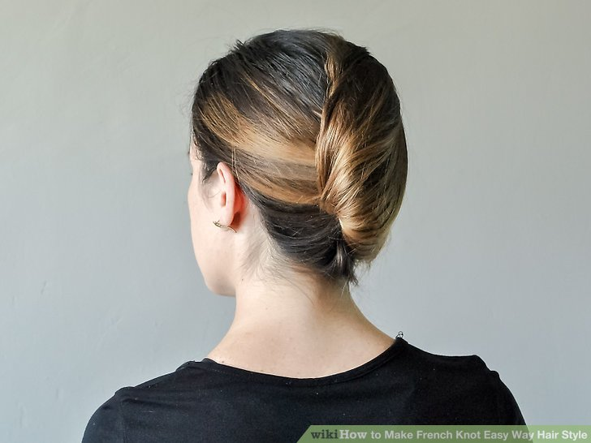

**14. Hair Swirl**

## Step One: The Side Part

Part your hair on the side that suits you best. Then divide again about three inches back starting at the end of the first part, taking it down to your ear. Pin remaining hair back.

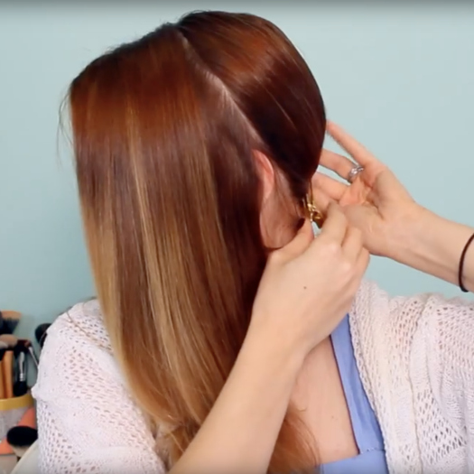

## Step Two: Curl Time

Start at the front, curling one-inch sections of the hair and pinning these curls into place to cool. Now curl the bottom layers of your hair and work your way up, pinning and setting each curl. Wait for your curls to cool off completely.

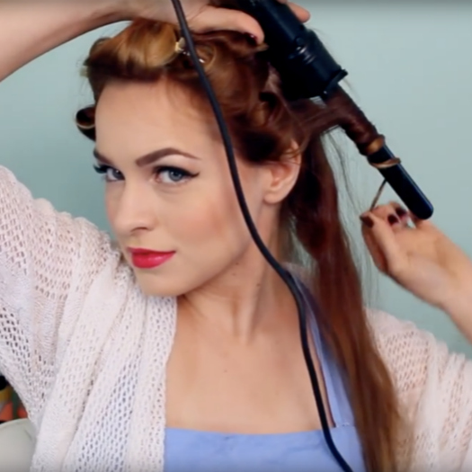

## Step Three: Brush & Shine

Leaving the top curls pinned, remove the pins from all other curls and begin gently brushing them out with a boar bristle brush. Spray your curls with [Shine Spray](https://numeusa.com/hottie-alert-shine-spray) to reduce post-brush frizz.

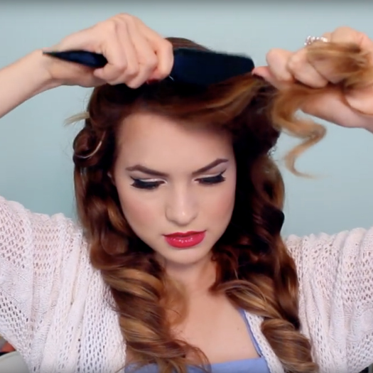

## Step Four: Victory Rolls

Release curls, brushing these out in the same fashion and tease for volume. Taking the deeper side part, roll the hair away from your face and turn the roll so that the center faces slightly forward. Pin the roll in place. Repeat with the other side.

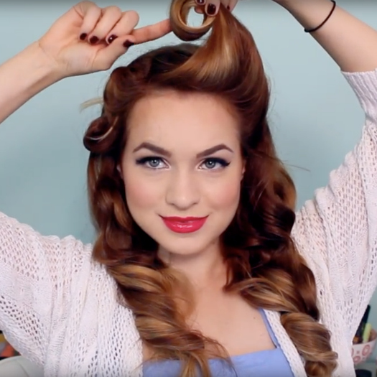

# 15. [French Twist Hair](https://www.wikihow.com/French-Twist-Hair)

When you're in need of an elegant hairstyle, try the classic French twist. This gorgeous look is a common sight at proms and weddings, but you can create a looser, more casual version for everyday wear. Read on to learn how to do a simple French twist or a classic twist with a slight bouffant on top.

### Method 1 - A Simple French Twist

**01.Sweep all your hair to one side.**

If you want the finished look to twist from left to right, brush it to the left side; if you want it to twist from right to left, brush it to the right. Hold your hair in place with your hand.

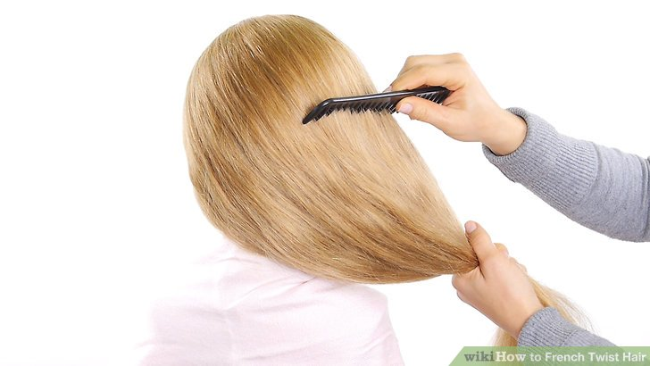

**02**. **Use grips or pins at the back of your hair to hold it in place.**

This will keep the hair pulled to one side. If your hair is long, thick, and heavy, using pins will help to keep it up all day long. Otherwise, you'll find that strands come loose throughout the day.

* You can create several criss crosses going vertically up the back of your head for maximum hold.

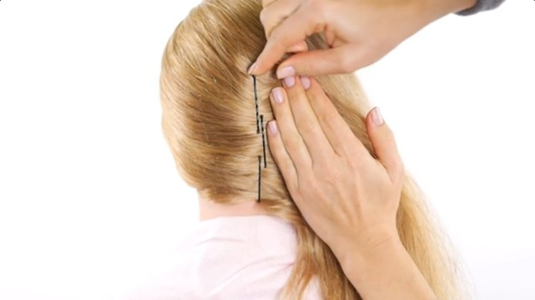

**03.Apply hairspray.**

Spray it lightly all over your hair at this stage if you'd like to keep all stray hairs in place. This can make the style look a little stiff, but it also helps to hold it all day long.

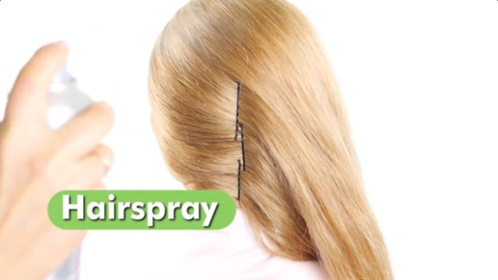

**04. Place your hand underneath the hair and brush it very gently.**

Make sure to brush it to the side so as to keep it in position and not dislodge the pins.

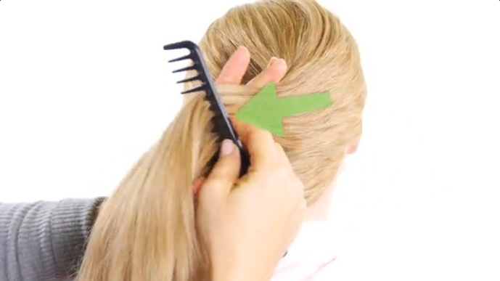

**05. Twist your hair up.**

Lightly grasp the hair and twist in the opposite direction that you swept it. If you swept it from left to right, twist it the other way. Tuck then ends into the tunnel created by the twist, or leave them loose for a more casual look.

* When you’re done, the hair should form a downward-pointing cone; for now, the excess hair will hang off to one side.

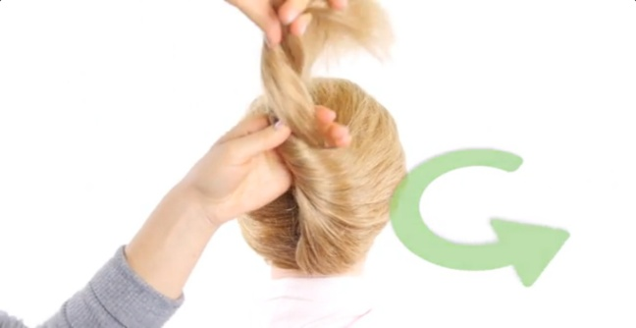

**06. Insert pins to hold the hair in place.**

Feed the tip of the pin into the hair curling through the twist and pin it to the hair along your scalp. Make sure to place the pins so that they’re hidden beneath the twist.

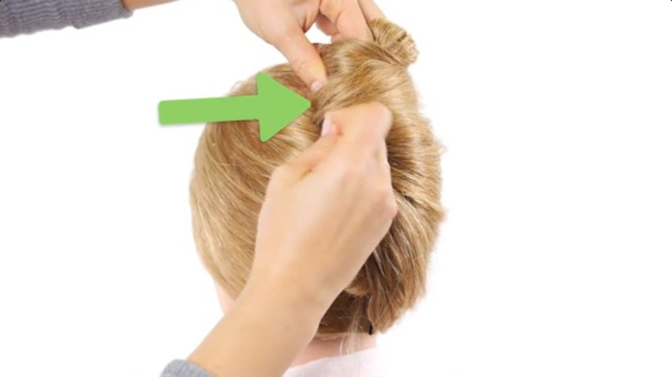

**07. Smooth it out.**

Use a bristle brush or a fine-toothed comb to neaten the style, then use hairspray to hold the twist together.

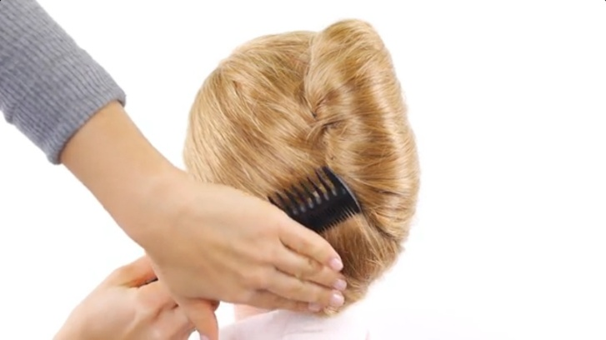

**08. Tuck the loose ends of the hair inside the twist.**

Use pins as needed to hold the ends in place, out of sight.

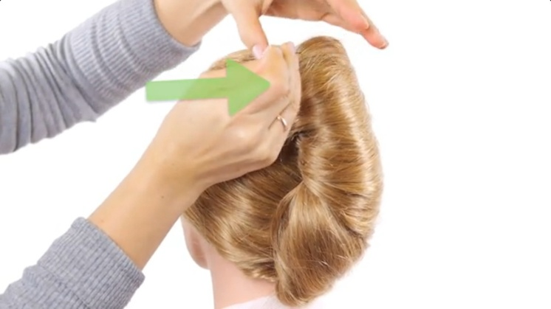 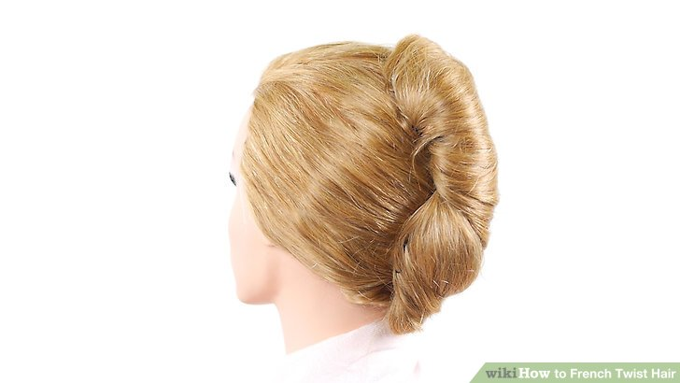

**Finished**

### Method 2 - A Classic French Twist

**01. Comb your hair back.**

Start with all of your hair combed back, without a part.

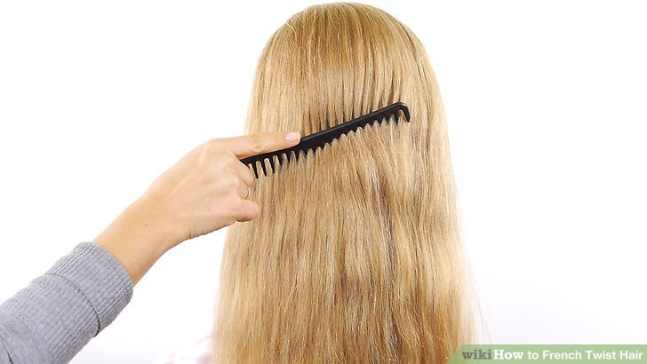

**02. Separate a 3-inch section of hair on top.**

Use a fine-toothed comb to separate a 3-inch section of hair from your forehead to the crown of your head, almost like a mohawk. Lift it above your head to keep it separated.

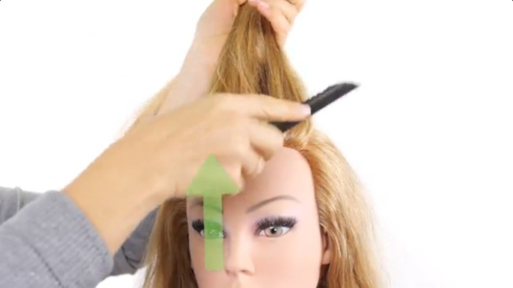

**03. Divide the separated section into 3 sections.**

One section should be in the front, one in the middle, and one at the crown of your head.

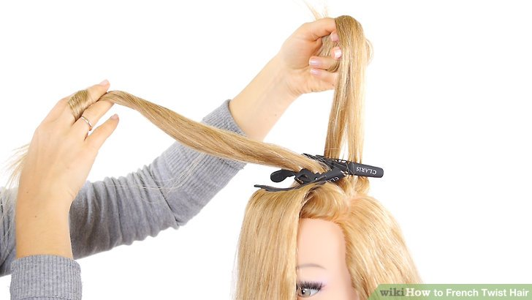

**04. Backcomb the sections.**

Take each of the 3 sections individually and backcomb them by running a fine-toothed comb from the tips to the roots. Tease each section gently, then drop them down toward your face to hold them out of the way for the time being.

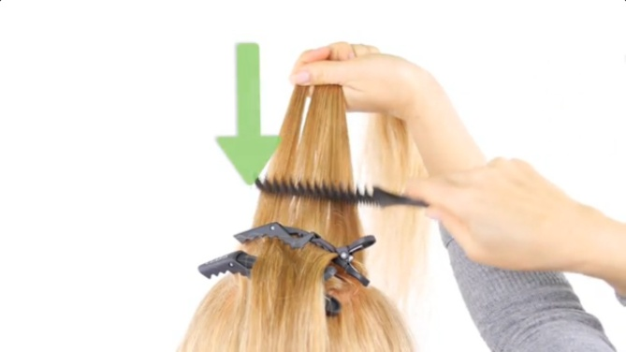

**05. Gather and twist the back of your hair.**

Hold it as if you are making a ponytail, then twist it until you've reached 3/4 way to the roots.

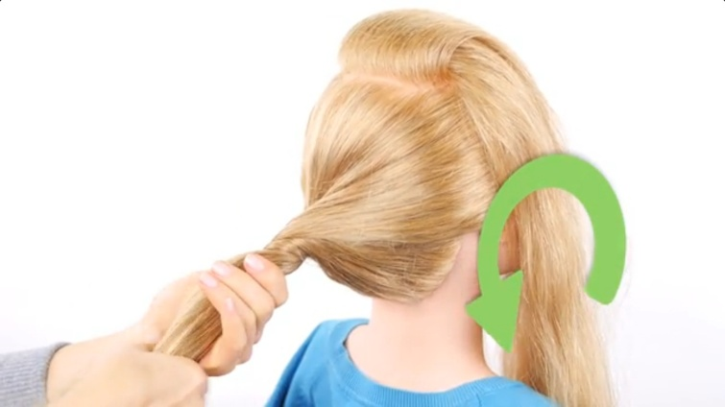

**06. Twist the hair up against your head.**

Now it's starting to look like a French twist! Twist it against your head, then use pins to hold the twist in place.

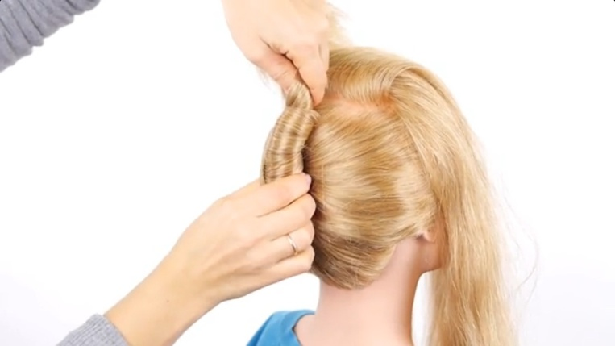

**07. Secure the tips of the hair in a small knot.**

Make a little bun and pin it in place just below the first section of teased hair.

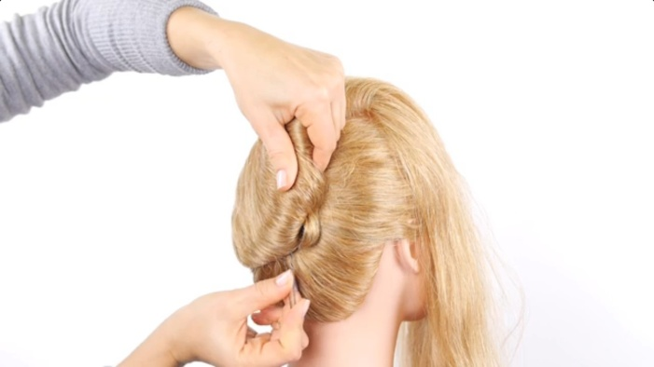

**08. Incorporate the front sections into the twist.**

Pull the front sections of hair that you teased back to the twist, and wrap the ends around the twist. Tuck them into the twist where it meets your head, and use pins to hold them in place.

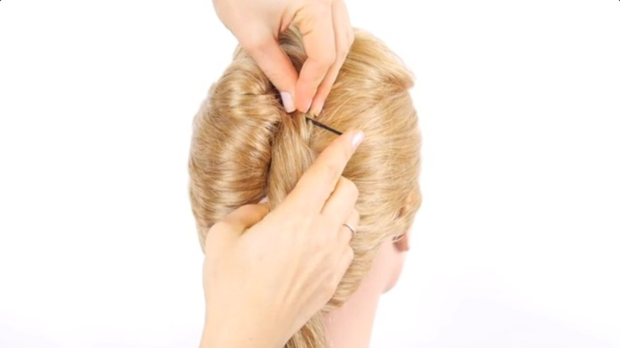

**09. Pin down any remaining loose pieces.**

Your hair should now look like a classic French twist, with a slight lift on top where the hair is teased.

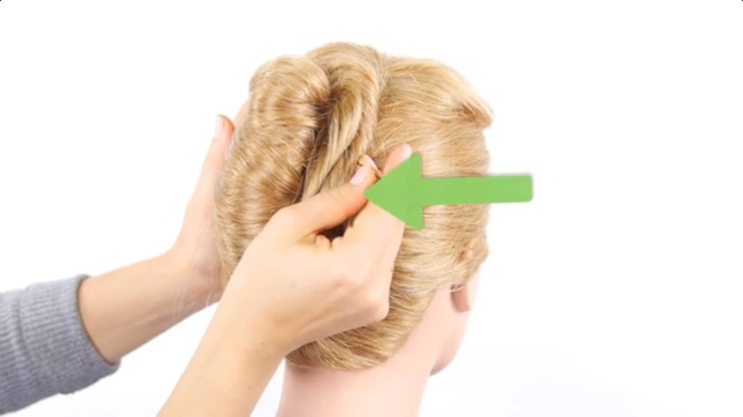

**10. Smooth your hair and neaten the look.**

Use a comb to lightly smooth the top and sides of your hair. Spray your hair with strong-hold hairspray to keep it in place.

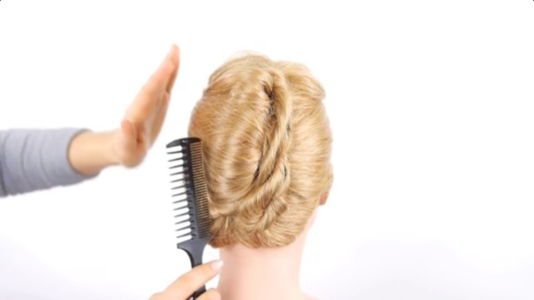

**11. Finished.**

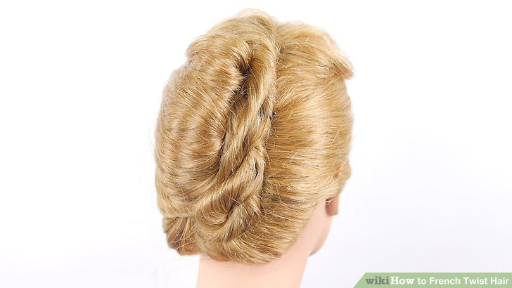

# 16. [Senegalese Twists](https://www.wikihow.com/Do-Senegalese-Twists)

# Senegalese twists are a popular protective hairstyle for Afro-textured hair sported by many trendy, chic women. The look can be created with hair extensions and is easier to do than microbraids, cornrows, and many other braided hairstyles. It takes up to 6 hours to do twists, but they can last 2 to 3 months if well cared for.

### Part 1 - Preparing Your Hair

**01. Determine if your hair is long enough.**

If your natural hair is about 0.75 in (1.9 cm) or longer, you can create Senegalese twists. Senegalese twists work with either natural or relaxed hair; in either case, you will have to use synthetic hair extensions.

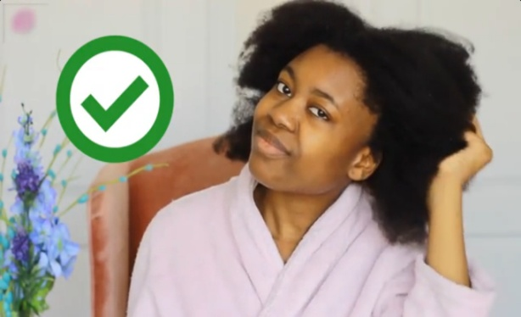

**02. Decide on a type of extension.**

A couple of popular types of synthetic hair extensions to use for this style are the ones labeled Kanekalon (silky braiding hair) and Toyokalon (yaki braiding hair).

* You will need 3 to 4 packages of hair if you're aiming for a medium-length style.
* You can also use Marley hair extensions, but the coarser quality of this type of extension means it is better suited for Marley Twists.

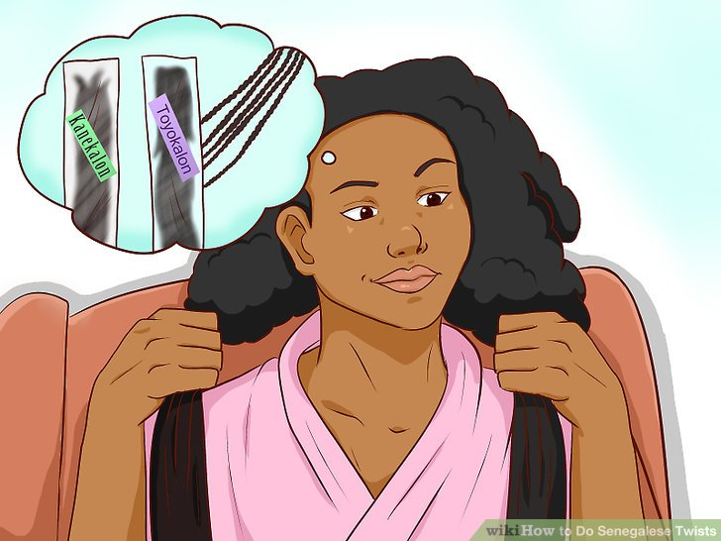

**03. Separate and trim the strands.**

Open the package of extensions and separate the strands of braiding hair, if woven together, by gently rubbing them between your fingers. Separate the extensions into sections based on how wide you want your twists to be. Then, fold each section in half so that it forms a “U” shape. The bend is the point at which the extension section will be added to your real hair, while the two ends will be woven into the twists.

* Proceed to trim the strands to your desired length using salon scissors.

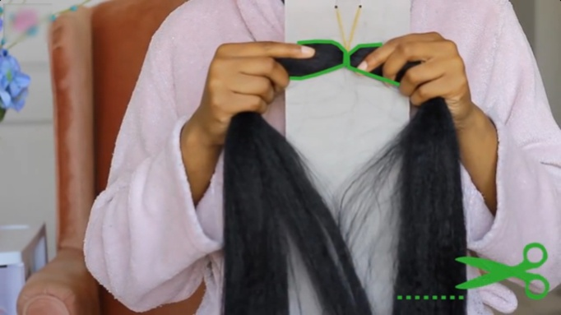

**04. Wash, detangle, and dry your hair.**

Wash your hair with your regular shampoo and conditioner. Detangle it using a wide-tooth comb and a detangling spray. Dry your hair naturally or with round, natural-bristle brush and a blow dryer on a low heat setting. This will straighten and stretch the hair before you braid it.

* Do not use any hair oil. You need your hair to be straight (but not slippery) in order for it to coil correctly. However, you may want to use a heat protectant product on your hair before you blow dry it.

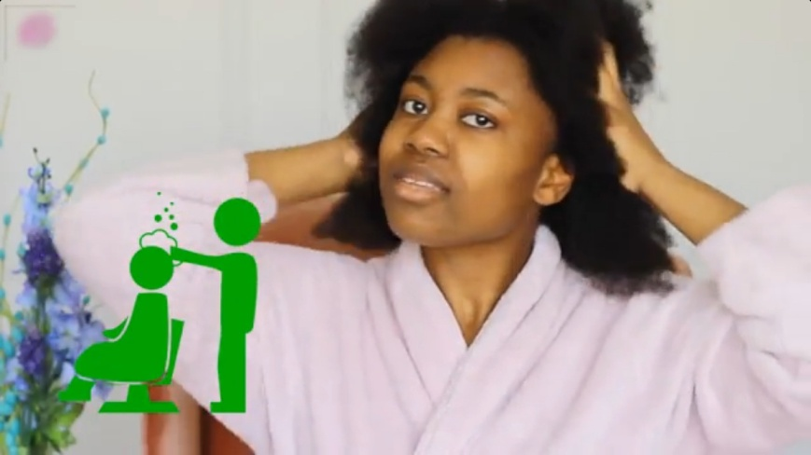

### Part 2 - Creating Senegalese Twists

**01. Part your hair as desired.**

It is best to do this before separating sections of hair, as the part you create will stay put once you do the twists, and trying to adjust it afterward can be difficult.

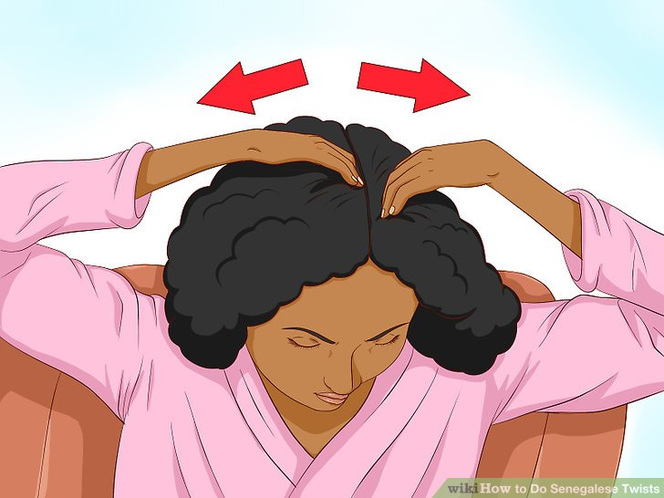

**02. Separate your hair into quadrants and then divide those sections.**

Use comb to divide your hair into 4 even sections. Then, divide each section into 4 sections. Each of these sections should be 1 inch (2.5 cm) or less in width. However, you might need to divide each section into halves or quarters if you have very thick hair.

* Comb the section of hair out to remove any tangles.
* Use small hair clips to keep the rest of your hair away from your fingers as you work on each particular section.

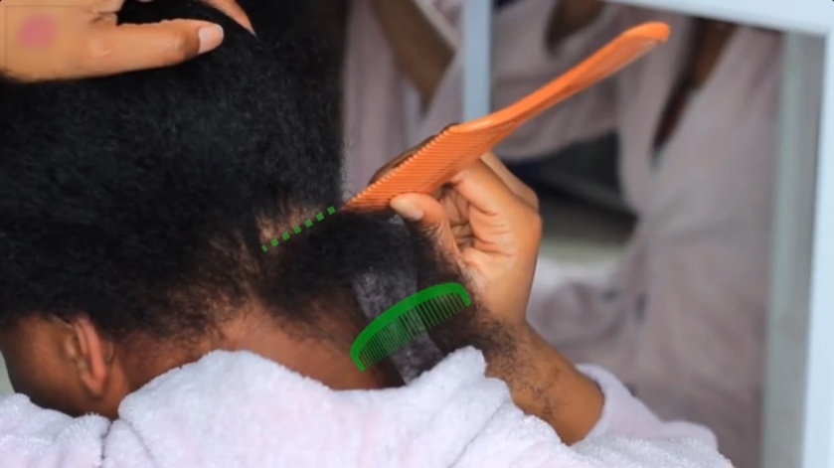

**03. Split the section of hair into 2 sub-sections.**

Use a comb or your fingers to carefully divide the section up into 2 halves of equal width.

* Do your best to completely separate the 2 smaller sections. You do not necessarily need to comb them out again, but each section should appear straight, and the 2 should not be joined together at any point.

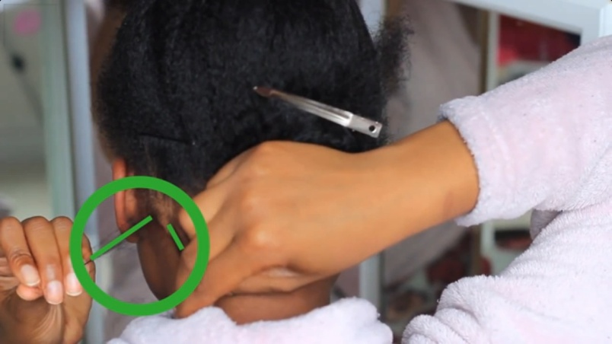

**04. Twist each section to the right.**

Use your fingers to gradually twist each smaller section to the right. Continue twisting until each section has been begun to twist into a coil.

* Grab each section 1 to 2 in (2.5 to 5.1 cm) from the scalp and twist from that point.
* The 2 sections should be evenly twisted.

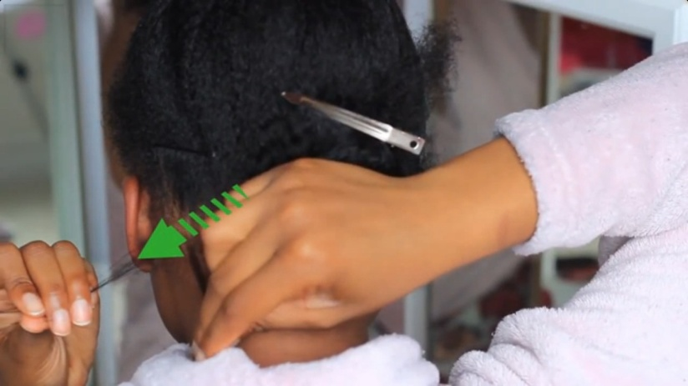

**05. Twist in extension hair.**

Lay the center of a prepared piece of synthetic extension hair over the 2 sections of real hair before you begin twisting and coiling them. Bend the extension hair so that the center remains in between the 2 split halves of real hair. The ends of the extension should drape over the 2 sections of real hair already separated out.

* Follow the same procedure used for real hair to twist the extension hair in. Grab both your real hair and the extension hair in between your fingers and twist to the right until it coils. This way, you secure the extension hair in place and weave it into your natural hair seamlessly.

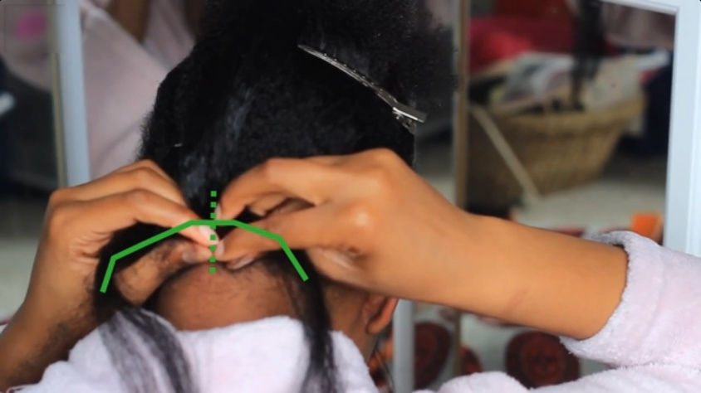

**06. Wrap the coiled strands around each other.**

Overlap the right-hand section of hair over the left-hand section once, and then twist the right-hand and left-hand sections so they are going in the same direction. Next, wrap the twisted sections around each other going in opposite directions. The right-hand section should be wrapping clockwise while the left-hand section is wrapping counter-clockwise. Coil the combined strands of hair to the right, bringing the overlapping section under and back up once more.

* From this point on, you should continue to twist and coil the hair in this manner, working over and under from the right, until you reach the end of the 2 combined sections.
* If done correctly, the twist should be tight enough and even enough to stay in place for a little while without being sealed immediately.

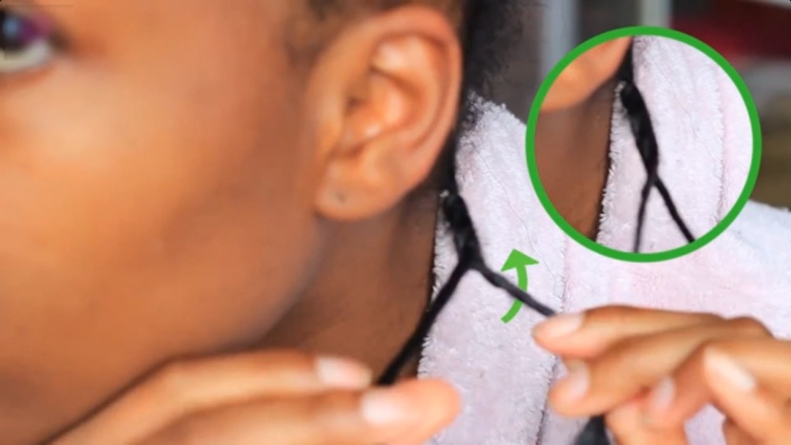

**07. Repeat the procedure with the rest of your hair.**

Separate your remaining hair into similarly sized sections, working on 1 section at a time.

* Each section of hair must be roughly the same size as the other sections. Otherwise, your Senegalese twists may look uneven when finished.
* Similarly, you should use the same amount of extension hair for each twist.

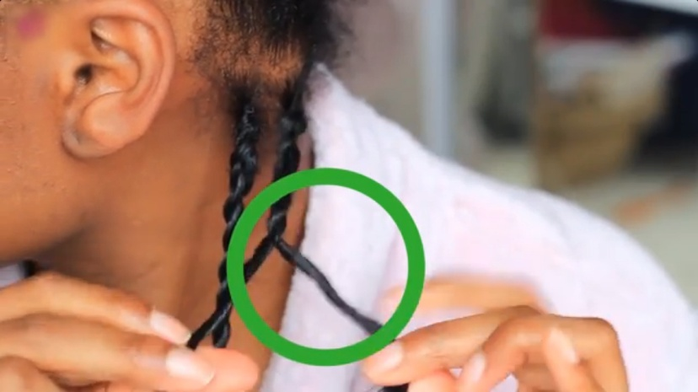

**08. Seal the ends in boiling water.**

Doing so will hold the Senegalese twists in place for a long-term style.

* Bring a small saucepan of water to boil over medium-high heat. Once it reaches a steady boil, remove the pan from the heat completely.
* Carefully dunk the bottom ends of each twist into the hot water. Submerge each twist so that all the loose ends are covered. Leave each end in water for 15 seconds.
* If doing Senegalese twists on smoother hair, you might need to gently knot the ends before sealing them in hot water or use hair elastics to tie them off.
* Allow hair to dry naturally.

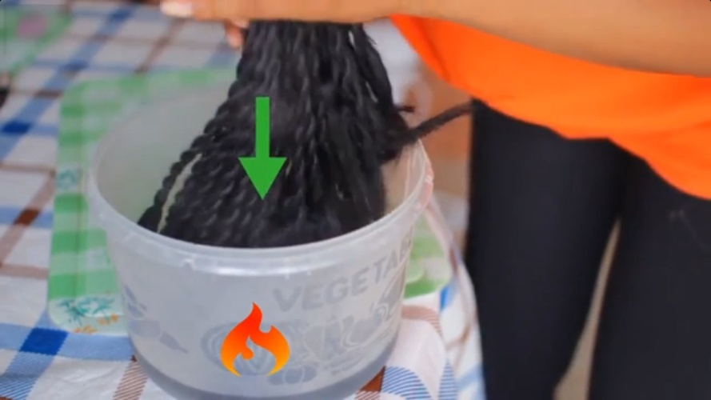

**09. Treat the ends with oil.**

It is recommended to dip the ends in olive oil or Jamaican castor oil after the water dries so as to lock moisture into the ends, preventing them from drying out. Allow to dry naturally once more.

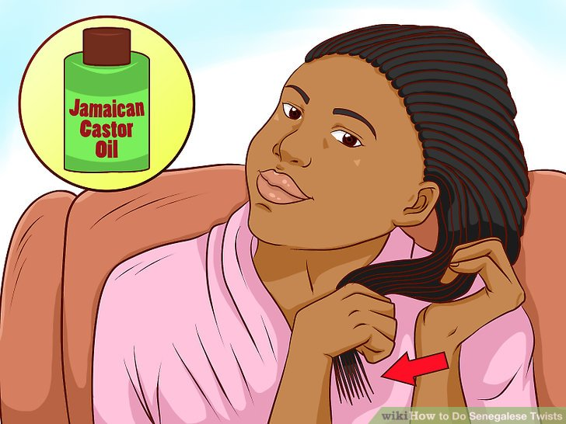

### Part 3 - Caring for Senegalese Twists

**01. Wash the twists once a week.**

You should only wash Senegalese twists once a week. Use shampoo diluted with equal parts water.

* If you wash your hair more frequently, you could cause the twists to unravel faster.

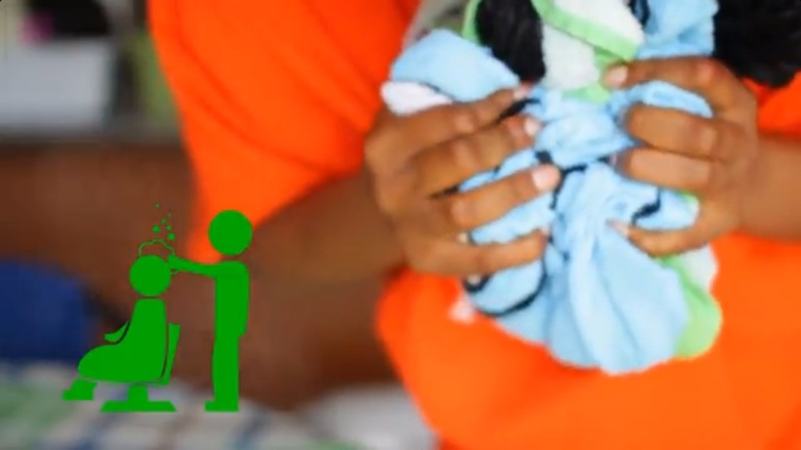

**02. Apply light oil on your scalp a few times during the week.**

2 to 3 times a week is ideal. Doing this will help hydrate your scalp.

* Peppermint, coconut, or Jamaican Black Castor Oil (JBCO) are examples of oils you could use.

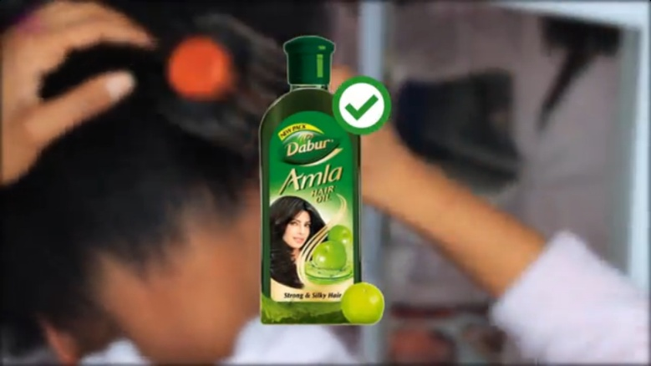

**03. Spray liquid leave-in conditioner on your braids daily.**

Braid spray or liquid conditioner can keep your hair moisturized and healthy. In order to promote optimal hair health, you should use it once a day.

* Avoid creamy conditioners while the braids are in place. Creamy conditioners can leave residue and build-up, and this, in turn, can create knots along the base of your twists.
* For an all-in-one option for both your hair and your scalp, mix a little coconut oil, JBCO oil, and conditioner into a spray bottle of water. Apply this solution to both your scalp and hair daily, and skip a separate oil treatment for your scalp.

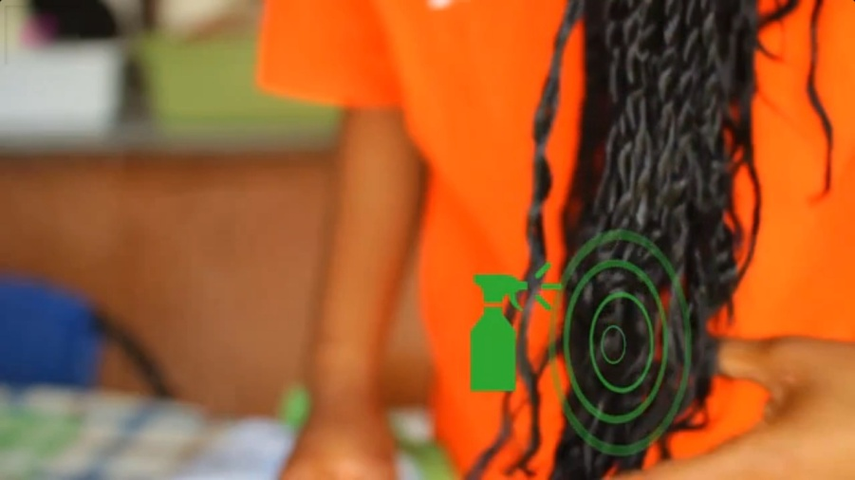

**04.Tie a silk or satin scarf around your braids before sleeping.**

Pull the twists back in a ponytail and tie a scarf made from a smooth material around your hair to protect them during the night.

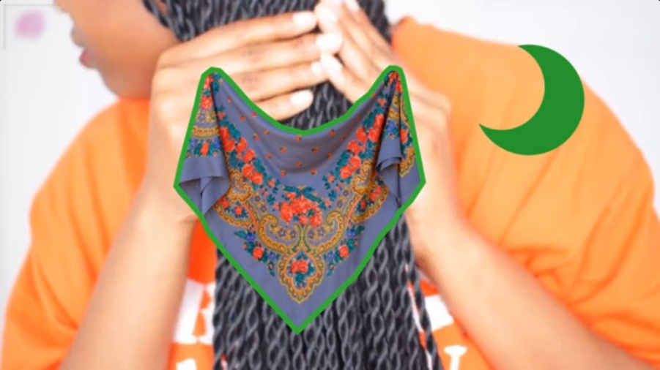

Top knot hairstyle

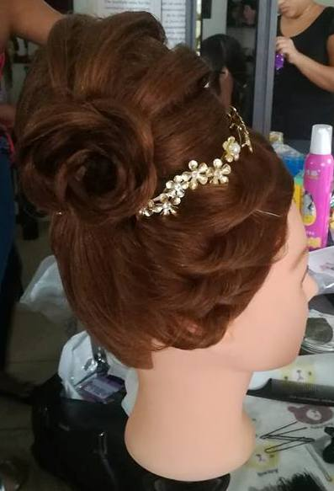 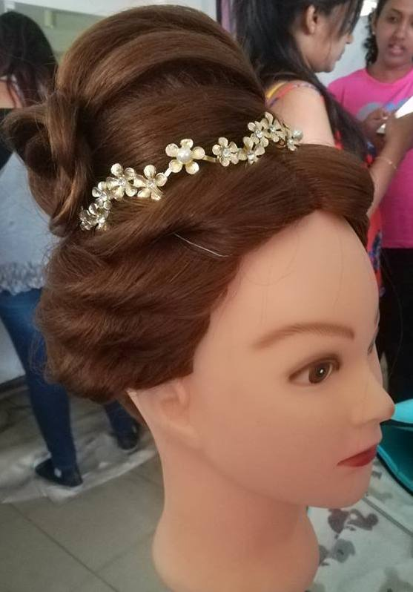

Messy rose & curton braid

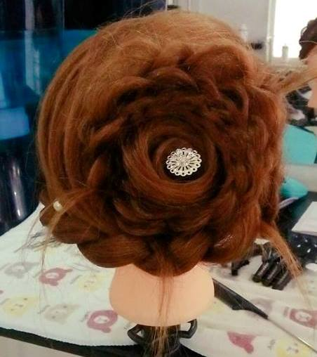 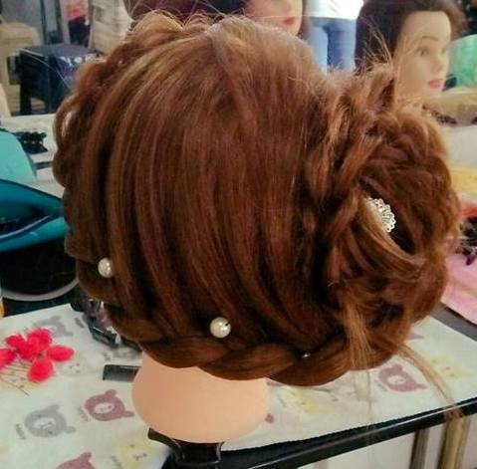 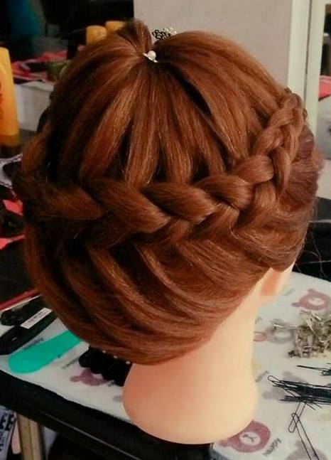

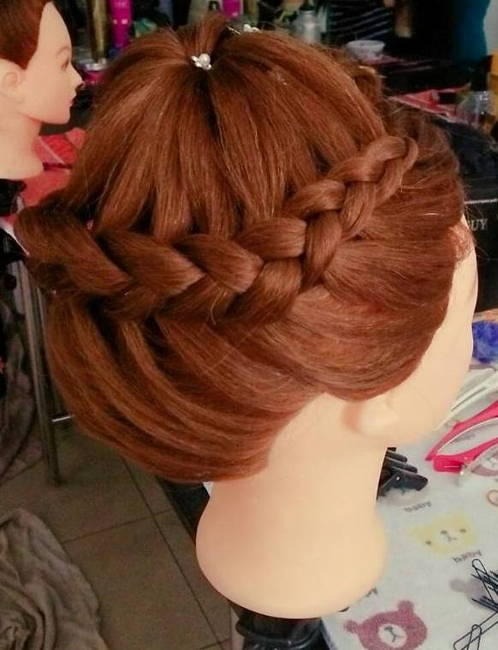 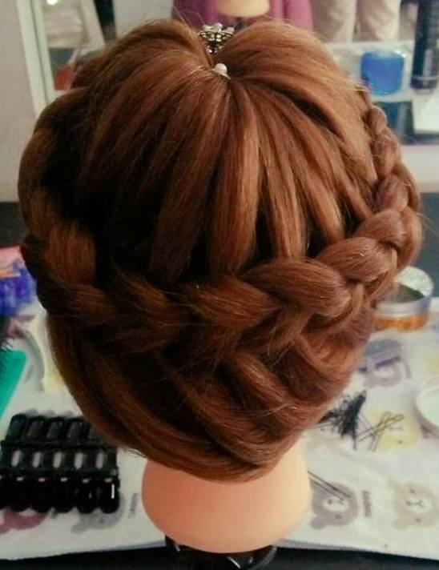

Bunch of curls hairstyle

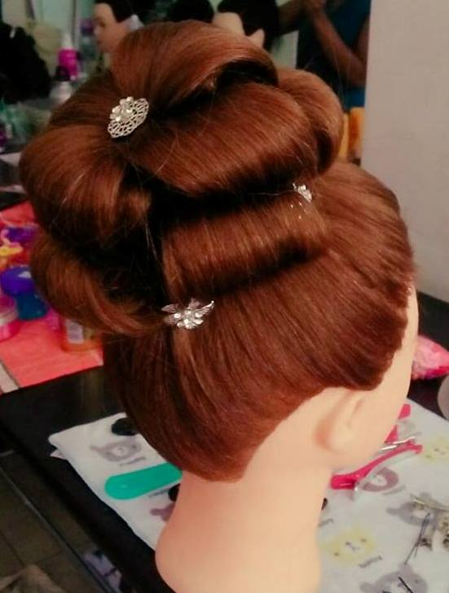 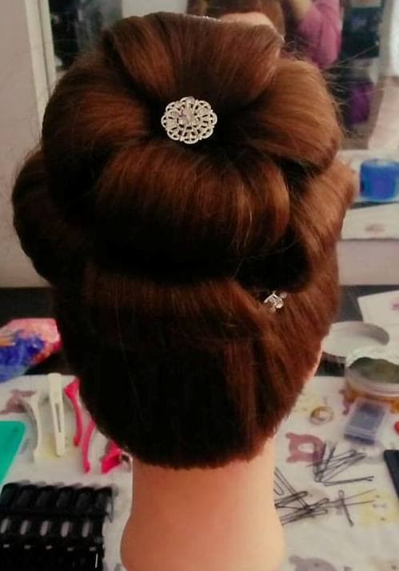 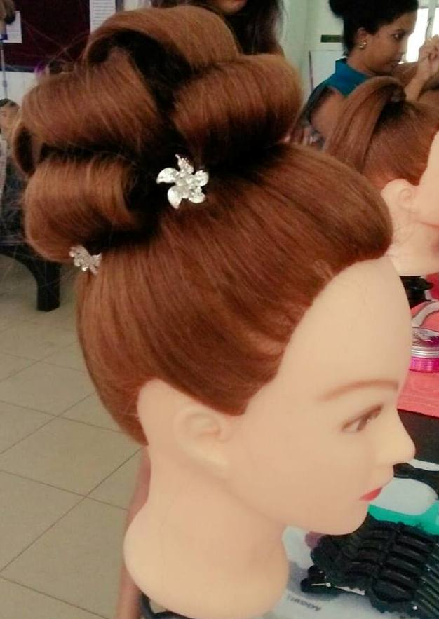

Kandian Braid

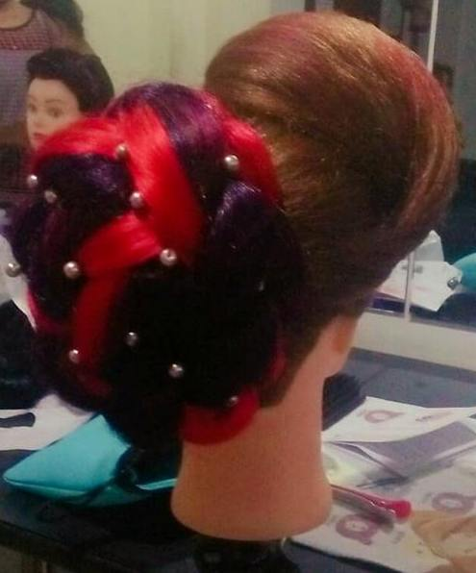 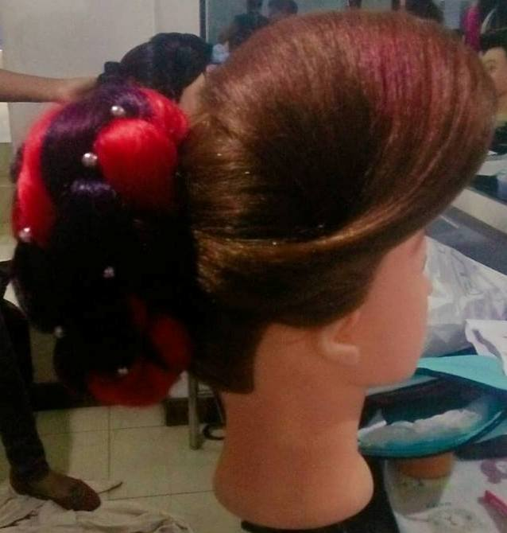 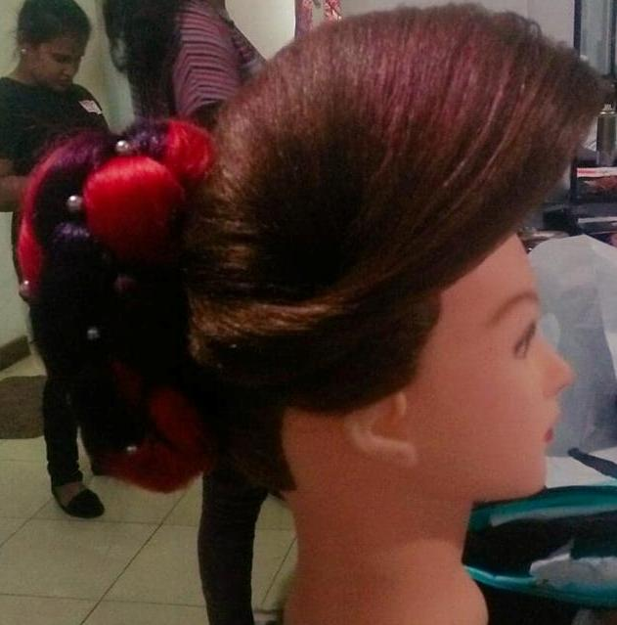

Rose curls hairstyle

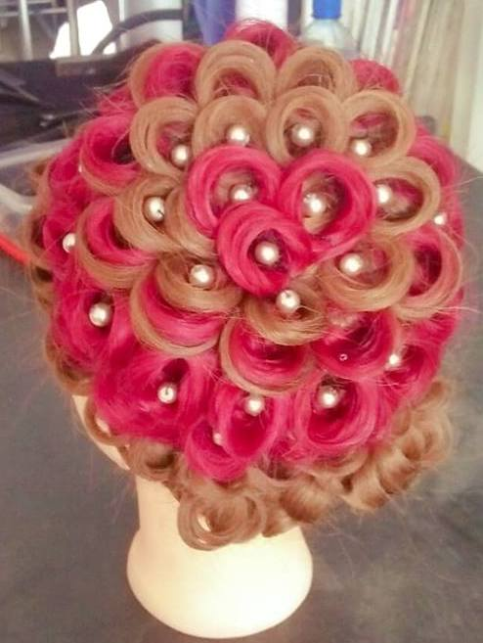 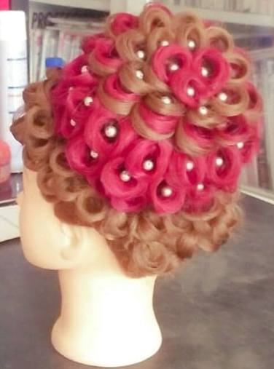

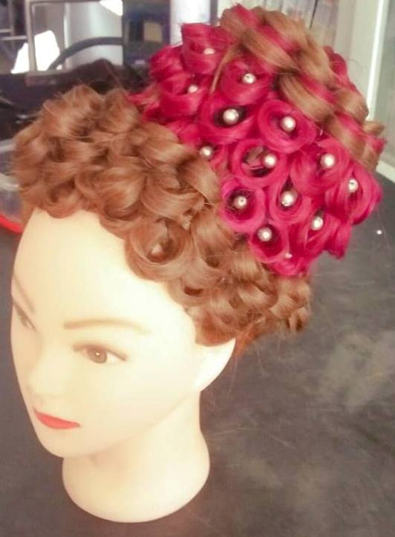 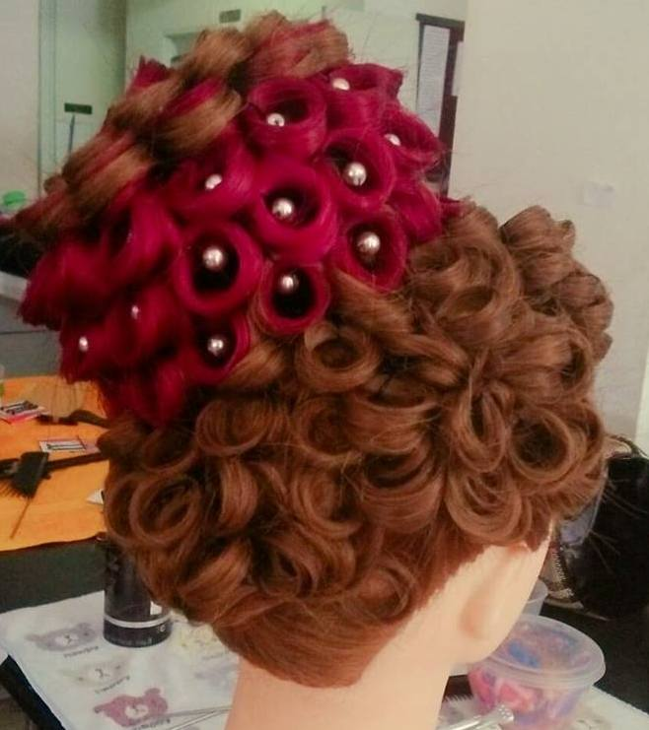

J. one pleat

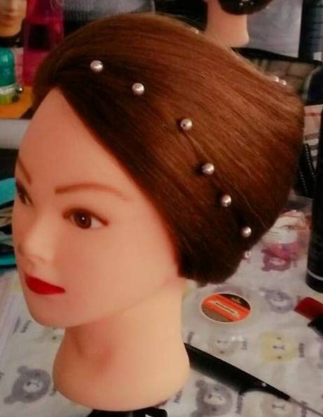 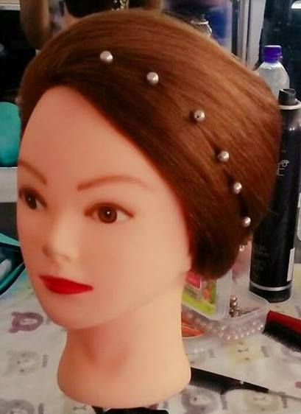 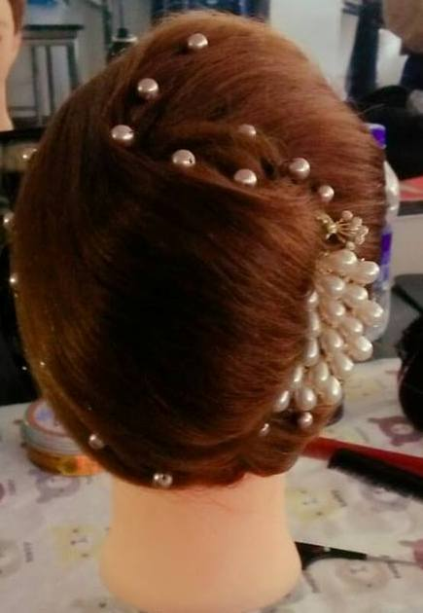

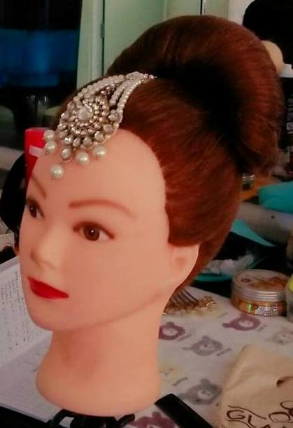 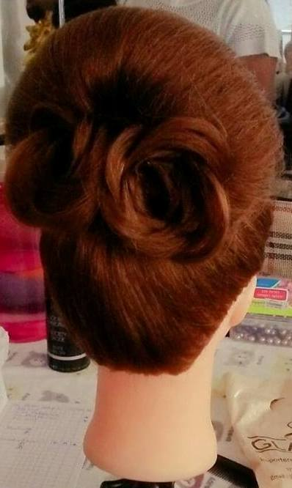 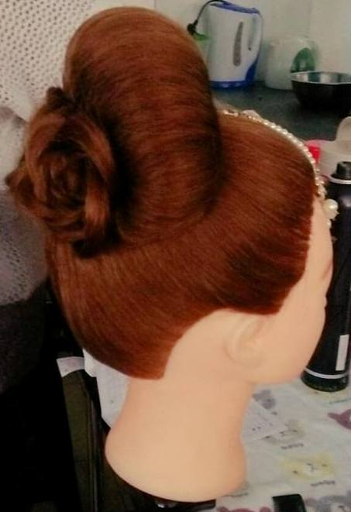

Kandian Bun

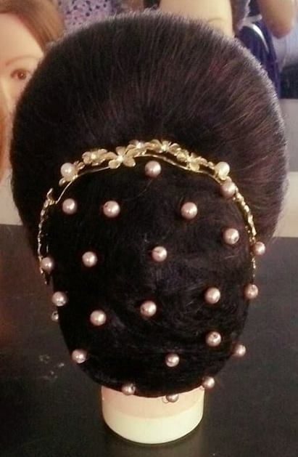 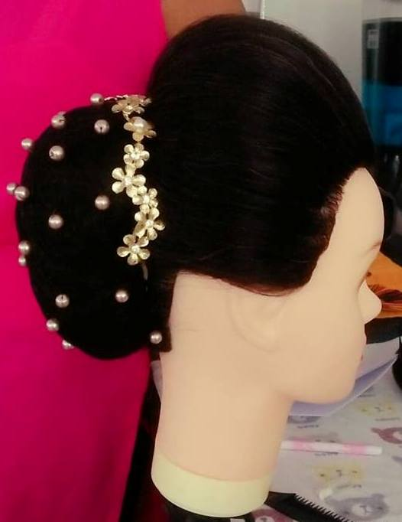 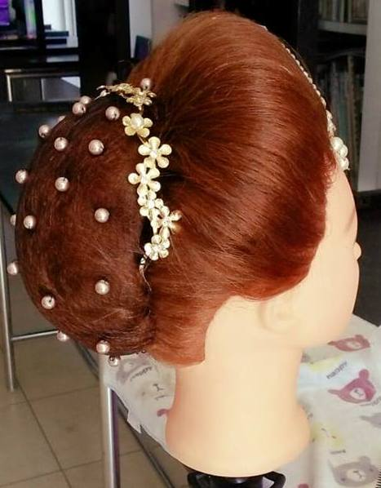

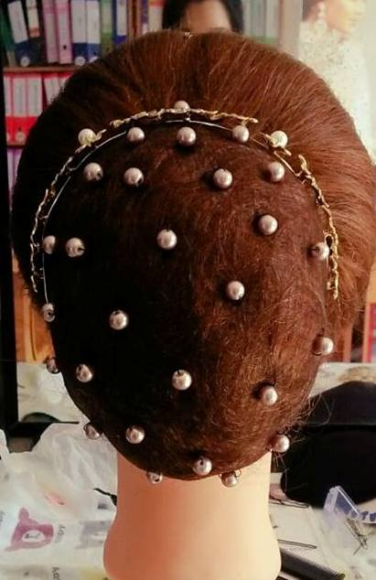 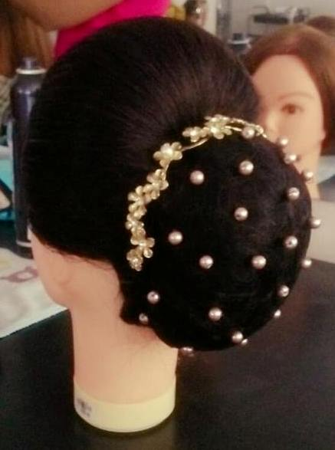 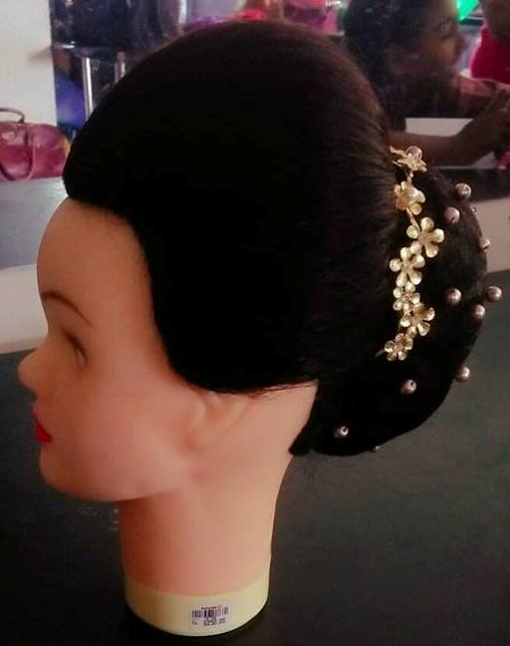

Hair swirl

